DOSSIER OF FACULTY DEVELOPMENT PROGRAM

“Data to Decision: Analytics for Research & Teaching with AI”

(Hybrid Mode: Online & Offline)

Organized by:
Jagran Institute of Management

Duration:
23rd May 2026 – 30th May 2026

Program Overview
The One-Week Faculty Development Programme (FDP) titled “Data to Decision: Analytics for Research & Teaching with AI” was successfully organized by Jagran Institute of Management in Hybrid Mode, facilitating active participation through both online and offline platforms.
The FDP aimed to strengthen faculty competencies in data analytics, research methodologies, Artificial Intelligence-driven academic decision-making, statistical tools, intellectual property rights, plagiarism ethics, and innovative teaching-learning practices. The programme provided an enriching platform for academicians, researchers, and educators to explore the integration of modern analytical tools and AI technologies into research and pedagogy.
The sessions were designed to bridge the gap between traditional academic practices and contemporary AI-enabled educational approaches, thereby enhancing research quality, academic productivity, institutional effectiveness, and evidence-based decision-making.

Objectives of the FDP
The Faculty Development Programme was organized with the following objectives:
- To familiarize faculty members with the fundamentals of data analytics in higher education
- To enhance understanding of research design and AI-assisted data collection methodologies
- To develop practical skills in SPSS-based statistical analysis
- To train participants in data cleaning, coding, transformation, and preparation
- To introduce AI-powered data visualization and interpretation tools
- To create awareness regarding Intellectual Property Rights (IPR) and plagiarism ethics
- To encourage the adoption of AI-enabled teaching methodologies and smart academic decision-making
- To strengthen research capabilities and promote innovation-driven academic practices
Participation
The FDP witnessed enthusiastic participation from faculty members across departments in both physical and virtual modes, ensuring collaborative learning and interdisciplinary exchange.

Inaugural Session

Date: 23rd May 2026

Time: 11:30 AM – 12:00 Noon

Mode: Online

The Faculty Development Programme commenced with a warm and gracious welcome address delivered by Mr. Pawan Omer, Assistant Professor, Jagran Institute of Management. He cordially welcomed the eminent guest, respected dignitaries, academicians, faculty members, researchers, and participants attending the FDP.
The address highlighted the growing importance of Artificial Intelligence and data-driven decision-making in transforming modern education and research practices. It emphasized that AI-powered analytical tools are enhancing teaching effectiveness, strengthening research quality, and improving institutional outcomes. The message reinforced the idea that Artificial Intelligence is not intended to replace educators but to empower them with deeper insights, faster analysis, and innovative possibilities.
The keynote session was graced by Dr. Manpreet Singh Manna, a distinguished academician and visionary educationist with over 32 years of experience in education, research, and technical innovation. Presently serving as Executive Director of GCC School, he has previously held prestigious positions including Vice Chancellor of Chandigarh University and Director at AICTE.
The session highlighted his significant contributions as Founder Director of the SWAYAM MOOCs initiative and his instrumental role in launching the Smart India Hackathon, thereby fostering innovation and problem-solving abilities among students nationwide.
During his address, Dr. Manna shared valuable insights on AI-enabled analytics in higher education, technology-driven teaching methodologies, and innovation-oriented academic ecosystems. He discussed the evolving transition from “Data to Science” and emphasized the accelerating role of Artificial Intelligence in academic and research advancement.
The inaugural session concluded with a heartfelt vote of thanks expressing sincere gratitude to Dr. Manna for his inspiring address and gracious presence.

Outcome
Participants gained valuable insights into the transformative role of AI and analytics in education, research, and institutional development.
Participants attending the inaugural session in hybrid mode
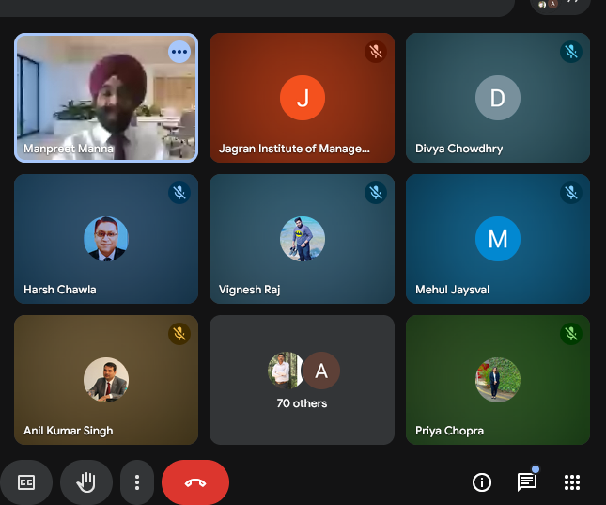
Welcome address during the inaugural session of the FDP
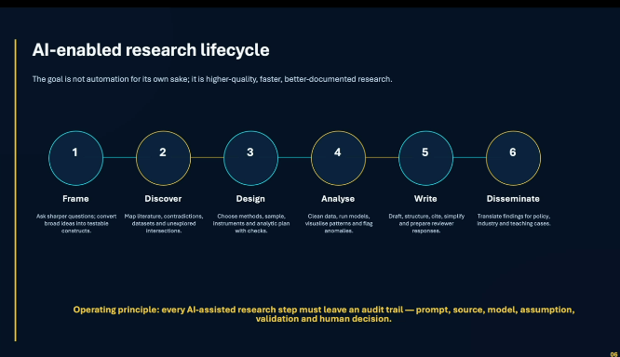
Keynote address by Dr. Manpreet Singh Manna
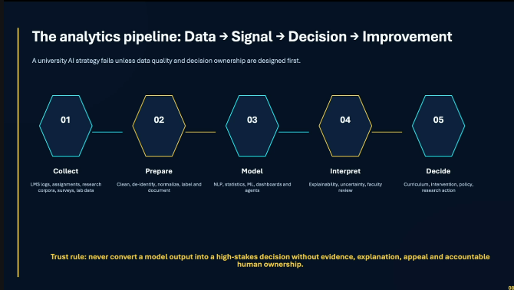
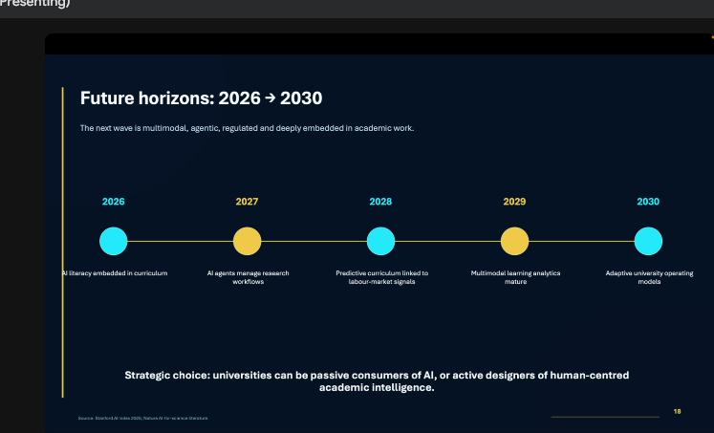
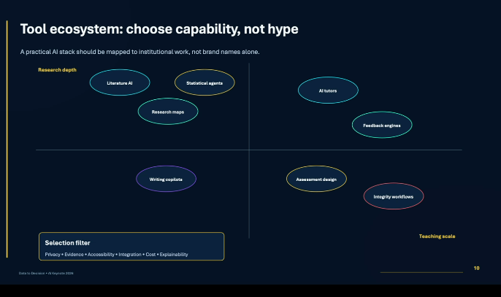
Interactive engagement of faculty members and researchers

Day 1: Foundations of Data Analytics in Academia, Research Design & Data Collection with AI

Date: 23rd May 2026

Time: 12:00 Noon – 2:00 PM

Mode: Online
Following the inaugural session, the proceedings were handed over to Dr. Akshat Gupta, who warmly welcomed the esteemed resource person, Dr. Chinmoy Kumar Roy, for the first technical session.
The session focused on the theme “Foundations of Data Analytics in Academia, Research Design & Data Collection with AI.” The discussion highlighted how data analytics has emerged as a critical component of evidence-based decision-making and scholarly advancement in modern academia. The integration of AI in research design and data collection is transforming traditional methodologies by improving efficiency, precision, reliability, and interpretation of complex datasets.
Dr. Chinmoy Kumar Roy, Assistant Professor at the Faculty of Commerce, Banaras Hindu University, shared his rich academic and research experience. He elaborated upon AI-assisted survey development, predictive analytics, ethical data collection practices, and intelligent research frameworks.
His practical examples and insightful explanations enabled participants to understand the transformative potential of AI-powered data analytics in academic research and institutional development.

Outcome
Participants gained clarity on designing impactful academic research using AI-assisted methodologies.
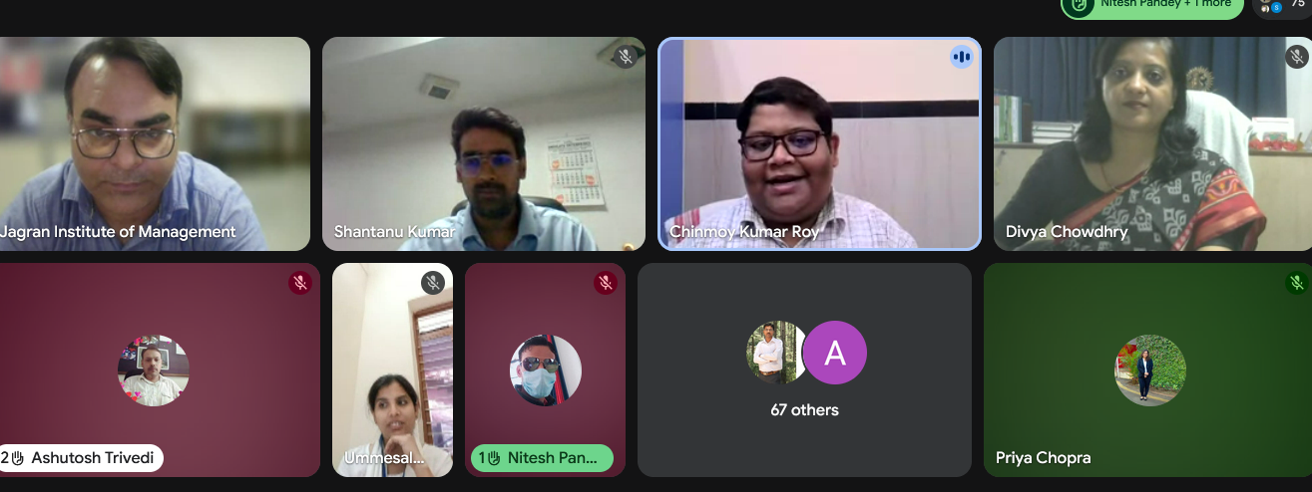
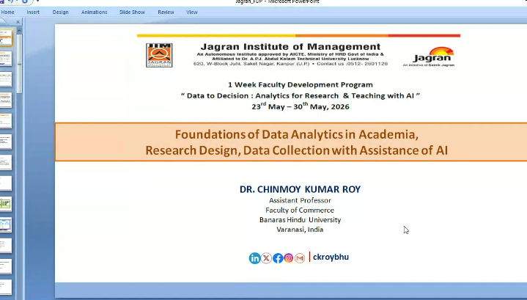
Technical deliberation on AI-assisted research methodologies
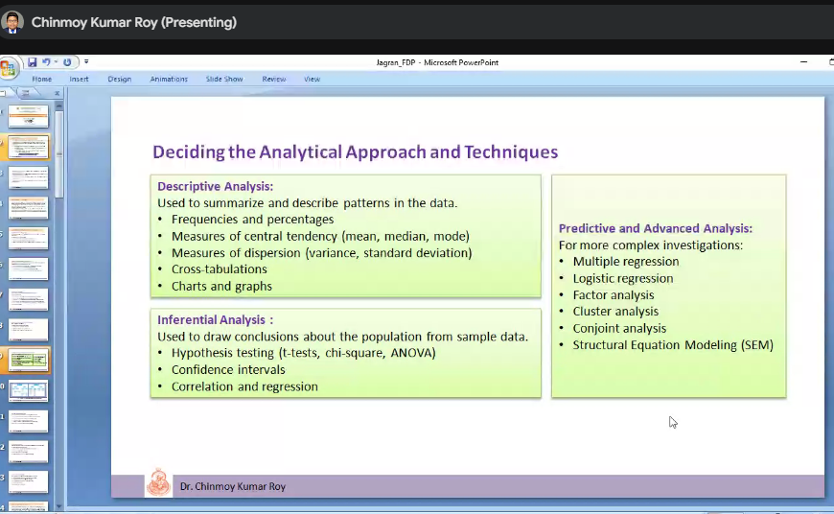
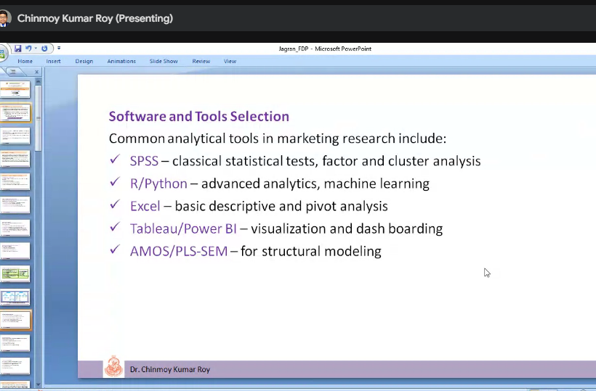
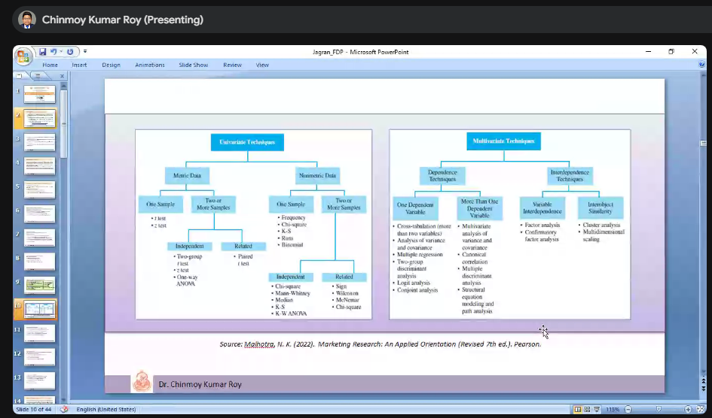

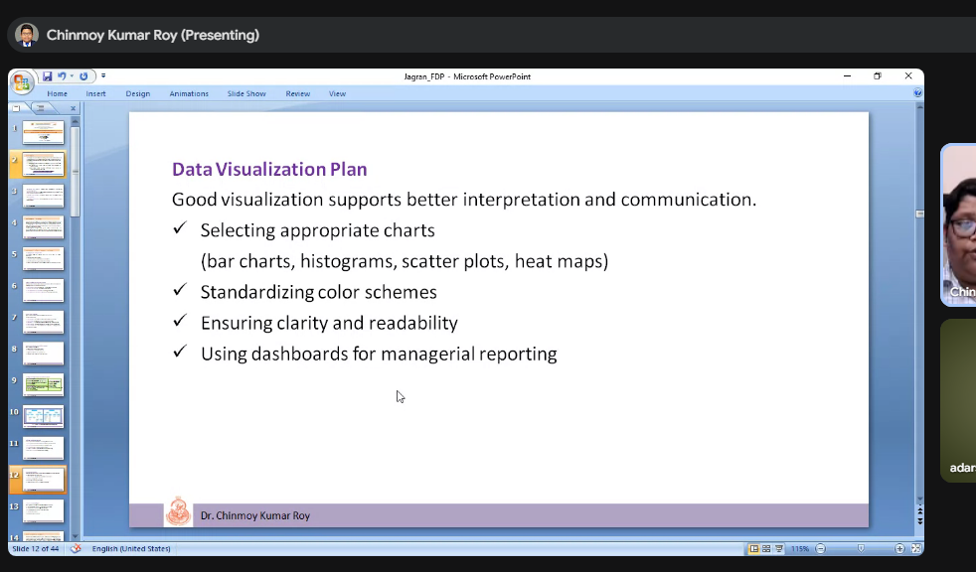
Online participation of faculty members and researchers
Interactive Q&A session with participants
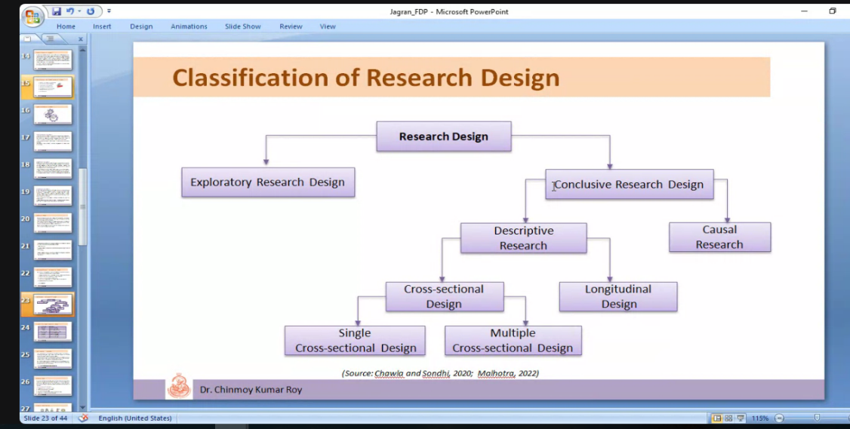
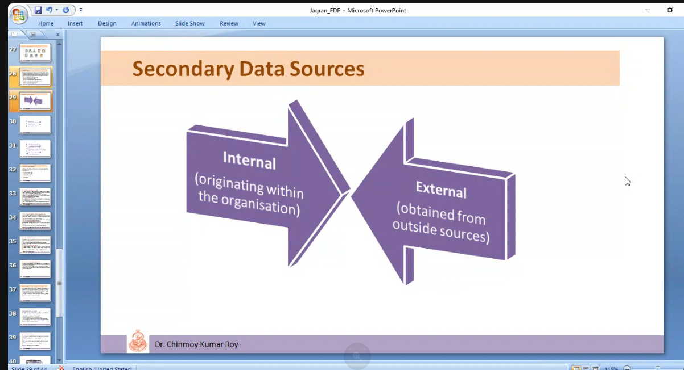
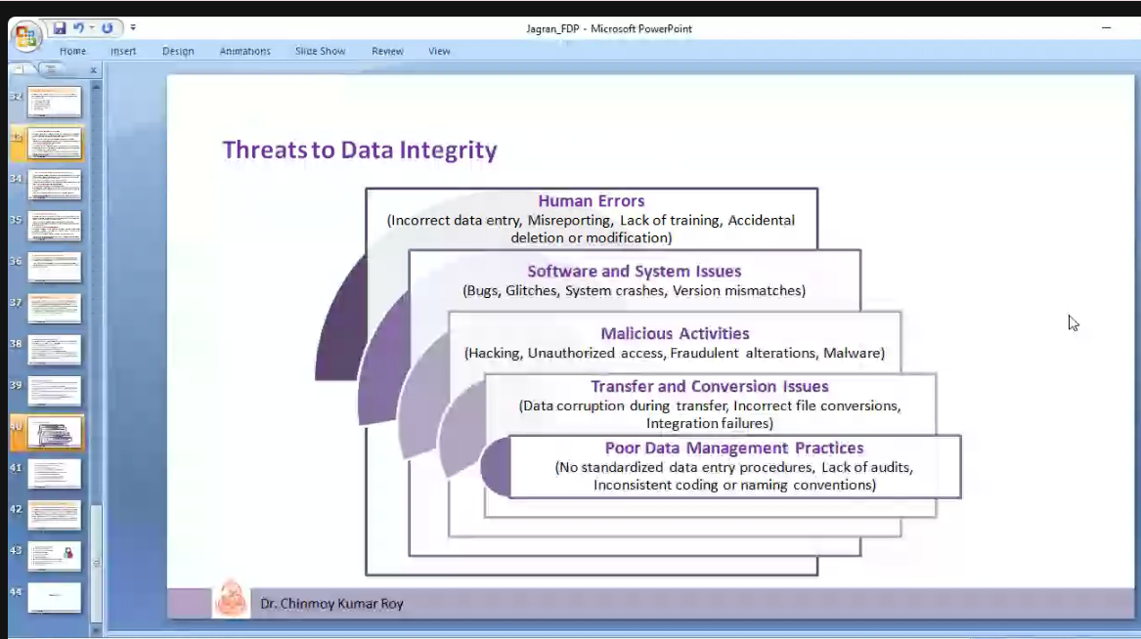

Day 2: Statistical Analysis using SPSS

Date: 25th May 2026

Time: 10:30 AM – 1:30 PM

Mode: Hybrid

The second day of the FDP commenced with enthusiasm and academic vigor. The session began with a formal welcome address by Dr. Anand Sir, who highlighted the importance of adopting emerging technologies and analytical tools in modern research and teaching practices.
The resource person for the session was Mr. Saurabh Agarwal, an eminent academician and expert in Business Analytics and Data Science, with academic affiliations to IIT Kanpur and IIT Delhi.
During the session, Mr. Agarwal provided hands-on demonstrations of SPSS applications, including data entry, descriptive statistics, inferential statistics, hypothesis testing, regression analysis, and statistical report writing. Participants were introduced to practical datasets and guided through various analytical procedures using SPSS software.
The session emphasized the significance of evidence-based decision-making and AI-driven analytics in academic research and institutional planning.

Key Highlights
- SPSS Interface and Data Entry
- Descriptive and Inferential Statistics
- Hypothesis Testing
- Correlation and Regression Analysis
- Statistical Report Writing
- Exploratory Data Analysis (EDA)

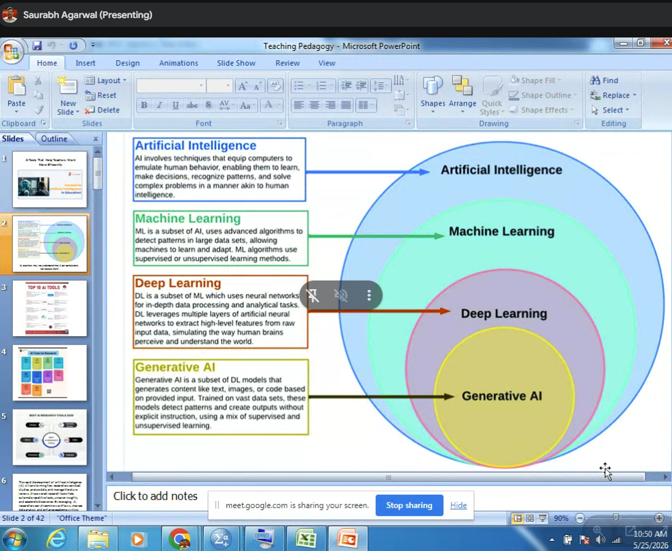

Faculty members developed practical proficiency in statistical data analysis for research and publication purpose

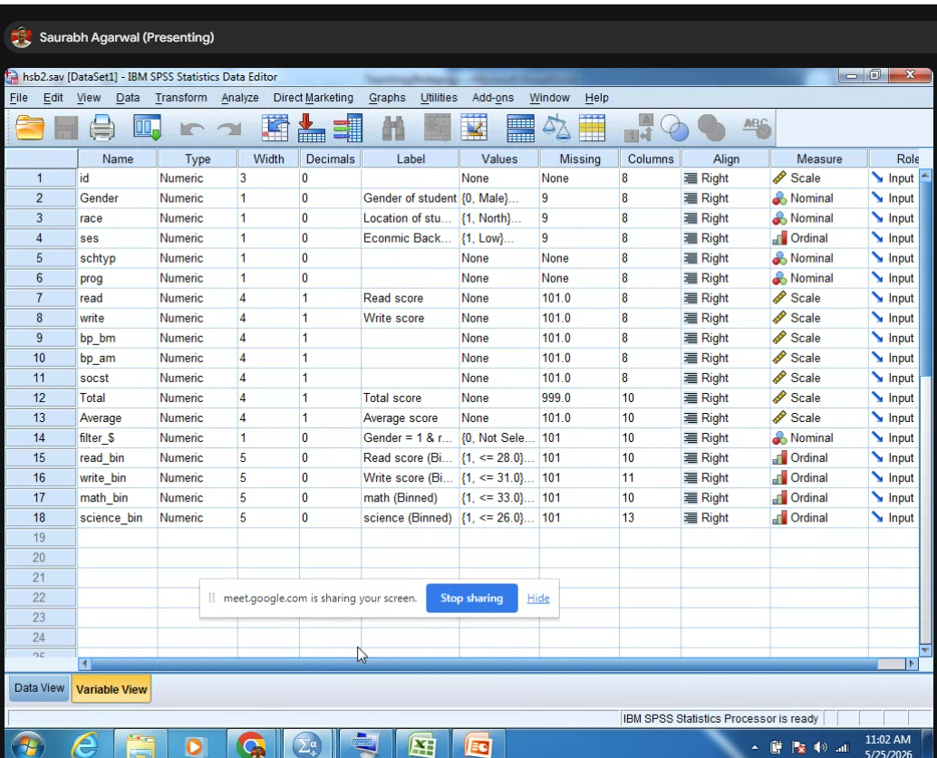

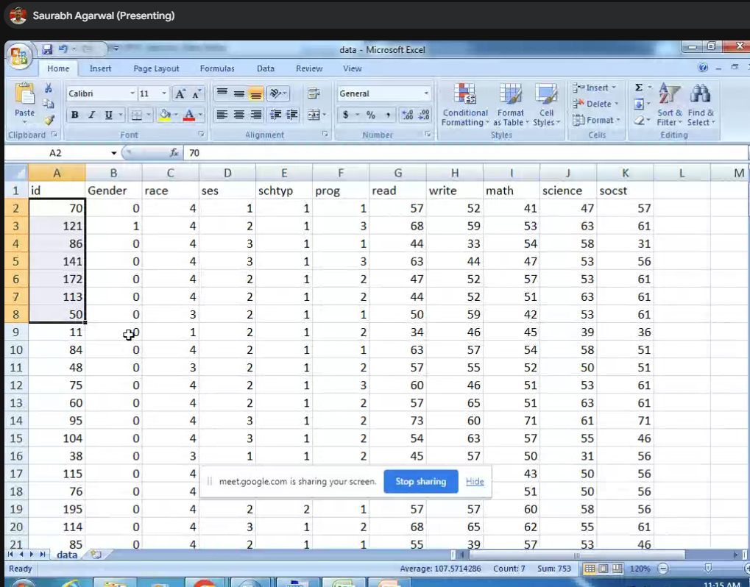
Question - How to create Variable View in SPSS?
Rule 1- NO BLANK SPACE
Rule 2 – FIRST LETTER CAPITAL
Rule 3 – DON’T GIVE NAME MORE THAN CHARACTER
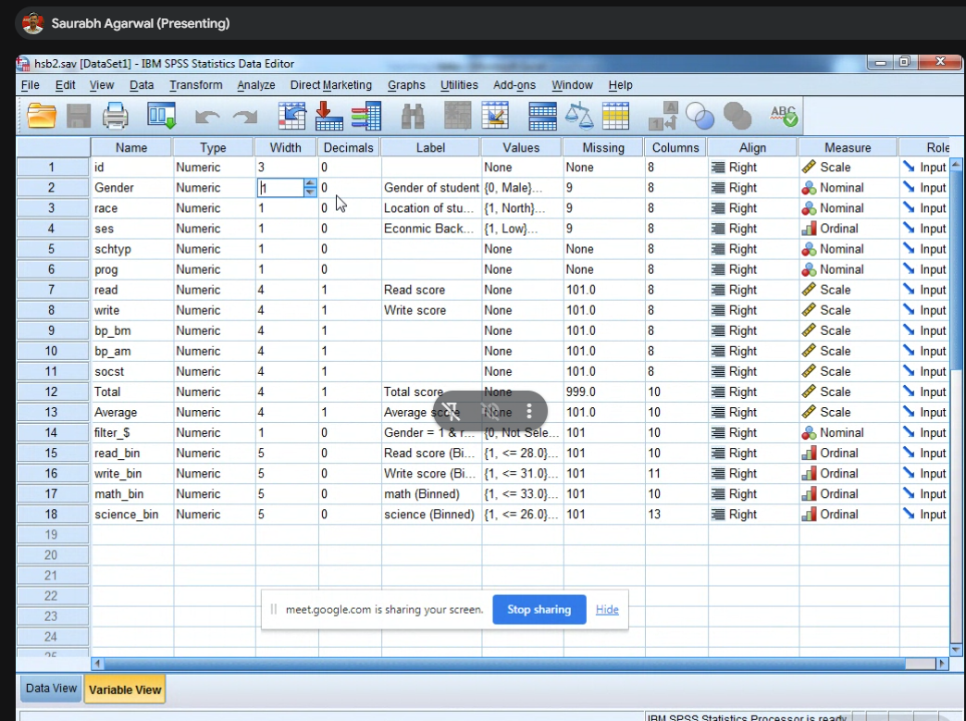
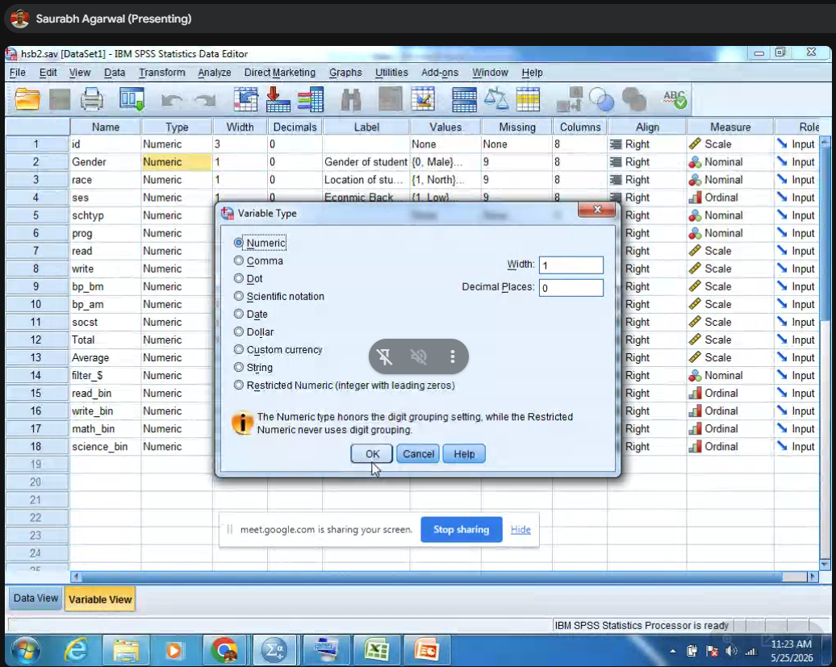
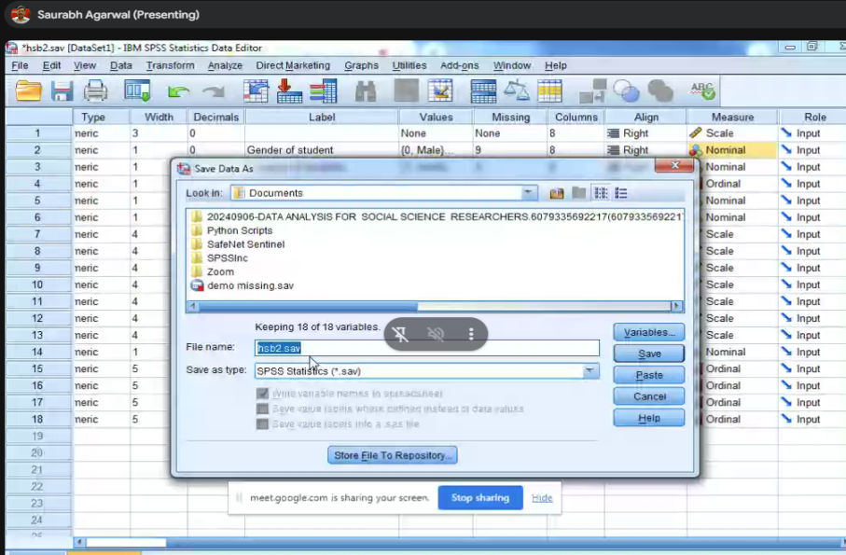
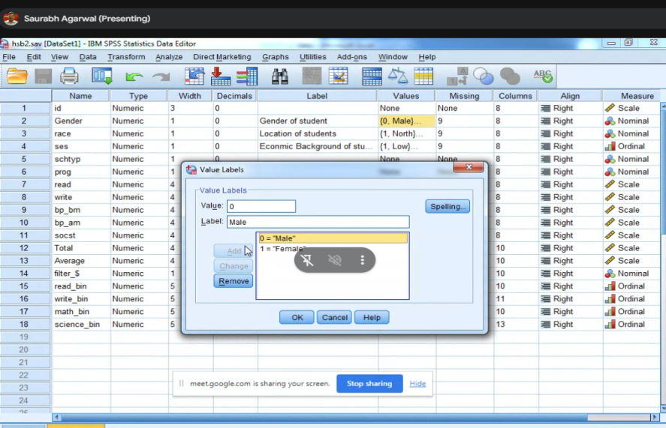

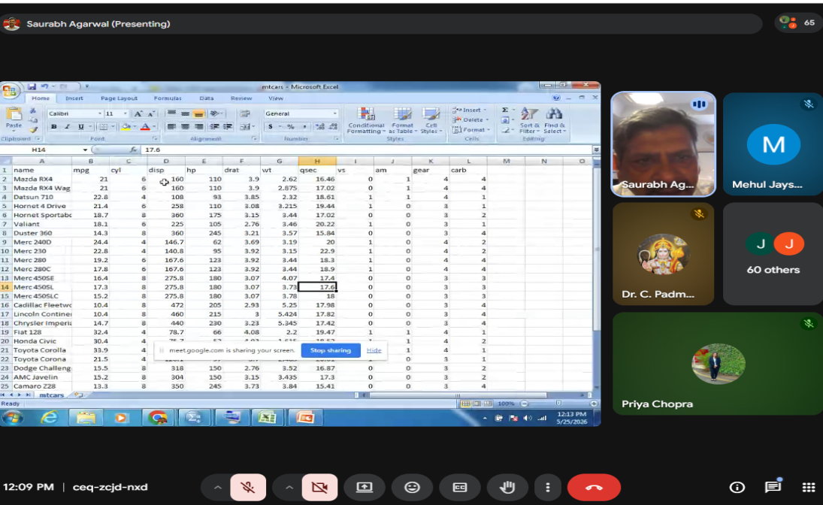
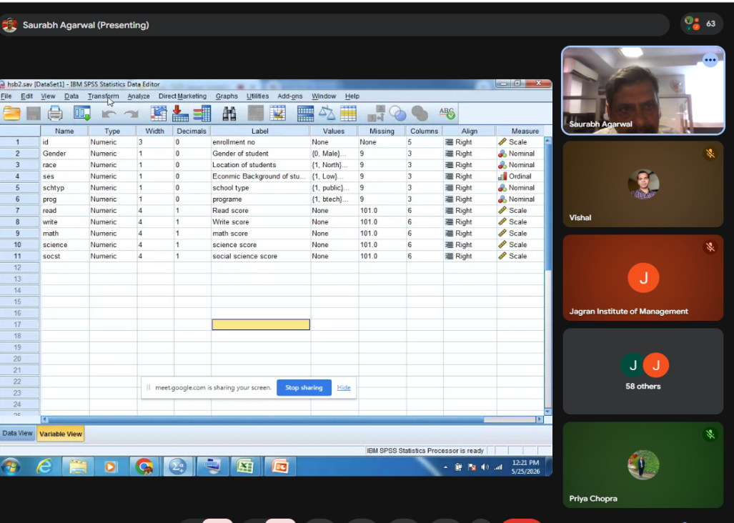
Another Sheet form practice
Zero – Fuel Based Car / One- EV
AM (0) – Manual / 1 – Automatic
Drag of the Car
Weight of the car

Gear
Carbon Emission BS stage1 , BS stage 2 , BS stage 3, BS stage 4
HP- Horsepower (Unit of Measurement Power)
Dis - Displacement

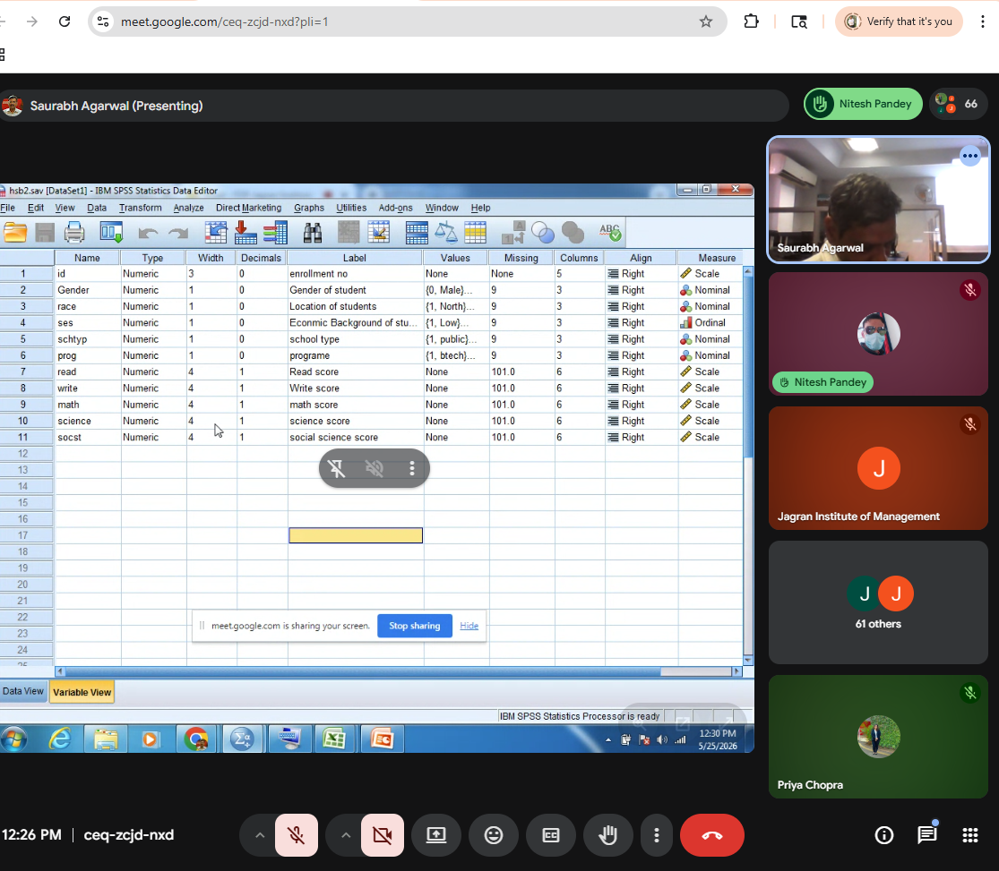
Question - To generate frequency table for the variable” Gender”(No of Male and Female)
EDA- Exploratry Date analysis
- To generate frequency table for variable GENDER
- Analyze descriptive statistics
- Sample size 200 and no missing values for gender
- Second output insert
- The more than category is FEMALES for Gender
Question – Generate the Frequency table for the following variables
- Race
- SES
- School Type
- Prog Along with the discussion
Question – For the empty car data set generate the frequency table for following variables
- VS
- AM
- Gear
- Carbon Variable
Indicate the missing value with the model category
Question - Find the mean and Standard deviation
Analyze – Descriptive Statistics – Descriptive – Transfer Variable – option – Mean and SD (Standard Deviation)
Question- In which subject student has performed well
Find mean of all 5 subjects (Read, Write, Math, science and social science
Question – In which subject student are more consistent?
Consistent means which subject has less Standard deviation
Question - In which subject performance is bad and good?
Question - In the empty car data set what is mean Mileage and house power?
SD for WT and QSTec?
Question -Find minimum and maximum mileage and house power of the car? Minimum and Maximum and conclude
Question - A data visualization to draw a pie chart showing to draw a pie chart showing % of males and females
Question -Create a pie chart for the following variables
  - Race
  - SES
  - School Type
  - Program

Points -
- Hands-on SPSS training session conducted by Mr. Saurabh Agarwal
- Participants performing statistical analysis using SPSS
- Demonstration of data visualization and hypothesis testing
- Interactive practical session during the workshop

Day 3: Data Collection, Cleaning & Preparation

Date: 26th May 2026

Time: 10:30 AM – 1:30 PM

Mode: Hybrid
The third day of the FDP focused on advanced concepts related to data collection, cleaning, coding, validation, and preparation. The session commenced with a warm welcome address delivered by Mr. Adarsh Srivastava, Assistant Professor, Jagran Institute of Management.
Continuing the insightful learning journey, Mr. Saurabh Agarwal conducted practical demonstrations on SPSS applications, data analytics, visualization techniques, and research-oriented statistical interpretation.
Participants were guided through systematic approaches to handling missing data, transforming datasets, validating variables, and ensuring research reliability. The interactive discussions enabled participants to strengthen their understanding of analytical frameworks and modern research practices.

Key Highlights
- Data Validation Techniques
- Handling Missing Data
- Data Cleaning and Coding
- Data Transformation
- Data Reliability Practices
- Cluster Bar Graphs and Pie Chart Visualization

Outcome
Participants learned systematic approaches for preparing high-quality and reliable research datasets.
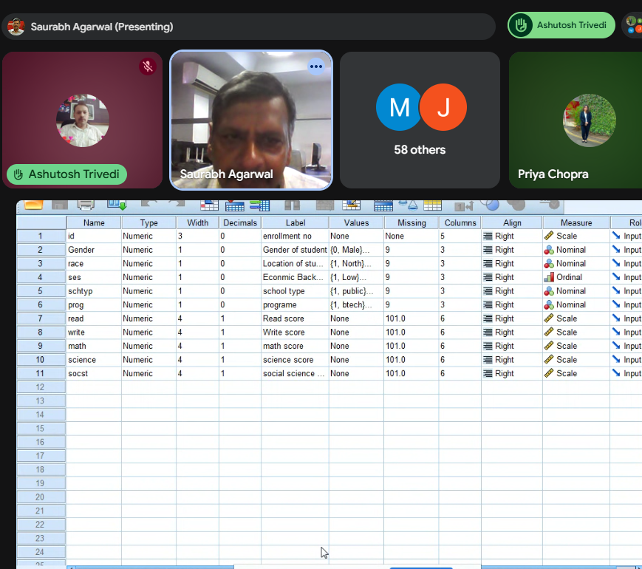
- Session on data cleaning and preparation techniques

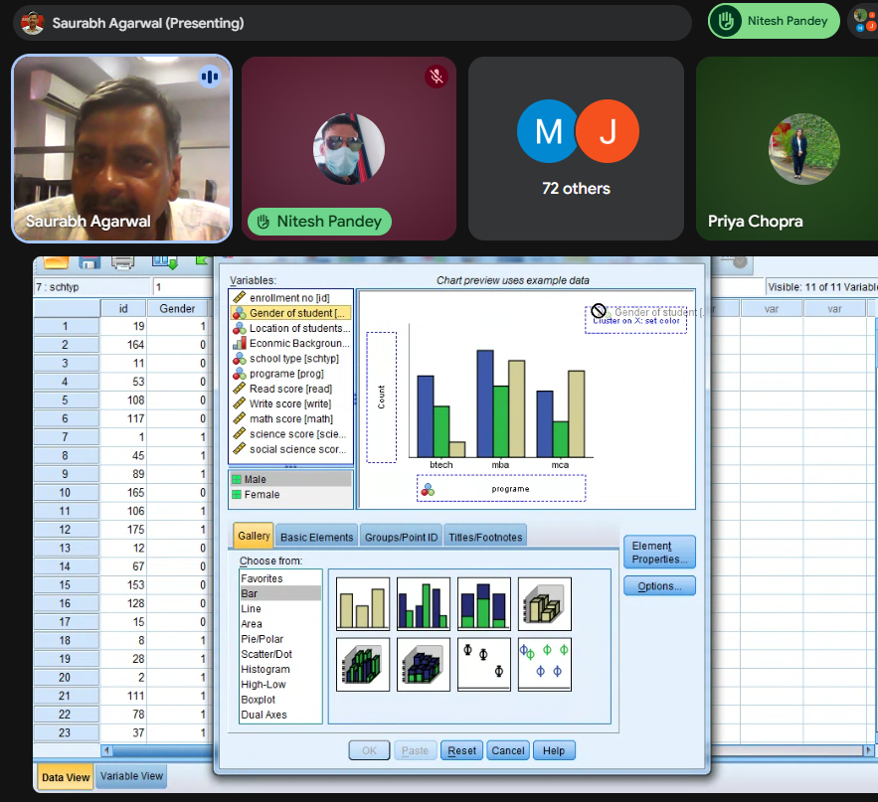
- Practical demonstration of data visualization tools
Question – Create a cluster bar plot for the following cases
- Breakup of Race with Program
- Breakup of SES with Program
- Breakup of school type with prog
- Breakup of gender with school type
- Breakup of race with school type

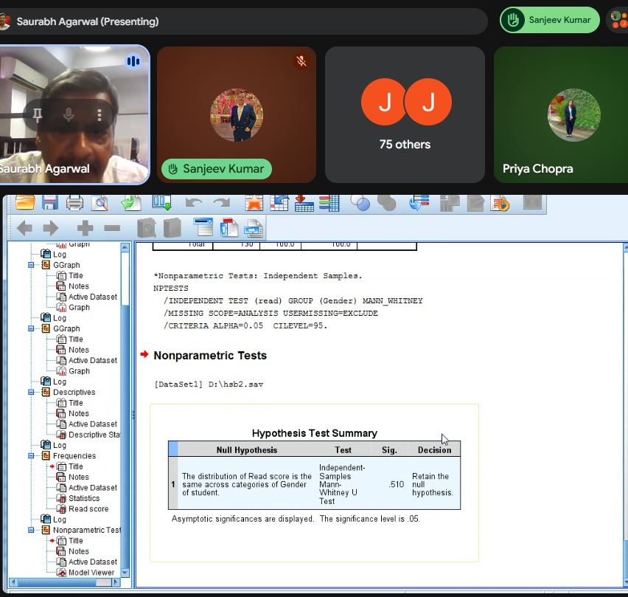
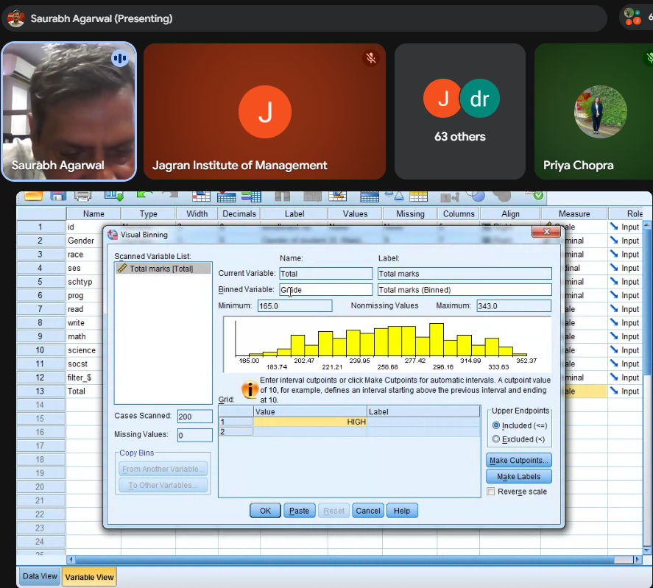

- Faculty members engaged in analytical exercises
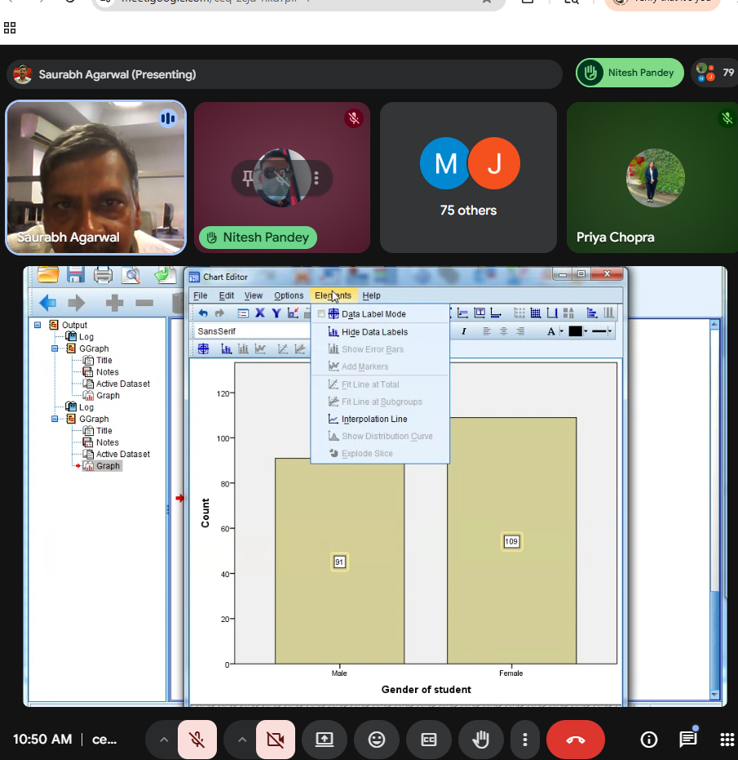
- Discussion on research reliability and dataset preparation

Day 4: AI-Driven Data Visualization Techniques & Decision Making

Date: 27th May 2026

Time: 11:30 AM – 2:30 PM

Mode: Hybrid
The fourth session was conducted by Mr. Avnish Srivastava, an Independent Consultant and seasoned Learning & Development expert with over 25 years of professional experience.
The session focused on AI-driven visualization techniques and institutional decision-making processes. Participants explored the importance of visual storytelling, analytical interpretation, and AI-powered tools such as Julius AI and Notebook LLM in academic research and planning.
The resource person demonstrated how AI-enabled visualization tools can convert complex datasets into meaningful insights, thereby improving academic planning, institutional efficiency, and evidence-based decision-making.

Key Highlights
- Fundamentals of Data Visualization
- Visual Storytelling in Research
- Data Interpretation for Decision-Making
- Institutional Planning using Data
- AI Tools: Julius & Notebook LLM

Outcome
Participants explored AI-based visualization tools to improve academic decision-making efficiency.
- Demonstration of AI tools for academic analytics
- Participants exploring data storytelling techniques
- Interactive discussion on institutional decision-making

Day 5 (Session 1): Intellectual Property Rights in Teaching & Academic Outcomes

Date: 29th May 2026

Time: 11:00 AM – 1:00 PM

Mode: Online
The fifth day of the FDP commenced with a warm welcome address delivered by Mr. Pawan Omer, Assistant Professor, Jagran Institute of Management.
The session focused on the theme “Intellectual Property Rights in Teaching & Academic Outcomes.” The discussion highlighted the growing significance of protecting intellectual creations, research innovations, teaching resources, and institutional identities within educational ecosystems.
The distinguished resource person, Mr. Prateek Shrivastava, Founder of PNA Intellectual Property & Technology Attorneys, shared valuable insights on patents, trademarks, copyrights, and innovation management.
He elaborated on the importance of Intellectual Property Rights in promoting innovation, preserving original research contributions, supporting commercialization, generating institutional revenue, and enhancing global academic recognition.
The session also addressed practical aspects of patent filing, intellectual property awareness, and ethical knowledge protection in higher education institutions.

Key Highlights
- Fundamentals of Intellectual Property Rights
- Copyrights and Patents
- Trademark Awareness
- Academic Innovation Protection
- IPR in Teaching Resources
- Patent Filing Procedures
- Commercialization of Research
- Ethical Use of Academic Content

Outcome
Participants developed awareness regarding Intellectual Property Rights, academic innovation protection, and ethical research practices.
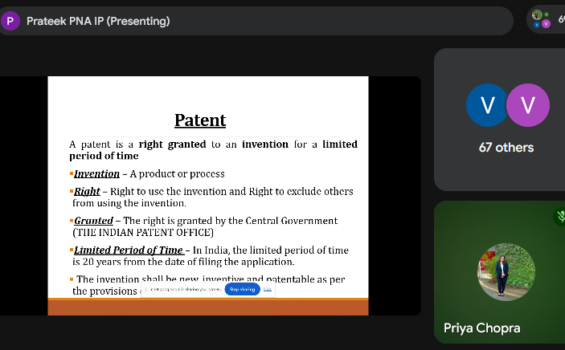
- Welcome address during the IPR session

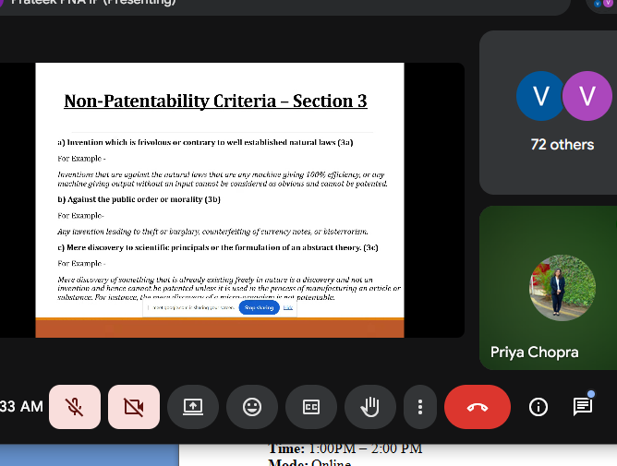
Expert lecture by Mr. Prateek Shrivastava on patents and trademarks
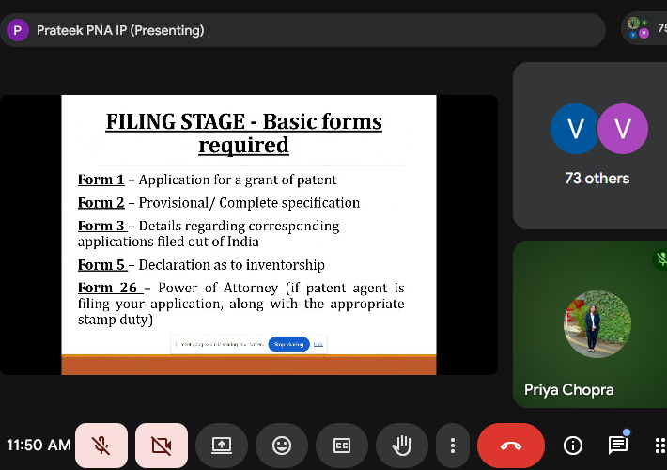
- Participants attending the online session on Intellectual Property Rights
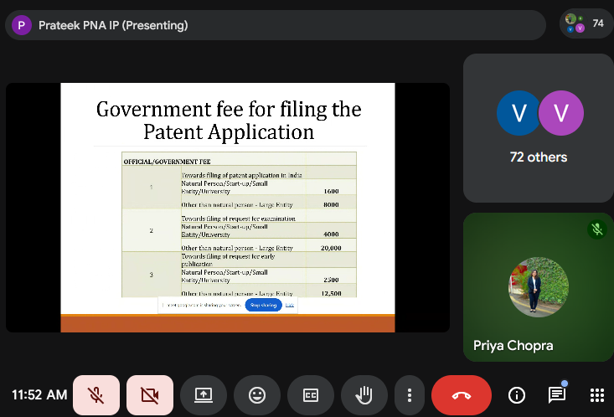
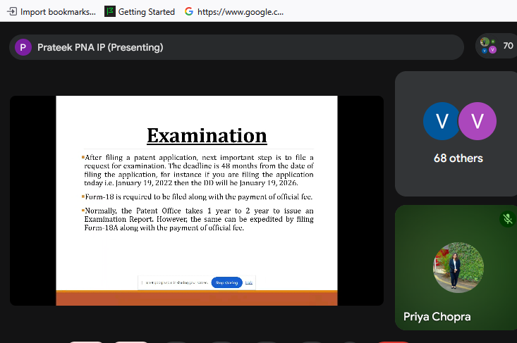
- Interactive discussion on academic innovation and IPR awareness
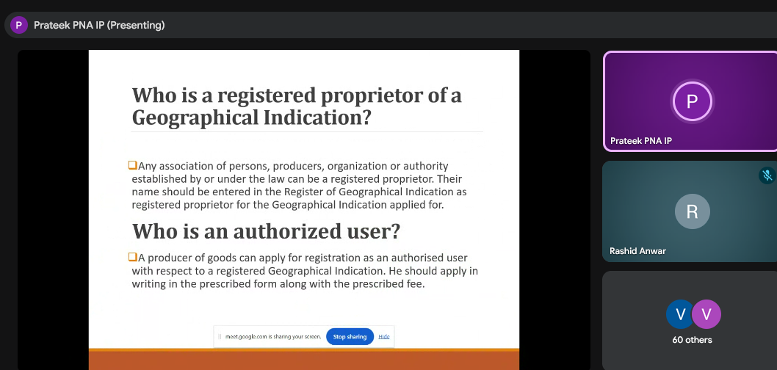

Day 5 (Session 2): Plagiarism & Ethics

Date: 29th May 2026

Time: 1:00 PM – 2:00 PM

Mode: Online

Resource Person: Prof. Prakash Singh
Dr. Prakash Singh is a Professor of Finance and Accounting at Indian Institute of Management Lucknow, where he has been serving since 2006. He teaches Financial Reporting & Analysis, Corporate Finance, Valuation, Risk Management, Banking, and Start-up Financing in the MBA program.
An alumnus of Harcourt Butler Technical University, University of Lucknow, and BITS Pilani, Dr. Singh brings a strong interdisciplinary background in engineering, management, and financial research.
With nearly two decades of combined industry and academic experience, he has worked with leading organizations such as Escorts Yamaha Motors Ltd and Kotak Mahindra Primus Ltd, alongside extensive consulting and executive training assignments for both private and government institutions.
Dr. Singh serves on various central and state government committees and as an Independent Director on the boards of Non-Banking Financial Companies (NBFCs). He also convenes SCIFI (SIDBI Centre for Innovation in Financial Inclusion) at IIM Lucknow, fostering start-ups in FinTech, AgriTech, rural livelihoods, and women empowerment.
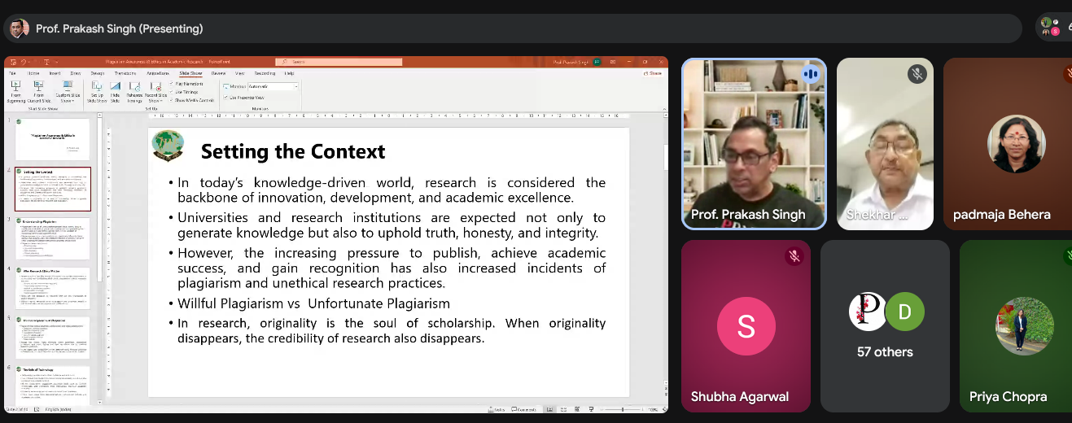
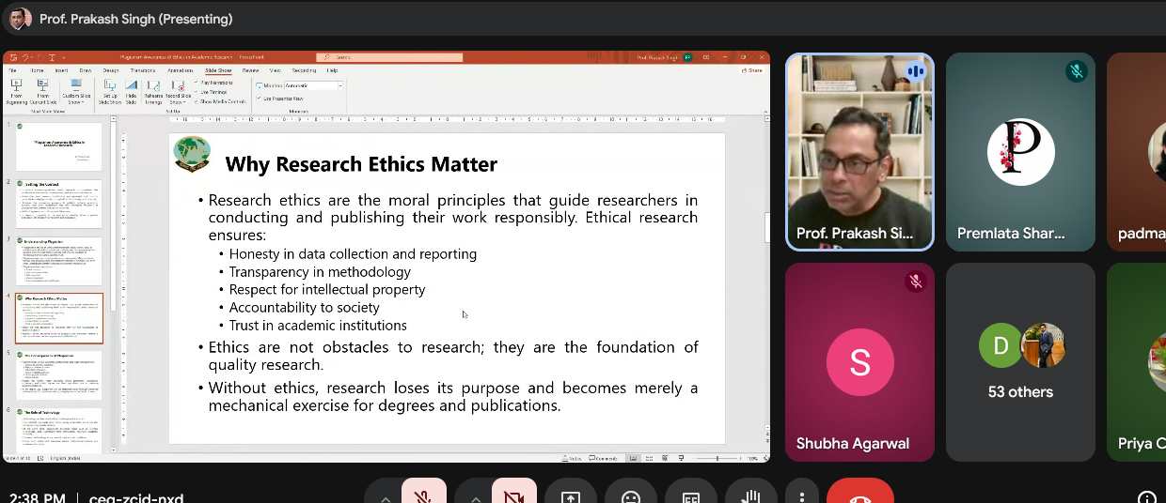
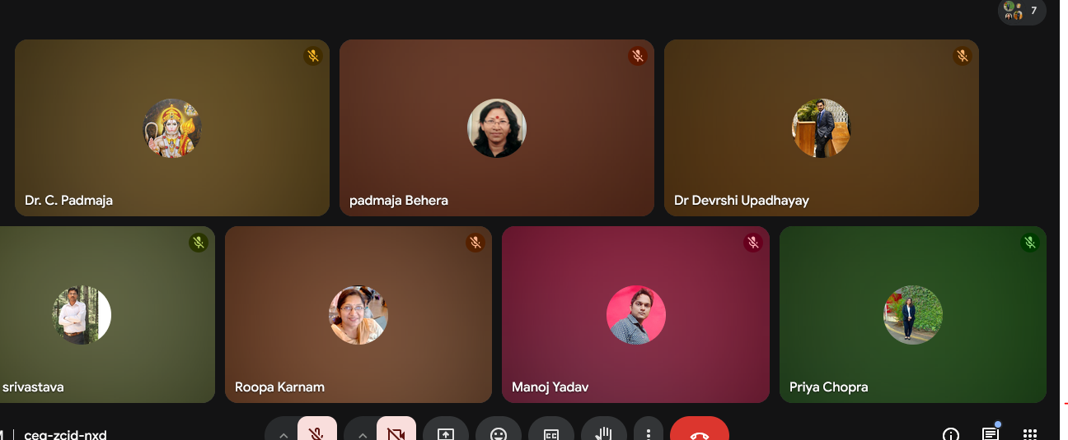

Key Highlights
- Academic Integrity
- Responsible Research Conduct
- Plagiarism Detection & Prevention

Outcome

Faculty strengthened ethical academic writing practices.

Day 7 Session Report

Topic:
AI-Driven Research, Teaching Innovations & Smart Academic Decision-Making
The final day of the Faculty Development Programme commenced with a warm welcome address delivered by Mr. Aman Kesharwani, Assistant Professor, Jagran Institute of Management. He extended heartfelt greetings to the distinguished resource person, respected Director, Dean, Heads of Departments, faculty members, researchers, academicians, and participants who joined the programme from various institutions.
The session focused on the transformative role of Artificial Intelligence in higher education, research, teaching methodologies, and academic decision-making. The discussion highlighted how AI-powered tools are revolutionizing the educational landscape by enhancing productivity, improving research quality, supporting personalized learning, and enabling data-driven institutional decisions.

Resource Person

Mr. Satyen Srivastava
Director & Chief AI Instructor, SNS Innovation Labs Pvt. Ltd.
Mr. Satyen Srivastava is a renowned AI educator, entrepreneur, author, and technology innovator. With more than 30 years of professional experience, he has been actively involved in promoting AI literacy and practical AI adoption through workshops, training programmes, and educational initiatives. He is also the creator of innovative AI platforms such as Vyakarni and Mergenta AI, designed to simplify language enhancement and AI interactions for users.

Key Highlights of the Session
The resource person emphasized the growing significance of Artificial Intelligence in academia and demonstrated various AI-powered tools that can assist educators, researchers, and academic administrators in their daily professional activities.

1. ChatGPT for Teaching and Research
Mr. Srivastava explained how ChatGPT can be effectively utilized in higher education for:
- Generating lesson plans and teaching materials.
- Creating quizzes, assignments, and case studies.
- Assisting in research paper drafting and content structuring.
- Simplifying complex concepts for classroom teaching.
- Brainstorming research topics and research questions.
- Enhancing academic writing and communication skills.
- Supporting personalized learning experiences for students.
He emphasized that ChatGPT should be used as an intelligent assistant while maintaining academic integrity and critical evaluation of AI-generated outputs.

2. Google Scholar for Academic Research
The session highlighted the importance of Google Scholar as a powerful academic search platform. Key applications discussed included:
- Identifying relevant scholarly articles and research papers.
- Tracking citations and influential publications.
- Accessing recent developments in specific research domains.
- Conducting comprehensive literature reviews.
- Discovering research gaps and emerging trends.
- Building a strong theoretical foundation for research projects.
Participants learned techniques for performing effective literature searches and filtering high-quality academic sources.

3. ProProfs for Assessment and Learning Management
Mr. Srivastava introduced ProProfs as an effective educational platform that supports:
- Online quiz and test creation.
- Automated assessment and grading.
- Student performance tracking.
- Knowledge evaluation and certification.
- Interactive learning activities.
- Easy management of academic assessments.
The tool was presented as a practical solution for enhancing learner engagement and streamlining evaluation processes.

4. Litmaps for Literature Review and Research Mapping
The resource person demonstrated Litmaps as an innovative research visualization tool. Important features discussed were:
- Creating visual maps of research literature.
- Identifying connections between scholarly publications.
- Discovering influential and highly cited papers.
- Tracking developments within a research area over time.
- Expanding literature reviews efficiently.
- Monitoring newly published studies related to ongoing research.
Participants appreciated how Litmaps simplifies the process of exploring and organizing academic literature.

AI-Driven Research, Teaching Innovations & Smart Academic Decision-Making
The session further explored how Artificial Intelligence is transforming educational institutions through:

AI-Driven Research
- Faster data collection and analysis.
- Automated literature reviews.
- Predictive analytics for research insights.
- Improved research accuracy and efficiency.
- Enhanced interdisciplinary collaboration.

Teaching Innovations
- Personalized learning pathways.
- Adaptive learning systems.
- AI-generated educational content.
- Virtual teaching assistants.
- Interactive and engaging classroom experiences.

Smart Academic Decision-Making
- Data-driven institutional planning.
- Student performance analytics.
- Early identification of learning challenges.
- Improved resource allocation.
- Enhanced policy formulation and academic governance.
.Link shared -https://www.proprofs.com/quiz-school/ugc/story.php?title=ndcymzc3oaciug
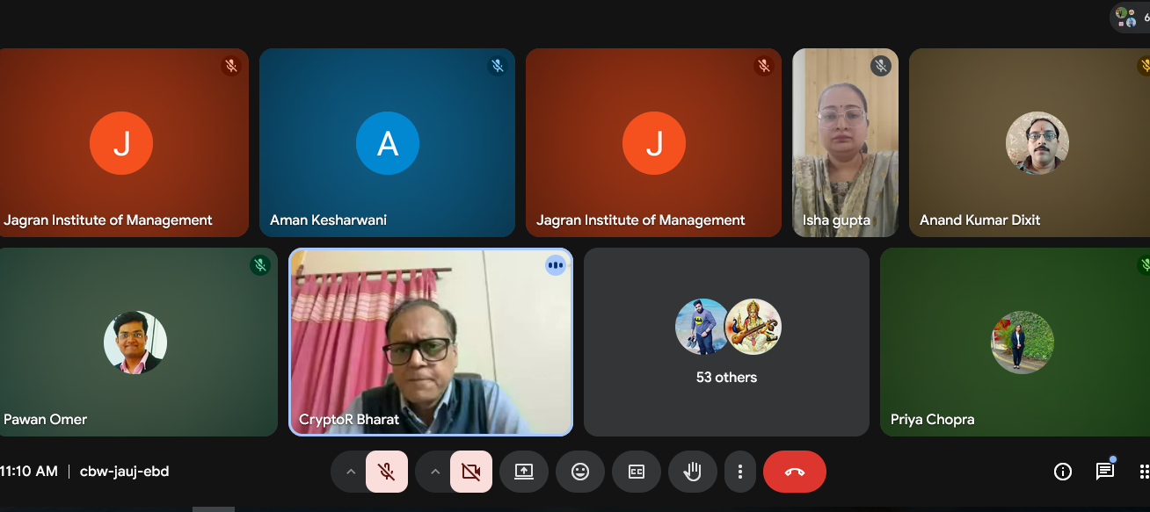
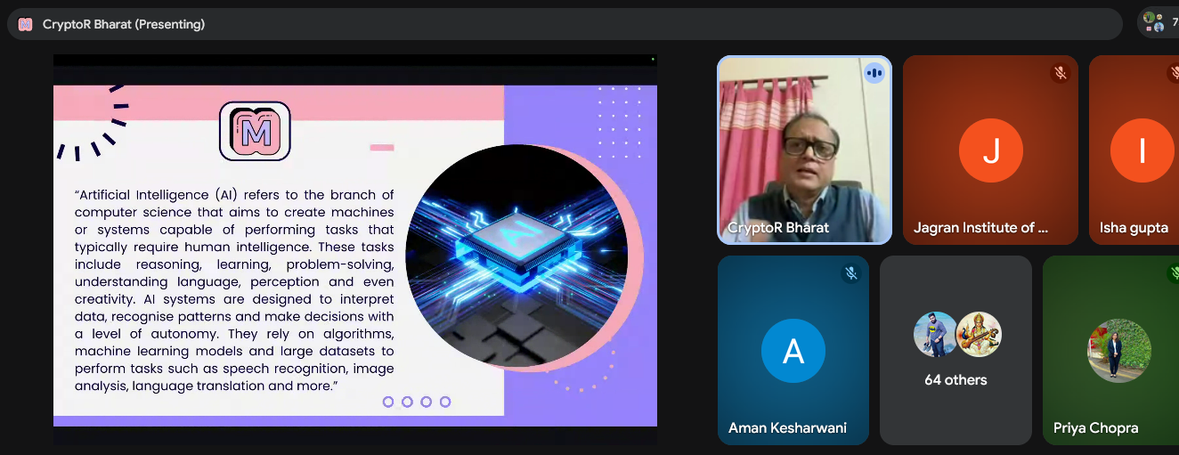

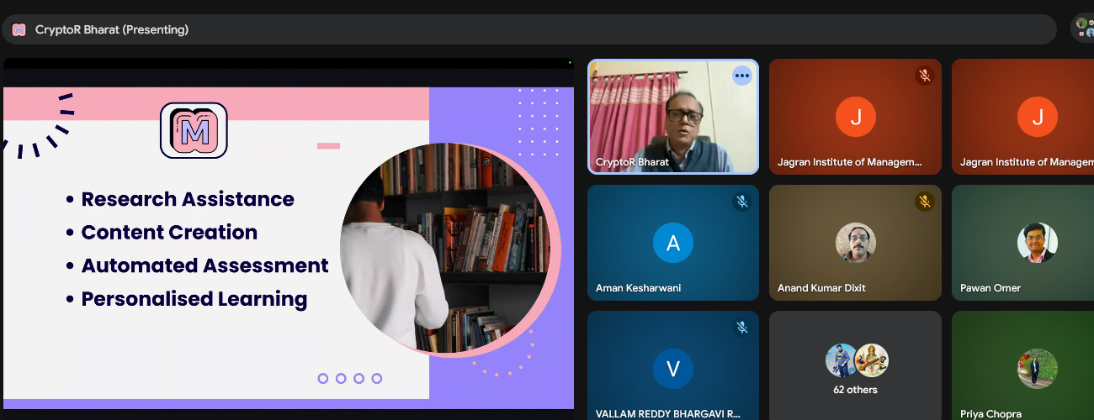

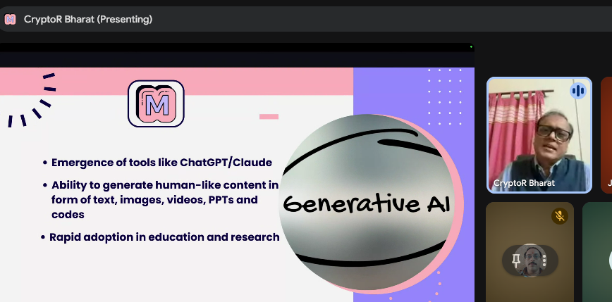
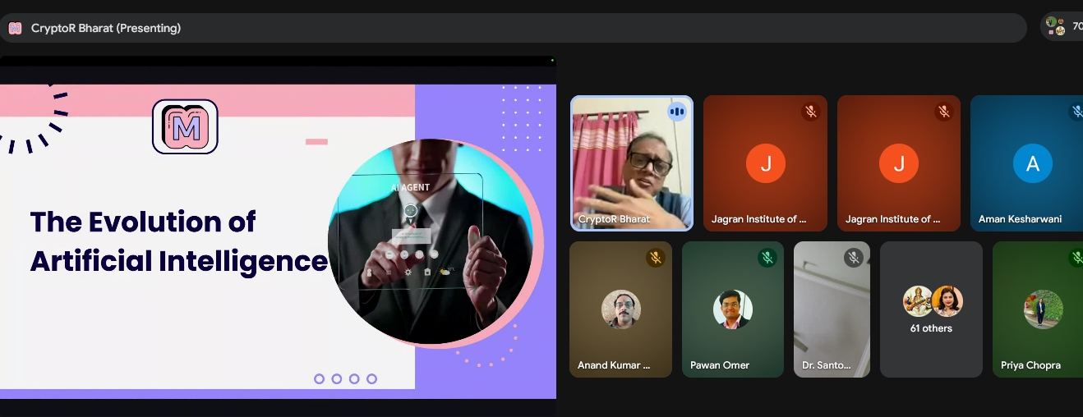
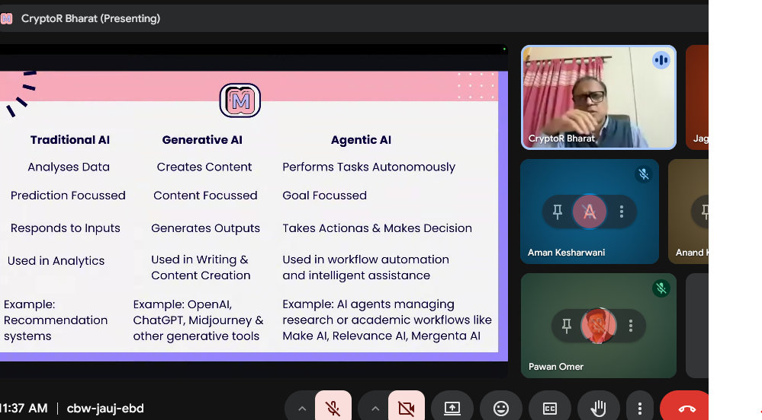

Create Courses, Quiz Maker tool.
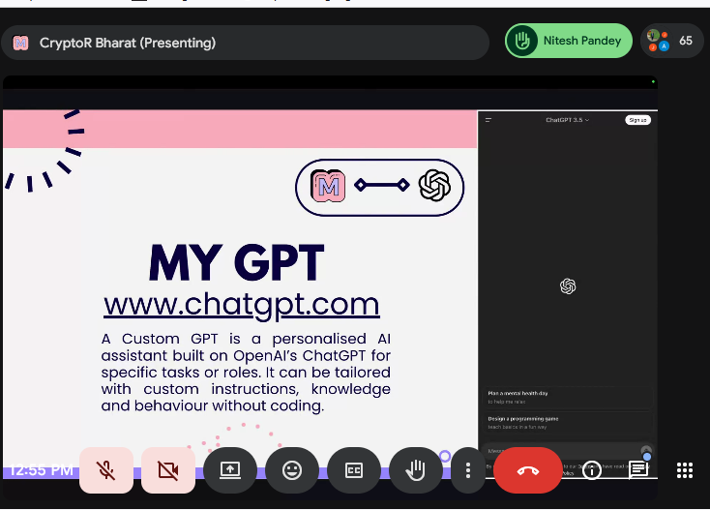
GOOGLE SCHOLAR – Research Paper

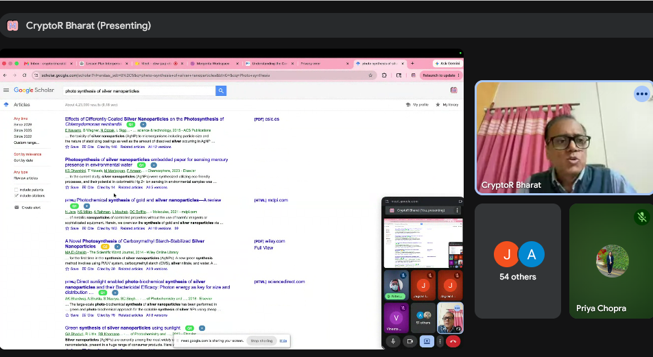
LIT MAP – for Literature Review
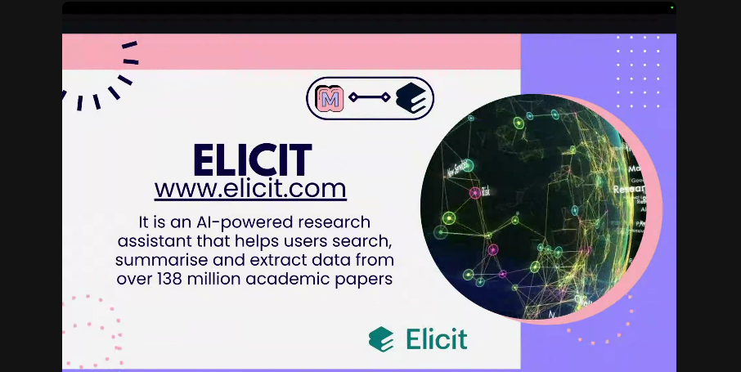
SIDER TOOL
IMPOTANT LINKS -
https://www.grammarly.com/thesis-statement-generator
https://chatgpt.com/g/g-6a1a922721248191bc528883334fdecf-business-communication-course-planner
www.editpad.org/tool/thesis-statement-generator

Outcome
Participants gained practical insights into integrating AI for smarter teaching-learning ecosystems.

Conclusion
The session concluded with an interactive discussion where participants explored practical applications of AI tools in teaching, research, and academic administration. The resource person encouraged faculty members to embrace AI responsibly and continuously upgrade their digital competencies to remain effective in the evolving educational ecosystem.
On behalf of Jagran Institute of Management, sincere gratitude was extended to Mr. Satyen Srivastava for delivering an insightful and enriching session. His expertise, practical demonstrations, and valuable guidance provided participants with a deeper understanding of AI-powered tools and their transformative role in higher education.
The session concluded with a vote of thanks, followed by the valedictory ceremony of the Faculty Development Programme.

6. Key Takeaways
Participants developed competencies in:
- Data-driven academic decision-making
- AI-assisted research design
- Statistical software applications
- Ethical research practices
- Academic innovation protection
- AI-enabled teaching transformation

7. Valedictory Session
The Valedictory Session marked the successful conclusion of the One-Week Faculty Development Programme titled “Data to Decision: Analytics for Research & Teaching with AI.” The session provided an opportunity to reflect upon the significant learning outcomes, insightful discussions, and collaborative engagement that characterized the programme throughout the week.
Addressing the gathering, the dignitaries highlighted that the FDP had served as a valuable platform for academic enrichment and professional development. The programme comprehensively covered contemporary themes including AI-assisted research design, data analytics in academia, SPSS-based statistical analysis, data cleaning and visualization, research ethics, intellectual property rights, and AI-driven teaching innovations and academic decision-making.
The resource persons, through their expert deliberations and practical demonstrations, provided participants with a deeper understanding of how Artificial Intelligence and data analytics can be effectively integrated into teaching, research, and institutional practices. Their sessions offered valuable insights into emerging technologies and their transformative role in higher education.
Special appreciation was extended to all the eminent speakers whose expertise and knowledge significantly contributed to the success of the programme. Gratitude was also expressed to the faculty members, researchers, academicians, and participants from various institutions across the country for their enthusiastic participation, active engagement, and commitment to continuous learning throughout the FDP.
The valedictory address emphasized that in the rapidly evolving academic landscape, Artificial Intelligence and data analytics have become indispensable tools for enhancing teaching effectiveness, conducting impactful research, and enabling evidence-based decision-making. At the same time, it was reiterated that the ethical, responsible, and meaningful use of these technologies remains essential for achieving academic excellence and contributing to societal progress.
The participants were encouraged to apply the knowledge and skills acquired during the FDP in their academic and professional endeavors and to continue exploring innovative, research-oriented, and technology-enabled approaches in higher education.
The organizing committee, programme coordinators, technical support team, and all individuals associated with the planning and execution of the FDP were acknowledged for their dedicated efforts in ensuring the smooth conduct and successful completion of the programme.
A thought shared during the session aptly summarized the spirit of the FDP:
"In the age of Artificial Intelligence, the true strength of education lies not merely in access to data, but in the wisdom to transform data into meaningful decisions."

Distribution of Participation Certificates
As part of the valedictory proceedings, the announcement regarding the distribution of participation certificates was made. The certificates were presented as a token of appreciation and recognition of the participants’ active academic engagement and successful completion of the Faculty Development Programme.
It was informed that participation certificates would be shared with all eligible participants through their registered email addresses during the following week. Eligibility for certification was based on regular attendance throughout the programme and timely submission of the prescribed feedback forms.
The certificates symbolize not only participation in the FDP but also the participants’ commitment to lifelong learning, professional excellence, and academic growth. The institute expressed its sincere appreciation for the dedication, perseverance, and intellectual curiosity demonstrated by all participants during this enriching academic journey.
The session concluded with a formal vote of thanks and best wishes to all participants for their future academic and professional endeavors.

Conclusion
The Faculty Development Programme successfully achieved its objectives by providing participants with practical exposure to modern analytical tools, Artificial Intelligence applications, statistical software, research methodologies, data visualization techniques, and Intellectual Property Rights awareness.
The programme significantly contributed toward enhancing research capabilities, technological adaptability, and innovative teaching-learning practices among academicians and researchers. The sessions inspired participants to integrate AI-enabled approaches into academic research, institutional planning, and pedagogical innovation for achieving excellence in higher education.

