WEB REPORT

ORIENTATION PROGRAM 2026

JAGRAN INSTITUTE OF MANAGEMENT
Date: 12-08-2026
Theme:From Aspirants to Achievers – Welcome to a New Beginning!
Venue: Lakshmi Devi Auditorium, JIM Campus
Time: 10:30 a.m.-01:30 p.m.

Introduction
Jagran Institute of Management organized its Orientation Program 2026 to warmly welcome the newly admitted students and their parents to the Jagran family. The programme marked the beginning of a new academic journey and provided students with an insight into the institute’s academic environment, faculty, facilities and opportunities for professional growth.

Welcome and Inaugural Ceremony
The programme commenced with the ceremonial lamp lighting and Ganesh Vandana, followed by a vibrant student talent segment featuring Monika Gupta, Vedika Gupta and Sapna. A virtual tour of the Jagran Education Foundation familiarized the students with the institution’s legacy and academic environment.

Chief Guest’s Address
The institute was honoured to welcome Mr.Anurag Saxena, Executive Director, TiE UP, as the distinguished guest speaker. An alumnus of IIM Ahmedabad, Mr.Saxena shared valuable insights on leadership, excellence, entrepreneurship and professional growth. His inspiring address motivated students to develop a positive attitude, embrace continuous learning and work towards achieving their career goals.

Faculty Introduction and Alumni Interaction
The faculty introduction presentation familiarized the newly admitted students with the academic team and their mentors. This was followed by an engaging alumni interaction with Mr.Ramandeep Singh, Business Head at World EdX, and Mr.PrajwalShukla, Senior Corporate Partnerships Executive at InfoEdge. Virtual interaction with MCA alumni Mr. Manish Narayan and Mr.Siddharth Mishra further provided students with valuable insights into professional life and career development.

Academic and Institutional Orientation
The students were briefed about important aspects of campus life and academic processes. Dr. Anil Singh, Dean Academics and Examination Controller, provided an overview of the examination process. Mr.Ashish Mishra, Assistant Professor &HoD-MCA, explained the general rules of discipline and code of conduct, while Ms.Premlata Sharma, Head-Librarian, briefed students about library rules and regulations. Mr.AdarshSrivastav, Senior Assistant Professor, provided information regarding placement opportunities and career development.

Conclusion
The Orientation Program 2026 successfully set a positive tone for the academic year and provided students with a comprehensive understanding of the institute’s academic environment, expectations and career opportunities. The programme concluded with an engaging student interaction activity, a vote of thanks and the National Anthem. The event inspired the newly admitted students to begin their journey with confidence, commitment and determination, moving from aspirants to achievers at Jagran Institute of Management.
Glimpses of the Event

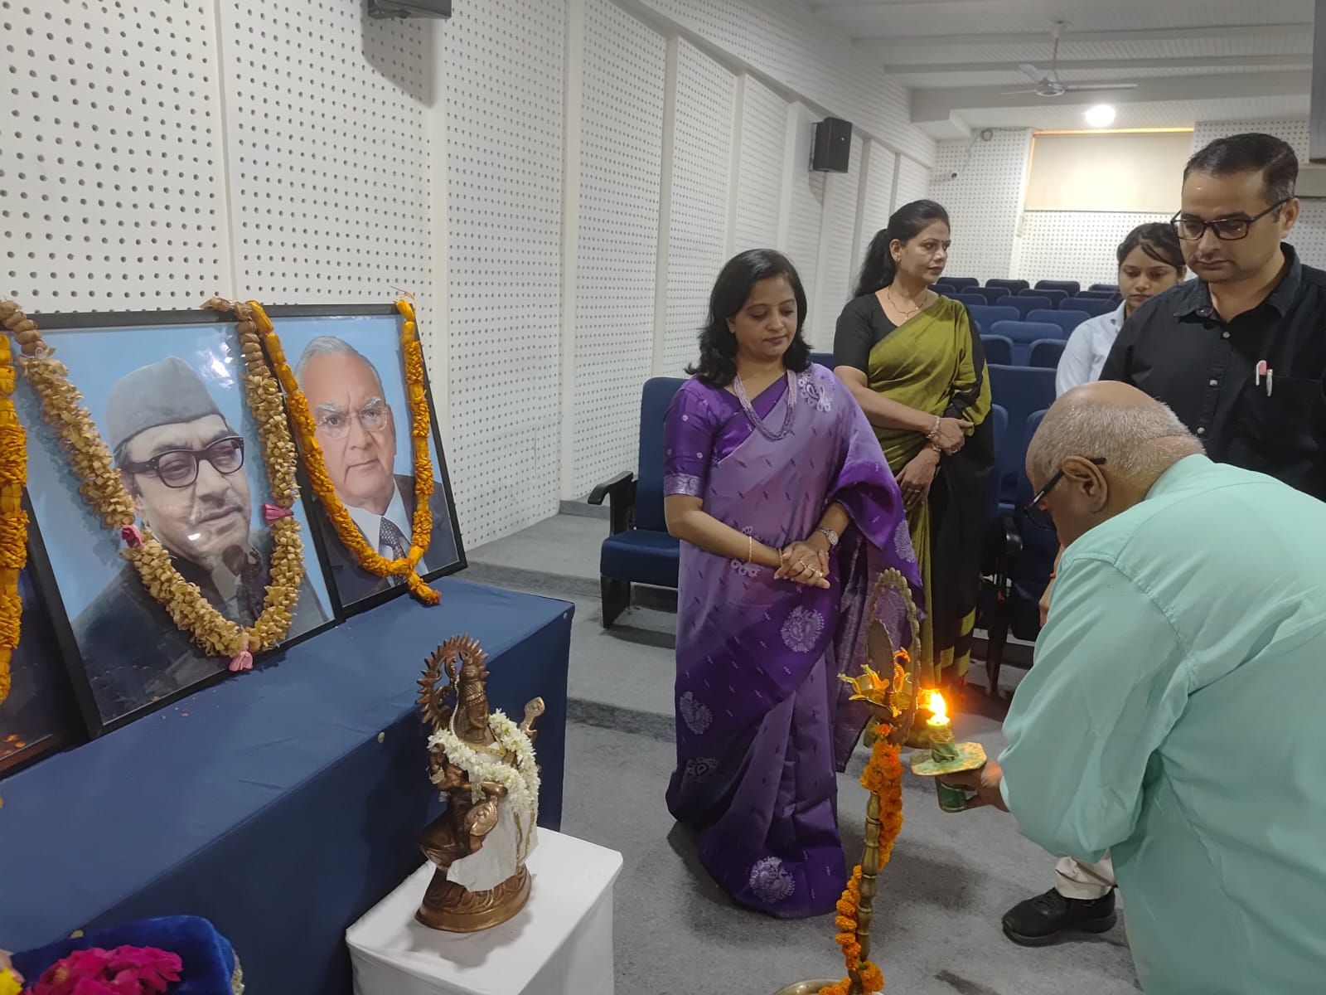

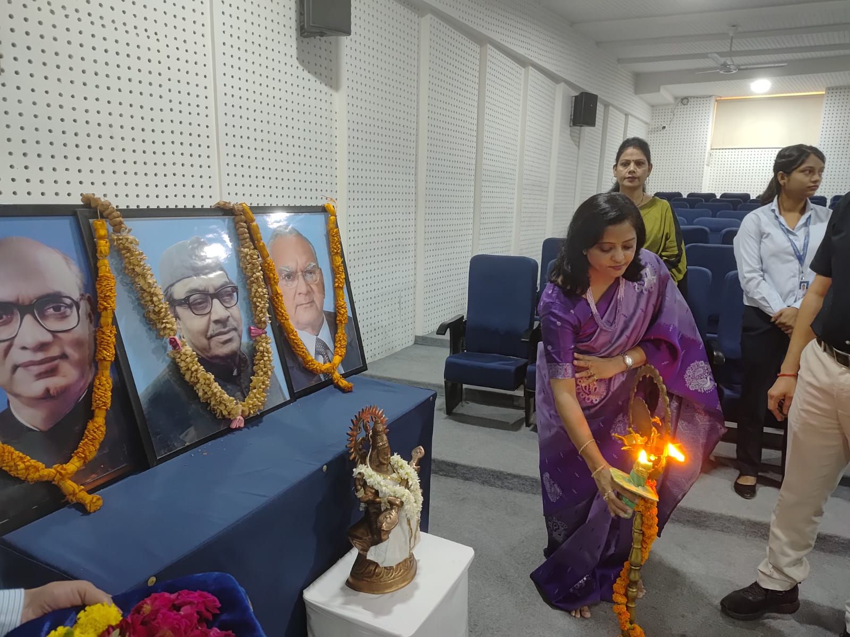

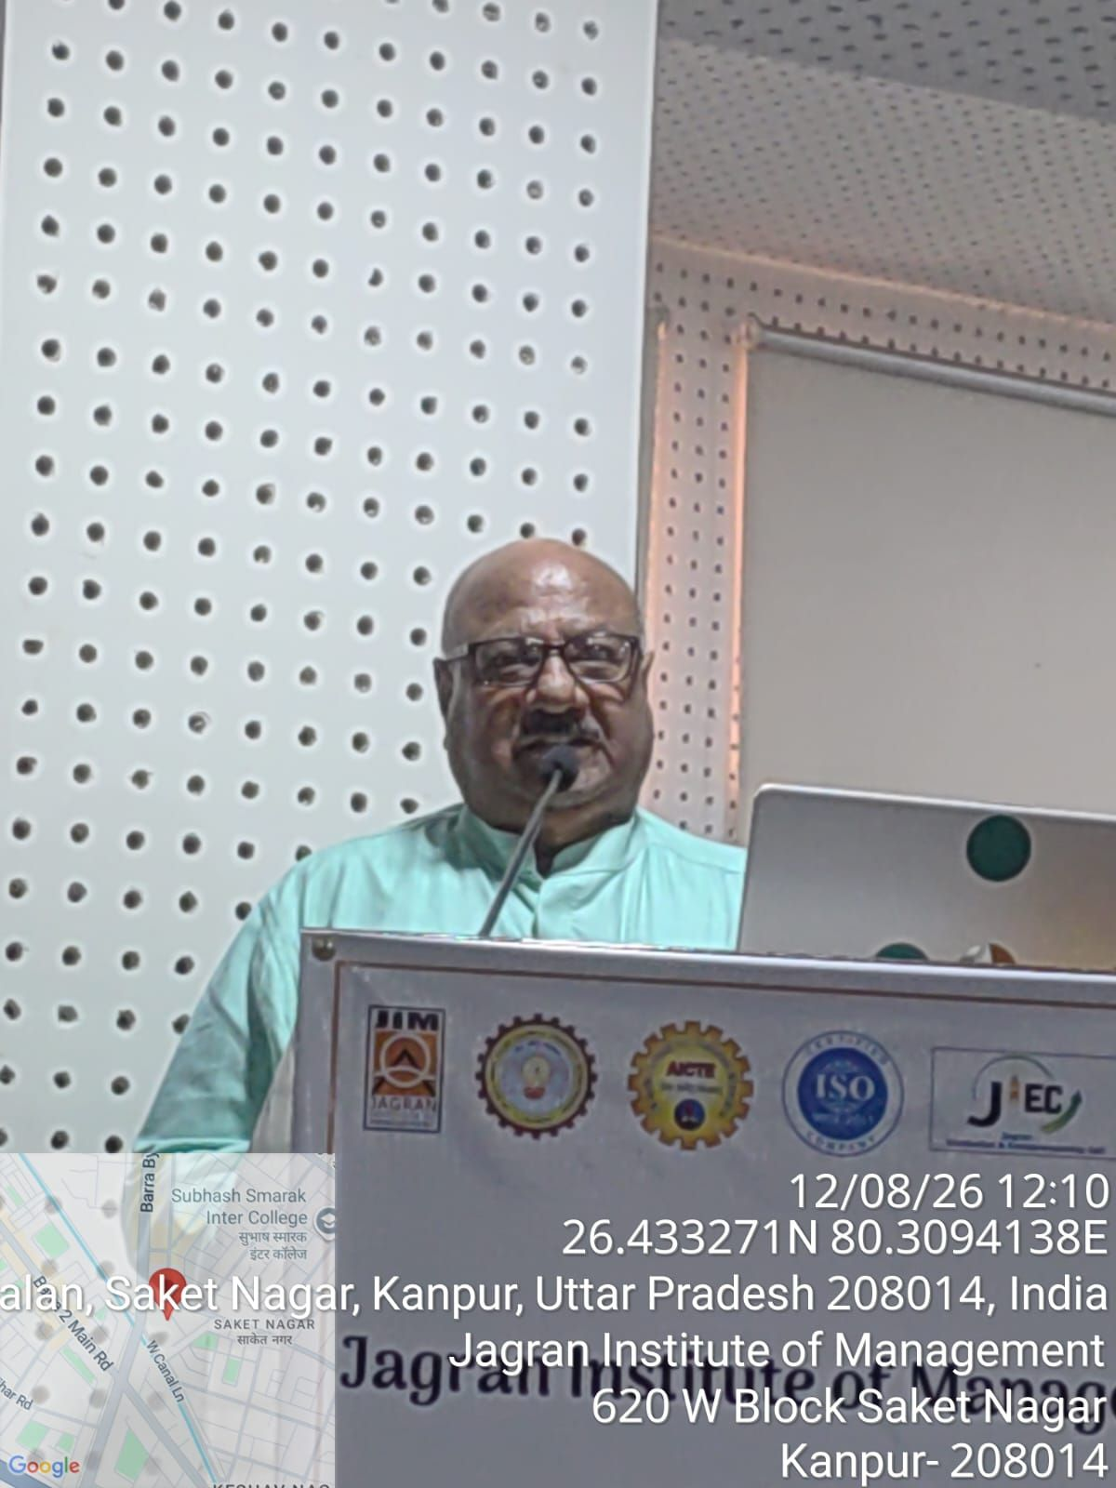

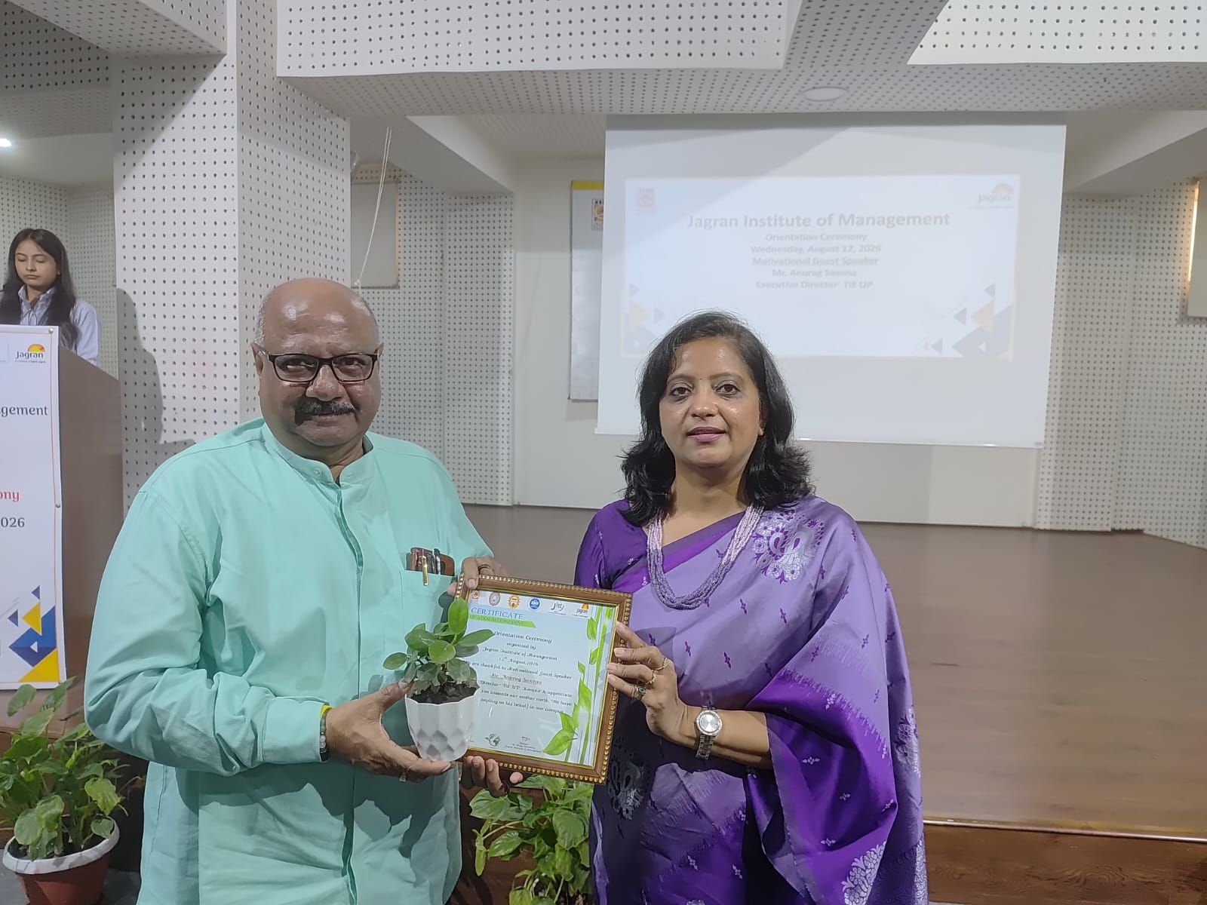

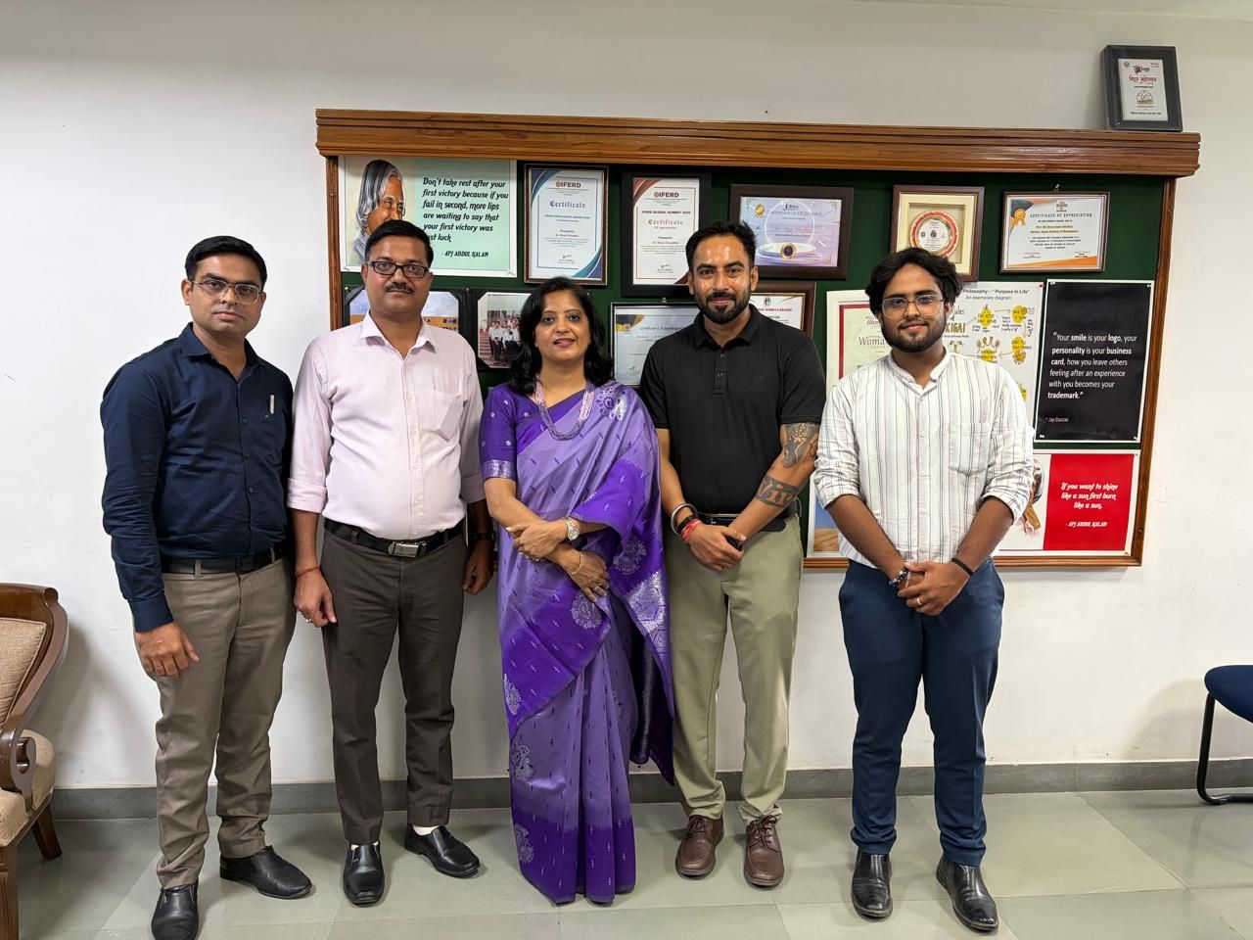

Press Release

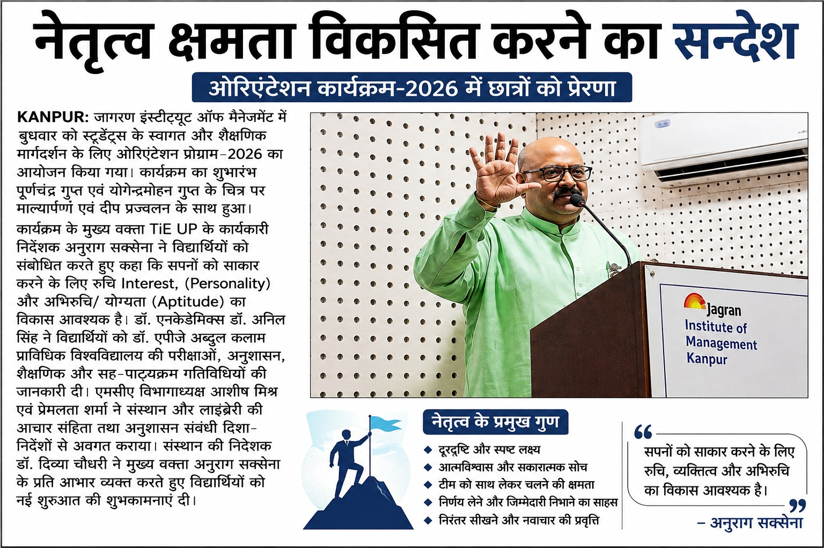

19th Annual Convocation 2026

JAGRAN INSTITUTE OF MANAGEMENT
Date:14-08-2026
Venue:Lakshmi Devi Auditorium, JIM Campus
Time:10:30 a.m.-01:30 p.m

Introduction
Jagran Institute of Management organized its 19th Annual Convocation to celebrate the academic achievements of its graduating students. The prestigious ceremony brought together distinguished dignitaries, faculty members, graduating students and their proud parents to commemorate this significant milestone.
The ceremony was graced by Hon'ble Chief Guest Prof. RachnaAsthana, Director, Dr.Ambedkar Institute of Technology for Handicapped, Kanpur, and Guest of Honour Prof. B. V. Phani, Head of the Department and Professor of Finance, IIT Kanpur, along with Chairman Dr.Mahendra Mohan Gupta, Vice Chairperson Mrs.Ritu Gupta, CEO Dr. J. N. Gupta, Director Dr.DivyaChowdhry, Dean Academics Dr. Anil Kumar Singh, Directors and Principals of JEF Verticals, faculty members and parents.

Inaugural Ceremony
The ceremony commenced with the academic procession, followed by the formal opening of the 19th Annual Convocation by Hon'ble Chairman Dr.Mahendra Mohan Gupta. The Chairman also delivered the Welcome Address and extended his blessings and best wishes to the graduating students.
The Director, Dr.Divya Chowdhry, presented the Annual Report, highlighting the academic achievements and accomplishments of Jagran Institute of Management.

Felicitation of the Chief Guest and Guest of Honour
As a mark of respect and gratitude, the Hon'ble Chief Guest and Guest of Honour were felicitated with saplings and mementoes by the dignitaries of the institute.

Conferment of Degrees
The most awaited segment of the ceremony was the Conferment of Degrees. Students who had successfully fulfilled the academic requirements were formally awarded their MBA and MCA degrees by the institute.
The graduating students were congratulated for their dedication, perseverance and academic accomplishments, marking the successful completion of an important chapter in their educational journey.

Awards and Recognition
The ceremony also recognized students who demonstrated exceptional academic performance and excellence.
Chairman's Gold Medal
- MBA:PriyaYadav
- MCA:Ayushi Omar
Chairman's Silver Medal
- MBA:Anushka Sahu
- MCA:Tanishqa Singh
The Director's Roll of Honour was also presented to meritorious students:
MBA Programme:Altamas, Alshaba and PragyaKushwah
MCA Programme:AkankshaShukla and ShrutiDwivedi
The outstanding achievers were felicitated with medals and certificates in recognition of their academic excellence.

Address by the Chief Guest
Prof. RachnaAsthana, Director, Dr.Ambedkar Institute of Technology for Handicapped, Kanpur, addressed the graduating students and shared her valuable insights and words of wisdom.
With over three decades of experience in teaching, research, academic administration and institutional development, Prof. Asthana inspired the graduates to pursue excellence, remain committed to lifelong learning and contribute meaningfully to society.

Address by the Guest of Honour
Prof. B. V. Phani, Head of the Department and Professor of Finance, IIT Kanpur, addressed the gathering and motivated the graduating students.
With extensive experience in academics, leadership, entrepreneurship and innovation, Prof. Phani emphasized the importance of continuous learning, innovation and entrepreneurial thinking in achieving professional success.

Vote of Thanks and Conclusion
The programme concluded with the Vote of Thanks proposed by Dr. Anil Kumar Singh, Dean Academics. The institute expressed its gratitude to the distinguished guests, management, faculty members, students, parents and all those who contributed to the successful conduct of the convocation.
The ceremony concluded with the National Anthem, followed by the academic procession. The graduating students then proceeded for the official group photograph, marking the memorable conclusion of their convocation ceremony.

Glimpses of the Event

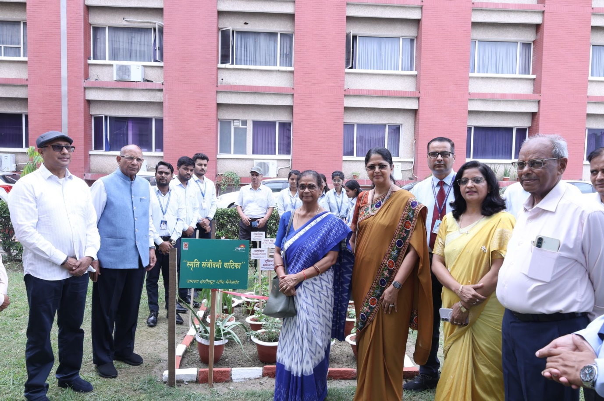

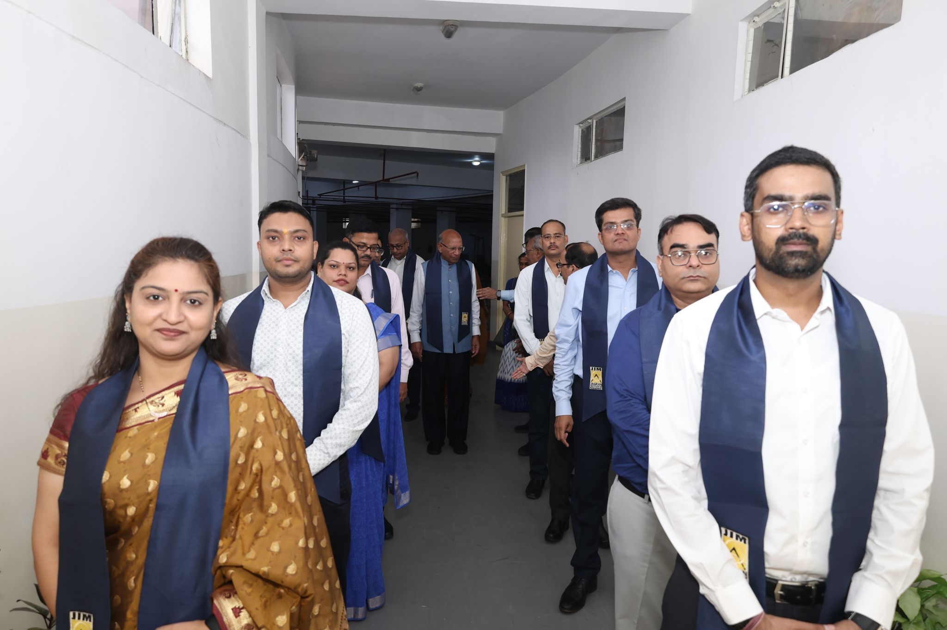

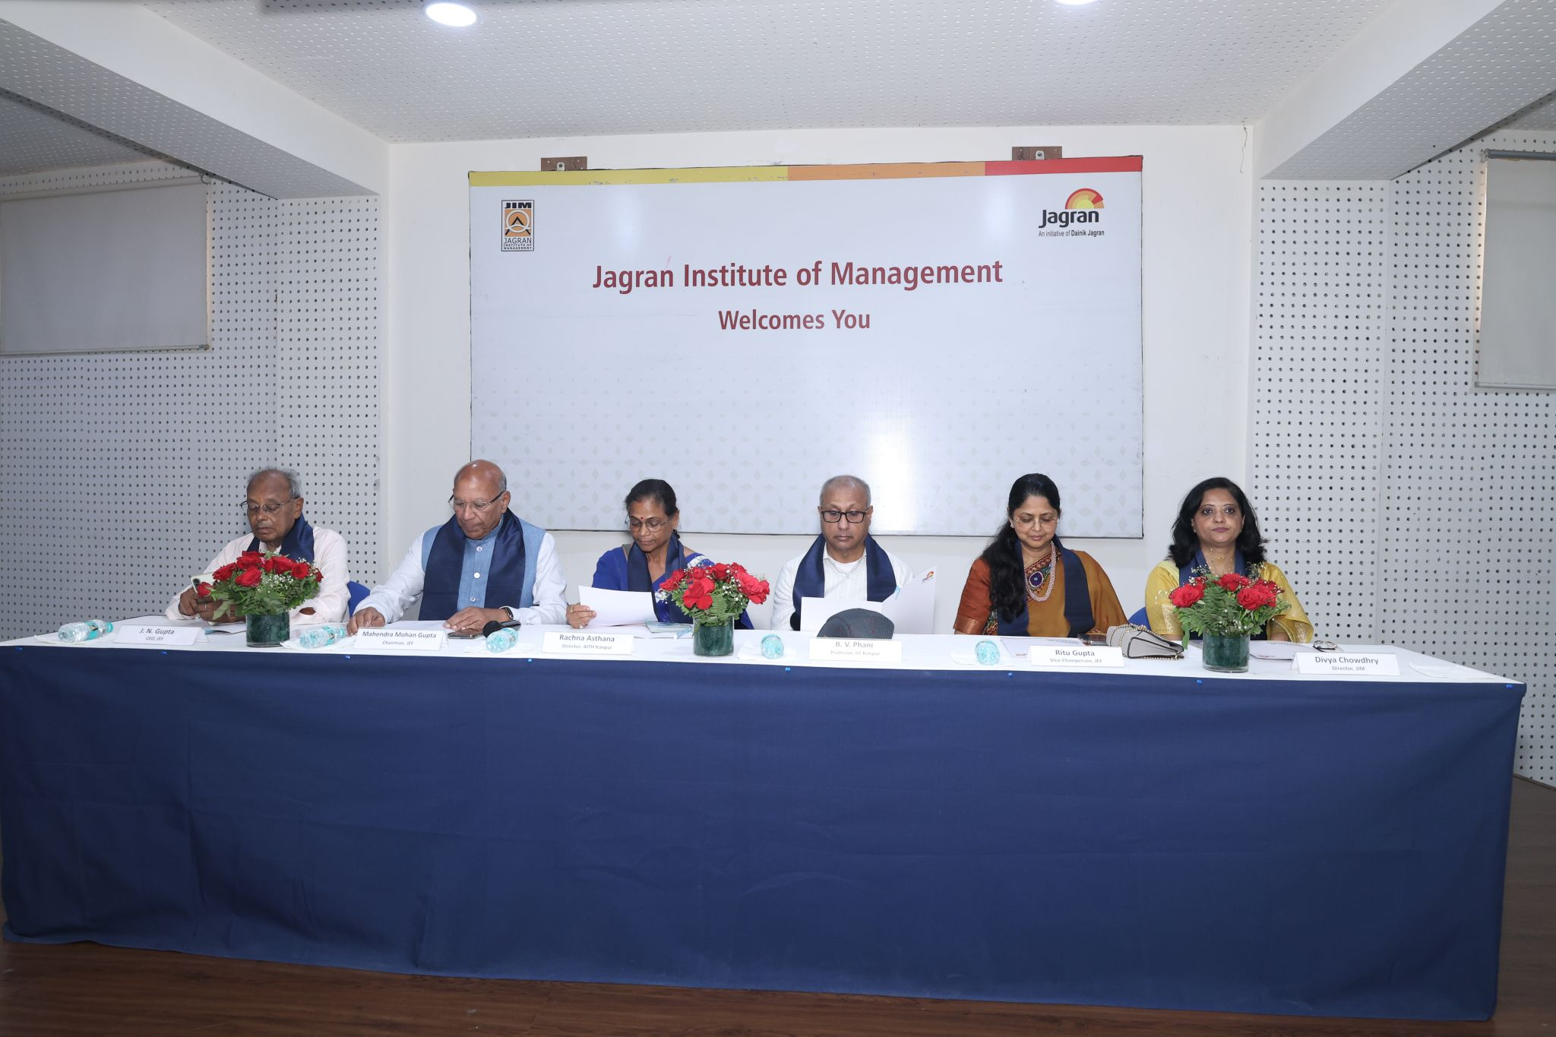

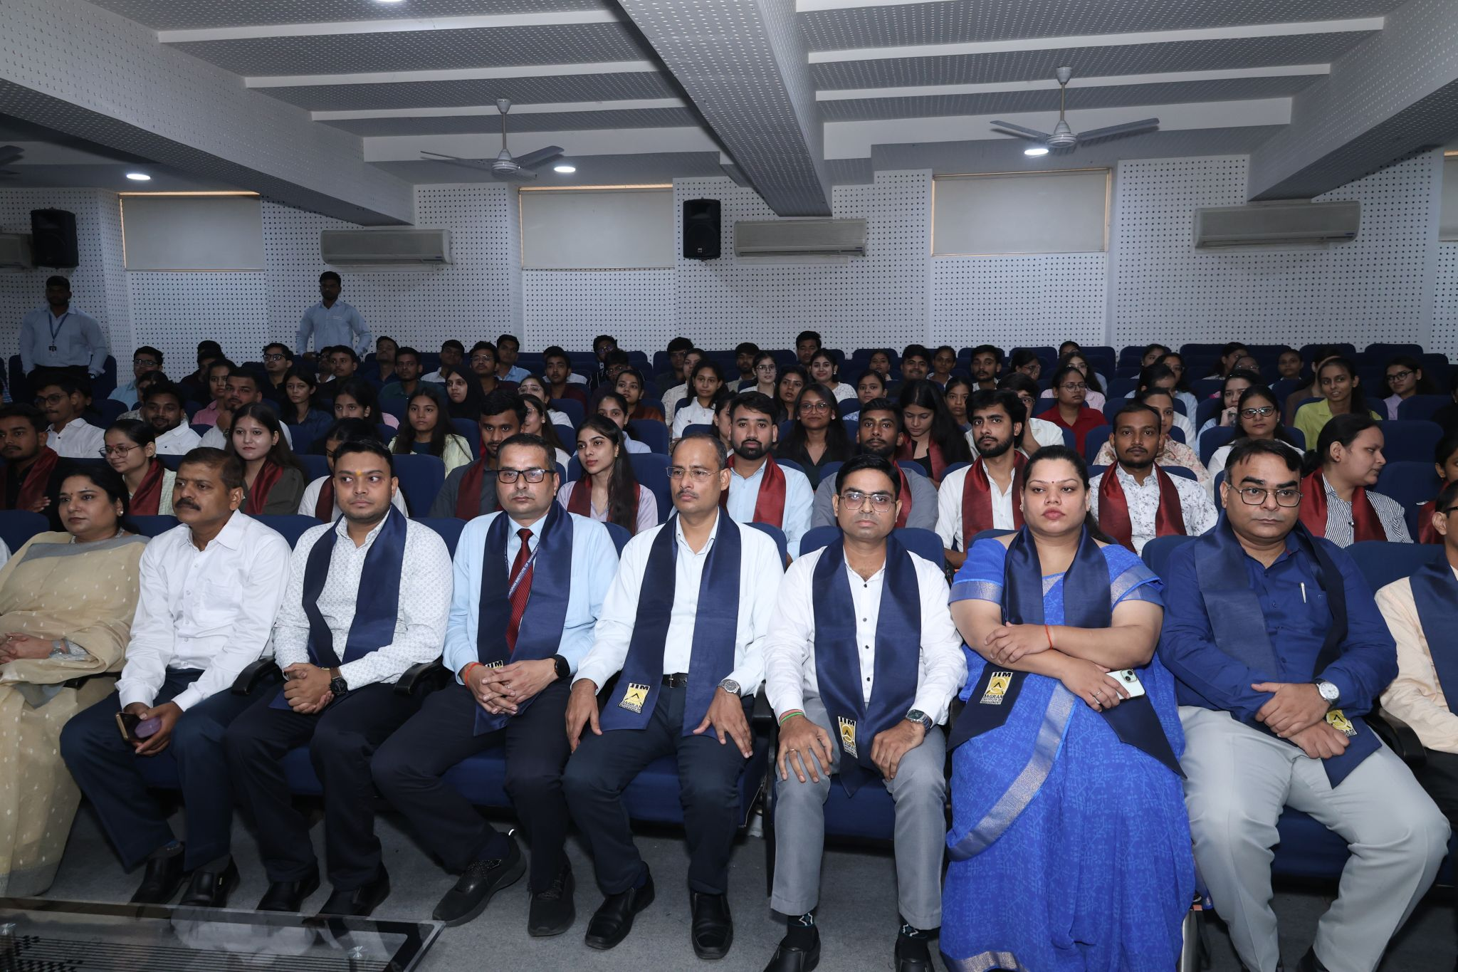

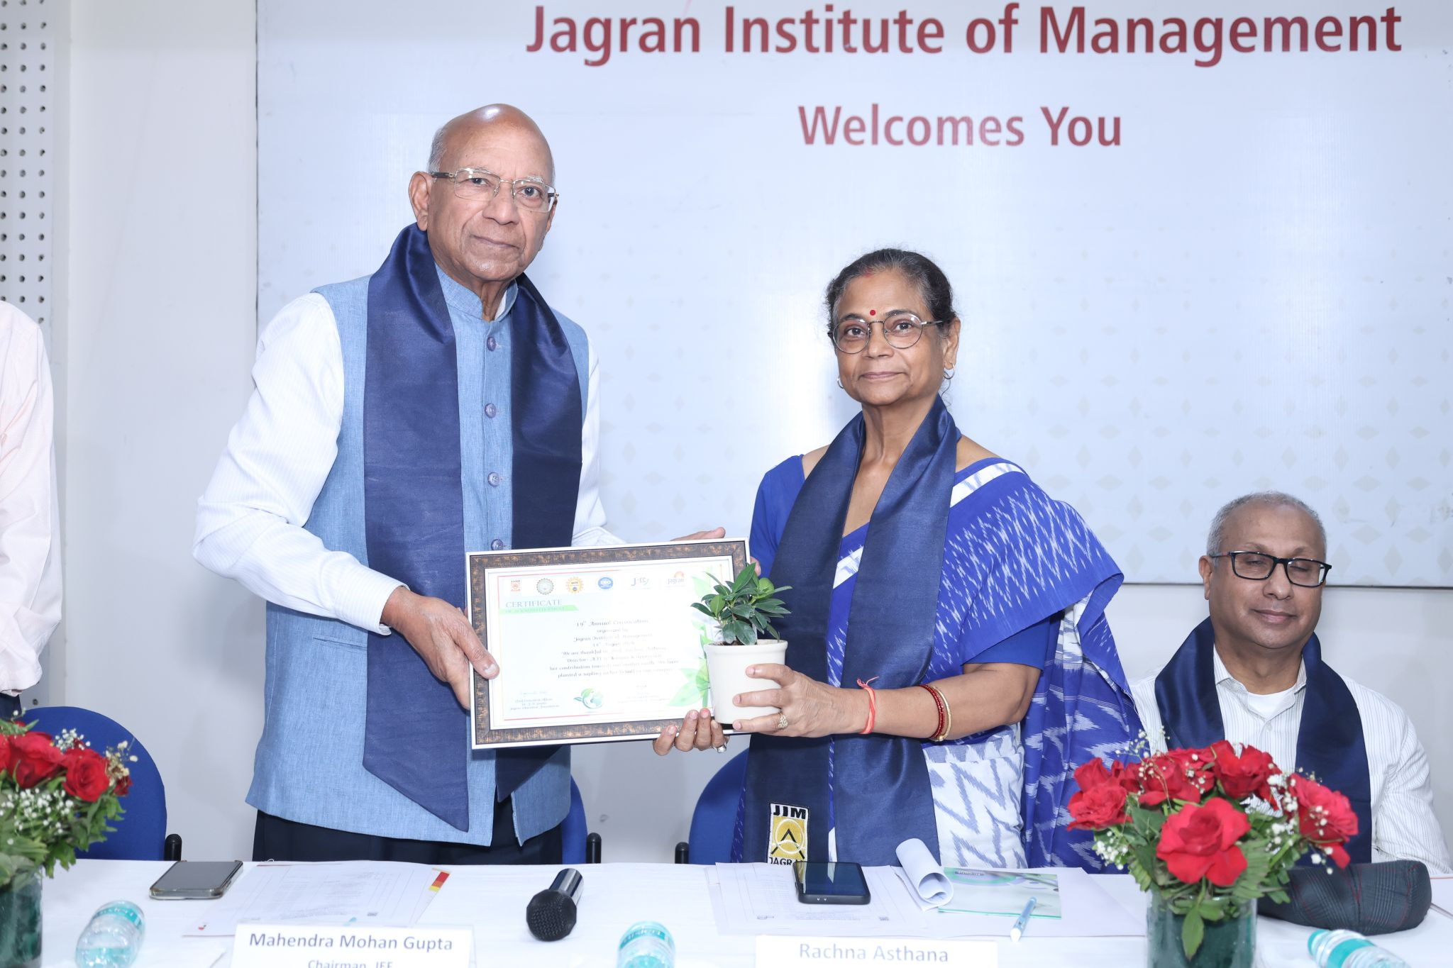

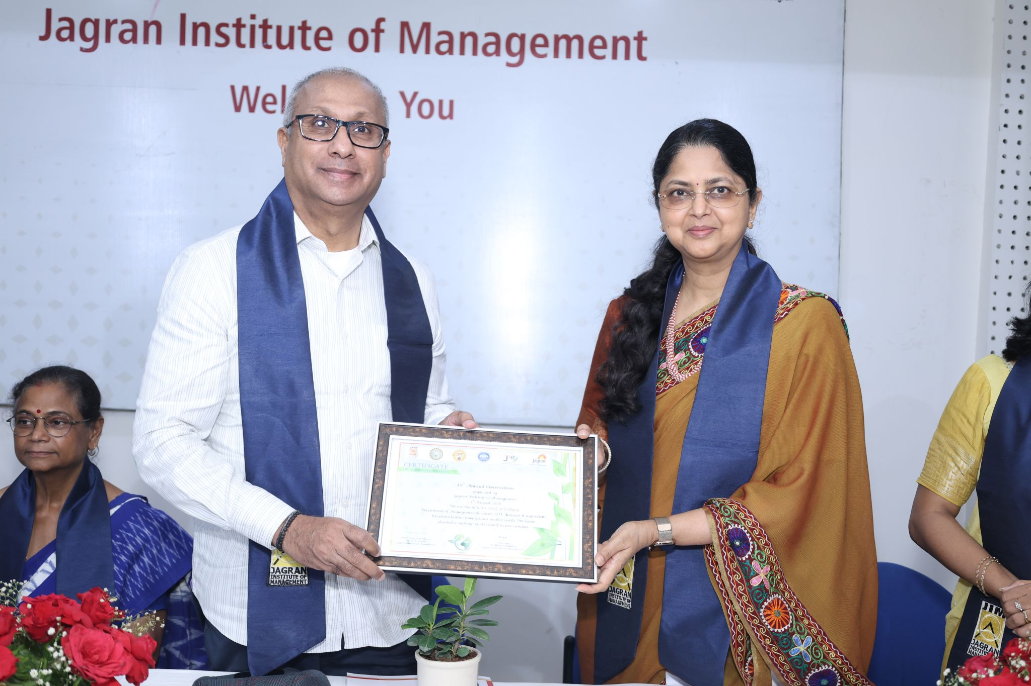

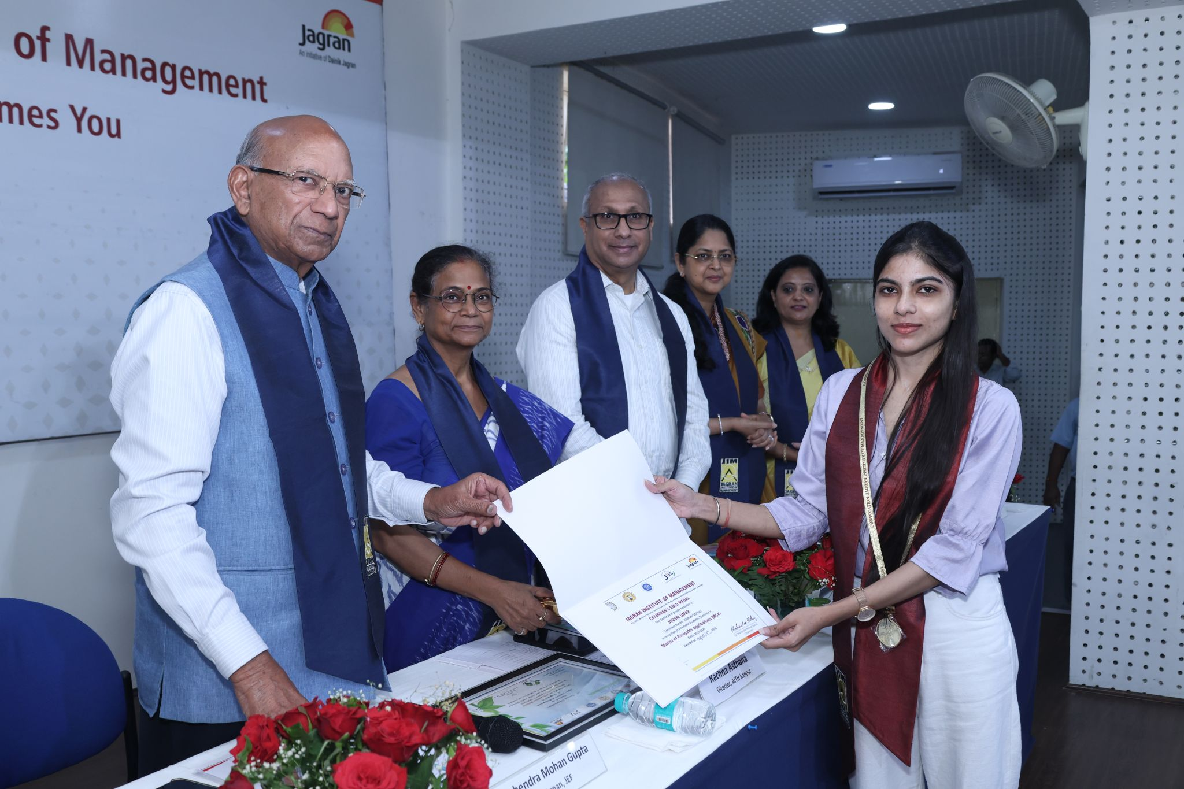

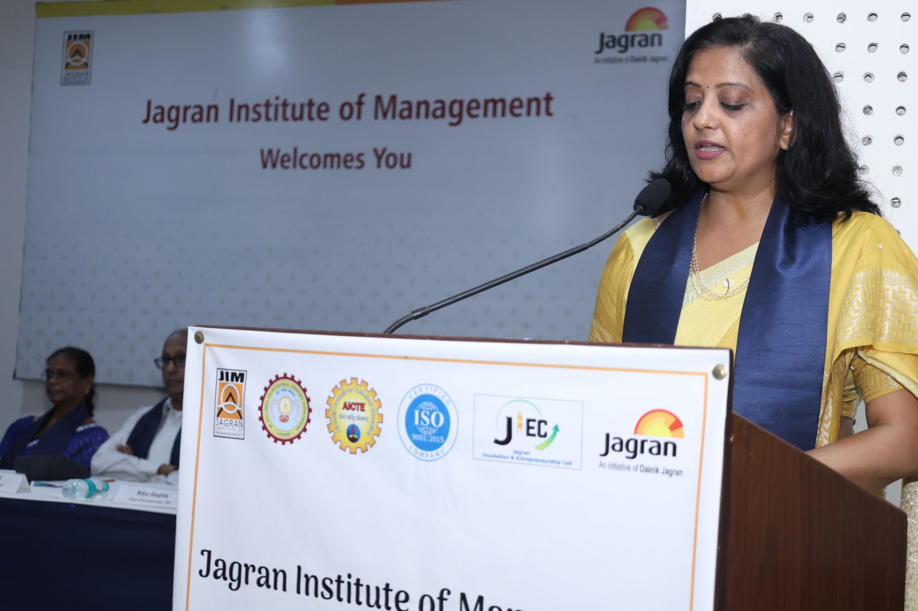

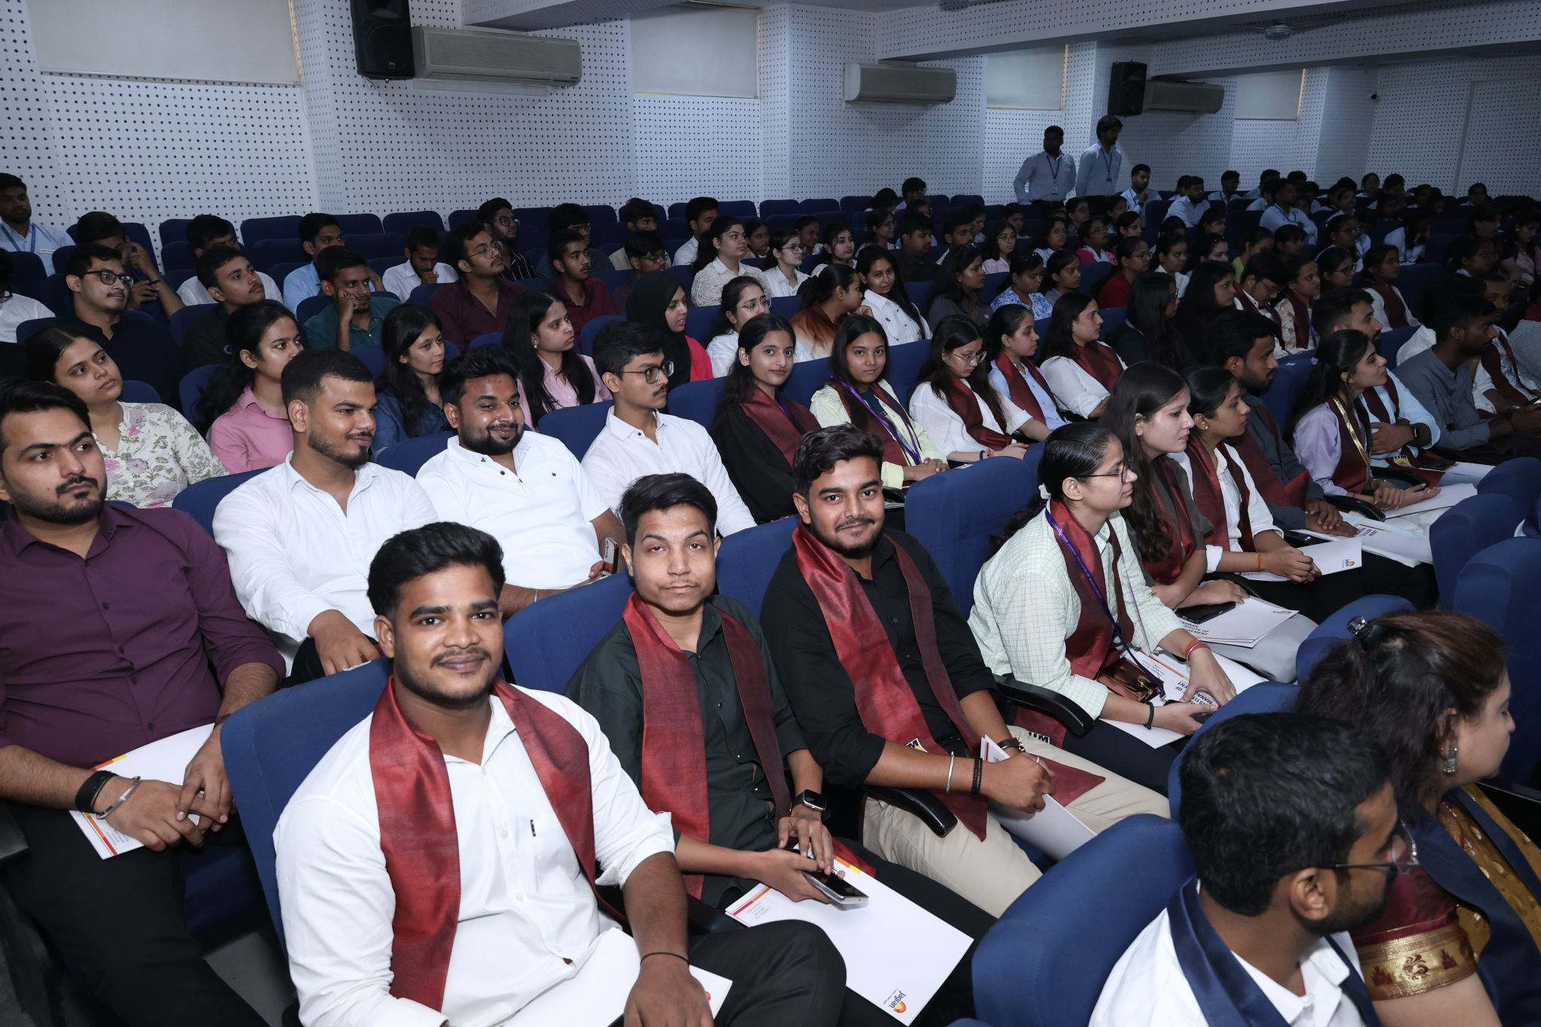

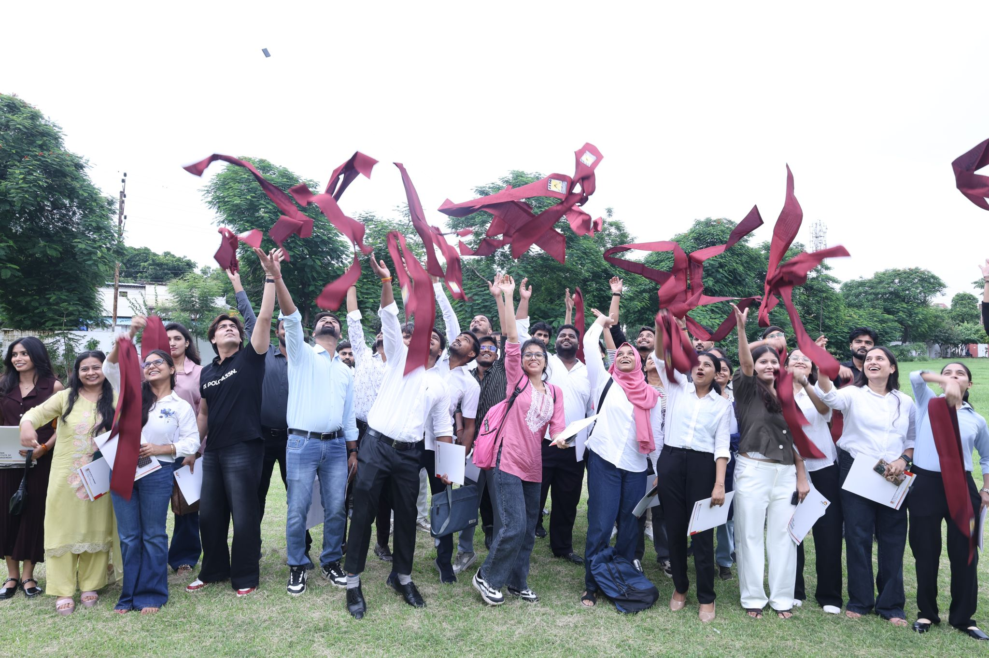

Press Release

