Sahaja Yoga Meditation Workshop

Event:Sahaja Yoga Meditation Workshop
Date & Time:Friday, Nov 07th, 2025
Venue:Laxmi Devi Auditorium
Participants: Students of JIM, JIMMC, JIDA

“Sahaja Yoga Meditation Workshop: Nurturing Inner Peace Among Students”
A transformative Sahaja Yoga Meditation Workshop was recently organized at Laxmi Devi Auditorium on 7th November,2025 with the objective of fostering inner peace, mental balance and holistic well-being among students and faculty members. The session, conducted under the aegis of the Sahaja Yoga Foundation, was coordinated by Ms. Bharti Garg and Mr. Mayur Dhanraj, who guided the participants through the profound yet simple techniques of Sahaja Yoga.
About Sahaja Yoga-
Sahaja Yoga, founded by Her Holiness Mataji Nirmala Devi, is a unique method of meditation that leads to self-realization through the awakening of the Kundalini energy. It enables individuals to experience inner silence, peace and an enhanced awareness of the self. The practice, known for its simplicity and universal appeal, focuses on balancing the seven chakras (energy centre’s) and bringing harmony between mind, body and spirit.
Workshop Highlights-
The workshop commenced with an introduction to the philosophy and principles of Sahaja Yoga. Participants were familiarized with the concept of Kundalini awakening and the functioning of the seven energy chakras that govern various aspects of physical and emotional well-being. The coordinators from the Sahaja Yoga Foundation explained how these chakras, when cleansed and balanced through meditation, contribute to mental clarity, emotional stability and spiritual growth.
An interactive meditation session followed, where attendees were guided through simple yet powerful yogic techniques designed to facilitate mindfulness, relaxation and self-awareness. The participants had the opportunity to personally experience the subtle energy flow and inner calm associated with the awakening of the Kundalini. The serene and focused atmosphere of the hall helped everyone connect deeply with their inner selves.
Participation and Presence -
The event witnessed enthusiastic participation from the students and faculty of Jagran Institute of Management (JIM), Jagran Institute of Digital Animation (JIDA) and Jagran Institute of Management and Mass Communication (JIMMC). The presence of esteemed dignitaries - Mrs. Ritu Gupta, Vice Chairperson, Jagran Education Foundation (JEF), Dr. J. N. Gupta, CEO, JEFand the Directors of JIM, JIMMC and JIDA - added grace and significance to the occasion. Their encouraging words inspired students to integrate meditation and mindfulness practices into their daily lives.
Vote of Thanks -
The workshop concluded with an address by Dr. Divya Chowdhry, Director, JIM, who expressed her heartfelt gratitude to the Sahaja Yoga Foundation and its coordinators for conducting such an enlightening and enriching session. She emphasized the importance of adopting meditation as a lifestyle practice to manage stress, enhance concentration and promote holistic development.
Conclusion-
The Sahaja Yoga Meditation Workshop proved to be an uplifting experience for all attendees. It offered a refreshing pause from the fast-paced academic routine and opened the doors to self-exploration and inner harmony. Through the guidance of the Sahaja Yoga team, participants learned to experience peace and balance from within - a valuable skill in today’s demanding world.
The event not only deepened awareness about the benefits of meditation but also strengthened the institute’s commitment to promoting the mental and emotional well-being of its students and staff.
Glimpses of the event-
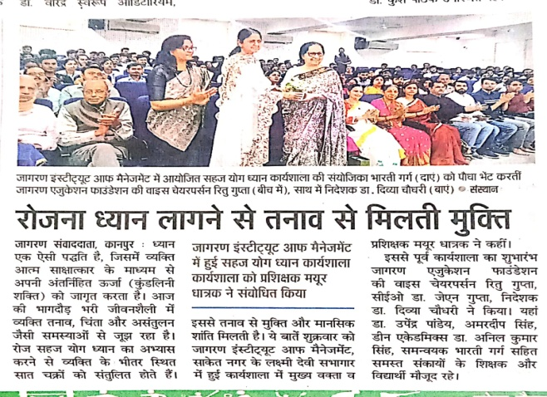
Danik Jagran news coverage on page no. 6
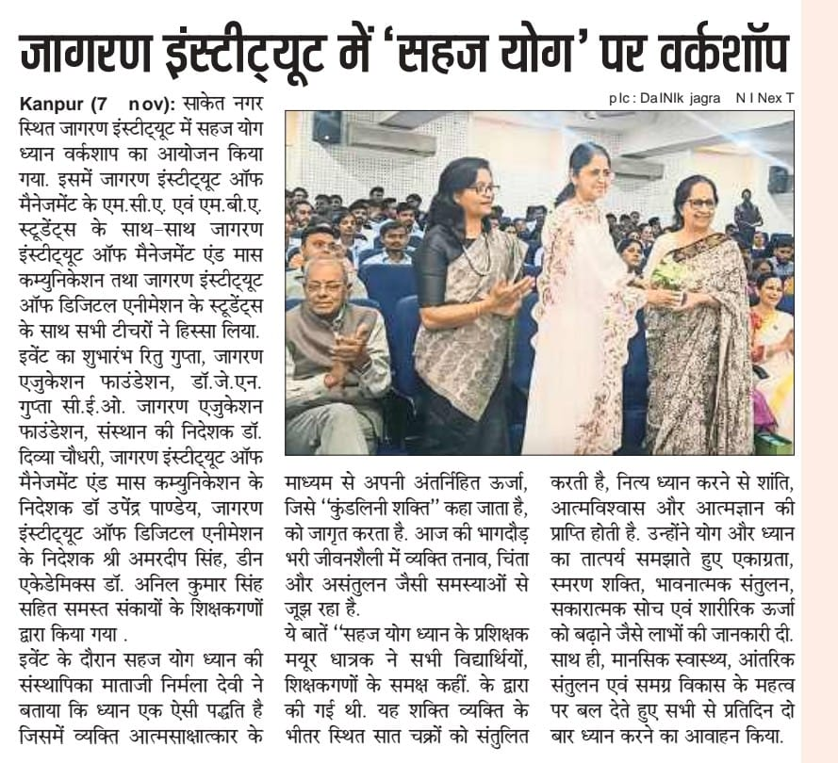
I Next news coverage on page no. 4
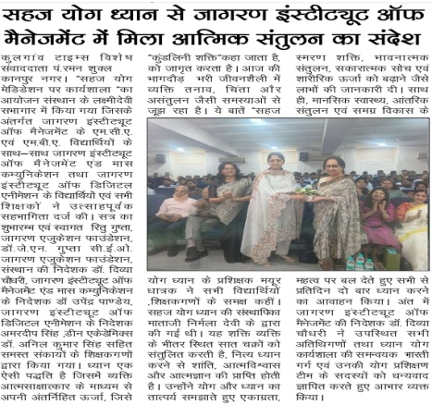Kulgaon Times news coverage on page no. 4

