Pool Campus Recruitment Drive - Trigya Innovations

Event:Pool Campus Recruitment Drive
Topic:Pool Campus Recruitment Drive - Trigya Innovations
Date & Time: Wednesday, 22thApril, 2026
Venue: Yogendra Mohan Gupta Academic Hall - JIM Campus
Participants: Final-year MCA and MBA students, along with external participants from various colleges and institutions.

“A pool campus drive is not just about recruitment, it is about discovering potential and shaping futures.”
Jagran Institute of Management proudly hosted a dynamic and high-energy Pool Campus Recruitment Drive for final-year MBA and MCA students on 22nd of April 2026 in collaboration with Trigya Innovations. The event was designed to provide a common recruitment platform where talented students from multiple institutions could come together, compete, and connect with industry professionals. The initiative reflected the institute’s commitment to enhancing employability and creating meaningful industry-academia linkages. Students from various reputed colleges, including PSIT, DAMS, and Jagran Degree College, actively participated in the drive, making it a diverse and competitive recruitment event. The primary roles offered during the drive included Software Development, Business Analysis, and other emerging profiles aligned with current industry demands.
The day commenced with a power-packed and insightful Pre-Placement Talk delivered by the team from Trigya Innovations. This session served as a foundation for the entire recruitment process, equipping students with a clear understanding of the company’s vision, operations, and expectations. The speakers shared valuable insights into the rapidly evolving technology landscape and emphasized the importance of adaptability, continuous learning, and problem-solving skills in today’s professional environment. Students gained clarity on career growth opportunities within the Trigya ecosystem, making the session both informative and motivating. The interactive nature of the talk allowed participants to engage directly with industry experts, ask questions, and receive practical guidance.
One of the most significant aspects of the recruitment drive was the knowledge-sharing environment it fostered.The presence of students from different institutions created a rich learning atmosphere, where ideas, experiences, and perspectives were exchanged. Such interactions played a crucial role in enhancing the confidence and professional outlook of the participants.
The recruitment process itself was designed as a multi-layered and comprehensive evaluation system to assess candidates thoroughly. It began with a technical and aptitude assessment aimed at evaluating candidates’ analytical thinking, logical reasoning, and subject knowledge. MCA students were primarily assessed on their programming skills, technical expertise, and project understanding, while MBA students were evaluated on their analytical abilities, problem - solving approach, and business acumen.
This was followed by technical interview rounds where candidates were required to demonstrate their in-depth knowledge, practical application skills, and clarity of concepts. The final stage comprised HR interviews, which focused on communication skills, personality traits, adaptability, and overall suitability for the organization’s work culture. This structured and rigorous process ensured that only the most competent and deserving candidates progressed through each stage.
The Pool Campus Recruitment Drive also stood out as a platform for collaboration and healthy competition. By bringing together students from institutions such as Pranveer Singh Institute of Technology (PSIT), DayanandAcademy of Management Studies (DAMS), Jagran Degree College, and Jagran Institute of Management.
The Placement Cell of Jagran Institute of Management played a pivotal role in the successful execution of the Pool Campus Recruitment Drive, ensuring seamless coordination with Trigya Innovations, along with efficient management of registrations, logistics, and overall event operations.
Tokens of appreciation were graciously presented by the Respected Director, Prof (Dr.) Divya Chowdhry, along with Placement Head Ms. Pratima Gupta and Mr. Adarsh Srivastava, marking a dignified and memorable conclusion to the occasion.
In conclusion, the Pool Campus Recruitment Drive was a remarkable success that highlighted the institute’s dedication to student development and career advancement. The success of this drive reinforces the belief that such collaborative initiatives are essential for shaping skilled, confident, and industry-ready professionals.
Highlights from the event offering a Glimpse into its success: -
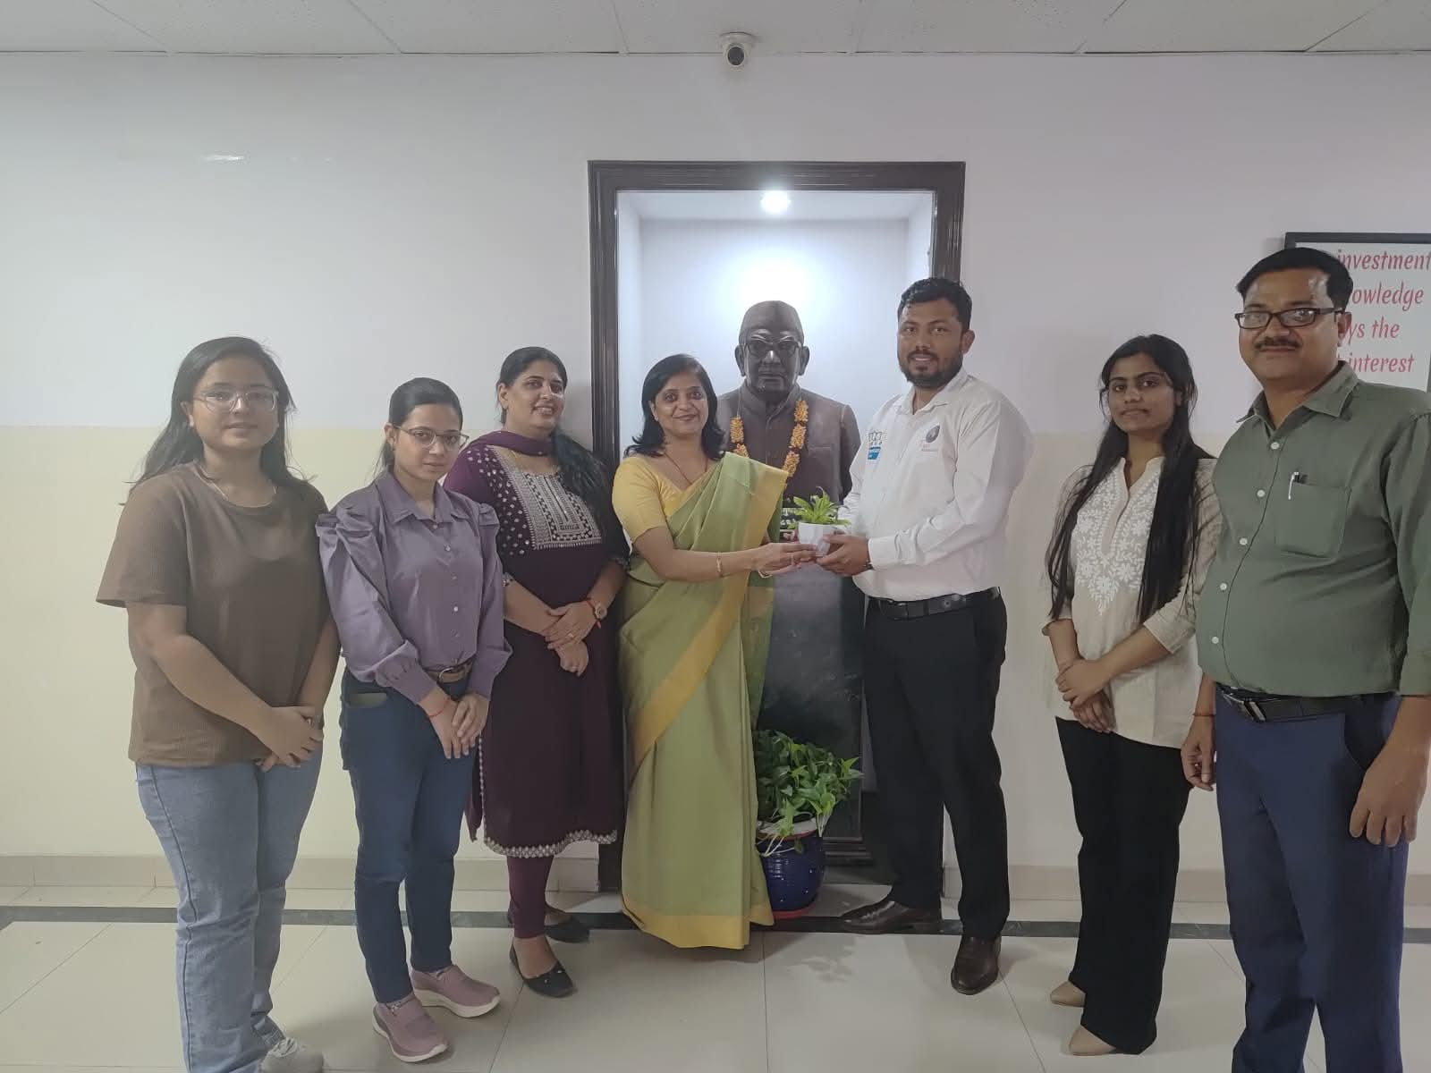
Felicitation and token of appreciation presented by the Director and Placement Coordinators to the HR team of Trigya Innovations.
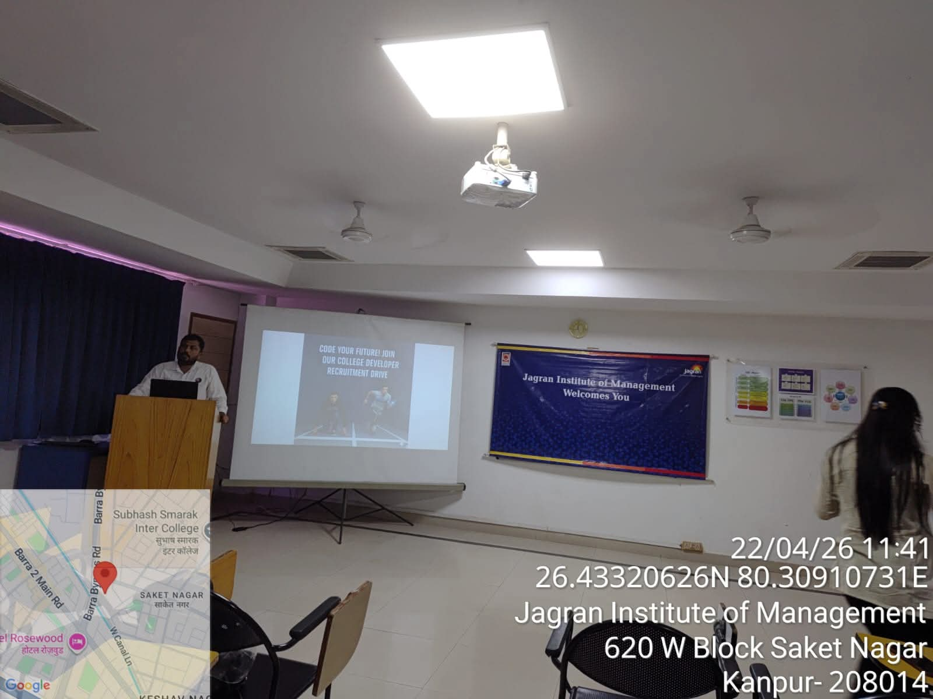
Pre-Placement Talk delivered by the team from Trigya Innovations.

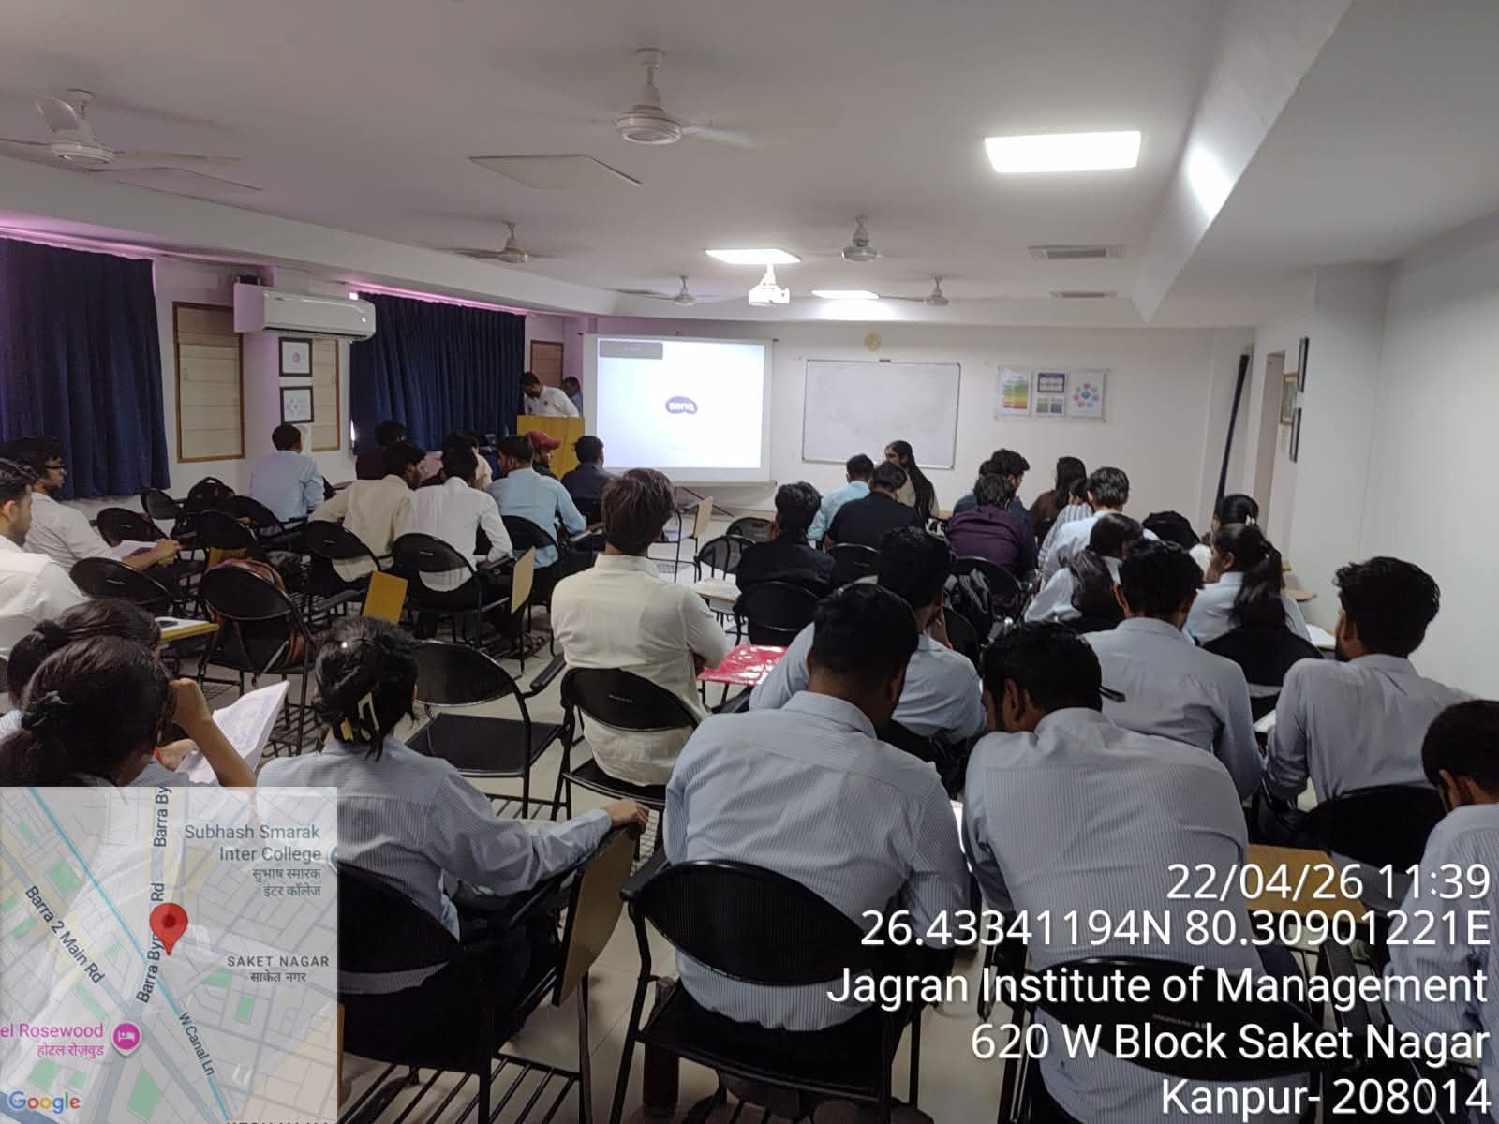Students actively participating in the technical and aptitude assessment
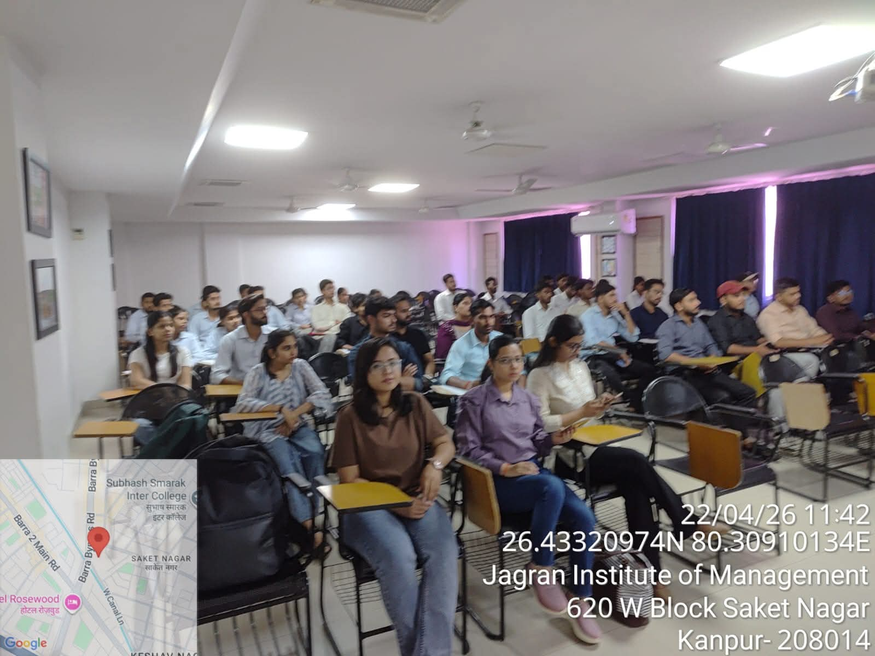
Aspiring professionals geared up for opportunities at the Pool Campus Drive

