Web Report on Annual Sports Meet - Victory Vibes 2026
Event: Victory Vibes 2026 (Two-Day Sports Event)
Date & Time: March 23rd & 24th, 2026
Venue: Sports Ground, Jagran Degree College & Indoor Hall, JIM Campus, Kanpur
Participants: MBA & MCA students from Jagran Institute of Management, Kanpur
Jagran Institute of Management organized two-day Annual Sports Meet, "Victory Vibes 2026," on March 23rd & 24th, 2026. The event was held at the spacious playground of Jagran Degree College & Indoor Hall of JIM Campus with featured variety of sporting competitions. A large temporary seating area was constructed to accommodate dignitaries, faculty, staff and students. The atmosphere was filled with excitement and enthusiasm as students from various streams participated in the events. The objective of this event was to encourage students to imbibe the values of sportsmanship, discipline, teamwork and physical as well as mental fitness.
The program was inaugurated by the Director of JIM, Dr. Divya Chaudhary, Dean Academics Dr. Anil Kumar Singh, along with all faculty and staff members. Various sports activities including Table tennis, Chess, and Tug of war were conducted, witnessing active participation from the MCA and MBA students, both juniors and seniors. The inauguration included a photo session and the release of balloons. The two-day Annual Sports Meet 2026 included the following events-
- Cricket
- Table Tennis
- 100m Race (Boys & Girls)
- 200m Race (Boys)
- Lemon Race (Boys & Girls)
- Tug of War (Boys/Girls)

In a cricket match, Team 2 posted a total of 92 runs in 10 overs. In reply, Team 1 was bowled out for just 26 runs.

Best Batsman: Akash Gupta
Best Bowler: Praveen Singh Bisht

In Table Tennis, Madhav Mahana emerged as the winner, while Raghav Bajpai secured the runner-up position.
In Athletics, the results were as follows:
- 100m Boys: Praveen Singh Bisht secured the winner’s position, while Prinshu Verma finished as runner-up.
- 100m Girls: Suwarna Kumari emerged as the winner, with Tanishka Gupta as runner-up.
- 200m Boys: Yash Kumar Jha claimed first place, and Harsh Tiwari finished as runner-up.
The event concluded with exciting Lemon Race & fun matches of Tug of War that brought cheer and joy to all participants. Towards the end, The Annual Sports Meet 2026 concluded with a prize distribution ceremony. The winners were honored with Certificate, Medals and Trophy for their achievements and contributions by Director Dr. Divya Chaudhary, Dean Academics, Dr. Anil Kumar Singh, all faculty and admin staff members. The event was attended by Divya Chowdhry, Director, Jagran Institute of Management and Dean Academics, Dr. Anil Kumar Singh, along with the faculty, staff & students of various verticals.
The event was coordinated successfully by Sports Club coordinator Assistant Professors Aman Kesharwani and Adarsh Srivastava. The celebration saw the wholehearted presence of all the faculties, students, and staff members, making it a memorable occasion.
Glimpses from Victory Vibes 2026
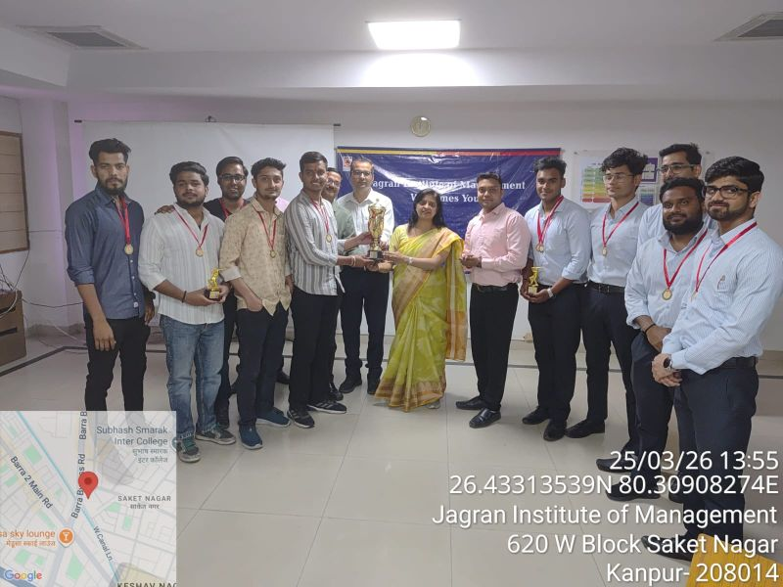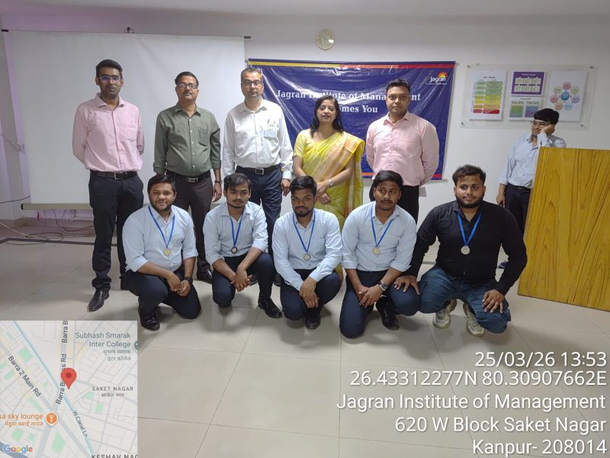
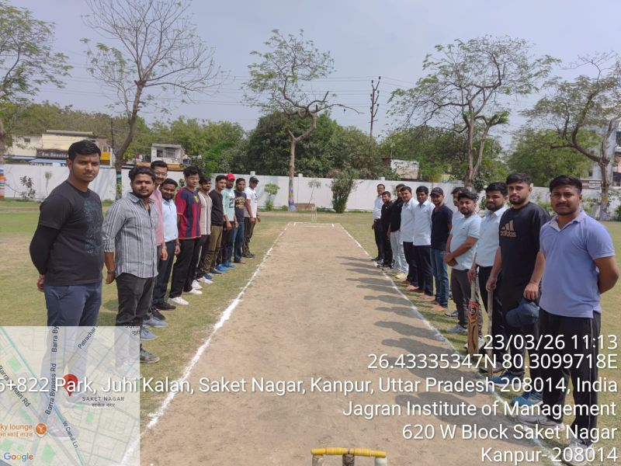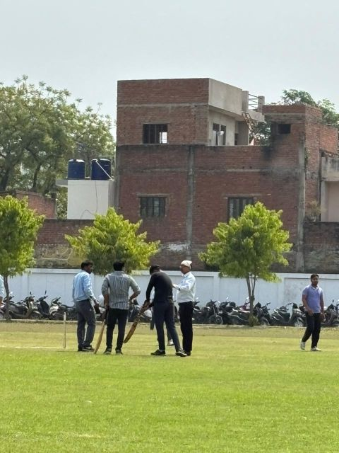
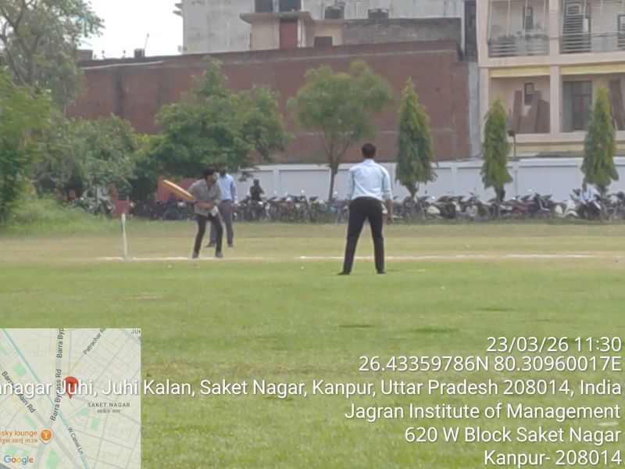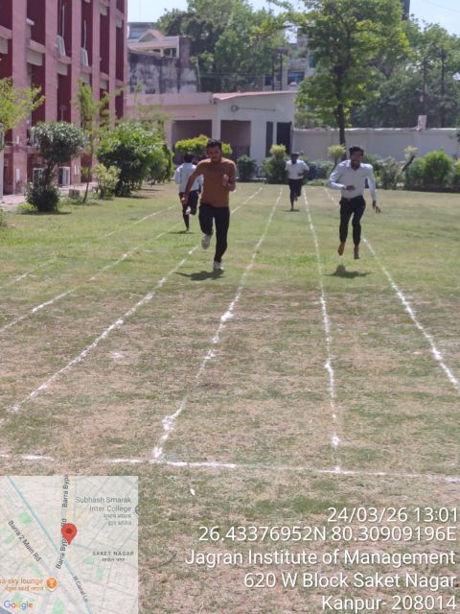
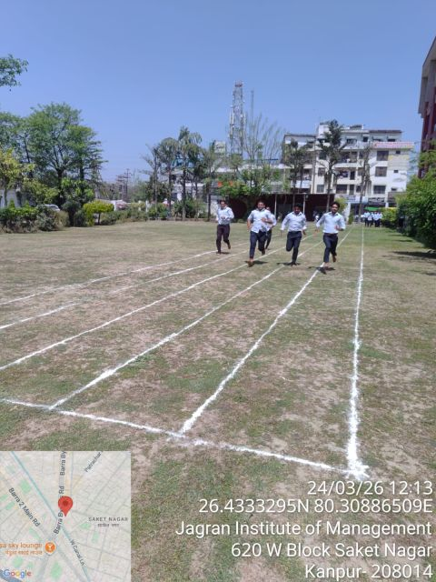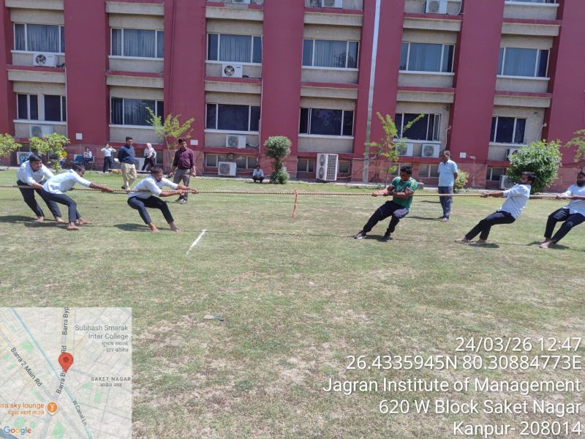
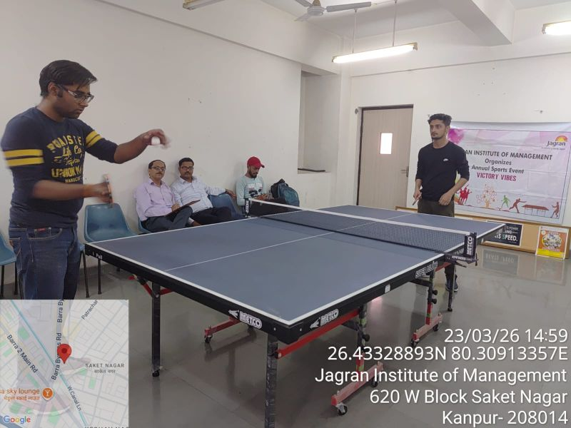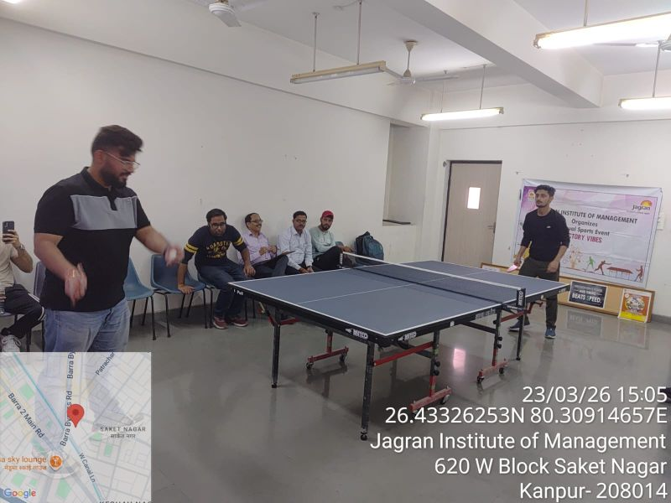
_________________*********_____________________********__________________
Press Coverage
