Web Report for Mind & Code Fest (InnovateX) 2026
Event : Biz Brain Quest 2026 & Code Quest 2026 (Mind & Code Fest (InnovateX) 2026)
Date & Time : Friday, 10th April, 2026
Venue : Computer Centre, Jagran Institute of Management, Kanpur (UP)
Participants : Students of MCA & MBA -1st Year

The Department of Informatics Club, Jagran Institute of Management has organized a Business Quiz and Coding Competition on “Biz Brain Quest 2026 & Code Quest 2026-(Mind & Code Fest (InnovateX) 2026)” for all the Students of MCA & MBA -1st Year dated on Friday, 10th April, 2026.
This event offers a unique opportunity for students to showcase their knowledge and skills among young minds. Participants are invited to take on exciting IQ challenges and demonstrate their problem-solving abilities. The aim of this competition is to showcase the analytical Skills and programming awareness that the participants admire the most. It provides a platform for students to compete with others and evaluate their programming skills in the field of competitive programming, while fostering the development of algorithmic, analytical, and productive thinking. It also helps students in placement activities and enhances their abilities.
This contest aimed to help students adapt to software development platforms, provide a space to support their learning process, and enhance their programming skills. It also offered a valuable opportunity for all students to explore and improve their software development abilities.
As a result, students will be encouraged to do a contest to get a better understanding of their own software development skill for helping them to make a suitable career in software development. However, these contests cannot explore you everything, but they can raise the knowledge among participants to make better plan for their future career aspect.
It was a computer-based online event designed for business and young-minded participants. The event consisted of two phases. The first phase, the Biz Brain 2026 competition for management students, was held from 11:00 AM to 12:00 PM with 24 participants in total. The second phase, for Computer Science and Application students, took place from 12:30 PM to 2:00 PM, with 44 participants in total. After the successful completion of both phases, the top five highest-scoring participants from each phase were declared winners at the end of the event. The following students have secured the top positions based on their performance:
Biz Brain Quest 2026 (Winners / Top Performers)-
Sr. No. | Position/Rank | Participant ID | Name of Participant | Course/Branch
1. | Rank 1 | 434007 | ANIKET TRIPATHI | MBA
2. | Rank 2 | 434010 | ANSHIKA TOMAR | MBA
3. | Rank 3 | 434005 | AMAN KUSHWAHA | MBA
4. | Rank 4 | 434039 | RITIK KUMAR | MBA
5. | Rank 5 | 434040 | RITU AGNIHOTRI | MBA

Code Quest 2026 (Winners / Top Performers)-
Sr. No. | Position/Rank | Participant ID | Name of Participant | Course/Branch
1. | Rank 1 | 434118 | DIVYANSH SHARMA | MCA
2. | Rank 2 | 434139 | PRINSHU VERMA | MCA
3. | Rank 3 | 434141 | RAJ SONI | MCA
4. | Rank 4 | 434115 | AYUSH SRIVASTVA | MCA
5. | Rank 5 | 434122 | HARSHIT SRIVASTAVA | MCA

The winners were selected based on participants’ performance in the business quiz and coding competition. After evaluating the results, the winners of both contests were announced. At the conclusion of the event, Dr. Divya Chowdhry, Director of Jagran Institute of Management, congratulated and appreciated the participants and winners for their active involvement.
Top Performers/Winners were awarded with an excellence prize and certificate. The event was coordinated by Mr. Vishnu Kumar Shukla, (Assistant Professor & Event Coordinator, Informatics Club), Dept. of MCA, Jagran Institute of Management. It was an interesting and nice event for the students as they participated in the competition with great enthusiasm.
Overall, all the students of MCA and MBA (1st year) actively participated in the business quiz and coding contest, and the Informatics Club committee members efficiently organized the event. The students were able to enhance their relevant knowledge through both the business quiz and coding competition.
Glimpses of the Event
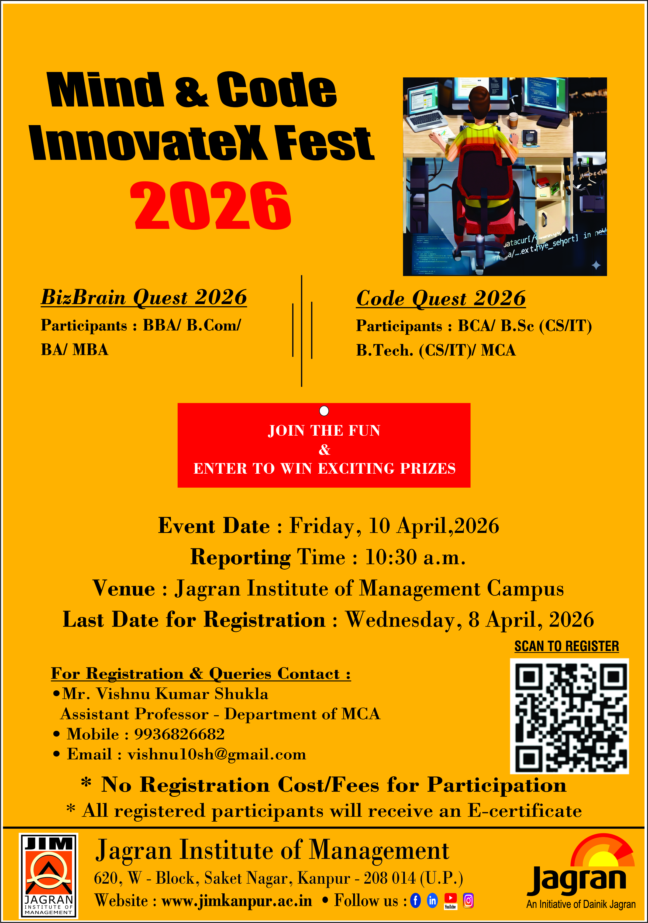

Participants/ Students Actively Participating in Biz Brain Quest 2026 and Code Quest 2026 Fest (Mind & Code Fest (InnovateX) 2026
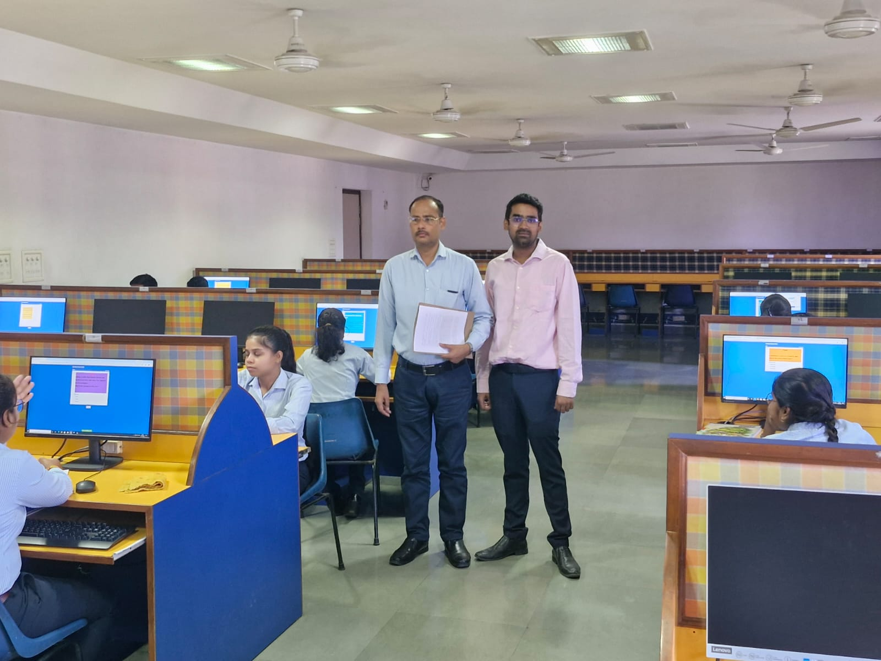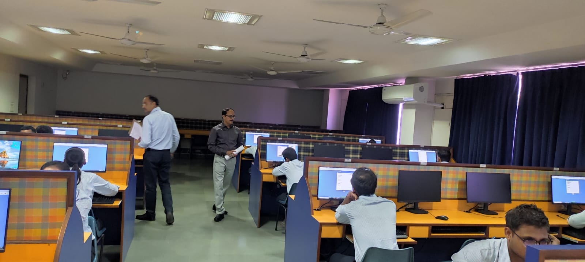
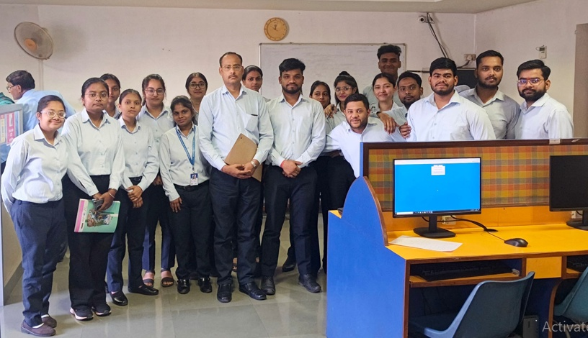

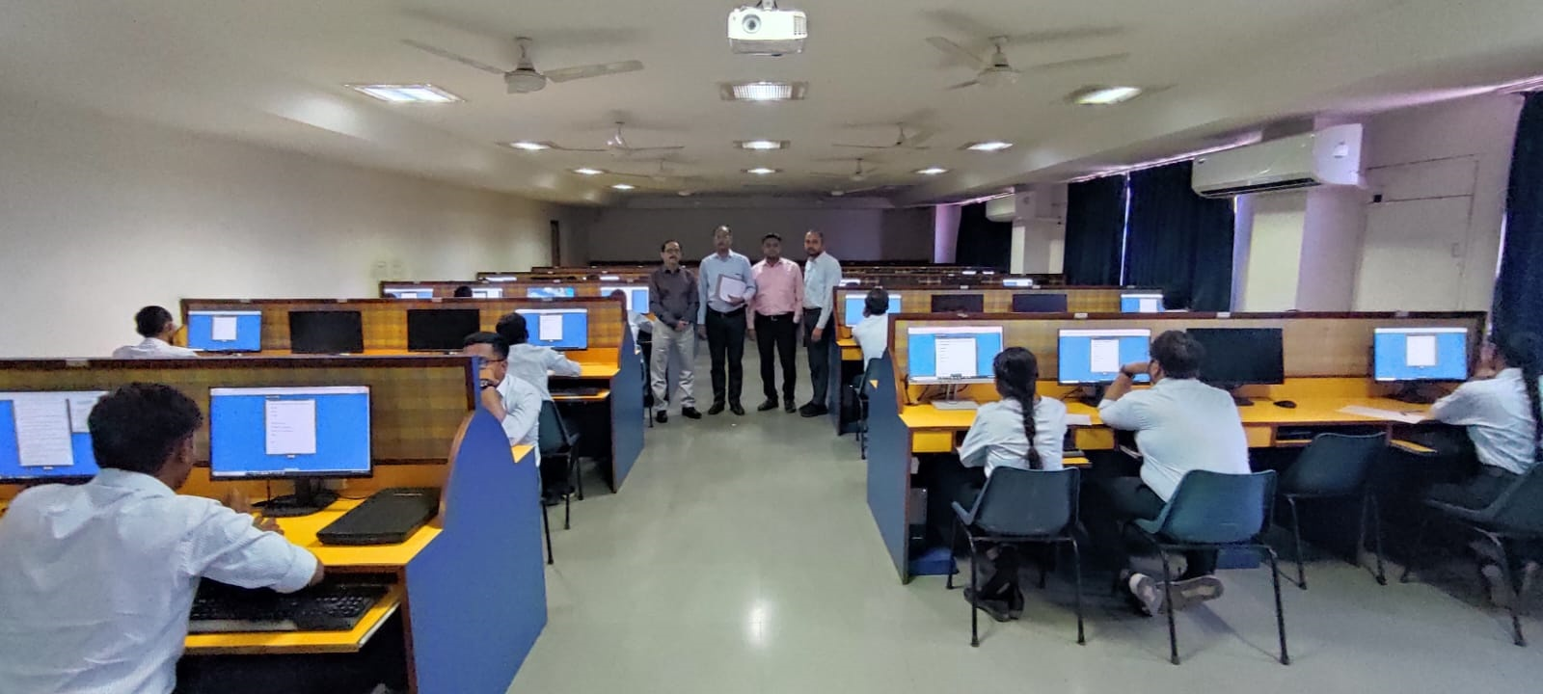
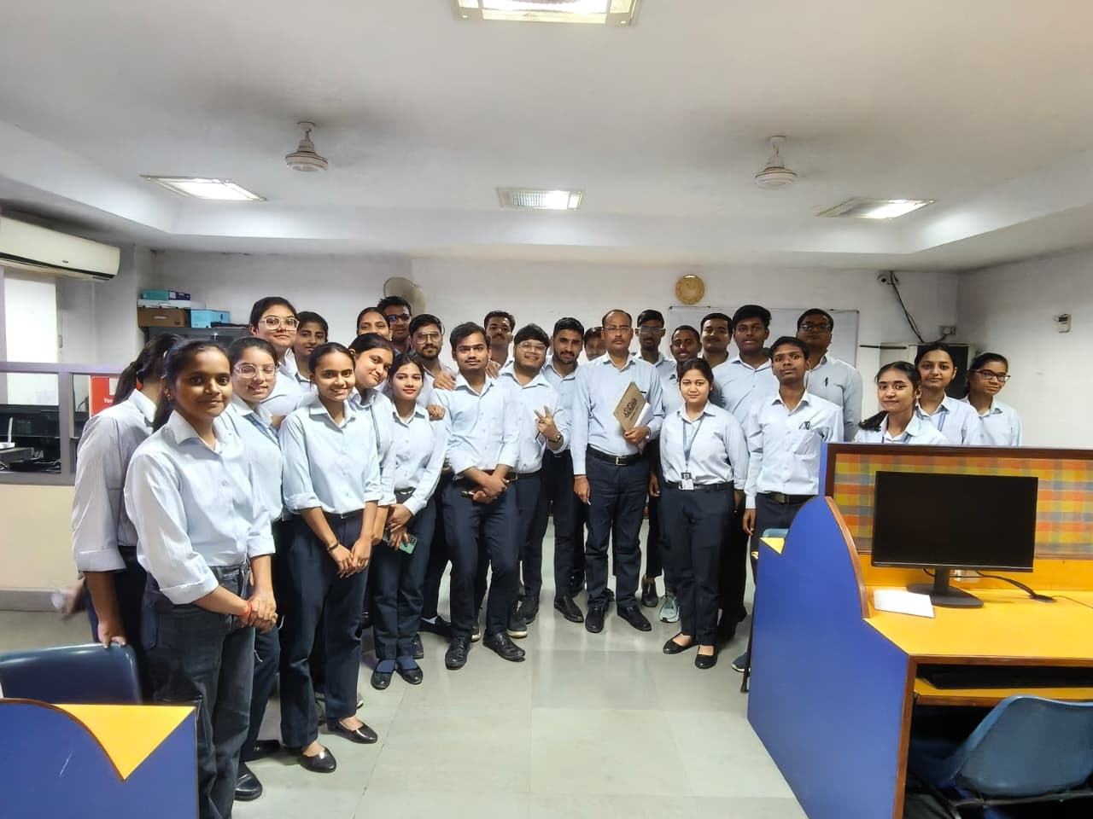
-----------------------------End---------------------------------

