Pool Campus Placement Drive - 2025

Event: Pool Campus Placement Drive – 2025

Date & Time: Wednesday, 12th November, 2025

Venue: Jagran Institute of Management

Faculty Coordinator: Mrs. Pratima Gupta Chowdhry

Participants: Students of BBA, B.Com and MBA

No. of Participating Companies: 3

Aim: The Pool Campus Placement Drive especially for Student of BBA, B.Com and MBA to make career better.

Description: Students of BBA, B.Com and MBA gave their best performances in the Companies. The Placement Drive was started by the presence of all the faculty members, students and Companies. The companies initiated the placement drive by giving the brief of their company and profile in their pre placement talk. Student participated with full zeal in Written, Group Discussion and Personal Interview round conducted by companies. Company are:

- Bajaj Life (Offline)
- Mavericks (Offline)
- Prasuta Finance (Online)

Bajaj Life: A leading name in insurance and financial services, offering roles in sales, financial consulting, and back-office operations.

Mavericks: A dynamic technology and consulting firm recruiting for roles in software development, IT consulting, and business analysis.

Prasuta Finance: A finance-focused company offering opportunities in credit analysis, accounting, and financial management.

Conclusion: The Student of BBA, B.Com and MBA came together and gave interviews in different companies. More than 15 student got their final placement in the Job Fair. All the companies were welcomed by the Director, Dr. Divya Chowdhry.

Photographs
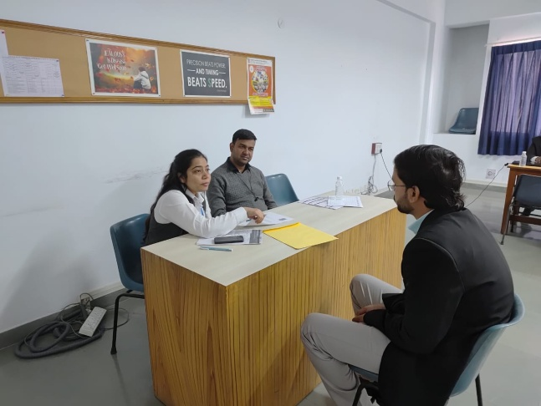
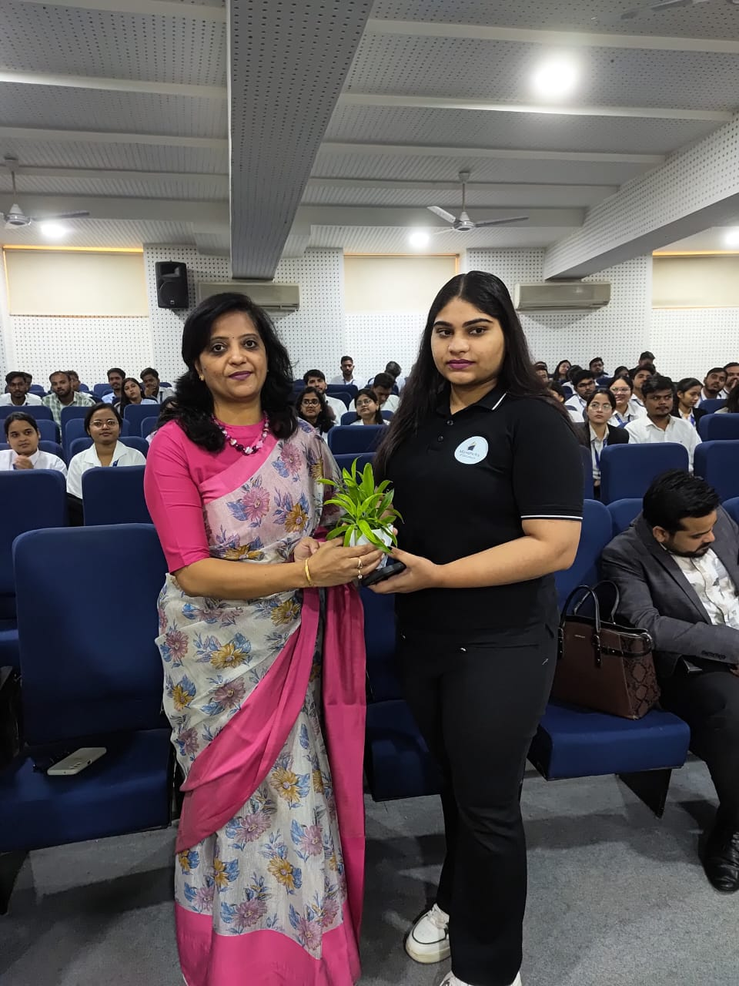

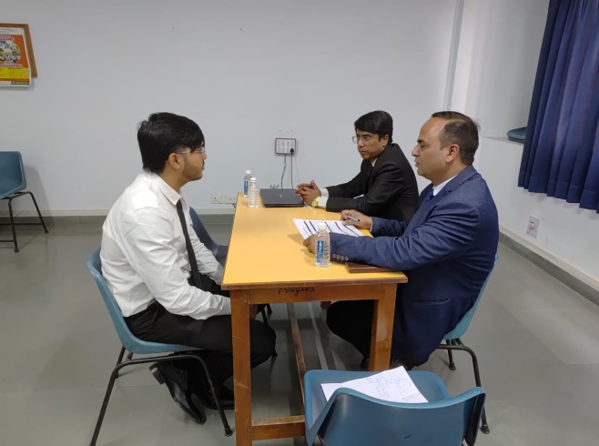

Mavericks

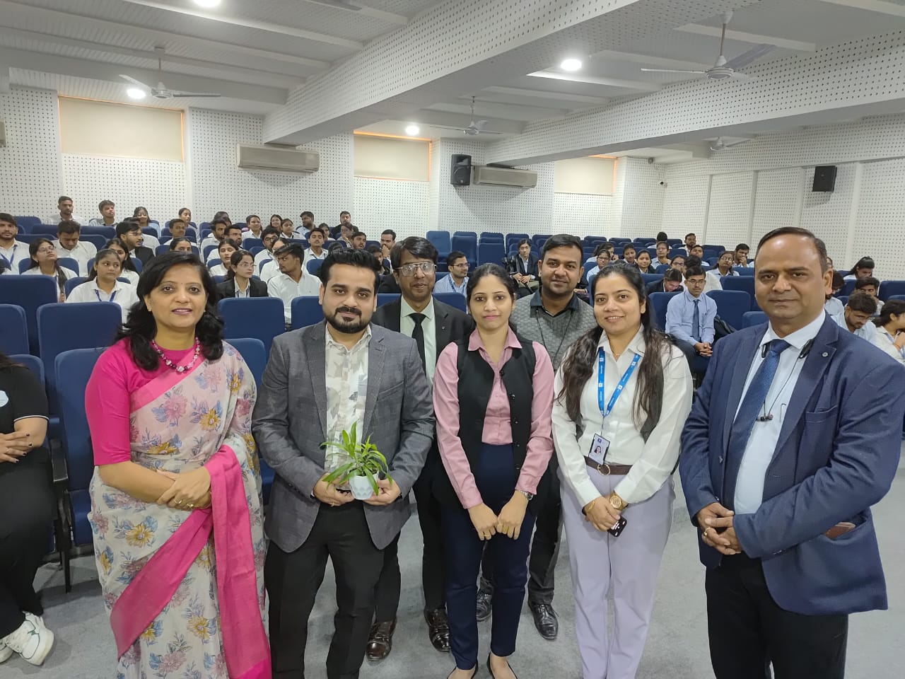

Bajaj Life

Media Coverage

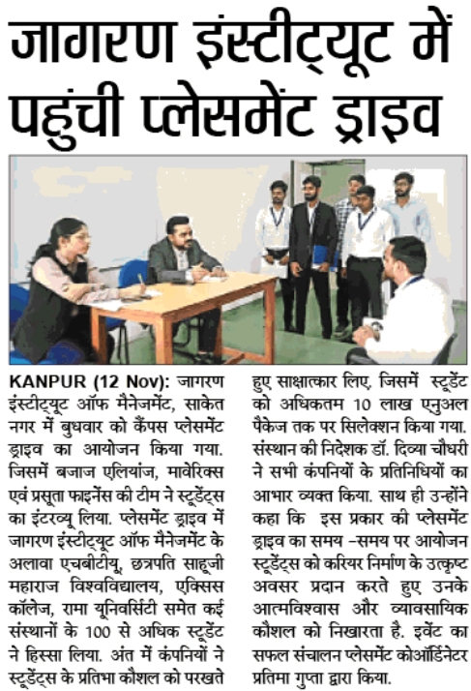
I-Next
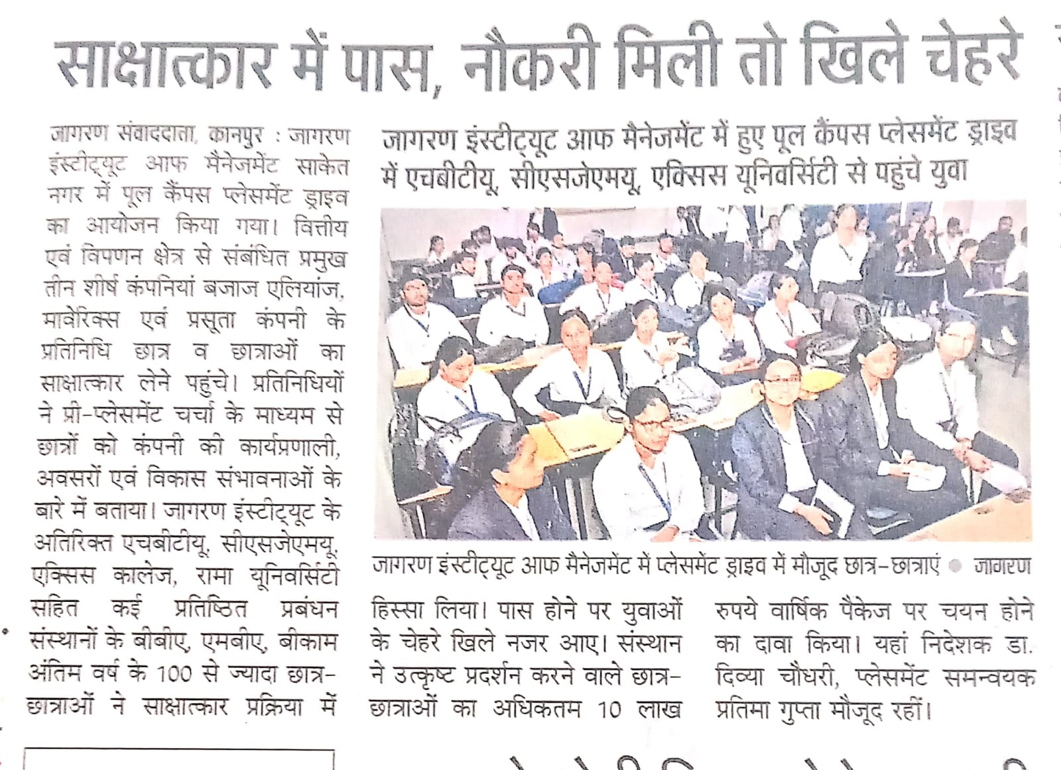
Dainik Jagran

