International Yoga Day-2026

Event: JIM Yog Diwas: A Journey Towards Wellness
Day & Date: Saturday, 20th June 2026
Time: 10:30 am to 12:30 pm
Venue: JIM Campus
Faculty Coordinators: Mr. Pawan Omer & Dr. Anand Kumar Dixit
Participants: Faculties, Staff and Students of JIM, JIMMC, JIDA

“Yoga is the journey of the self, through the self, to the self” -The Bhagavad Gita
Introduction & Objectives-
World Yoga Day is an internationally recognized event celebrated on June 21st each year. This day highlights yoga's universal appeal and its ability to foster holistic well-being. Jagran Institute of Management enthusiastically participated in International Yoga Day, organizing a special event on its premises. With the presence of renowned yoga instructor Ms. Poonam Bajpai (Certified- Senior Yoga Instructor & Reiki Grand Master), the event aimed to introduce students and faculty members to the transformative power of yoga & stimulates the physical, mental and spiritual benefits of practicing yoga.
Description of the event-
The event commenced with an inaugural speech about the benefits of the Yoga by Respected Director Prof. (Dr.) Divya Chowdhry, who also presented a green certificate as token of love & appreciation to the guest.
The yoga session was conducted under the guidance of an experienced yoga instructor, Ms. Poonam, who led the participants through a series of Surya Namaskar, Yoga Asanas (postures) and Pranayama (breathing techniques). She emphasized the numerous benefits of yoga, explaining how it positively impacts both the body and mind & highlighted yoga as a holistic practice that enhances physical health, mental clarity and emotional stability and its positive impact on both the body and mind for those who incorporate it into their lives.
The programme also featured a yoga competition for students, wherein participants demonstrated various yoga postures and competed for excellence. Outstanding performers were recognized and awarded prizes for their achievements.

Beyond the physical aspects, yoga has a profound impact on mental and emotional well-being. The instructors emphasized that yoga serves as a powerful tool for stress reduction. By incorporating deep breathing exercises, meditation and mindful movement, individuals can experience a sense of calm and relaxation, alleviating anxiety and tension.
Regular yoga practice enhances mental clarity, concentration and focus, enabling participants to manage their daily tasks and challenges with greater ease.
Conclusion-
The International Yoga Day event at Jagran Institute of Management with the presence of expert instructors was a remarkable celebration of yoga's transformative power. Participants, including students, faculty & staff members had the opportunity to learn and experience the physical, mental and spiritual benefits of yoga. The event reinforced the institution's commitment to holistic education and well-being. By incorporating yoga into their lives, participants were inspired to embark on a journey of personal growth, balance and overall wellness.
Thus International Yoga Day is a celebration of a timeless tradition that contributes to health and harmony in a modern context. By embracing yoga, individuals can experience significant improvements in their quality of life, fostering a healthier and more peaceful world.

Media Coverage of the event-
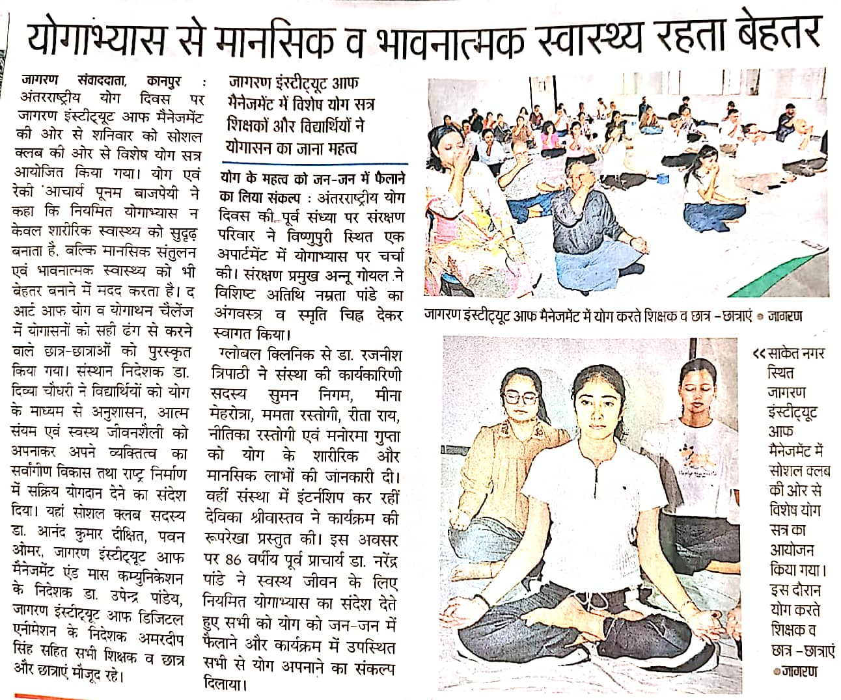
Danik Jagran (Jagran City) news coverage on page no. 2

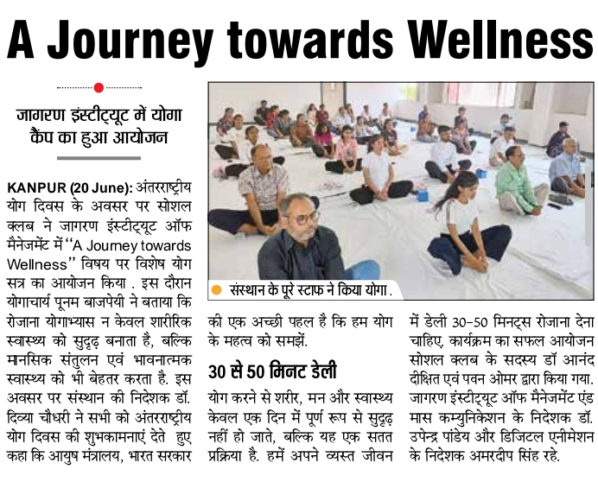
I Next news coverage on page no. 4

Glimpses of the event-
