Web Report
Event: Alumni Meet Reconnect 2026
Day & Date: Saturday,24 January 2026
Venue: Lakshmi Devi Auditorium – JIM Campus, Kanpur
Theme: Neon with a 90’s Vibe
Jagran Institute of Management (JIM), Kanpur successfully hosted its much-anticipated Alumni Meet, “Reconnect 2026,” on 24th January 2026 at the JIM Campus. The event aimed to reinforce the enduring bond between the institute and its alumni, celebrate their achievements, and foster meaningful interaction among alumni, faculty members, dignitaries, and students.
The meet witnessed the enthusiastic participation of alumni, many of whom attended with their family members and spouses. Their presence infused the campus with warmth and vibrancy, creating a welcoming, inclusive, and celebratory atmosphere throughout the day.
Arrival, Registration & Welcome Experience
The event commenced in the Open Arena with the arrival and registration of alumni. A thoughtfully curated welcome experience set an engaging and nostalgic tone for the evening. A vibrant stalls arena featured food stalls, face art counters, perfume and fragrance kiosks, and a Polaroid photo corner. Neon bands, welcome gifts, and refreshing welcome drinks further enhanced the experience. This interactive setup encouraged informal conversations, joyful reunions, and nostalgic bonding among alumni from different batches, instantly reviving cherished campus memories.
Inaugural Session
The formal proceedings were held at the Laxmi Devi Auditorium in the presence of dignitaries, faculty members, alumni, and members of the organizing committee. The session began with a grand opening and welcome note, followed by the ceremonial lighting of the lamp, symbolizing knowledge, wisdom, and institutional growth.

Cultural Performances and Engagement Activities
A series of vibrant cultural performances added energy and enthusiasm to the event. These performances were strategically interspersed throughout the program to maintain audience engagement. Interactive games and alumni engagement activities encouraged enthusiastic participation, fostering camaraderie and togetherness among alumni from diverse batches.
Awards and Recognition Ceremony
One of the most prestigious highlights of Reconnect 2026 was the Awards and Recognition Ceremony, organized to honor alumni who have demonstrated excellence and impact in their professional and social endeavors. The institute proudly recognized:
- Global Reach Award – Ms. Riya Gupta (MBA, 2022) for her outstanding professional achievements and global presence
- Technological Excellence Award – Ms. Vasudha Sharma (MBA, 2022) for innovation and contributions in the field of technology
- Entrepreneurial Vision Award – Mr. Simran Singh (MCA, 2010) for exemplary entrepreneurial leadership
- Social Impact Award – Mr. Akhilesh Mishra (MCA, 2022) for significant contributions to social development and community welfare
The ceremony marked a proud moment for the institute and served as a strong source of inspiration for students and fellow alumni.
Entertainment, Music & Alumni – Institute Connect
The celebrations continued with additional cultural performances and a soulful singing performance by Shlok Sharma, which was warmly appreciated by the audience. A special segment titled “Down the Memory Lane – Audio & Visuals” showcased key milestones and memorable moments of JIM, evoking nostalgia and emotional connections among the alumni.
An Alumni–Institute Connect Session provided a valuable platform for alumni to share suggestions related to student mentoring, placements, and institutional growth. During this session, the Alumni Membership Plan was formally introduced, highlighting its objectives, benefits, and opportunities for sustained engagement with the institute.
The evening was further enlivened by a stand-up comedy performance by guest comedian Kartikey Pandey, adding humor and relaxation while strengthening informal bonding among attendees.
The program concluded with a vote of thanks by the Director, acknowledging the enthusiastic participation and contributions of alumni, faculty members, dignitaries, and the organizing committee. The event concluded on a joyful note with a cake-cutting ceremony, group photographs, and a networking dinner accompanied by light music in the Open Arena.
Glimpses of Events
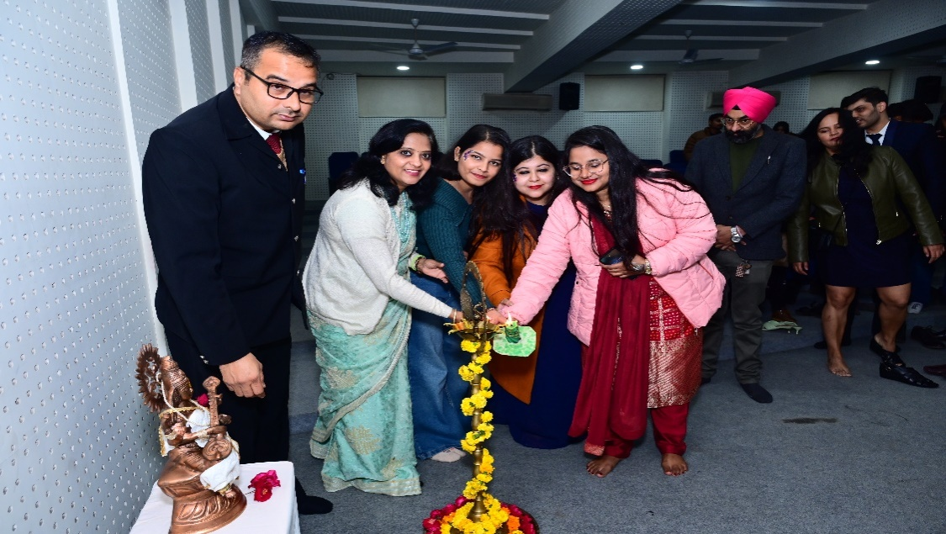
Lamp lightning by Alumni
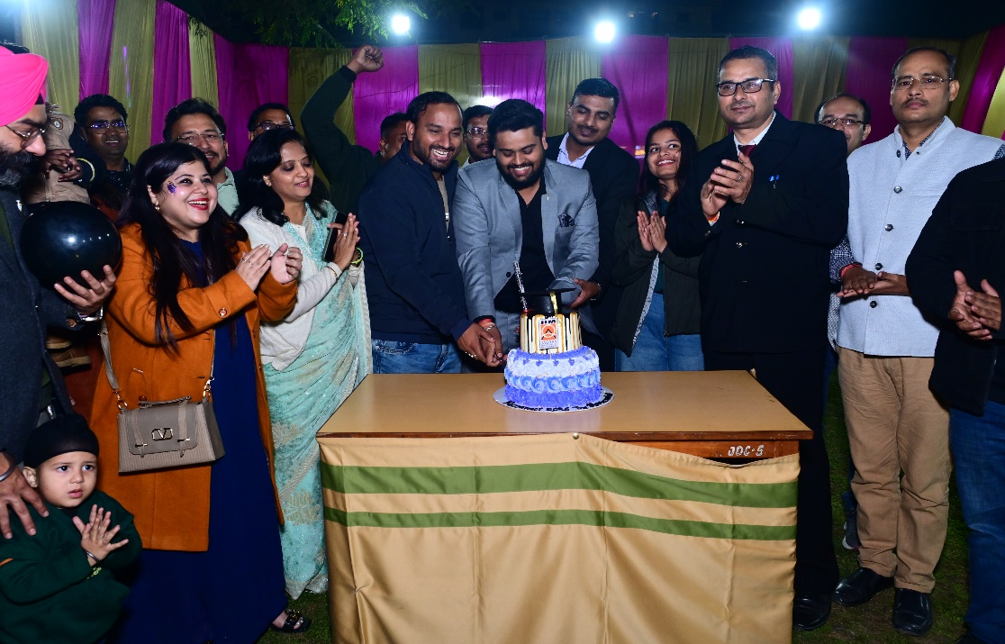
Cake Cutting
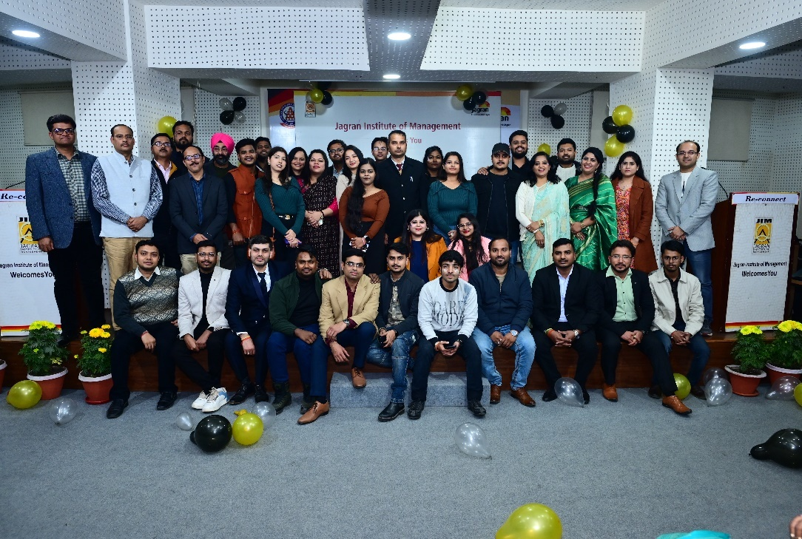
Alumni Gathering

Press Coverage
