Web Report: One-Day Sports Event

Event: One-Day Sports Event

Date & Time: 30th August 2025

Venue: Sports Ground & Indoor Hall

Participants: MBA & MCA students from Jagran Institute of Management

On the occasion of National Sports Day, the Sports Club of Jagran Institute of Management, Kanpur organized a one-day sports competition filled with energy, and enthusiasm and team spirit .

The program was inaugurated by the Institute’s Director Dr. Divya Chaudhary, Dean Academics Dr. Anil Kumar Singh, along with all faculty members. Various sports activities including Table tennis, Chess, and Tug of war were conducted, witnessing active participation from the MCA and MBA students, both juniors and seniors.

The objective of this event was to encourage students to imbibe the values of sportsmanship, discipline, teamwork, and physical as well as mental fitness.

- Table Tennis: Aviral Awasthi (MBA I Year) showcased remarkable skill and defeated Madhav Mahana (MBA I Year) with scores of 11-7, 11-6.

- Chess: In a thrilling final match, Raj Soni (MCA I Year) triumphed over Aman Singh (MCA I Year).

The event concluded with exciting fun matches of Tug of War that brought cheer and joy to all participants.

Towards the end, the winners were honored with Certificates and Medals by Director Dr. Divya Chaudhary, Dean Academics Dr. Anil Kumar Singh, and all faculty & admin staff members.

The event was coordinated successfully by Sports Club coordinator Assistant Professors Adarsh Srivastava & Aman Kesharwani. The celebration saw the wholehearted presence of all the faculties, students, and staff members, making it a memorable occasion.

Glimpses of the Event
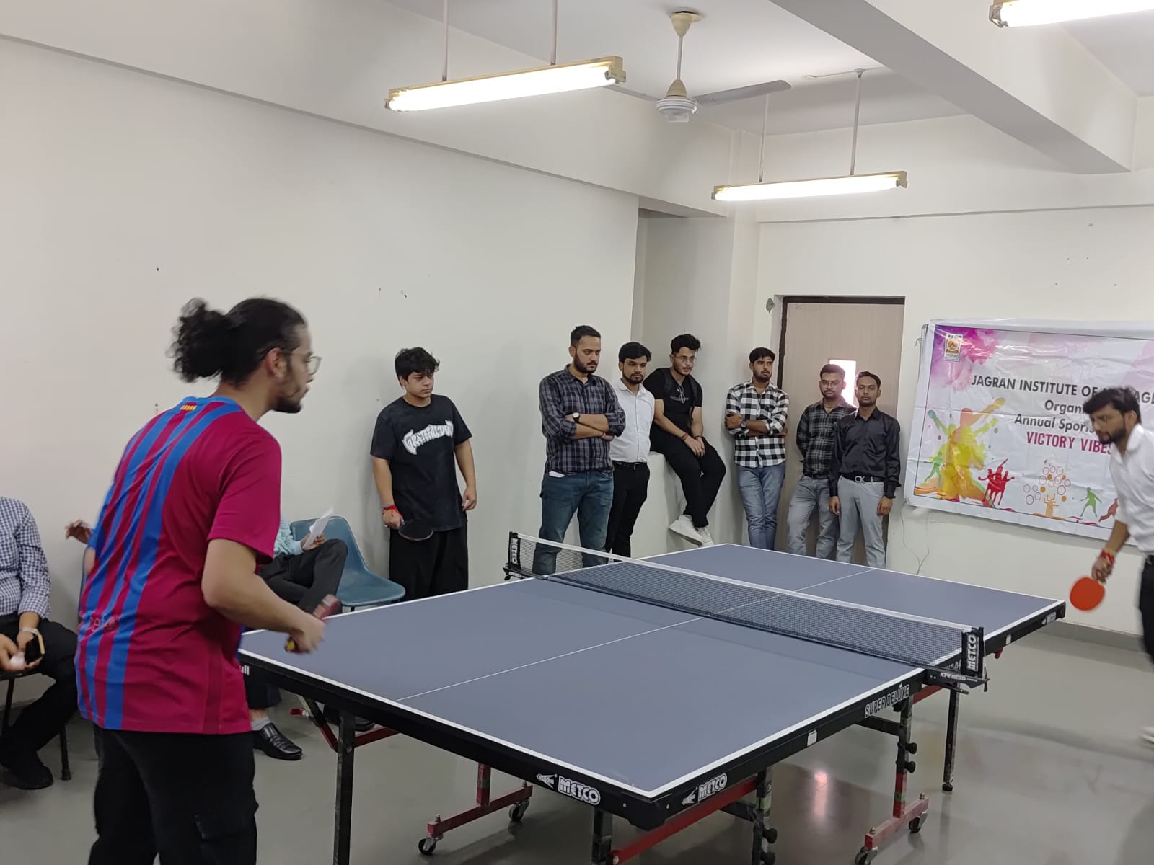
Table Tennis
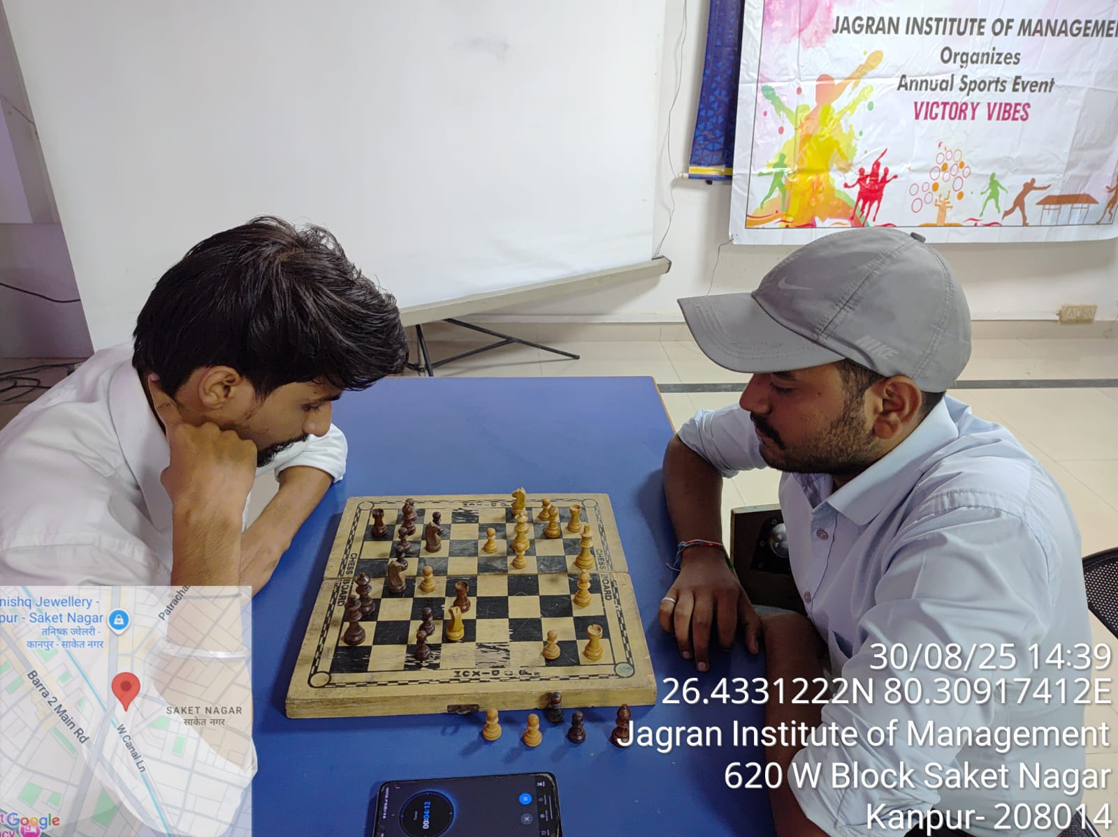
Chess
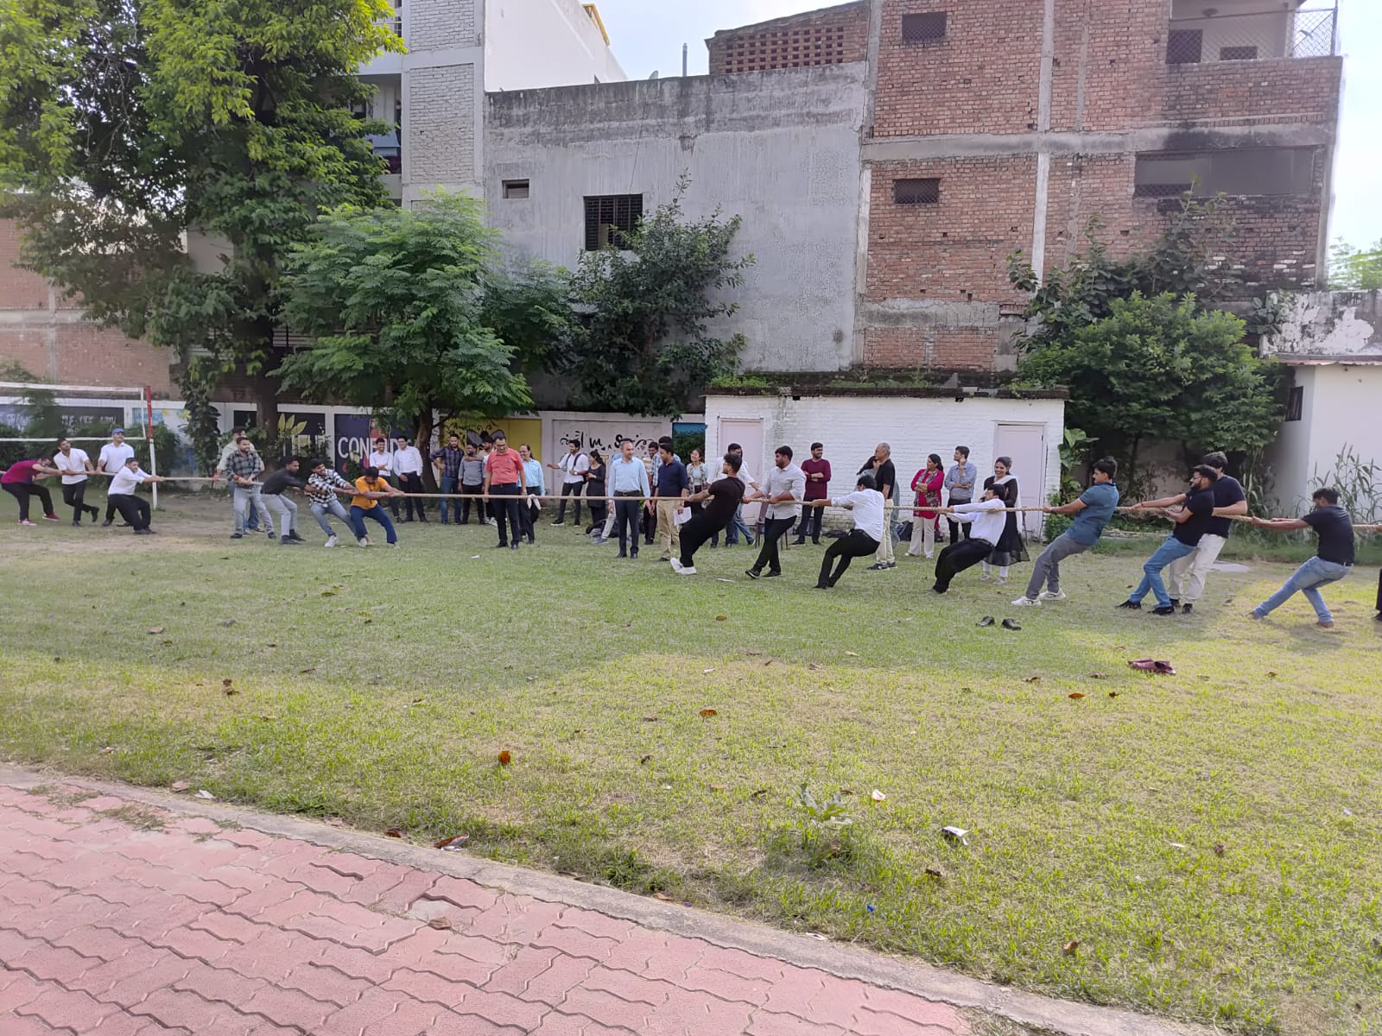
Tug of War
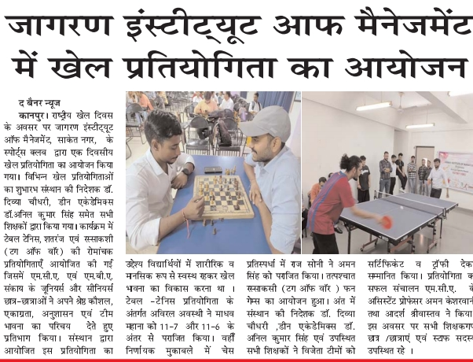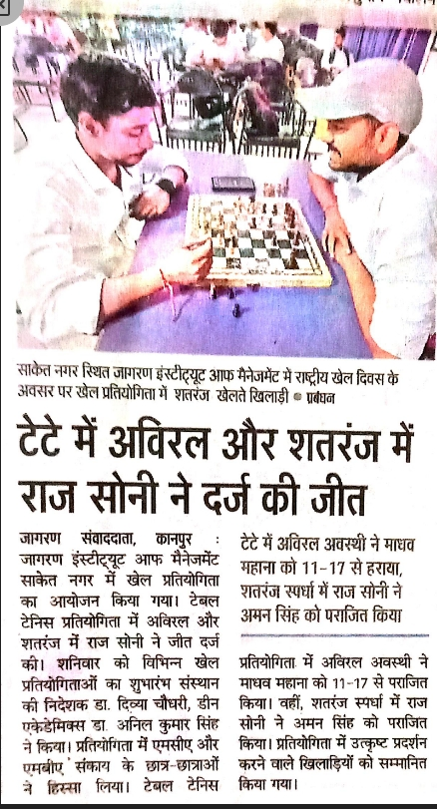
I -Next News Coverage Sports event on pg. -4 dated: 31.08.2025

