NATIONAL SEMINAR
Event: National Seminar on Union Budget 2026 — Prudence, Sustainability and Growth Pathways for Viksit Bharat
Day & Date: Thursday, February 5th, 2026
Venue: Lakshmi Devi Auditorium – JIM Campus, Kanpur
Participants: MBA, MCA & other Students of various Institutes and Verticals

Jagran Institute of Management organized a National Seminar on Union Budget 2026 themed “Prudence, Sustainability and Growth Pathways for Viksit Bharat” on Thursday, February 5th, 2026. The seminar aimed to provide a platform for academic dialogue and analytical discussion on fiscal strategies, sustainable development priorities, and economic growth trajectories outlined in the national budget.
The event began with an inaugural session welcoming participants and speakers, emphasizing the importance of understanding budgetary provisions in shaping India’s long-term economic vision. A Budget Survey Report presentation titled “Budgetary Analysis and Economic Implications: Union Budget 2026” was delivered under the guidance of CS Shantanu Kumar by Madhv Mahana and Sneha Gupta (MBA). The presentation highlighted key economic signals, fiscal priorities, and sectoral implications of the budget.

Resource Persons – Profile (Dossier Format)

CA Dharmendra Kumar Srivastava
The symposium had the honour of welcoming Dharmendra Kumar Srivastava, a distinguished Chartered Accountant and Senior Partner at M/s Dharmendra Srivastava & Associates, Kanpur. He possesses extensive professional experience in Service Tax and GST litigation and representation before CESTAT.
He is the Founder President of the Association of GST Tribunal Practitioners and Past President of the Kanpur GST (CA) Association. Additionally, he serves as Advisor to the GST Committee of the Merchant’s Chamber of Uttar Pradesh and as Vice Chairman of the All India Federation of Tax Practitioners. His professional contributions extend to academia and knowledge dissemination through his role as Technical Editor of Indirect Tax Talk and active engagement with professional accounting and taxation bodies across Kanpur and Lucknow.
He was formally welcomed by the CEO with the presentation of a sapling and memento.

CA Govind Maheshwari
The second distinguished speaker was Govind Maheshwari, a practicing Chartered Accountant recognized for his expertise in taxation and professional training. Over the course of his career, he has trained more than 15,000 candidates and has served as an empaneled speaker at Institute of Chartered Accountants of India as well as faculty at the National Academy of Customs Indirect Taxes and Narcotics.
He is also a visiting faculty member for Direct Tax and GST at ICAI and Institute of Company Secretaries of India. His leadership roles include active involvement in the Kanpur Income Tax Bar Association and prior service as Vice President at Institute of Computer Accountants, along with tenure as State Head of Training at Reliance Industries.
He was honoured by the Director with a sapling and memento as a token of institutional appreciation.

CMA CS Ajai Kumar Sharma
The symposium further featured Ajai Kumar Sharma, presently serving as Secretary and distinguished faculty member at the Institute of Cost Accountants of India, Kanpur Chapter. An accomplished academic and professional, he holds qualifications including M.Com, ACMA, ACS, CA (Inter), LLB, PGDFM, and diplomas in French and Urdu.
With extensive teaching experience across premier institutions and his current professional association with Defence Research and Development Organisation, he has mentored numerous students pursuing professional excellence in Chartered Accountancy and Company Secretaryship.

Concluding Academic Outcome
Collectively, the expert deliberations provided multidimensional insights into the Union Budget 2026–27, covering taxation reforms, compliance simplification, sectoral support mechanisms, and entrepreneurship-driven employment generation. The discussions enriched participants’ understanding of how fiscal policy, infrastructure investment, and regulatory incentives contribute to India’s transition toward sustainable, inclusive, and innovation-driven development in the decades ahead.

Technical Paper Presentation Sessions
In the technical session, student teams presented analytical papers under faculty mentorship, covering diverse thematic areas aligned with the seminar theme.
Team 1 — Taxation & Investment
Under the guidance of Dr. Divya Chowdhry, students Archita Agnihotri and Prajwal (MBA) presented on “Tax Reforms and Investment Climate.” The presentation examined simplification of tax structures, incentives for capital investments, and foreign direct investment enhancements aimed at strengthening investor confidence and business competitiveness. The presentation explored structural reforms aimed at simplifying the taxation system and improving the investment climate. Discussion included rationalization of tax compliance procedures, digitalization of tax administration, and policy incentives encouraging domestic and foreign investments. The team analyzed how streamlined regulatory mechanisms and capital cost incentives could enhance ease of doing business and stimulate entrepreneurial confidence. Furthermore, the study evaluated potential implications of tax reforms on capital markets, industrial growth, and public revenue sustainability, highlighting their role in strengthening India’s financial ecosystem.
Team 2 — Agriculture & Rural Economy
Guided by Dr. Anil Kumar students Singh, Swasti Mishra (MCA) discussed “Agriculture, Agri-Tech and Rural Credit Reforms.” The presentation emphasized rural prosperity through technological integration, credit accessibility, and policy interventions ensuring food security and agricultural sustainability. This study addressed budgetary measures targeting agricultural modernization and rural economic transformation. The presentation emphasized technological adoption in agriculture, expansion of rural credit accessibility, and strengthening of agri-value chains. It discussed how policy initiatives promoting sustainable farming practices, digital platforms, and infrastructure development could increase productivity and rural incomes. The team also evaluated the broader socio-economic impact of empowering rural communities through credit reforms, market integration, and food security programs that align with inclusive national development.
Team 3 — MSMEs, Startups & Exports
Under Mr. Pawan Omer students Praveen Kumar Bisht and Manju Bisht (MBA) analyzed the role of MSMEs and startups in strengthening global competitiveness, export growth, and employment generation through policy support and financial inclusion. The analysis focused on the role of MSMEs and startups as engines of employment and innovation. It examined budget provisions supporting credit expansion, export incentives, and entrepreneurial ecosystems. The presentation highlighted initiatives designed to enhance competitiveness through technology adoption, skill development, and global market linkages. Particular attention was given to export promotion policies enabling Indian enterprises to integrate with international supply chains, thereby contributing to economic diversification and industrial resilience.

Team 4 — Digital Economy & Cyber Security
Guided by Mr. Ashish Mishra students Anshika Agarwal and Ananya Agnihotri explored digital public infrastructure and cybersecurity implications in the budget, highlighting technological resilience and data protection priorities in the evolving digital economy. This presentation evaluated budgetary priorities related to digital transformation and cybersecurity frameworks. The team discussed expansion of digital public infrastructure, data governance models, and investments supporting digital service delivery. It analyzed the importance of cyber resilience in safeguarding economic activities and institutional operations in an increasingly digital environment. The literature emphasized that robust cybersecurity policy integration not only protects digital assets but also enhances trust in digital platforms, facilitating innovation and technological growth.
Team 5 — Social Welfare Initiatives
Under Dr. Akshat Gupta students Diya Seth and Vikram Sharma presented insights on inclusive growth through welfare initiatives, examining budget allocations aimed at social equity, poverty reduction, and community development. The study assessed budget initiatives addressing socio-economic disparities through targeted welfare programs. It discussed resource allocation for poverty alleviation, community support mechanisms, and access to essential services such as housing, nutrition, and livelihood support. The presentation emphasized the importance of inclusive policy design in ensuring equitable distribution of economic benefits and reducing inequality. By linking welfare interventions to broader economic development, the analysis demonstrated how social investments contribute to long-term national stability.
Team 6 — AI & Data Economy
Guided by Dr. Anand Kumar Dixit students Mahi Mishra (MCA Final Year) discussed policy perspectives on artificial intelligence, data governance, and digital transformation as drivers of economic expansion. This presentation examined emerging policy support for artificial intelligence and data-driven economic expansion. It highlighted investments in digital infrastructure, research ecosystems, and skill development necessary for technological leadership. The team analyzed how AI integration across sectors could enhance productivity, governance efficiency, and innovation capabilities. The study emphasized ethical data governance, regulatory frameworks, and public-private collaboration as critical elements for responsible digital transformation.
Team 7 — Infrastructure & Transport
Under Mr. Adarsh Srivastava students Sheetal Kaur and Ameesha Tripathi (MBA) analyzed infrastructure priorities including railways, roadways, ports, and aviation, emphasizing their role in economic connectivity and productivity. The literature explored infrastructure investments across transportation sectors including railways, road networks, ports, and aviation. It analyzed how improved connectivity enhances trade efficiency, reduces logistics costs, and stimulates regional development. The presentation highlighted capital expenditure in infrastructure as a catalyst for employment generation and industrial expansion. Emphasis was placed on sustainable and technologically advanced infrastructure planning aligned with long-term national growth objectives.

Team 8 — Education, Technology & Skills
Guided by Mr. Aman Kesharwani students Saraj Trivedi and Yash Kumar Jha (MCA) presented on building a future-ready workforce through investments in education quality, skill development, and AI-enabled learning ecosystems. This presentation evaluated education and skill development policies aimed at preparing a technologically adaptive workforce. It examined funding for educational infrastructure, digital learning initiatives, and industry-aligned training programs. The team highlighted integration of emerging technologies such as AI into academic curricula and workforce preparation strategies. The literature underscored the importance of human capital development in supporting innovation-driven economic growth.
Team 9 — Healthcare & Public Health Financing
Under Mr. Vishnu Kr. Shukla students Dev and Arpita Pandey (MCA) discussed healthcare financing, infrastructure strengthening, and wellbeing initiatives supporting inclusive public health outcomes. The study addressed budgetary emphasis on healthcare accessibility, infrastructure enhancement, and financing reforms. Discussion included expansion of health services, digital health initiatives, and capacity building in medical infrastructure. The team examined the link between public health investment and national productivity, emphasizing that improved health outcomes contribute to economic resilience. The presentation highlighted equitable healthcare access as a critical component of inclusive development.
Team 10 — Travel & Tourism
Guided by Mrs. Priya Chopra students Arora, Sarfaraz, Ritik Kumar, and Divya explored tourism-led growth and employment generation, highlighting sectoral investments contributing to regional development. The analysis focused on tourism as a strategic sector for employment generation and regional economic growth. It discussed infrastructure support, promotion of cultural heritage, and sustainable tourism development initiatives. The team evaluated the sector’s multiplier effect on hospitality, transportation, and local entrepreneurship. The presentation concluded that strengthening tourism policy frameworks contributes significantly to national income diversification and global cultural engagement.

Glimpses of the Event
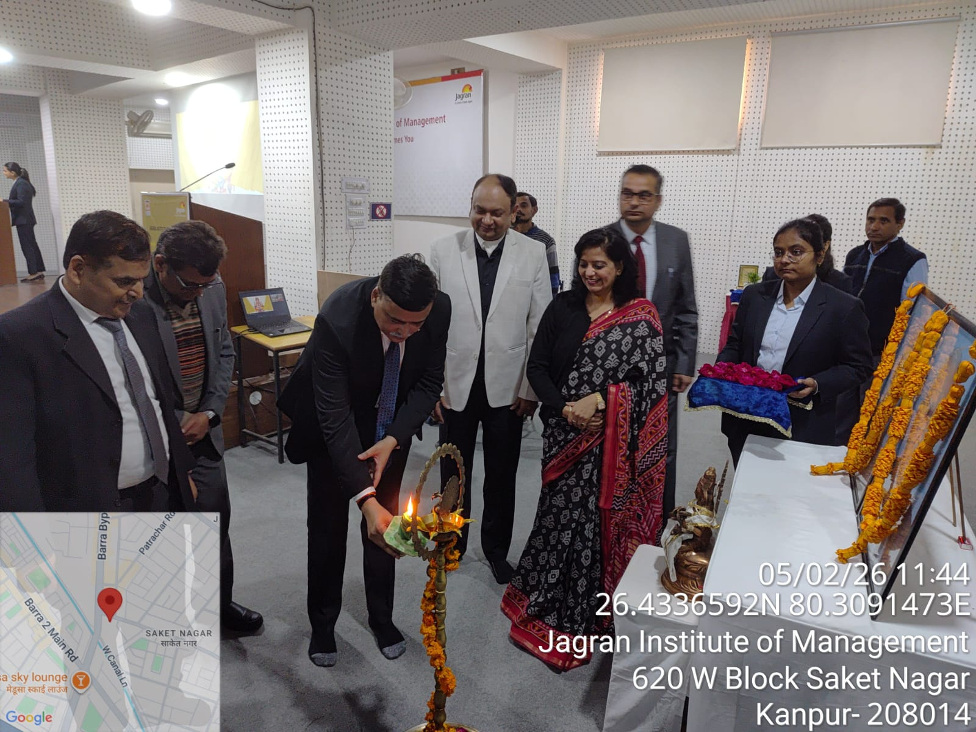
Analysis and Economic Implications: Union Budget 2026

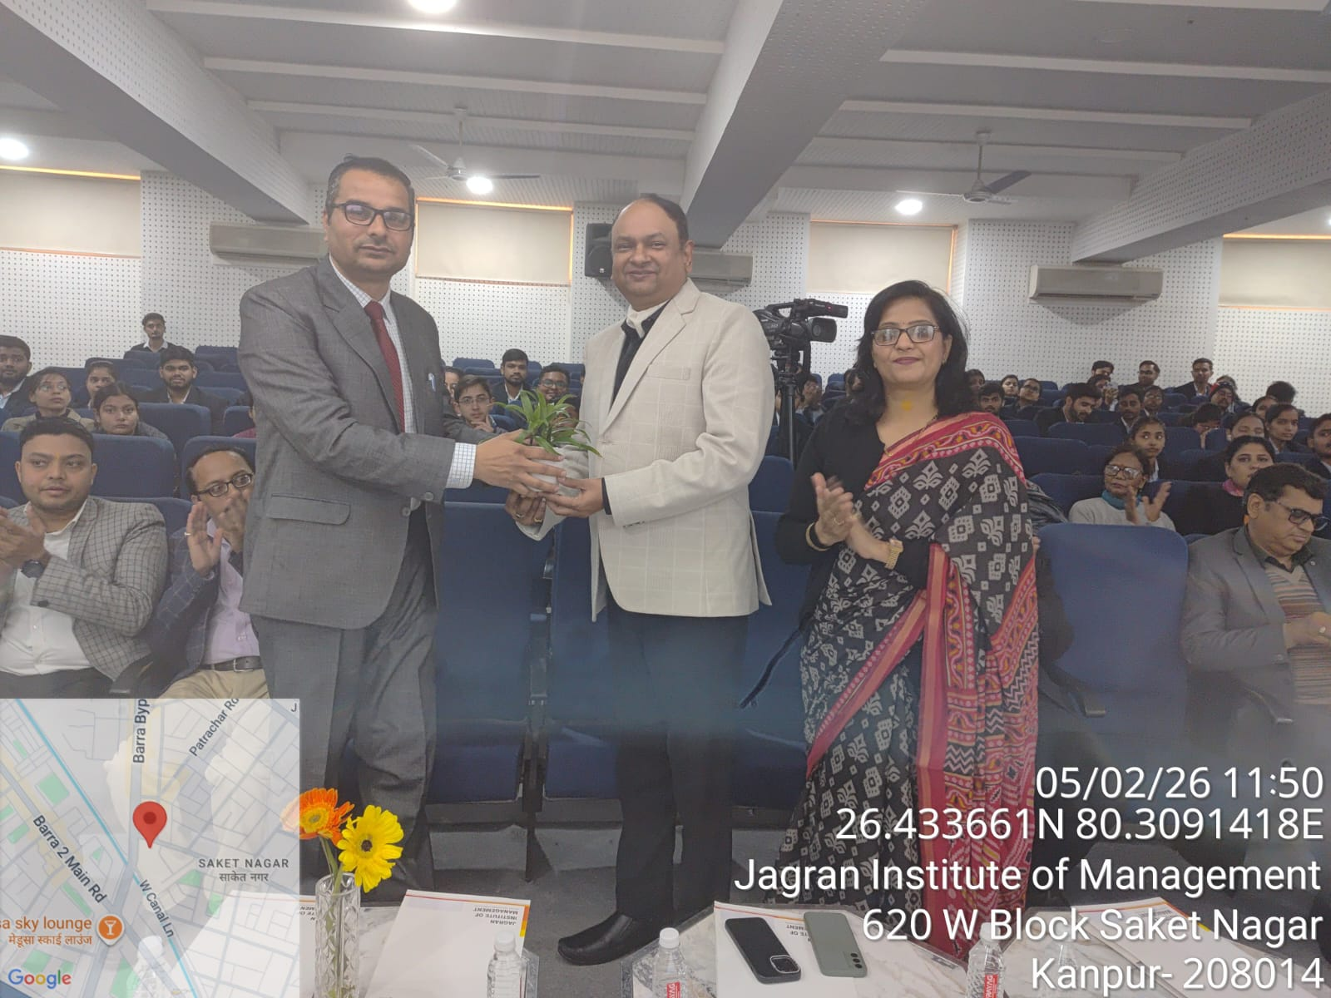

Facilitate to guest CA Govind Maheshwari

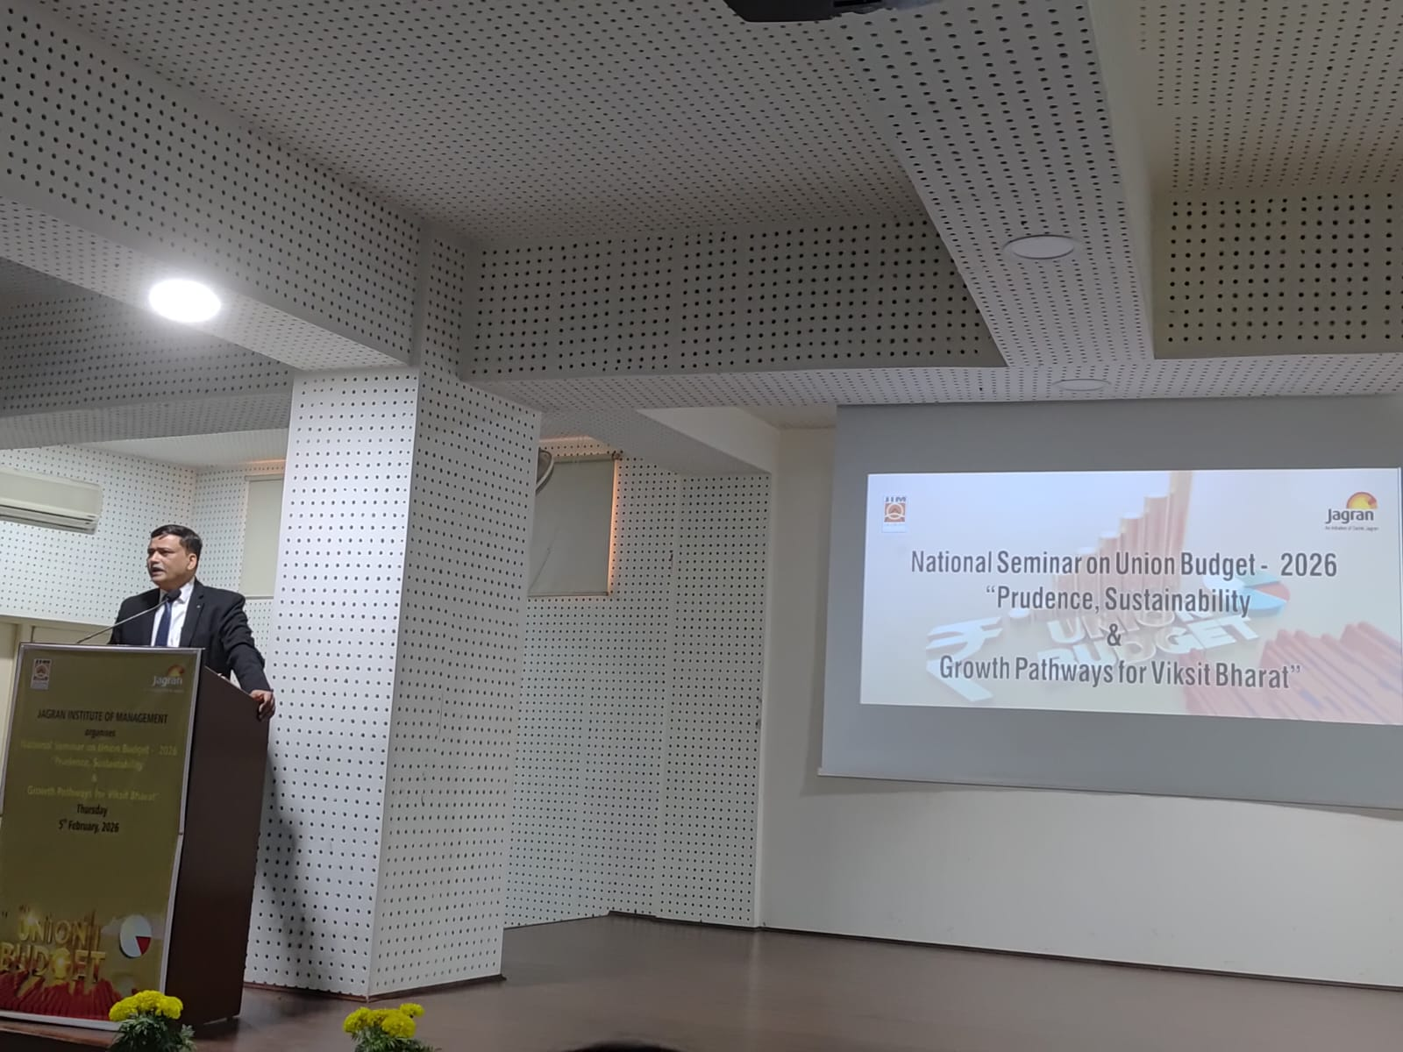

CA Dharmendra Kumar Srivastava address the gathering

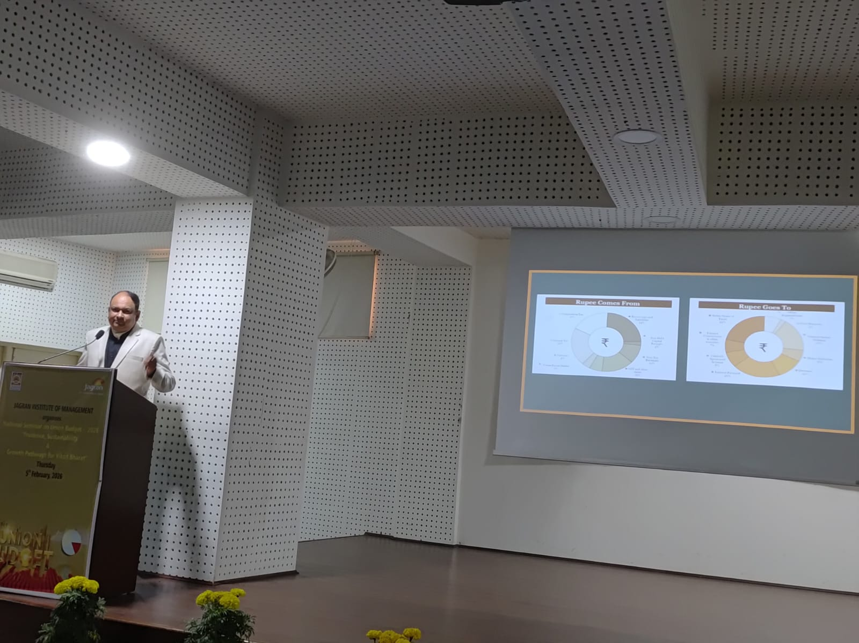

CA Govind Maheshwari address the gathering

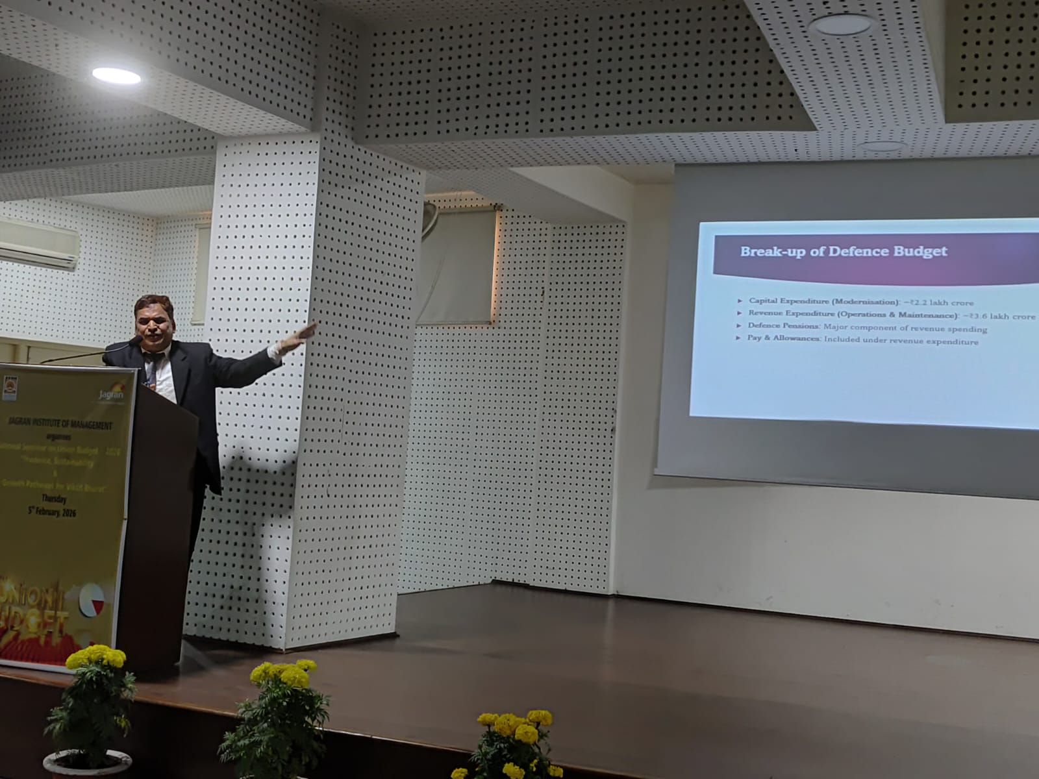

CMA CS Ajai Kumar Sharma address the gathering

Press Coverage

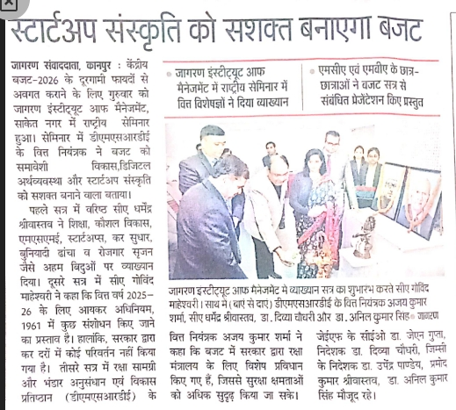
Dainik Jagran Newspaper (6th February 2026)

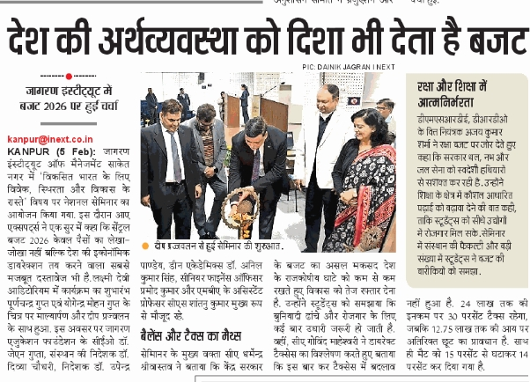
i Next Newspaper (6th February 2026)

