WEB REPORT ON JIM QUEST-2025

Event: JIM Quest 2025
Date & Time: Monday, 27th October 2025
Faculty Coordinator: Ms. Priya Chopra Arora and Mr. Pawan Omer
Venue: Laxmi Devi Auditorium
Participants: Graduating students from reputed Colleges & Institutes of Kanpur

Jagran Institute of Management organized the 10th edition of JIM Quest on Monday, 27th October 2025. JIM Quest is an innovative and interactive knowledge contest designed to promote the exchange of ideas through engaging and intellectually stimulating quiz rounds. Over the years, the event has earned widespread appreciation and witnessed enthusiastic participation from various colleges across Kanpur.
The event commenced with the lighting of the ceremonial lamp by Dr. Divya Chowdhry (Director, JIM), Dr. Anil Kumar Singh (Dean Academics), and the esteemed faculty members. This was followed by a virtual tour of the JEF film. This year’s edition featured quiz rounds based on diverse themes such as General Awareness, Corpolite, Brandolite, and Epithetolite, making the competition both enriching and exciting for the participants.
Sneha Gupta, an MBA First-Year student, briefed the participants and audience about the rules and regulations of the event. A total of seven teams participated in “JIM Quest 2025,” which comprised four competitive rounds — Famous Monuments, Corporate Brand Visuals, Taglines, and General Awareness. The participating teams represented various reputed colleges of Kanpur, including PPN College, Maharana Pratap College of Professional Studies, Kanpur Institute of Technology, Jagran Institute of Management and Mass Communication and Jagran College of Arts, Science and Commerce. The objective of these rounds was to assess and showcase the participants’ knowledge, analytical abilities, and overall intellectual acumen.
Both the participants and audience members displayed remarkable enthusiasm and zeal, contributing to the lively and engaging atmosphere of the event.
Upon the successful completion of all the rounds, Poorna Singh Rathore and Saiyma Aziz from PPN Degree College, Kanpur emerged as the winners of JIM Quest 2025, securing a cash prize of ₹3,000.
The 1st Runner-up position was bagged by Dhruv Hada and Aditya Raut from Jagran College of Arts, Science and Commerce, who received a cash prize of ₹1,500. The 2nd Runner-up team, comprising Ankit Tiwari and Priyanka Gupta from Jagran Institute of Management and Mass Communication, was awarded a cash prize of ₹1,000, along with certificates and trophies.
Dr. Divya Chowdhry (Director, JIM) and Dr. Anil Kumar Singh (Dean Academics), along with the faculty members presented cash prizes, trophies, and certificates to the winning teams. The program was efficiently conducted by Assistant Professors Ms. Priya Chopra Arora and Mr. Pawan Omer.
Students from MBA and MCA actively participated in organizing, coordinating, and executing various event activities. The event concluded with a group photo session featuring all the faculty members, dignitaries, and participants from the participating colleges, marking a memorable end to JIM Quest 2025.
Glimses of the Event

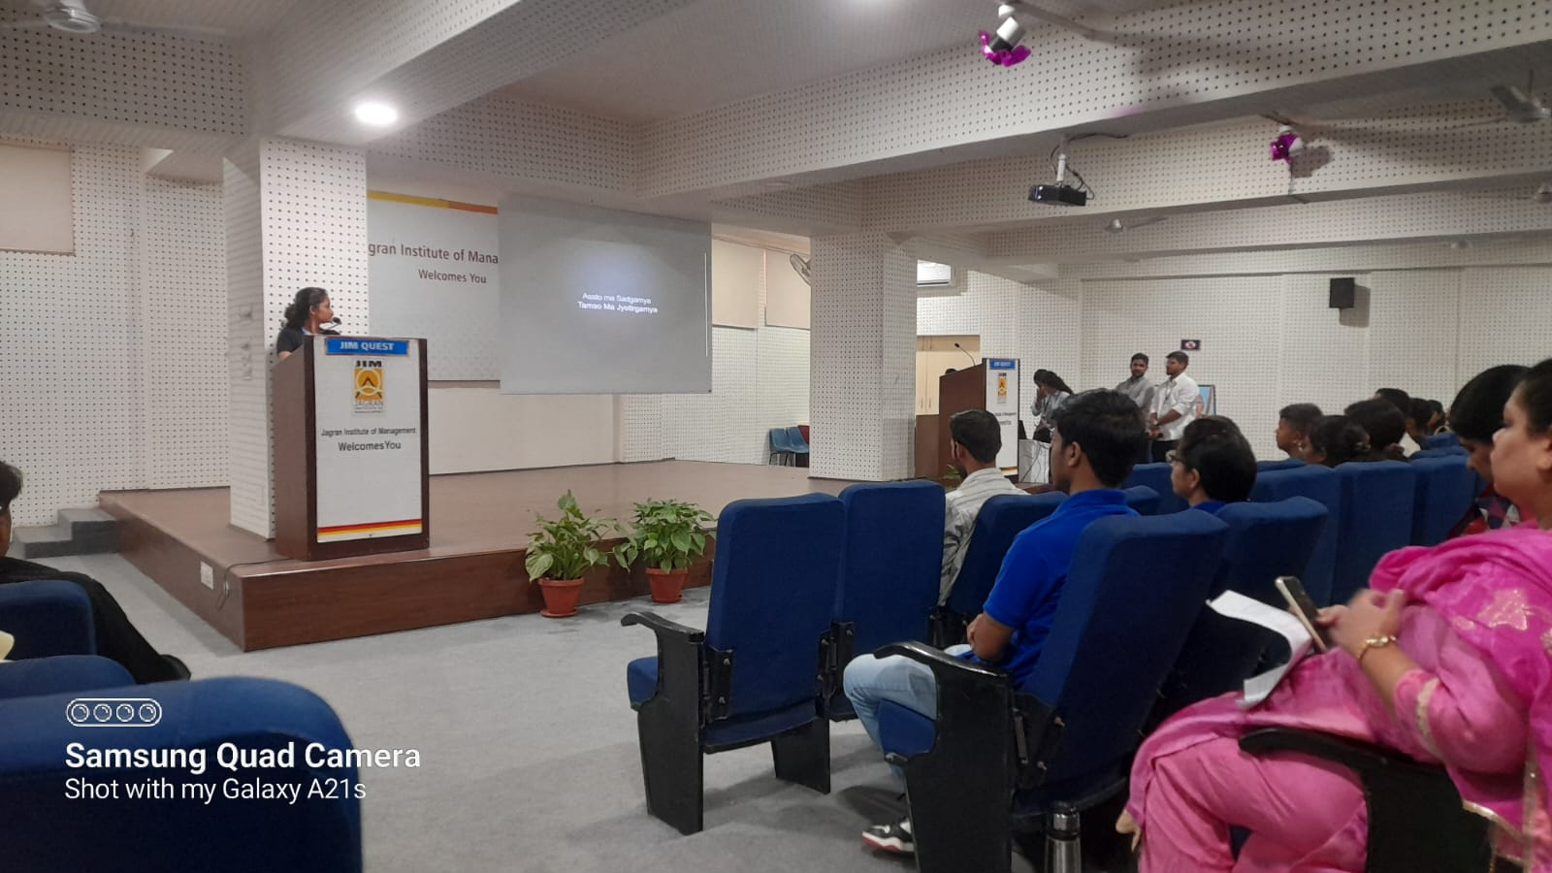

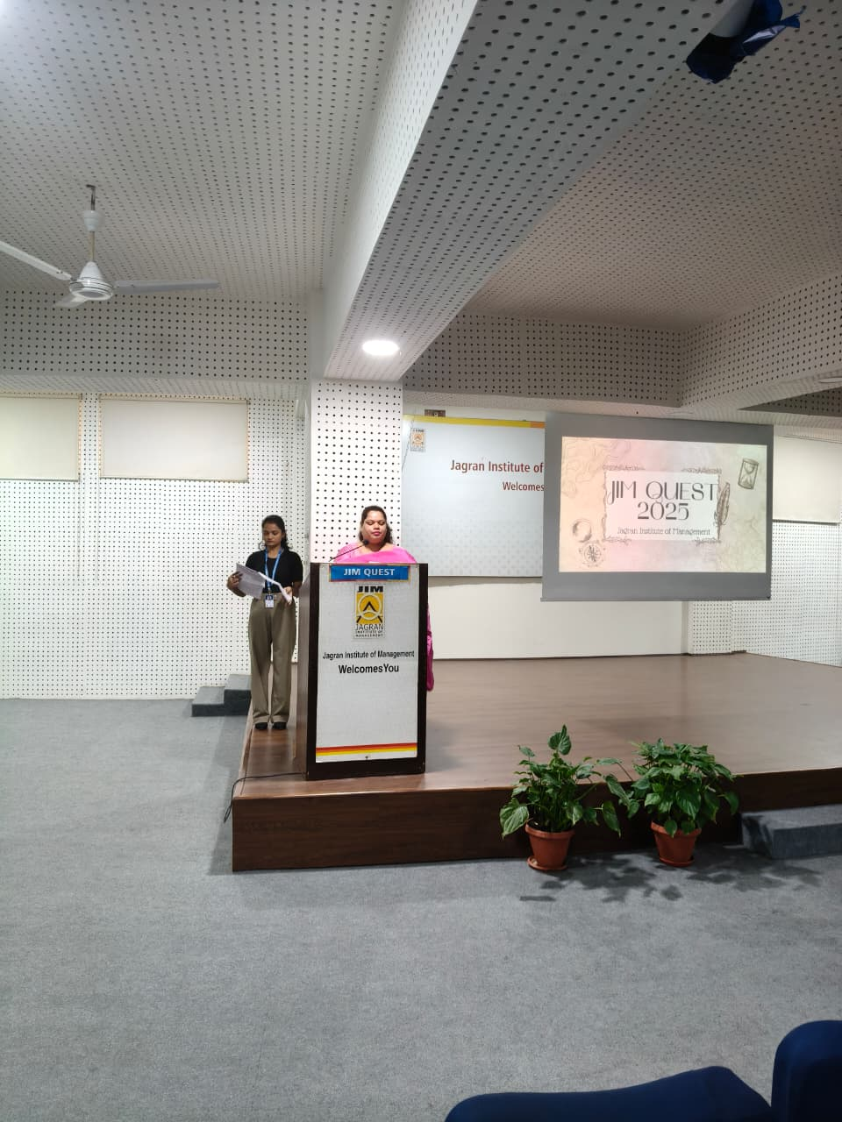
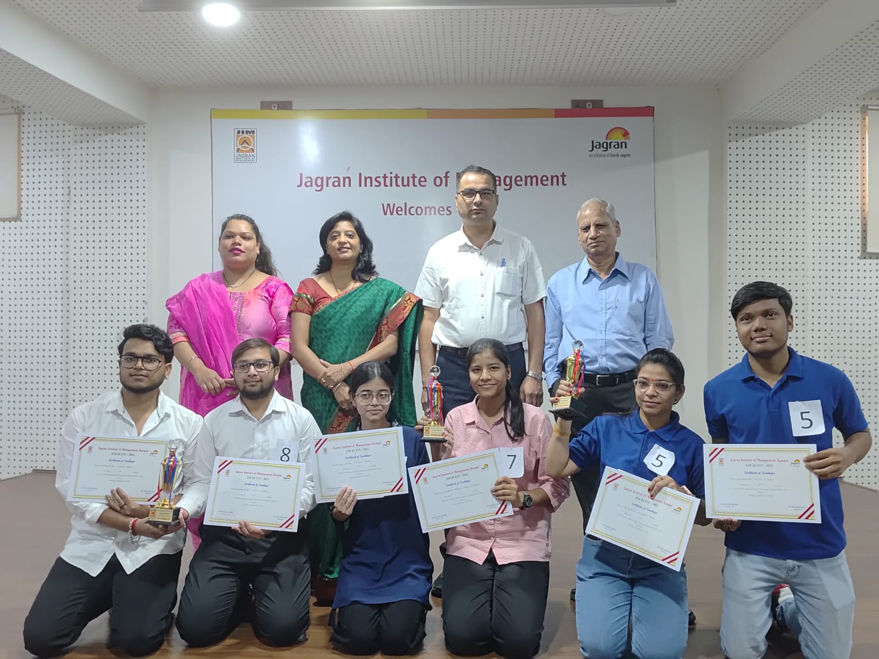
Winner of JIM QUEST -2025

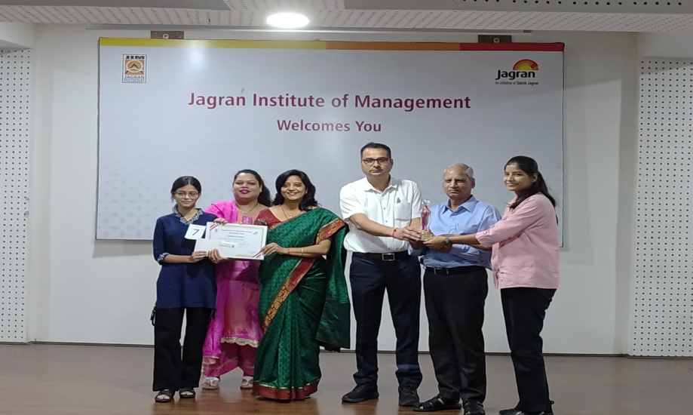
Winners of JIM QUEST -2025
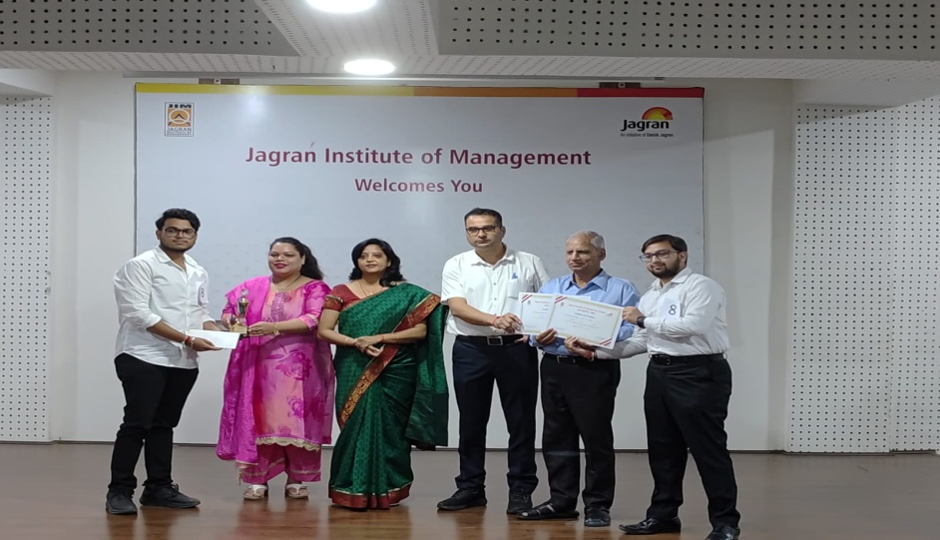
1st Runner up of JIM QUEST -2025
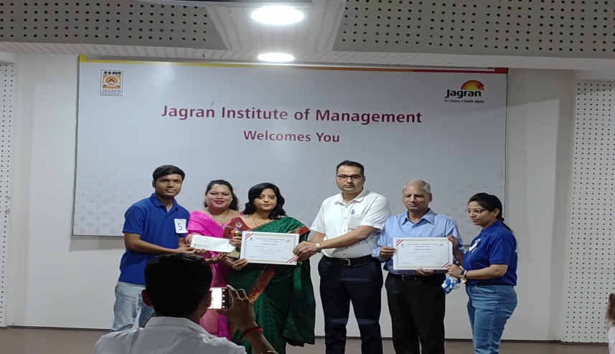
2nd Runner up of JIM QUEST -2025
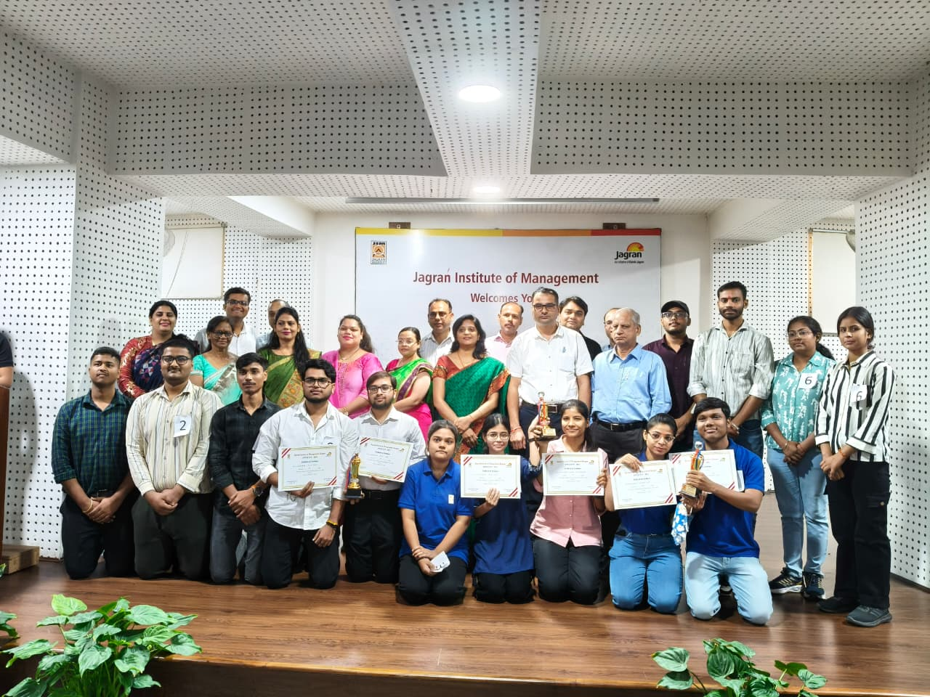
Participants at JIM QUEST - 2025
Media Coverage
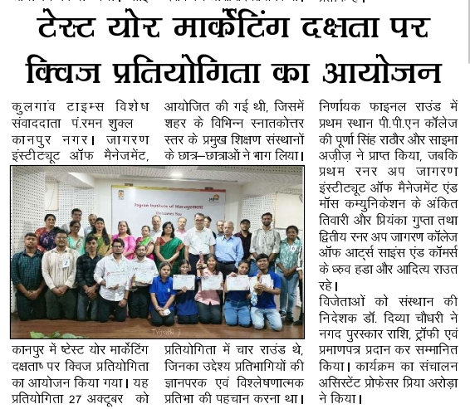
News Coverage of JIM Quest 2025 in Kulgaon Times
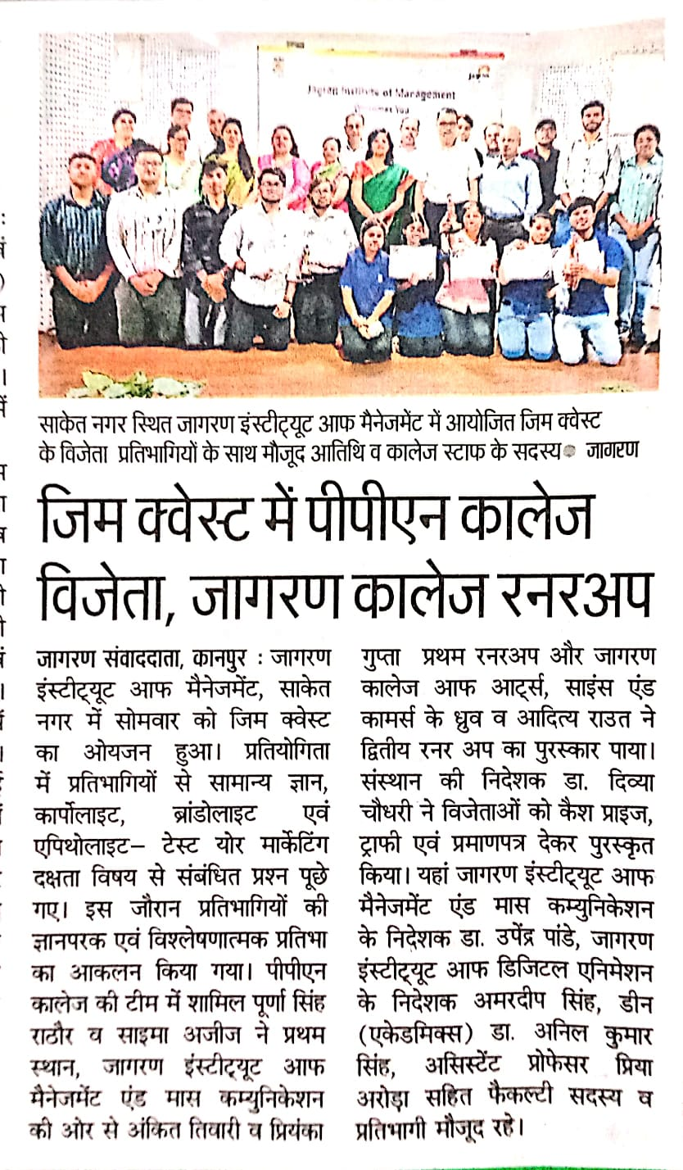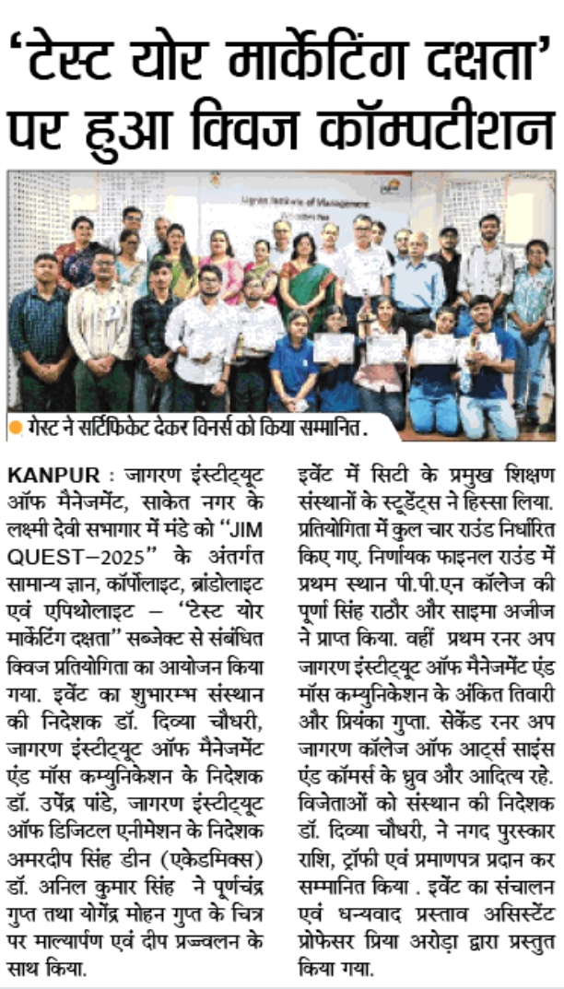

Dainik Jagran Newspaper Coverage of INEXT Newspaper Coverage of
JIM QUEST-2025 JIM QUEST-2025

