Web Report

Event: Fresher Party - 2025
Date & Time: Saturday, 11th October, 2025 & 11 a.m. onwards
Venue: Auditorium
Coordinator: MCA & MBA-2nd Year Students
Participants: All juniors and seniors of MCA & MBA

The 11th October 2025, was marked as a memorable day in the life of every fresher at Jagran Institute of Management students, Kanpur. Fresher’s party was a gracious and a cordial welcome by the second year students to the first year students. It is an event where fresher’s are not only given a chance to exhibit their talents but also feel comfortable and adapt to the new surroundings. The Fresher’s day was a day that was filled with excitement, joy, music, enthusiasm, laughter and happiness.
Akshat Sir and Adarsh Sir were the faculty coordinator for the event. The celebration started at 11.00 am by giving surprise gift to all the juniors at the entrance along with the Dhol. Students took some refreshments and settled at their seats. The program started by offering the flowers to Maa Saraswati that was further followed by Ganesh Vandana which was performed by a group of seniors to seek the blessings of lord Ganesh. Senior students arranged many activities for fresher’s which include cultural events where everyone got chance to showcase their talent.
After that several dance performances, singing and games were conducted and presented by senior students to fill the party with more fun. The program kick-started with all the participants elegantly dressed and briskly walked on the ramp.
The participants for Mr. and Miss. Fresher’s were selected by the judges based on various rounds. The first round for the selected students was the ‘Fashion Show’ which was judged by our esteemed by faculties of the institute. The second round was ‘Question-Answer round’ where they had to execute their talent by the judges based on their Talent. The judgment was based on the performing style and speed of the participant. The results were finally declared by the judges.
Ms. Sanskriti Gupta and Mr. Bhaskar Tripathi won the titles of Ms. Fresher and Mr. Fresher respectively. There were two more titles, Ms. Eve and Mr. Eve, which was won by Ms. Sapna Tiwari and Mr.Karan Dubey.
The other awards given were best performer award which was given to Ms Monika Rajput.
The winners were crowned by Director Prof. (Dr.) Divya Chowdhry along with the judges Prof. (Dr.) Anil Kumar Singh; their presence was highly motivating for all.
All awards were given by the jury to the concern students, including sachets and gifts for Mr. and Mrs. Fresher. The Fresher’s party was filled with joy and happiness and was very well organised, conducted & performed by 2nd MBA & MCA students.

Glimpses of the Event
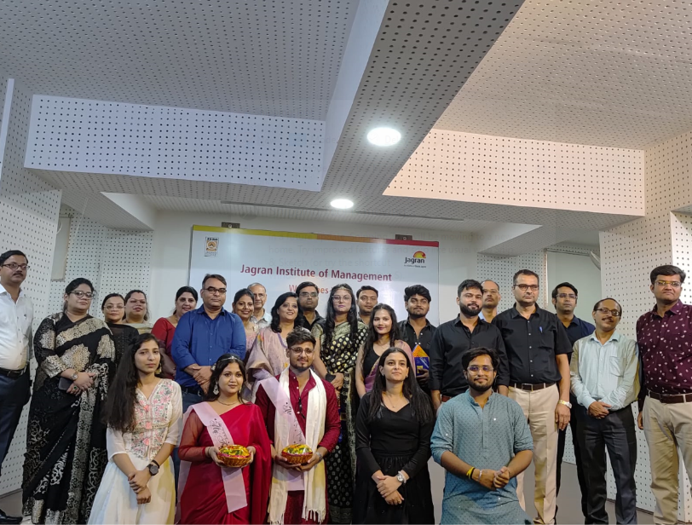
Miss and Mr Fresher 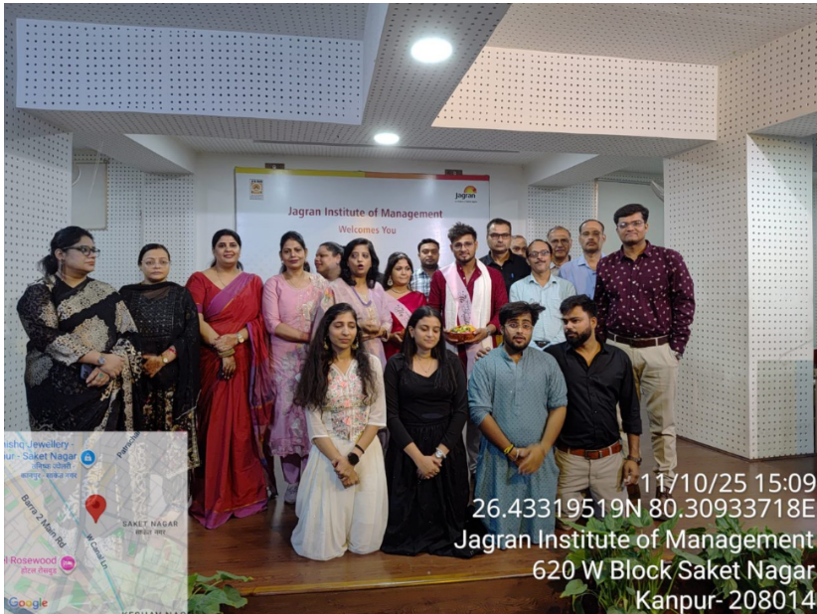

Press Coverage

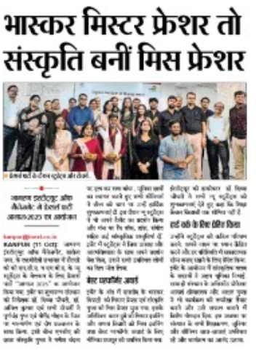
I-Next news Coverage
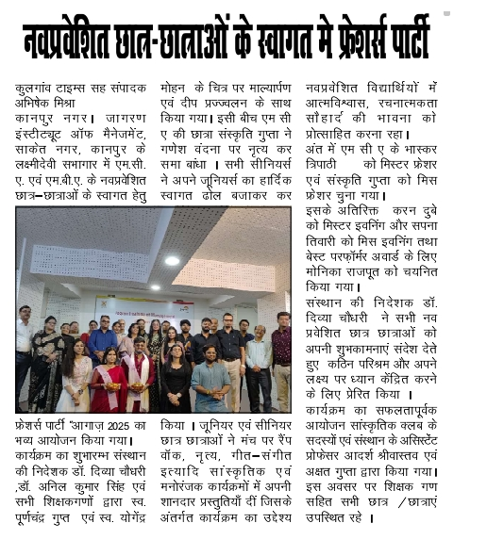

News paper Coverage – Kulgaon Times News Coverage

