Farewell - 2026

Event: Farewell Party 2026 – “Echoes”
Date & Time: Saturday, 6th June, 2026
Venue: Lakshmi Devi Auditorium - JIM Campus
Coordinator: Mr. Adarsh Srivastav
Participants: Students from both the Junior and Senior batches of the MCA and MBA.
“Every new beginning comes from some other beginning's end”.
June 6, 2026, became an unforgettable day for every MBA and MCA senior at Jagran Institute of Management, Kanpur, as the farewell celebration overflowed with excitement, joy, music, enthusiasm, laughter and heartfelt moments.
Jagran Institute of Management, Kanpur, bid a heartfelt farewell to its outgoing MBA/MCA batch of 2024–2026 with an evening filled with emotion, celebration and reflection. The event, held at the institute’s auditorium, was organized by the first-year MBA/ MCA students under the guidance of faculty members and saw enthusiastic participation from students, staff, and invitees.
The farewell themed “Echoes”, began at 03:00 PM with the traditional lamp lighting ceremony, followed by a soulful Ganesh Vandana performed by a Senior Ms. Mahi Mishra to invoke the blessings of Lord Ganesha. The event was graciously hosted by Mr. Himanshu, Arpit and Ms. Subhanshi, who kept the audience engaged throughout. The program commenced with participants dressed elegantly, ready to showcase their talents.
The celebration continued with a lively blend of dance and singing performances, poetry recitations, and interactive games, all spiritedly presented by enthusiastic volunteers, filling the evening with joy and excitement.
The atmosphere turned deeply nostalgic as a series of cultural acts including music, dance, and heartfelt poetry were lovingly dedicated to the graduating students. A touching video montage showcasing memorable moments from classrooms, college events and everyday campus life stirred emotions, bringing both laughter and tears to the audience.
As part of the tradition, titles and tokens of appreciation were presented to the seniors, adding a sentimental touch to the occasion. This was followed by the much-anticipated “Mr. and Ms. Farewell” contest, which brought an element of fun, charm, and elegance to the evening.
The title of Mr. Farewell was awarded to Mr. Prajjwal Shukla from MBA, while Ms. Shrestha Jain proudly earned the title of Ms. Farewell, both honored for their outstanding presence and spirited journey throughout their time at the institute.
Additionally, the title of Mr. Evening was claimed by Prabhat from MCA, and Ms. Evening was awarded to Ms. Archita Agnihotri from MBA. The title of Perfect Senior was claimed by Ms. Mahi Mshra. . Many students also seized the moment to share heartfelt messages and express their gratitude towards their mentors and peers during an emotional open mic session.
In their speech, the student representative of the outgoing batch, shared, Jagran Institute of Management has been more than just an institute; it has been a home, a launchpad and a family. We leave here with not just knowledge but lifelong bonds.”
The event concluded with an evening full of dance, laughter, and a lively DJ night, where students danced their hearts out, treasuring their final moments together on campus.
The farewell signified not just the conclusion of an academic chapter, but the beginning of exciting new journeys ahead. The Jagran Institute of Management community whole heartedly extended its best wishes to the outgoing batch as they step into their professional lives with confidence, determination, and integrity.

PHOTOGRAPH

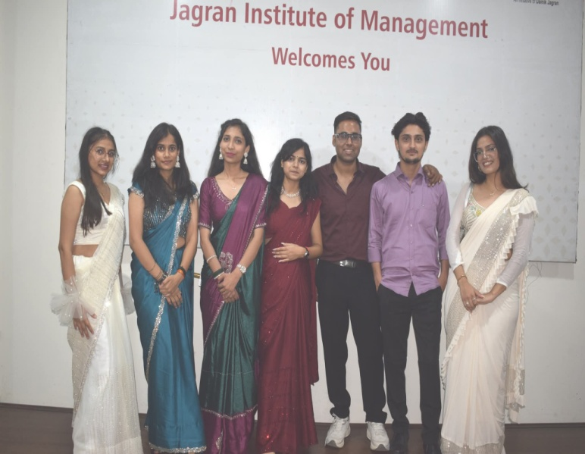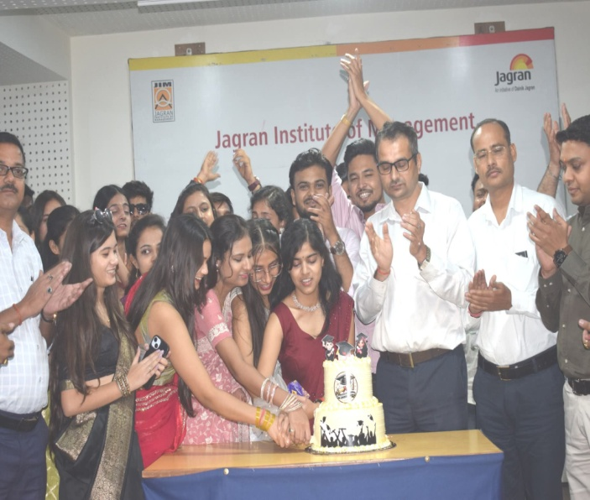

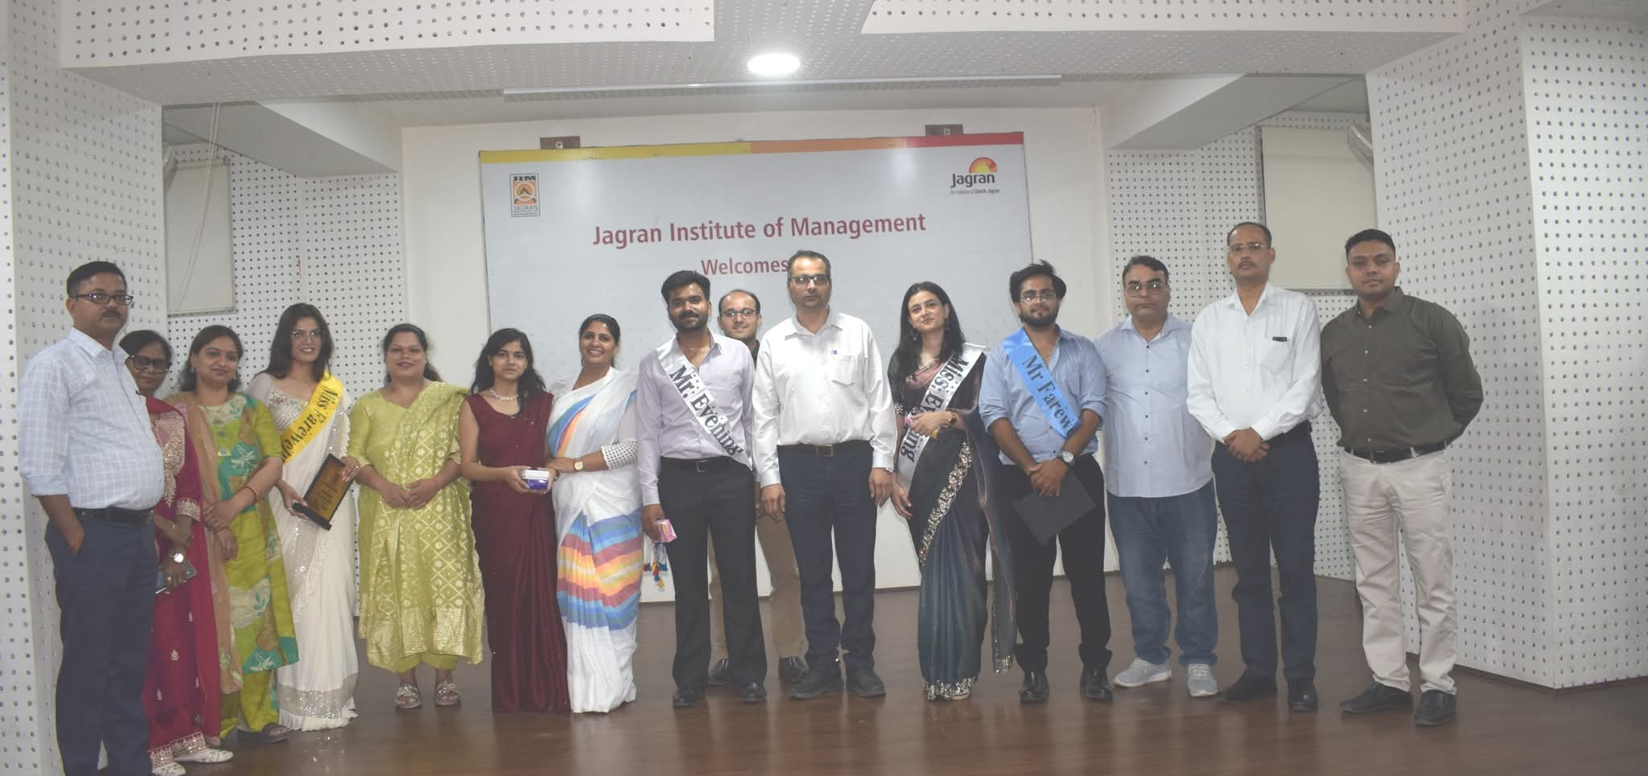

NEWS PAPER COVERAGE

