Three day FDP on “Universal Human Values”
Resource Persons: Mr. Alok Kumar Pandey, Shri. Pankaj Kumar Yadav, Dr. Indu Prabha Singh.
Event coordinator: Mr. Aman Kesharwani
Date and Place: 6th, 7th and 8th August, 2025, Jagran Institute of Management, Kanpur
Day-1 - Topic: Basic human aspirations and its fulfillment
Basic human aspirations are the fundamental desires that shape people’s lives and drive their actions. They include the pursuit of happiness, security, love, and respect. Every individual aspires to live a life of dignity, free from fear and want. Education, good health, meaningful work, and a supportive community form the foundation of these aspirations. Beyond material needs, people seek personal growth, peace of mind, and the freedom to express themselves. These aspirations unite humanity across cultures, inspiring progress and cooperation. By fulfilling basic human aspirations, societies create conditions where individuals can thrive and contribute to the well-being of all.
The combination of right understanding, relationship, and physical facilities should be based on their correct priority to fulfill basic human aspirations. Right understanding comes first because it enables individuals to accurately identify needs, make wise decisions, and develop meaningful perspectives on life. With right understanding, one can foster healthy and fulfilling relationship, which is essential for emotional well-being, mutual happiness, and societal harmony. Physical facilities, such as food, shelter, and resources, are necessary for comfort and survival, but they should be prioritized last, as their optimal use and requirements are clarified by right understanding.
The correct sequence is:
Right Understanding → Relationship → Physical Facilities
- Right Understanding
  - This means having clarity about the self, human values, and the purpose of life.
  - Without it, relationships and use of resources can be misguided.
  - It forms the foundation for everything else.
- Relationship
  - With the right understanding, we naturally develop trust, respect, and affection in our relationships.
  - Healthy relationships reduce conflict and create harmony in the family and society.
- Physical Facilities
  - These are material resources to fulfill bodily needs.
  - When relationships are harmonious, physical facilities are used wisely—not as a substitute for happiness, but to support well-being.
Day-2 - Topic : Source of motivation for our imagination and its implications
The source of motivation for our imagination is mainly our basic aspiration for continuous happiness and prosperity.

1. Source of Motivation
- Every thought, plan, or dream we create in our imagination is driven by our desire to live happily and to feel secure.
- This aspiration influences the content of our imagination—what we think about, how we set goals, and what actions we take.
- The motivation can come from two places:
  - Right Understanding → leads to harmony, long-term well-being.
  - Preconditioning (beliefs, social influence) → may lead to short-term excitement but long-term conflict or dissatisfaction.

2. Implications
- If driven by Right Understanding:
  - Imagination supports sustainable happiness.
  - Leads to mutual trust in relationships and responsible use of resources.
  - Actions are ethical, inclusive, and in line with human values.
- If driven by Wrong Understanding or Preconditioning:
  - Imagination can result in unrealistic desires, competition, and stress.
  - May lead to exploitation of others and overuse of physical facilities.
  - Short-term pleasure but long-term unhappiness.
Essentially, the quality of our imagination—and its results—depends on whether our motivation comes from a clear understanding of life or from borrowed, unchecked beliefs.
Day-3 - Topic: Harmony in Family, Society and Nature
Harmony in Family, Society, and Nature is a concept from Holistic Human Development that explains how a person can live in alignment with themselves, with others, and with the environment.

1. Harmony in the Family
- Basis: Relationship grounded in trust and respect.
- Core Idea: When family members understand each other’s needs and intentions, they work together instead of competing.
- Indicators of harmony in the family:
  - Open communication and mutual understanding.
  - Cooperation instead of conflict.
  - Caring for each other’s physical and emotional well-being.

2. Harmony in Society
- Basis: Extending the same values (trust, respect, affection) from family to the larger community.
- Core Idea: When families are harmonious, they collectively contribute to a peaceful society.
- Steps towards harmony in society:
  - Justice in relationships (identifying rights and duties clearly).
  - Mutual fulfillment of needs through cooperation, not exploitation.
  - Ensuring equity and participation for all.

3. Harmony in Nature
- Basis: Understanding the interdependence of humans, animals, plants, and the environment.
- Core Idea: Using natural resources responsibly so they remain available for future generations.
- Indicators of harmony in nature:
  - Sustainable agriculture and resource management.
  - Avoiding pollution and waste.
  - Maintaining balance in ecosystems.

Overall Connection
- Right Understanding → builds harmony in the family.
- Harmonious families’ → create harmony in society.
- A just and peaceful society → lives sustainably, leading to harmony in nature.

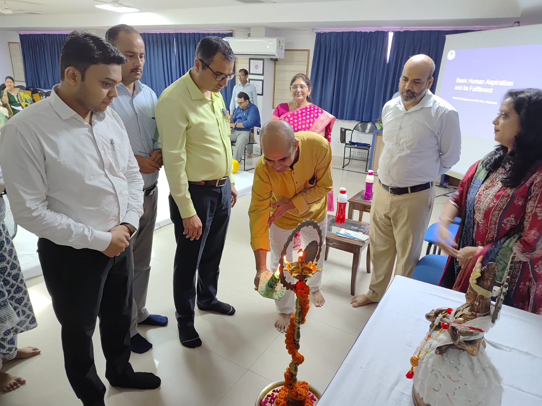
Lamp Lighting by the dignitaries
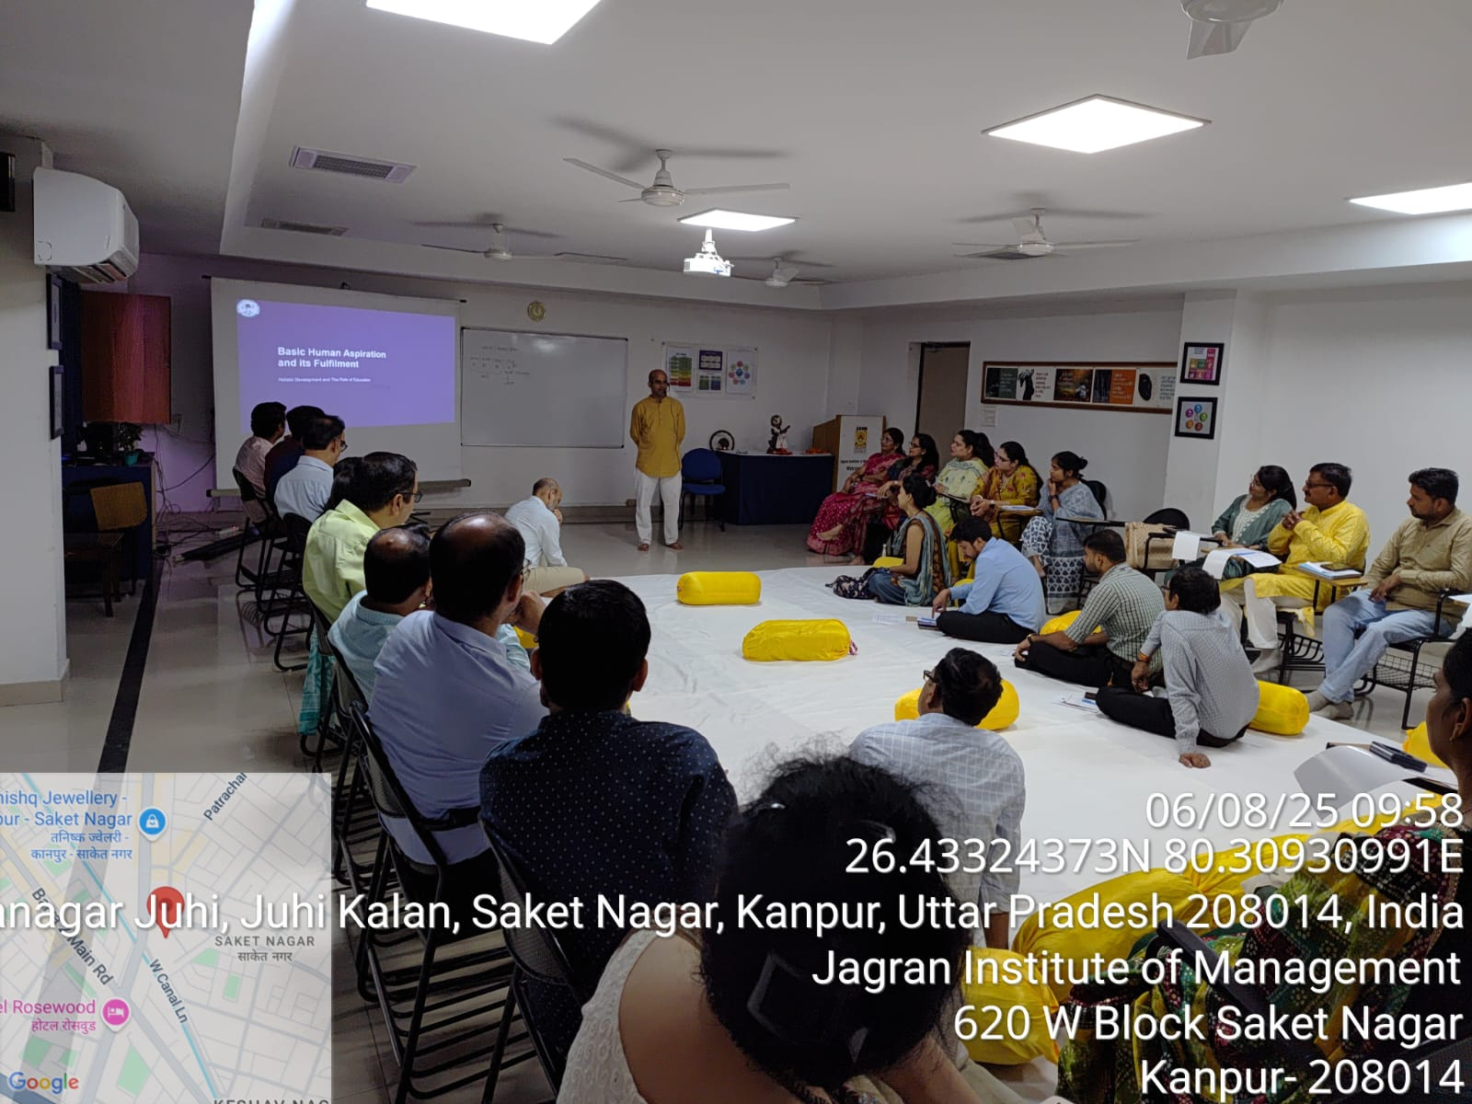
Session taken by Mr. Alok Kumar Pandey
Session on Day-2
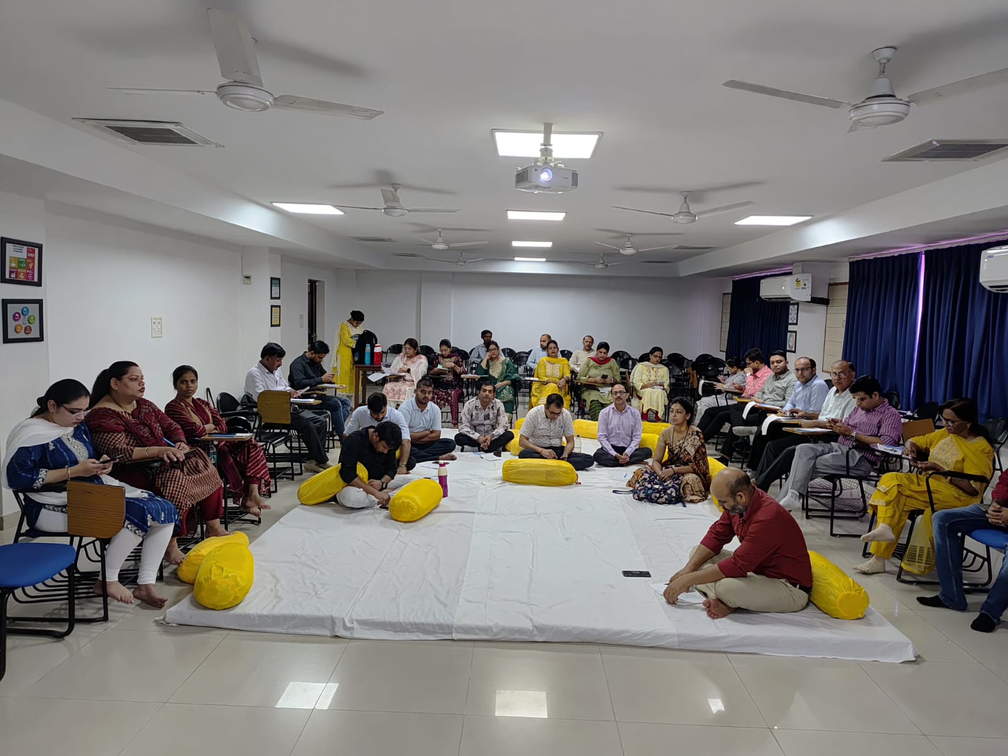

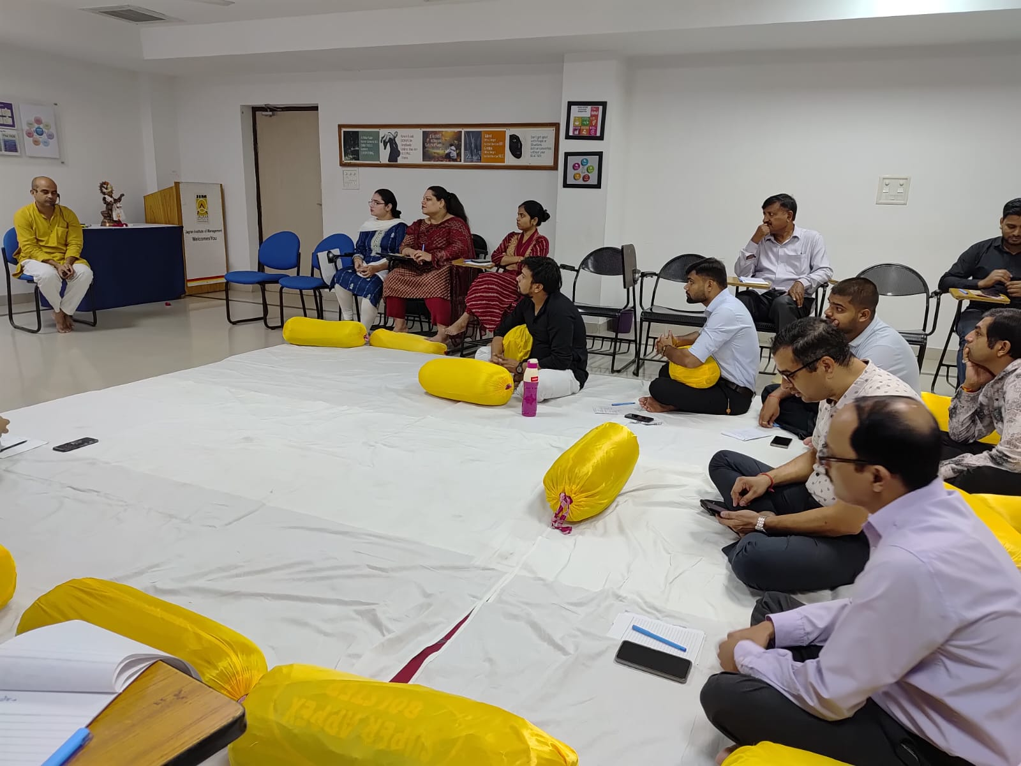

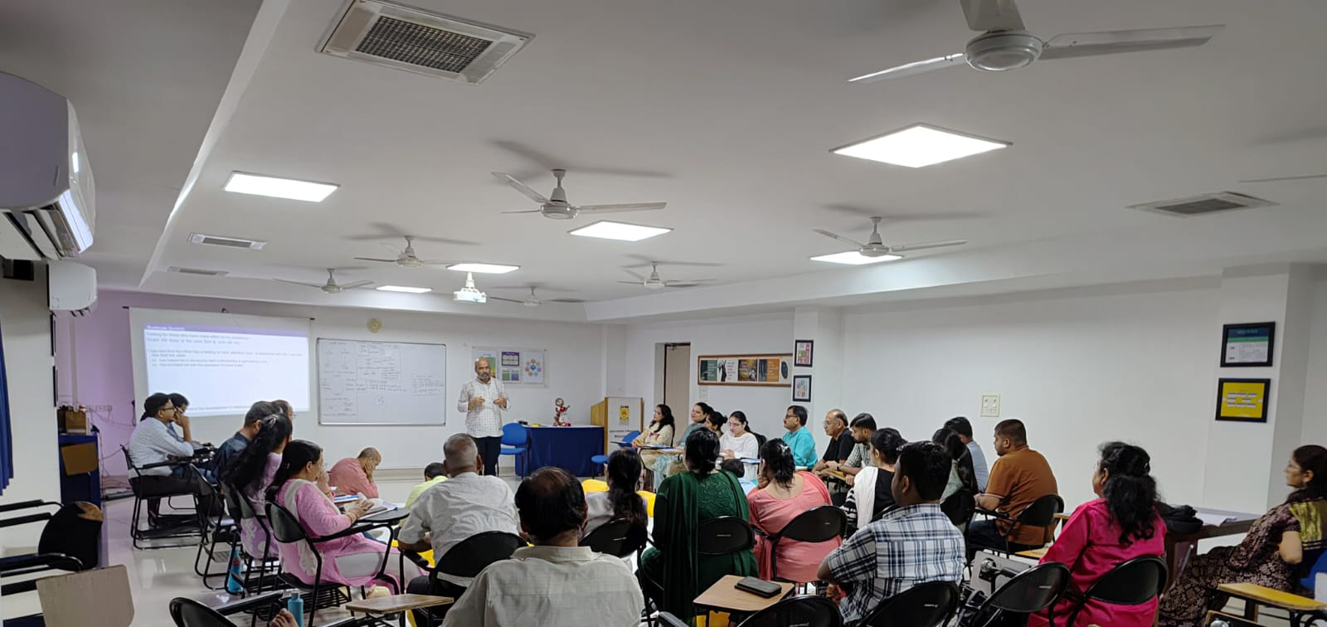
Session on Day-3
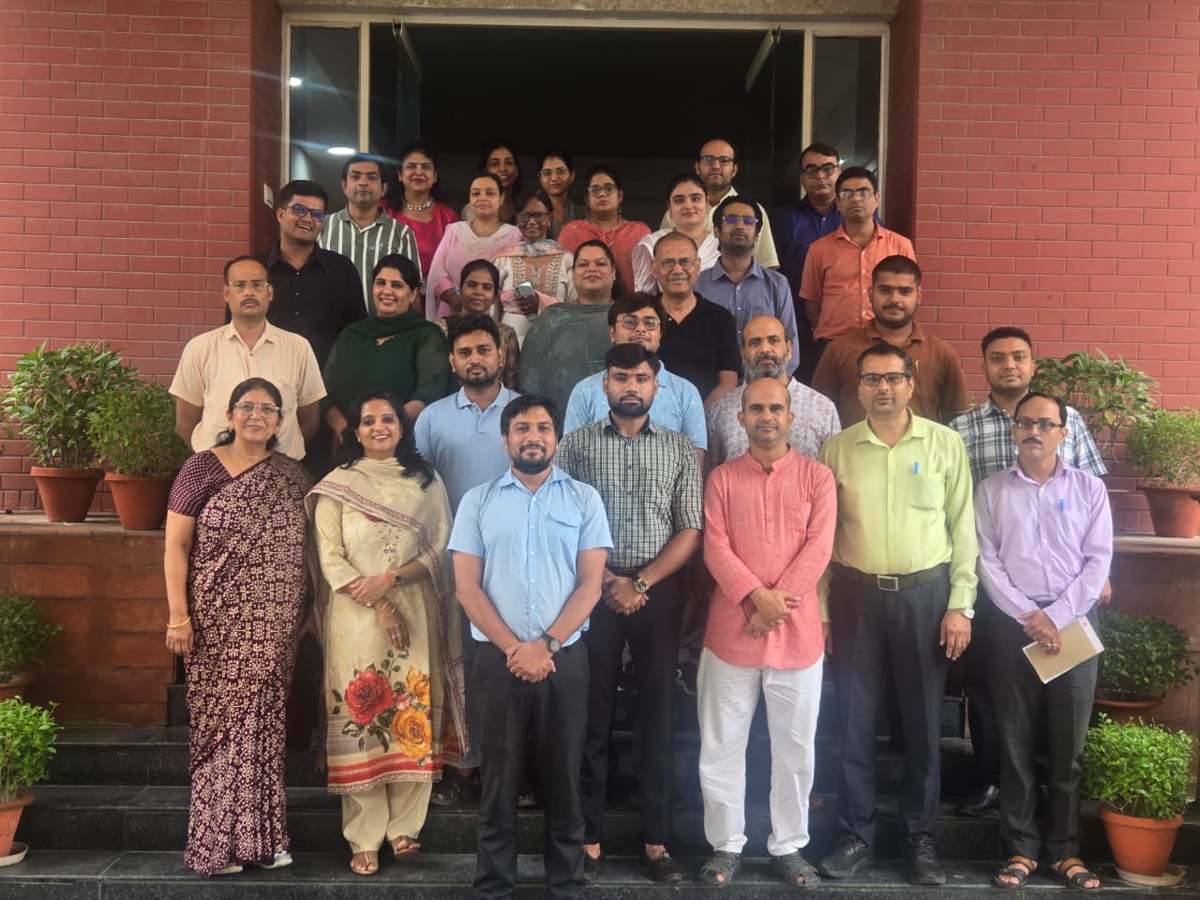
Group Photograph of Participants

Press Release
