JAGRAN INSTITUTE OF MANAGEMENT
Two-Day Ceremony
Convocation & Orientation Ceremony - 2025
August 26th & 27th, 2025

Jagran Institute of Management is delighted to host its grand two-day 18th Convocation and 19th Orientation Ceremony on August 26th & 27th. This special occasion is a blend of celebration and inspiration — as we honor the achievements of our graduating students during the Convocation and simultaneously welcome the new batch of MBA and MCA students with warmth and enthusiasm during the Orientation. The event symbolizes both the culmination of hard work and the beginning of new journeys, truly reflecting the spirit of growth, success, and transformation at JIM. The Chief Guest for the occasion was Prof. Manuka Khanna (vice chancellor-university of Lucknow), with other members of the governing council Chairman Dr. Mahendra Mohan Gupta, Vice-Chairperson Mrs. Ritu Gupta, CEO Dr. J.N. Gupta & Director Jagran Institute of Management Dr. Divya Chowdhry together with the staff, students, their parents and media.
The Two-Day Convocation & Orientation Ceremony event was inaugurated with the academic procession of the JIM faculty with the auspicious occasion of 18th Annual Convocation Mantra Uchharan by students, accompanied by the serene tradition lightning of the lamp in front of Goddess Saraswati by the dignitaries. Floral tributes were offered in reverence to the late visionaries – Late Shri Purnachandra Gupta Ji, Late Shri Narendra Mohan Gupta Ji, and Late Shri Yogendra Mohan Gupta Ji, whose enduring legacy continues to inspire generations. The welcome address was given by the Chairman Dr. Mahendra Mohan Gupta to encourage the students.

Director Dr. Divya Chowdhry presented the annual report of the institute wherein she included all the new developments that have happened in the past year. She discussed the progress of the institute as to the introduction of the new courses and live projects for the students. She emphasized on the skill development training which the students receive regularly. She also made note of the achievements of the faculty in the field of academics and of the students in the field of their recruitments with the names of their recruiting partners. The report also summarized the various academic and non-academic events which happened throughout the year.
The Director conferred the Degrees to the students of MBA and MCA respectively. The meritorious students were awarded with the Gold Medal, Silver Medal & Director Roll of Honor by the Chairman and the Chief- Guest.

Chairman Gold Medal MBA Chairman Gold Medal MCA
MS. AKSHATA PRAJAPATI MS. JYOTI JOSHI
Chairman Silver Medal MBA Chairman Silver Medal MCA
MS. SHADMA QAIYOOM MS. BALPREET KAUR
Director’s Roll of Honor Director’s Roll of Honor
MS. NIKITA BAJPAI MS. NAMRATA SHIVHARE
MR. SHASHANK SHUKLA MS. HARSHITA NIGAM
MR. PRANAY OMER MS. IQRA RIAZ

We are also proud to share that some of our brilliant and talented meritorious students have secured top positions in Dr. A.P.J. Abdul Kalam Technical University merit list.

Ms.Ayushi Omar, MCA Batch 2023-2024 – 4th Position

Ms.Tanishqa Singh, MCA Batch 2023-2024 – 6th Position

Ms. Vaishnavi Awasthi, MCA Batch 2023-2024 – 9th Position

Their remarkable achievements are a reflection of their dedication, hard work, and academic excellence, bringing pride and glory to our institute.
The Chief Guest for the occasion was Prof. Manuka Khanna (vice chancellor-university of Lucknow),. She emphasized that true success lies not only in acquiring education but also in developing the strength to face life’s challenges with conviction. Prof. Khanna highlighted India’s role as a “Vishwaguru” and encouraged students to shape their careers by embracing artificial intelligence and emerging technologies in the fields of management and computer science. She further inspired the youth to engage in research and self-driven learning, while reminding them of their responsibility to become ideal citizens of India.
Session 2
Dr. Anil Kumar Singh, Dean-Academic Affairs briefed the new students about the examination and grading system. Mr. Ashish Mishra, Assistant Professor explained the general rules of discipline and code of conduct. Ms.Premlata Sharma Head Library explained the general rules of discipline and code of conduct for Library, Ms. Pratima Gupta, Head Training & Placement briefed students about internships, live projects, training and placement process in the institute.
In Alumni Talk, Mr. Prashant Sharma from MCA Batch 2017-2019 & Ms. Alima Akhtar from Batch 2020–22, were present to share their experience and motivated the newly admitted students.

The second day of the ceremony commencing with Ganesh Vandana, the ceremonial lamp lighting, and floral tributes. The Convocation & Orientation Ceremony was further graced by the presence of our esteemed Guest Speakers — Mr. Arunendra Soni, renowned Motivational Speaker & Life Coach, and Mr. Adhish Anand, System Integration Engineer & Defect Manager at Mercedes-Benz AG, Germany. Their valuable insights and inspiring words added immense significance to the occasion.
Mr. Arunendra Soni, delivered an inspiring address to our new students. His session focused on self-leadership, positivity, and unlocking individual potential, leaving students motivated to pursue excellence in both their academic and professional journeys.
Mr. Adhish Anand talked about Cross-cultural diversity becomes extremely important in education, corporate life, and international collaborations. Students who step into global workplaces often find that cultural sensitivity and adaptability are just as important as technical skills. For instance, what may be considered polite in one culture may appear overly formal or even distant in another.

Glimpses two-day Convocation and Orientation Ceremony

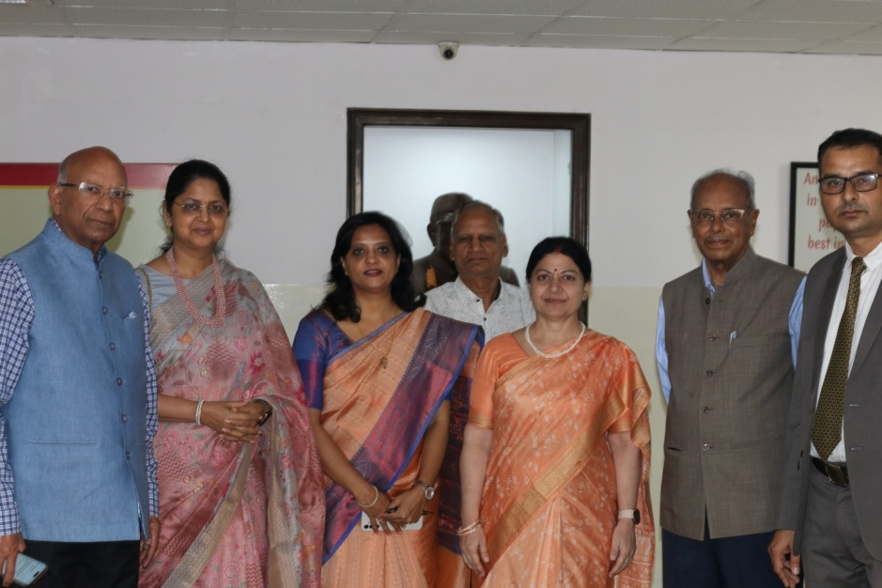
Dr. Mahendra Mohan Gupta & other dignitaries inaugurating the Two Day Conclave
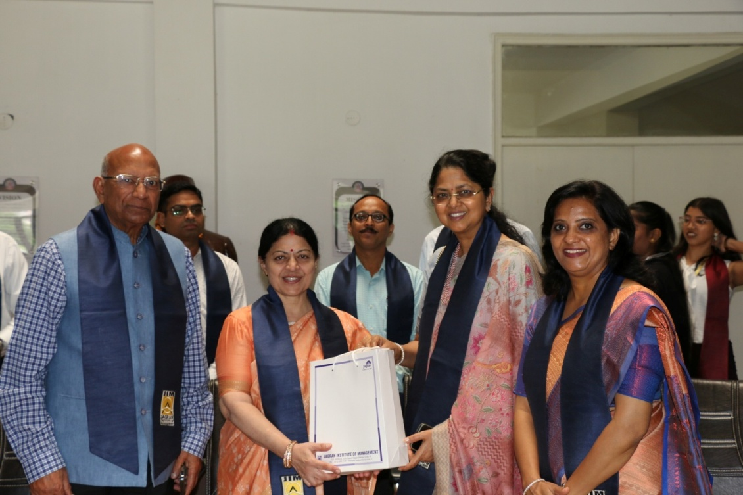
Presenting sapling & Token of gift to Chief Guest Prof. Manuka Khanna (vice chancellor-university of Lucknow), by the
Chairman Dr. Mahendra Mohan Gupta & Vice-Chairperson Mrs. Ritu Gupta

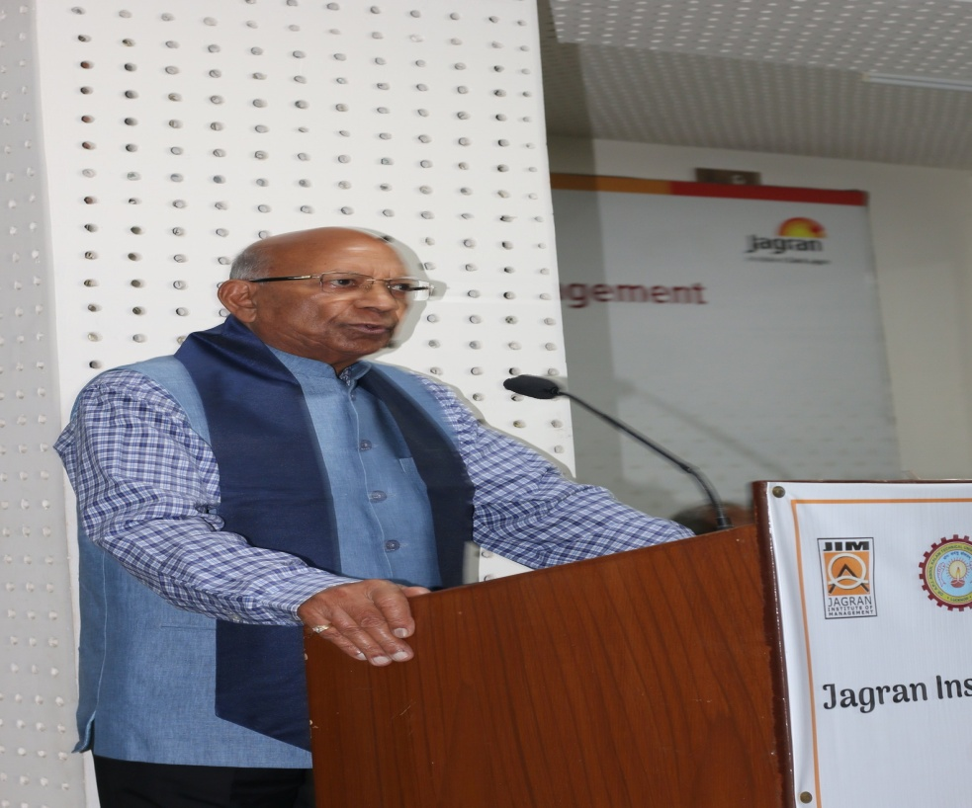
Welcome Address by the Chairman Dr. Mahendra Mohan Gupta
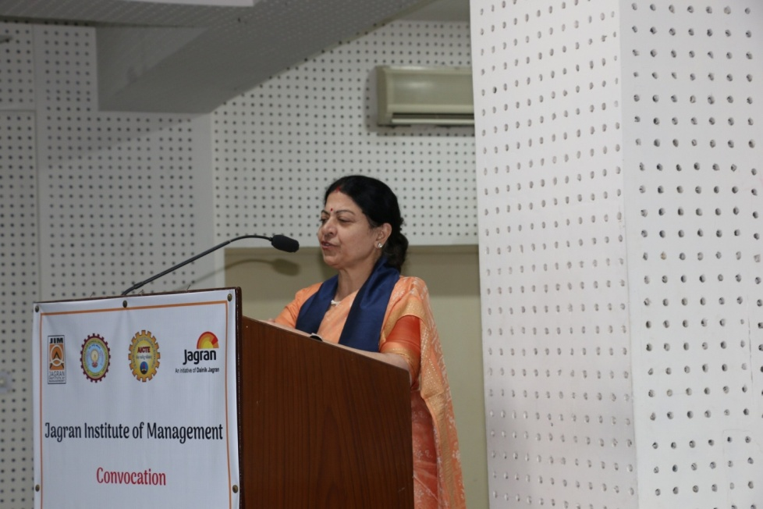
Convocation Address by the Prof. Manuka Khanna (vice chancellor-university of Lucknow)

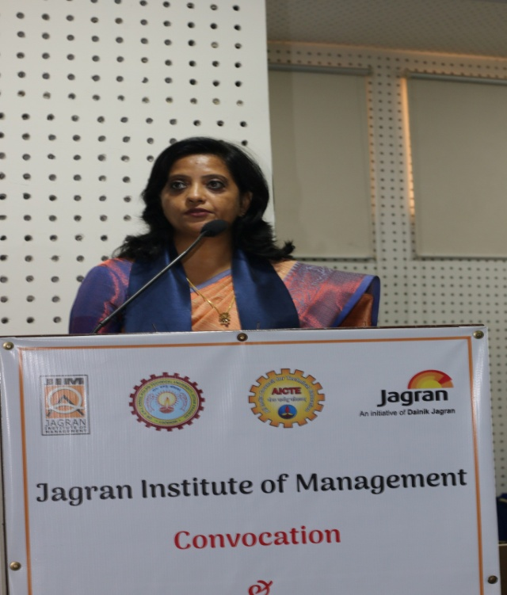
Annual Report Presentation by the
Director Dr. Divya Chowdhry

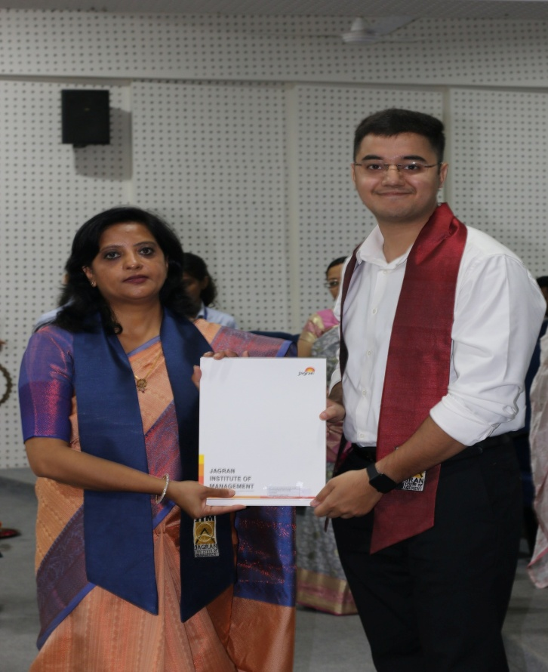

Degree Conferment by the Director
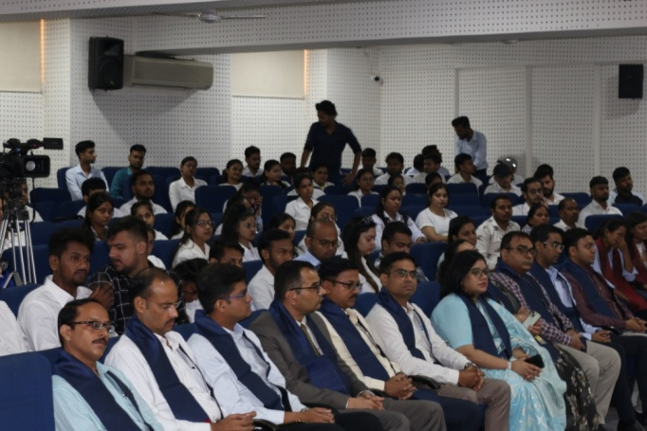
All Faculty Memebers with Students

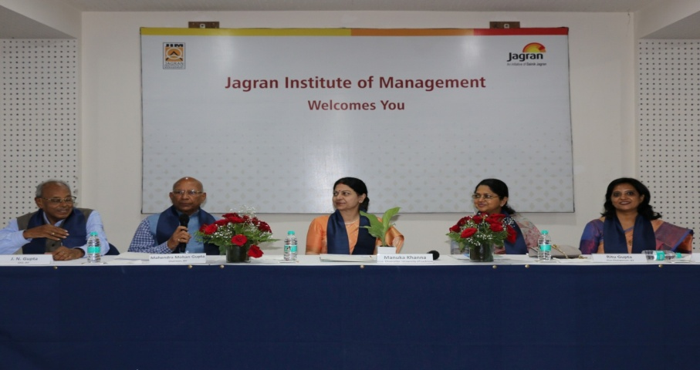
Declare Convocation open by the Chairman Dr. Mahendra Mohan Gupta

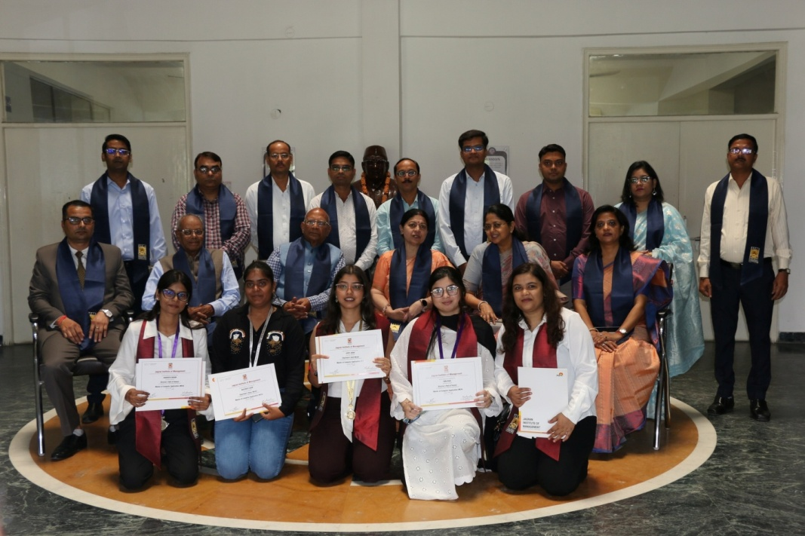
Awarded Degree with Dignitaries

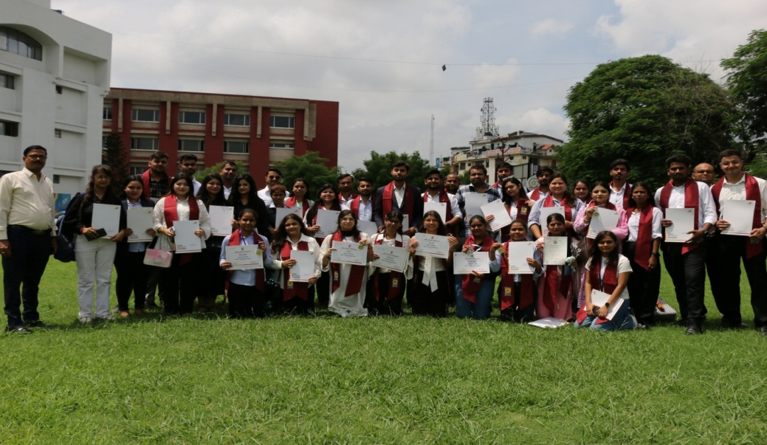
Group Photo with Degree

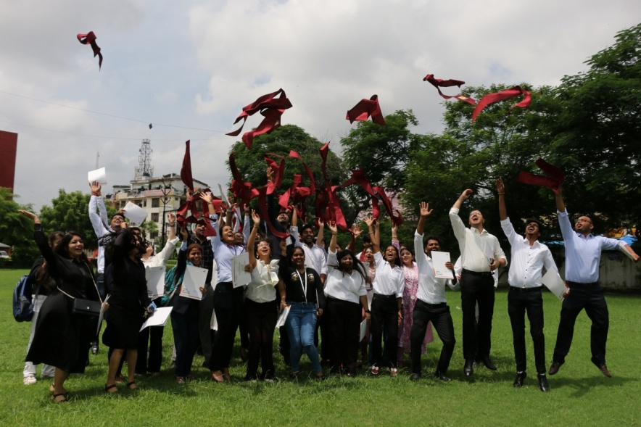
Celebration of Degree Conferment

Newspaper Coverage

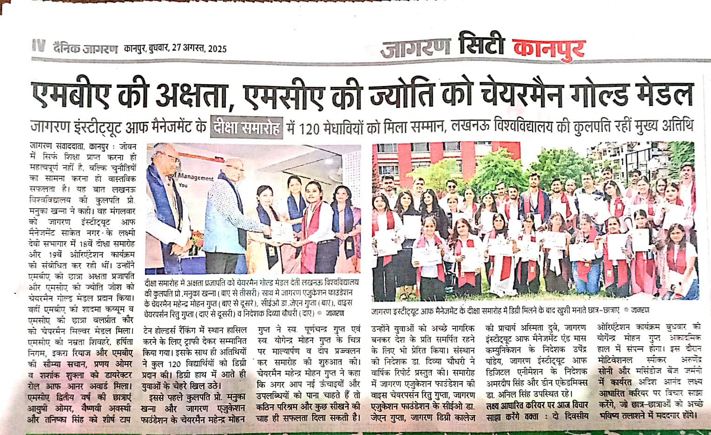

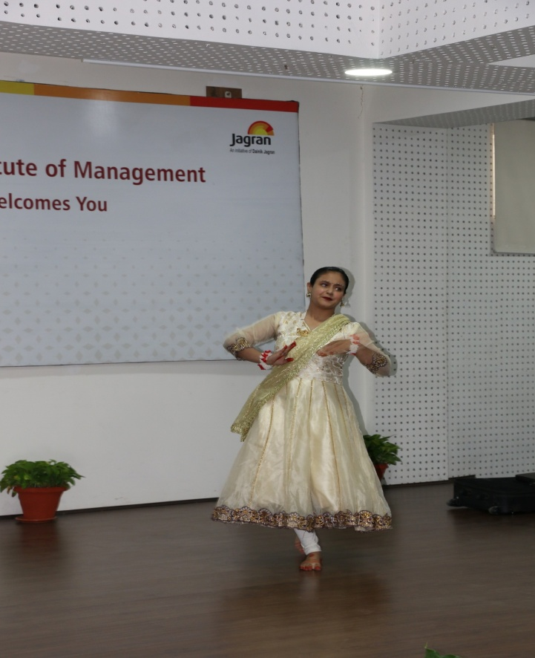
Saraswati Vandana by Student
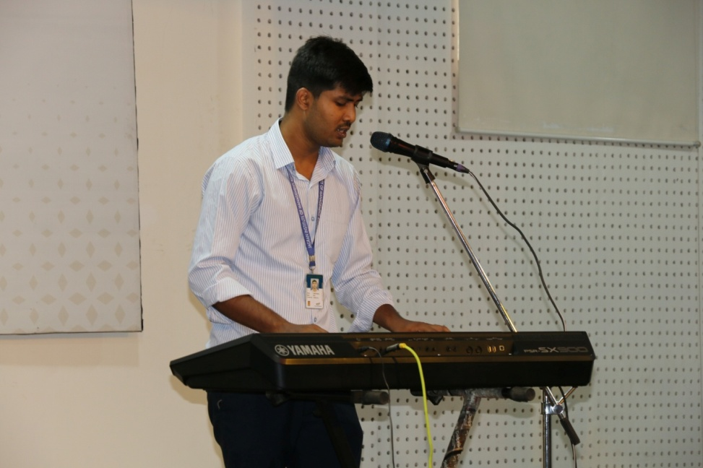
Performance by Student

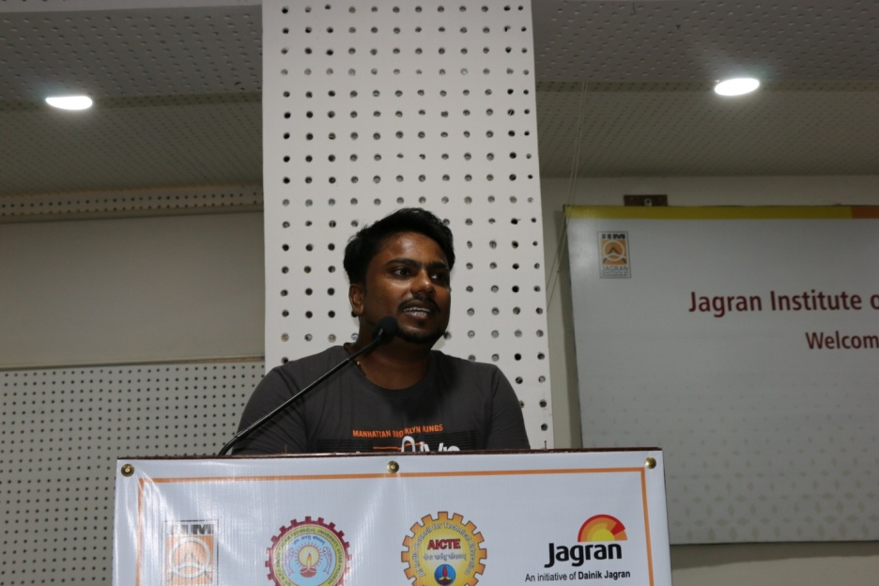
Aumni Talk by Prashant Sharma(Batch 2017-2019)
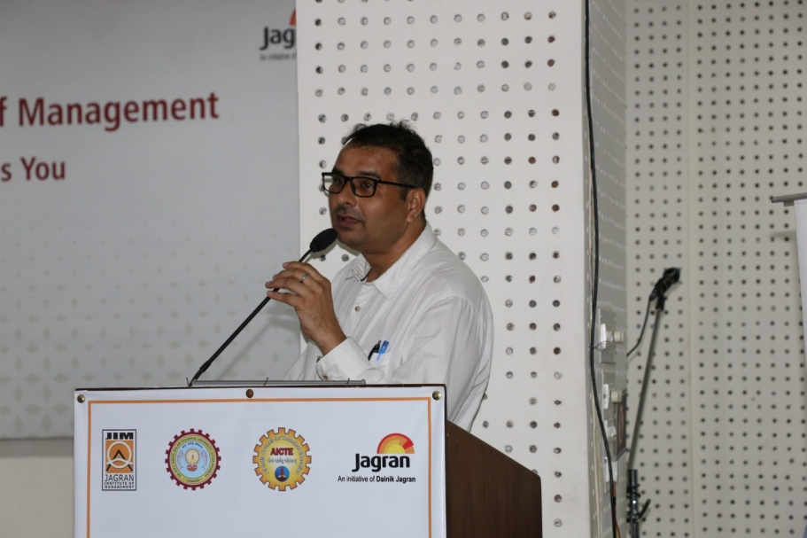
Examination Overview by Dr. Anil Kumar Singh(Dean Academic)

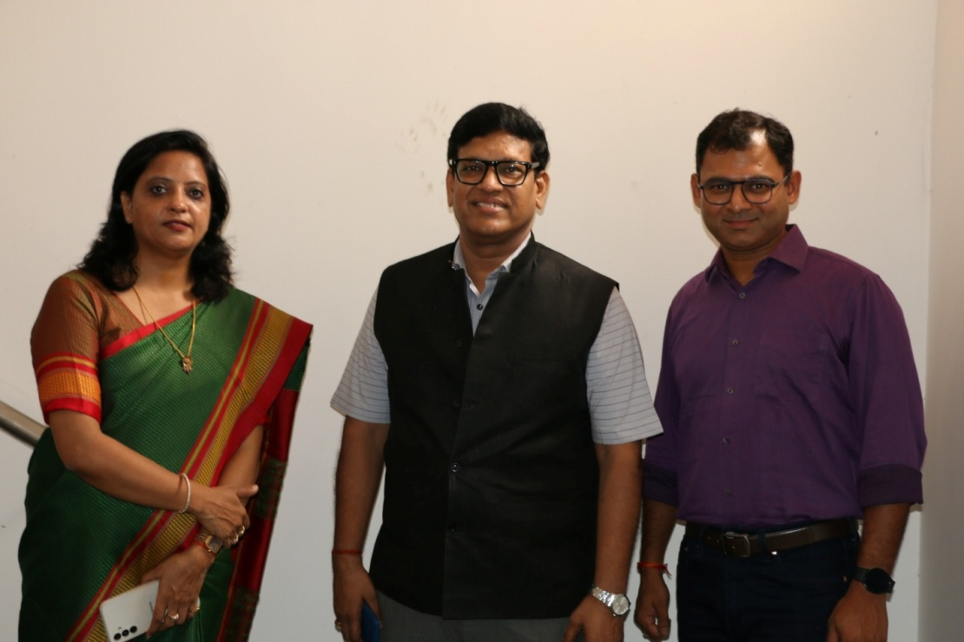
Director- Divya chowdhry Ma’am with Guest Speaker
Mr. Auendra soni & Mr.Adish Anand (Day -2 orientation ceremony)

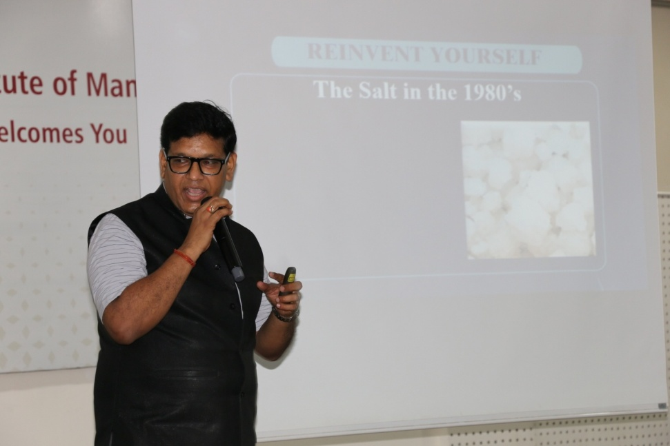
Guest Speaker- Mr. Auendra soni (Movtivational speaker & Life Coach)
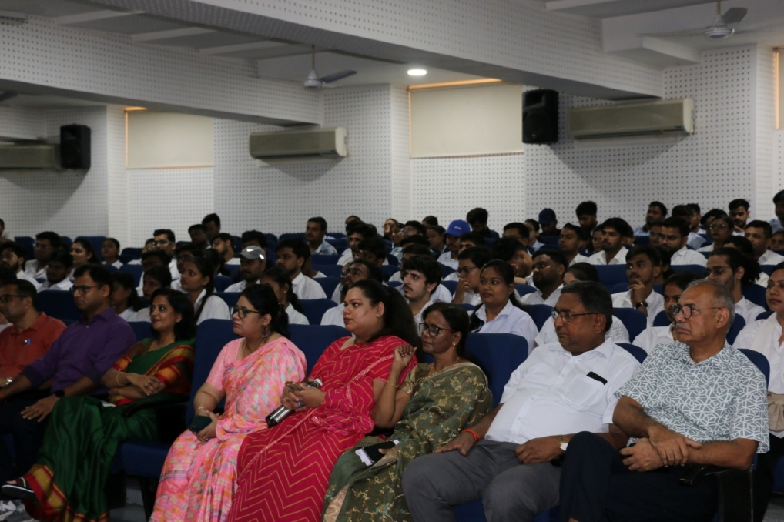
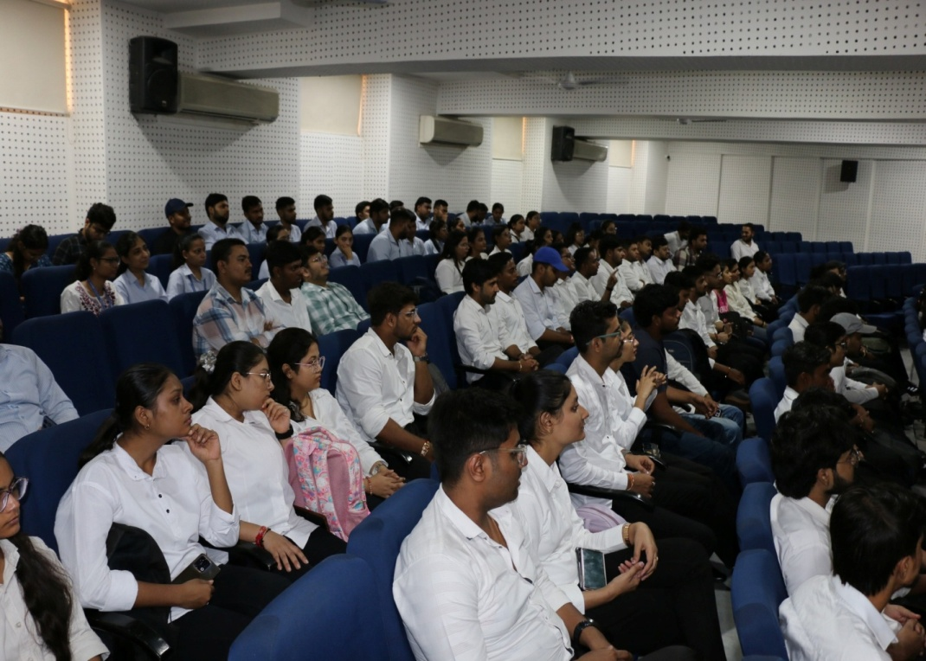
Day-2 Orientaion program MBA & MCA Students
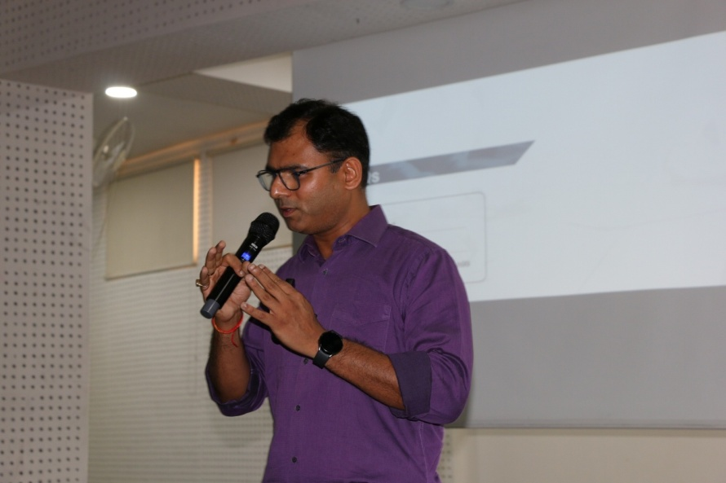
Guest Speaker- Mr. Adish Anand, Mercedes-Benz AG System Integration Engineer& Defect Manager

