JAGRAN INSTITUTE OF MANAGEMENT

8th International Conference
On
“Next-Gen Solutions for Business Excellence and Leadership”
(NITBEL-2025)
Saturday, 29th November, 2025
Aim of the Conference
The conference aims to examine how emerging technologies, innovative business strategies, and contemporary leadership frameworks can be effectively leveraged to achieve business excellence in an increasingly digital and competitive environment. It seeks to highlight the significance of next-generation solutions- such as artificial intelligence, data analytics, automation and digital transformation models- in strengthening decision-making, improving operational efficiency and fostering long-term sustainability.
A key focus of the conference is to stimulate meaningful dialogue on leadership in the digital era, emphasizing the need for agility, creativity and strategic foresight. By bringing together academicians, industry experts, entrepreneurs and researchers on a common platform, the conference aspires to encourage collaboration, exchange of knowledge and co-creation of innovative approaches. Ultimately, it aims to pave the way for future-ready business and leadership practices capable of navigating rapid technological and market disruptions.

Introduction
The theme “Next-Gen IT Solutions for Business Excellence and Leadership” underscores the transformative impact of advanced technologies- such as Artificial Intelligence, Blockchain, Cloud Computing, IoT, Big Data Analytics, Cybersecurity and the Metaverse- on the future of organizational growth and competitiveness. In a dynamic digital era, businesses can no longer rely solely on traditional methods; they must adopt innovative IT-driven approaches to achieve superior efficiency, enhance customer experience, ensure sustainability and stay competitive on a global scale.
Furthermore, leadership today demands a technology-enabled vision that fosters innovation, resilience, and ethical governance. Next-generation IT solutions not only streamline business processes but also act as powerful enablers of leadership excellence. By integrating digital tools and insights, organizations can empower leaders to make informed decisions, adapt swiftly to change and guide teams with clarity and purpose. This theme reinforces the idea that technology and leadership must evolve together for enterprises to thrive in an ever-changing global landscape.

Objective of the Conference
The primary objective of the conference is to establish a comprehensive platform for the dissemination and exchange of knowledge on innovative IT solutions and their applications across various domains of business and management. It aims to bridge the gap between academic research and practical implementation through case studies, empirical findings and best practices that address real-world challenges. The conference also seeks to explore critical issues related to technology adoption, governance, digital ethics, and change management.
A central goal is to nurture leadership that is adaptive, ethical and aligned with the principles of sustainability, inclusivity and social responsibility. By fostering collaboration among academic institutions, industry professionals, startups, researchers and policymakers, NITBEL-2025 aspires to anticipate future technological trends, build institutional and individual capacities and outline strategic pathways for businesses aiming to achieve long-term competitive advantage in a rapidly evolving digital ecosystem. Following are the sub-themes of the Conference. However, the list is not exhaustive and researchers may submit their work relevant to any of the topics mentioned below or as per theme
Sub Theme
• Startups and Next-Gen IT-Driven Entrepreneurship
• Artificial Intelligence and Machine Learning for Business Excellence
• Marketing and Finance
• Innovation Ecosystems and Digital Entrepreneurship
• Blockchain Applications in Finance, Supply Chain, and Governance
• Human Resources Management
• Sustainable Business Transformation and Practices
• Cloud and Edge Computing for Scalable Enterprises
• Green IT and Energy Efficient Eco System
• Internet of Things (IoT) and Smart Business Models
• Cybersecurity, Data Privacy, and Risk Management
• AI and Predictive Analytics for Financial Decision-Making
• Big Data Analytics for Consumer Behaviour and Market Forecasting

The NITBEL-2025 Conference had Three main sessions- Inaugural Session, Technical Sessions (Technical Session - I - Information Technology and Technical Session - II – Management) and Valedictory Session. A brief of all 3 sessions is as follows-

INAUGURAL SESSION

The International Conference commenced with the ceremonial lamp lighting by Dr. Mahendra Mohan Gupta, Chairman; Mrs. Ritu Gupta, Vice Chairperson and Dr. J. N. Gupta, CEO, Jagran Educational Foundation, accompanied by Prof. (Dr.) Divya Chowdhry, Director; Dr. Anil Kumar Singh, Dean and Conference Convenor; the Chief Guest and the Keynote Speaker.
Dr. Mahendra Mohan Gupta, Chairman, delivered the welcome address.
The Chief Guest, Dr. Jai Krishna Pandey, Former Chief Scientist and Head, Mine Fire, Ventilation and Miners’ Health Research Group, CSIR-CIMFR, Dhanbad, delivered the Inaugural Address on Mining Technology, Education, and Management, emphasizing the growing relevance and impact of IT solutions in business operations.
The Keynote Address was delivered by Mr. Sean Paul, Teacher Trainer and Educational Consultant, London, who discussed the current education landscape in India and its alignment with global standards.
Guest Speaker Dr. Raghuraj Singh, Professor and Dean (Research & Development) at HBTU Kanpur, delivered an engaging session on leveraging AI solutions for achieving business excellence. He discussed the latest advancements in emerging technologies, including Agentic AI, supervised learning and blockchain, highlighting their transformative potential for organizations. Dr. Singh also illustrated how these technologies can optimize decision-making, enhance operational efficiency and drive innovation in the modern business landscape.
Guest Speaker Mr. Sandeep Joshi, Regional Head- Academic Alliances at Tata Consultancy Services, provided an insightful overview of the Tata Group’s pivotal role in driving technological innovation. He emphasized how the company has consistently contributed to the development of advanced IT solutions that address complex business challenges. Additionally, he shared examples of Tata’s initiatives in fostering digital transformation and nurturing academic-industry collaborations to prepare future-ready talent.

TECHNICAL SESSION - I - INFORMATION TECHNOLOGY

- Venue/Mode: Hybrid through Google meet platform
- Time: 02:00 P.M. to 04:00 P.M.
- Session-Chair: Dr. Neerja Garg, Principal Scientist, IMCS CSIR CSIO, Chandigarh
- Rapporteur: Mr. Adarsh Srivastava, Jagran Institute of Management
- Faculty Coordinator: Mr. Ashish Misra, Jagran Institute of Management
- Best Paper Award: Pawasi Saxena

The First Technical Session was chaired by Dr. Neerja Garg, Principal Scientist, IMCS CSIR CSIO, Chandigarh (connected virtually). There was a total of 12 papers out of which 8 papers were presented.
Mr. Adarsh Srivastava, Rapporteur for Technical Session-I
- Reena Gupta
Topic - Green IT and Energy-Efficient Ecosystem

Green IT and energy-efficient ecosystems focus on reducing the environmental impact of technology by optimizing energy consumption, utilizing renewable resources, and promoting sustainable practices in IT infrastructure, thereby enhancing both operational efficiency and environmental responsibility.

- Pawasi Saxena
Topic - Big Data Analytics for Consumer Behaviour and Market Forecasting

Big Data Analytics for consumer behaviour and market forecasting leverages large-scale data patterns to deliver precise insights that enhance decision-making, optimize marketing strategies, and predict future market trends.

- Mamta Verma
Topic - Achieving Enterprise Scalability Through Intelligent Cloud–Edge Synergy

Achieving enterprise scalability through intelligent cloud–edge synergy enables seamless, real-time processing and optimized resource allocation by unifying centralized cloud power with agile edge capabilities.

- Anurag Chandra Mishra, Ram Awtar, Joydeep Das, Ankita Dixit
Topic -Causal Inference in Deep Learning: Moving Beyond Correlation to Cause – Effect Reasoning in AI Decision Making

Causal inference in deep learning advances AI decision-making by enabling models to move beyond surface-level correlations and infer true cause-effect relationships for more reliable, explainable, and impactful outcomes.

- Sandeep Tripathi
Topic - Exploring the Role and Significance of Data Mining in Machine Learning and Artificial Intelligence

Data mining plays a pivotal role in machine learning and AI by uncovering hidden patterns in large datasets, enabling smarter models, informed decision-making, and more accurate, data-driven insights.

- Dev Agnihotri, Dr. Anand Kumar Dixit
Topic - Her Mind Matters: Combining AI Insights and Digital Care to Support Women’s Mental Wellness

Combining AI insights with digital care empowers personalized, accessible support for women’s mental wellness, fostering early intervention, resilience, and holistic wellbeing.

- Adarsh Srivastva, Ashish Mishra, Kunj Tiwari
Topic - Predicting Stock Market Indices Using Artificial Intelligence and Machine Learning: A Comprehensive Framework and Empirical Study

A comprehensive AI/ML framework- combining feature engineering, time-series and deep-learning models, ensemble methods, and rigorous back testing- can improve stock market index forecasting and inform better risk-adjusted decisions, while acknowledging inherent market uncertainty.

- Deepesh Kumar, Siddhartha Mishra
Topic - AI and Automation for Operational Excellence: Impact on Productivity, Efficiency and Cost Reduction

AI and automation are driving operational excellence by significantly boosting productivity, enhancing efficiency, and reducing costs across modern enterprises.

TECHNICAL SESSION - II – MANAGEMENT

- Venue/Mode: Hybrid through Google meet platform
- Time: 02:00 P.M. to 04:00 P.M.
- Session-Chair: Dr. Sadhvi Mehrotra, Professor & Director, Dayanand Academy of Management Studies, Kanpur
- Rapporteur: Dr. Akshat Gupta, Jagran Institute of Management
- Faculty Coordinator: CS. Shantanu Kumar, Jagran Institute of Management
- Best Paper Award: Dr. Manisha Gupta and Isha Gupta
The Second Technical Session was chaired by Dr. Sadhvi Mehrotra, Director, Dayanand Academy of Management Studies, Kanpur. There was a total of 14 papers out of which 9 papers were presented.
Dr. Akshat Gupta, Rapporteur for Technical Session-II

- Ruchi Singh, Dr. Sudesh Srivastava, Aftab Ahmad, Shantanu Kumar and Dr. Sidhanshu Rai
Topic - Mapping Global Research Collaboration: A Country-Based Co-Authorship
Perspective on Role of Self –Help groups in Rural Development

It reports that India plays a central role in global SHG research networks, with cross-country collaborations strengthening knowledge on rural development, empowerment, and community transformation.

- Dr. Meenakshi Jaiswal
Topic- Financial Inclusion and Development: Evidence from India

It notes that despite significant gains via PMJDY and UPI, challenges persist in account usage, credit access, and adoption of financial products, highlighting ongoing gaps in India’s financial inclusion efforts.

- Aftab Ahmad, Shantanu Kumar, Ruchi Singh, Dr. Sudesh Srivastava and Dr. Sidhanshu Rai
Topic- Sustainable Business Transformation and practices in Textile Industry - Challenges and Opportunities

It highlights that adoption of eco-design, green supply chain management, and CSR practices is essential for reducing environmental impact and achieving sustainable production in India’s textile sector.

- Dr. Akshat Gupta
Topic- Use of Content Marketing Strategy Tools in Research Institutes

This emphasizes that digital tools like blogs, webinars, and infographics are increasingly vital for enhancing research institutions’ visibility and stakeholder engagement, though adoption remains uneven.

- Priya Chopra Arora
Topic- Diversity, Equity, and Inclusion (DEI) in Human Resource Management: Benefits, Challenges, and Strategies for Effective Implementation

This asserts that integrating DEI into HR practices enhances organizational performance and employee wellbeing, but challenges such as bias, weak leadership support, and measurement gaps necessitate strategic, data-driven implementation.

- Ms. Sakshi Shukla and Ms. Prachi Malhotra
Topic- IT Entrepreneurship and Gen Z in India: A Study of Startup Aspirations and Emerging Trends

It shows that India’s Gen Z entrepreneurs leverage digital tools, social media, cloud computing, and AI to reshape the startup ecosystem, though challenges remain in skills, mentorship, and ethical technology use.

- Isha Gupta and Dr. Manisha Gupta
Topic- Women Empowerment and Digital Innovation: Exploring the Intersection of Social and Economic Advancement

This reveal that digital tools improve women’s access to education, entrepreneurship, and financial inclusion, though gaps in digital literacy, access, and rural infrastructure require targeted interventions.

- Pawan Omer and CS Shantanu Kumar
Topic- Impact of Sustainability Reporting on Startup Valuation and Investor Decision-Making in India

It shows that sustainability reporting positively impacts startup valuation and investor confidence in India, though standardization and credibility remain critical for maximizing its influence.

- Archita Agnihotri, Prajwal Shukla and Prof. (Dr.) Divya Chowdhry
Topic- A Comprehensive Study on the Impact of Gamification on Young Adults (Ages 20-27) in India: An Evidence-Based Analysis of Social Transformation Through Digital Engagement
It finds that gamification improves mental health, education, and social engagement among Indian young adults, with effectiveness dependent on culturally sensitive, meaningful, and sustainable design.

VALEDICTORY SESSION
A total of 26 papers were presented and published at the 8th International Conference on “Next-Gen Solutions for Business Excellence and Leadership” (NITBEL-2025), marking a significant milestone in the academic journey of Jagran Institute of Management. The conference and its technical sessions aimed to bring together leading experts and researchers to exchange insights, share knowledge and strengthen collective understanding. These interactions helped build consensus on policy directions essential for addressing current and future challenges in innovation.
We believe that the rigorous discussions held across various sessions enriched the deliberations, identified critical issues requiring attention and laid a strong foundation for progressive advancements in the respective domains. The conference theme emphasized innovation as a catalyst for accelerating sustainable development, guiding the structure and focus of all technical sessions.
In the presence of Prof. (Dr.) Divya Chowdhry, Director; Dr. Anil Kumar Singh, Dean and Convenor; Dr. Anand Kumar Dixit and Ms. Priya Chopra Arora, Co-Convenor, certificates were awarded to all authors and presenters in both physical and online modes. The jury panel faced a challenging task in selecting the best papers from the technical sessions. These awards serve as a strong motivation, inspiring participants to strive for excellence and achieve greater academic heights.
Best paper awards in the Information Technology and Management categories were presented as follows:
Authors | Paper
Pawasi Saxena | Big Data Analytics for Consumer Behavior  and Market Forecasting
Isha Gupta and  Dr. Manisha Gupta | Women Empowerment and Digital Innovation: Exploring the Intersection of Social and Economic Advancement
Dr. Anil Kumar Singh, Dean and Conference Convenor, delivered the Vote of Thanks, expressing deep appreciation to all International and National dignitaries for their valuable presence and contributions. He conveyed special gratitude to Chairman Dr. Mahendra Mohan Gupta ji, Vice Chairperson Mrs. Ritu Gupta ji, CEO Dr. J. N. Gupta ji, and Director Prof. (Dr.) Divya Chowdhry ji for their unwavering guidance, support and encouragement, which played a pivotal role in the successful conduct of the conference. He also acknowledged the Chief Guest, Session Chairs, invited speakers, participants and all faculties and staff whose collective efforts enriched the conference deliberations and ensured its smooth execution.
The conference drew to a dignified close with the rendition of the National Anthem, marking a solemn and respectful conclusion. This final tribute to our motherland served as a unifying moment, reinforcing the spirit of national pride and collective commitment to academic excellence and societal progress.
INAUGURAL SESSION
NITBEL-2025 Inaugural Session
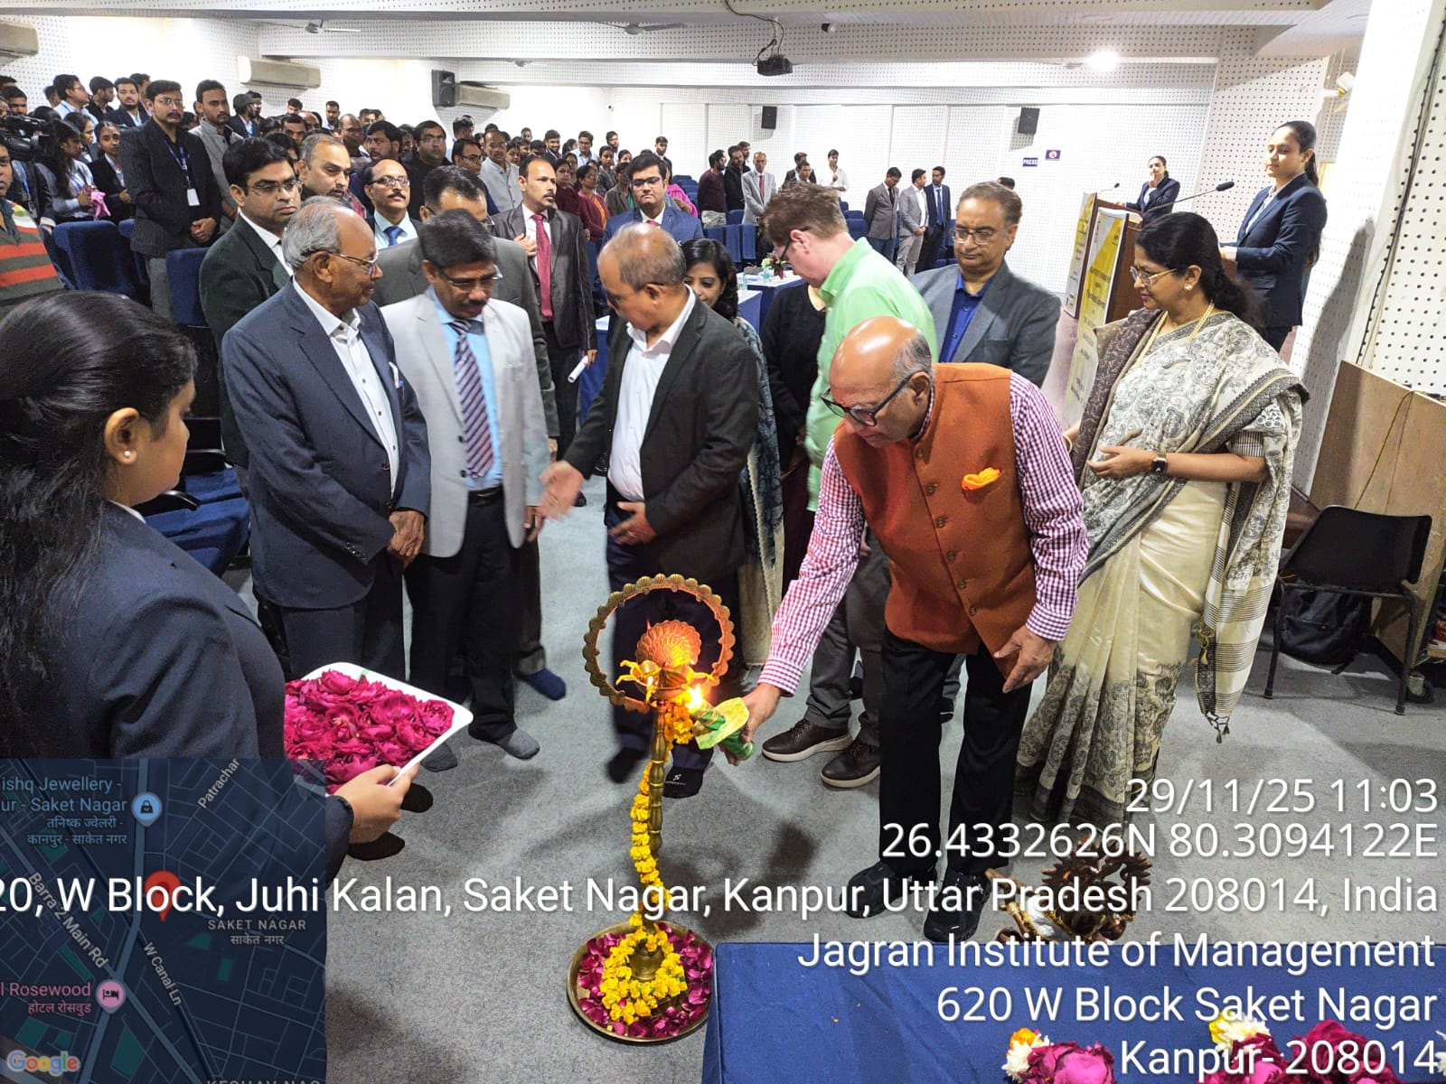

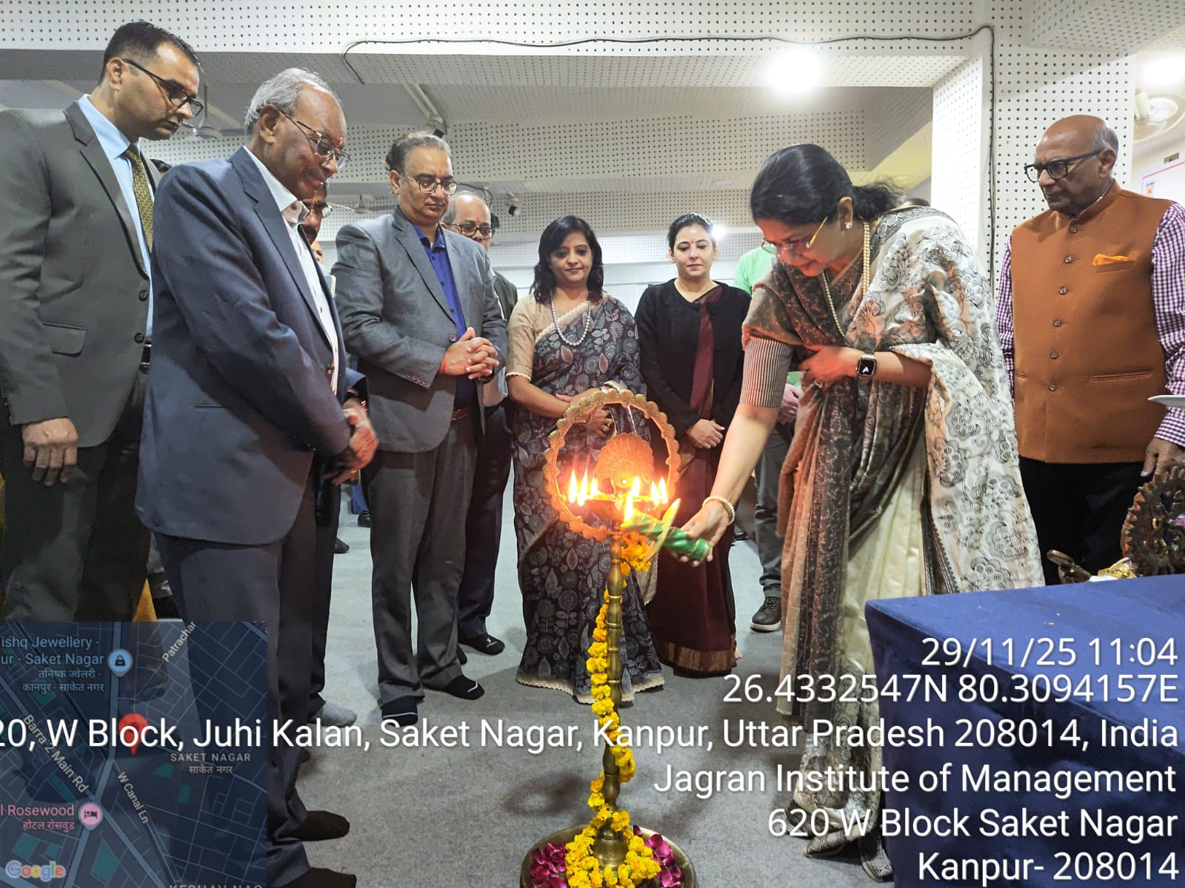

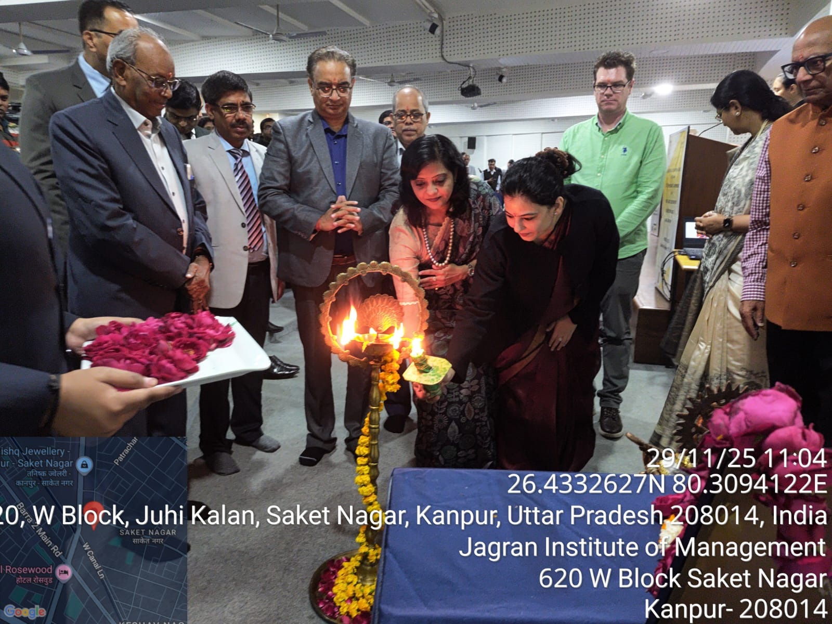

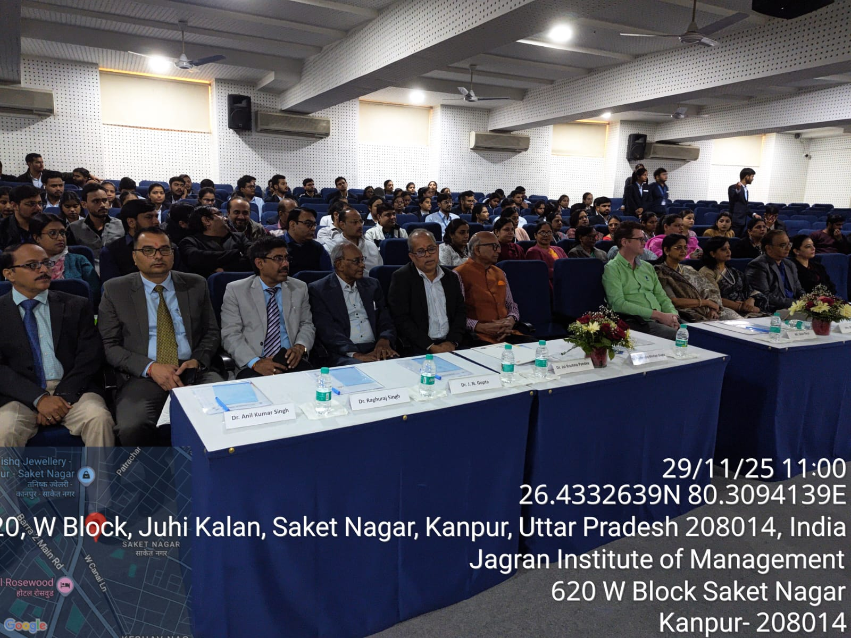

Release of the International Journal by the Dignitaries

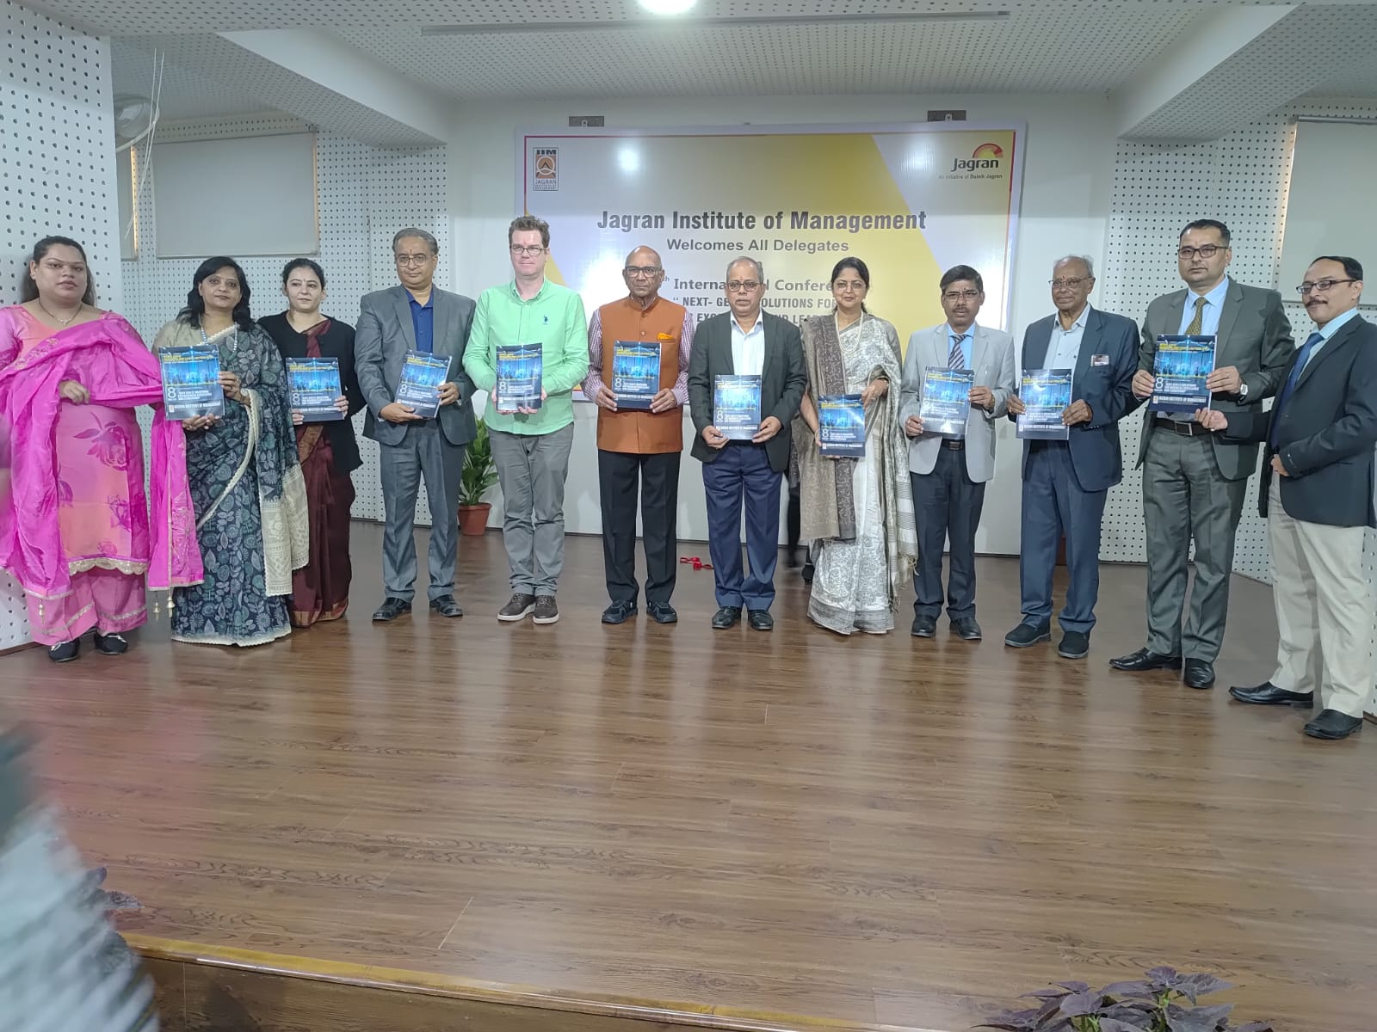

Vote of Thanks by Dr. Anil Kumar Singh, Dean and Conference Convenor
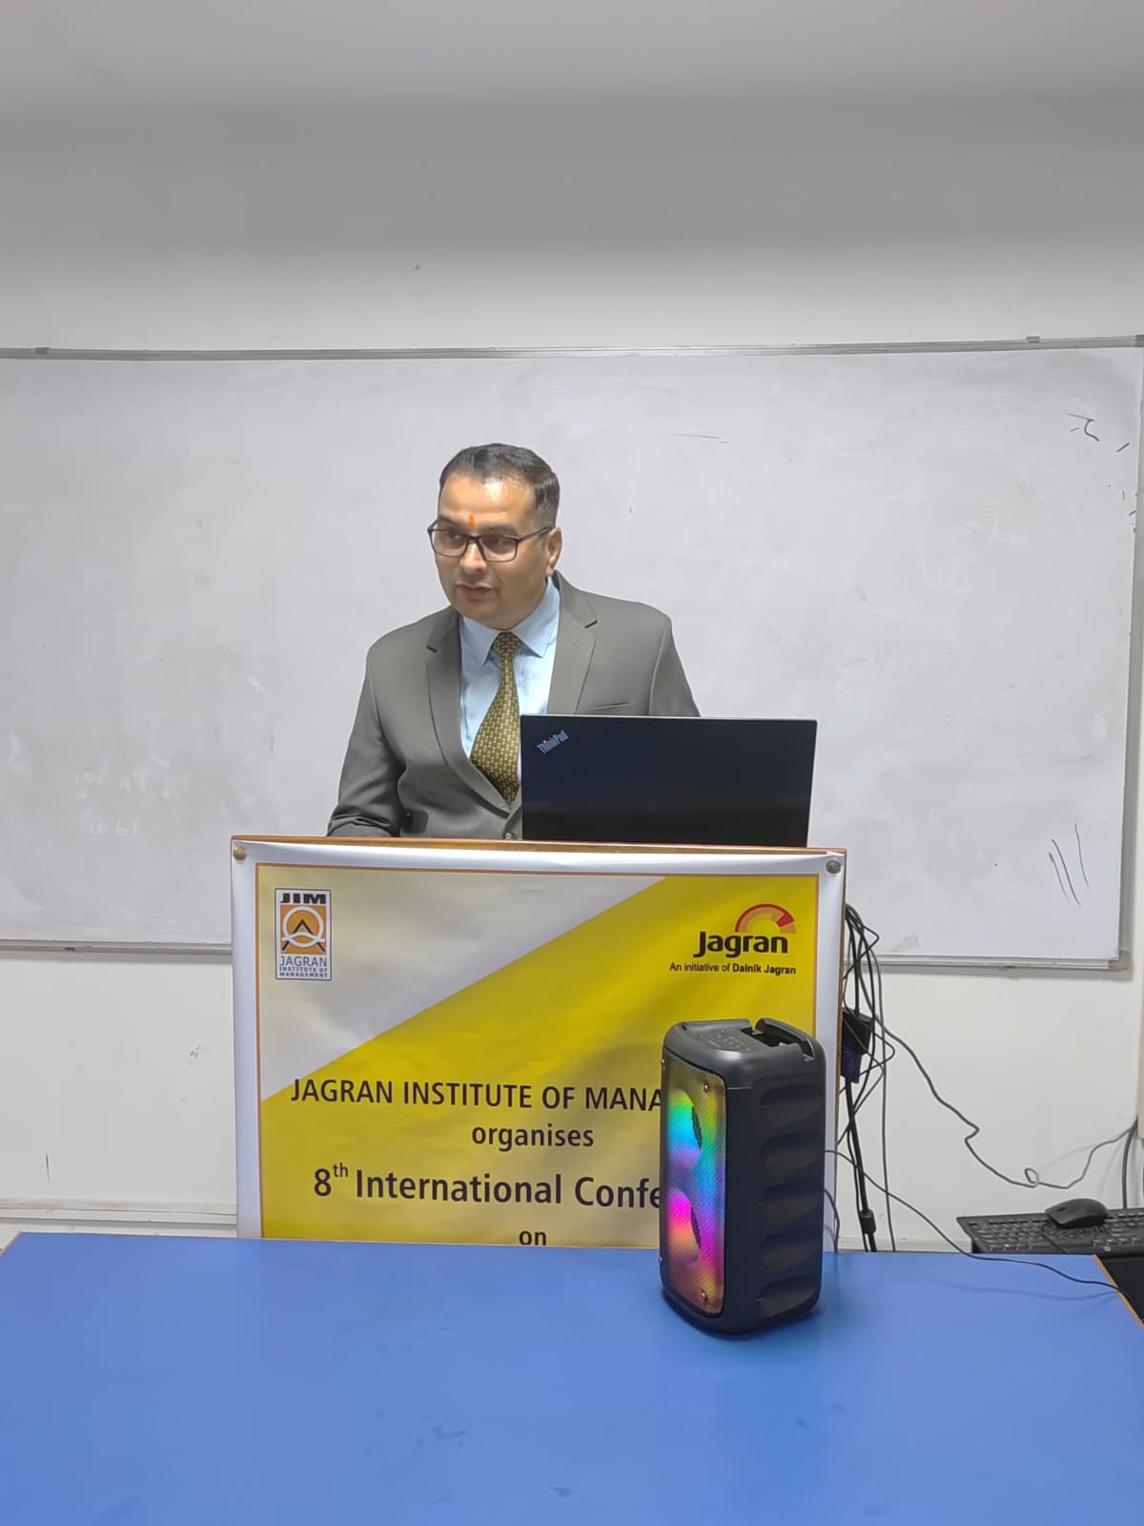
Certificate distribution to Presenters

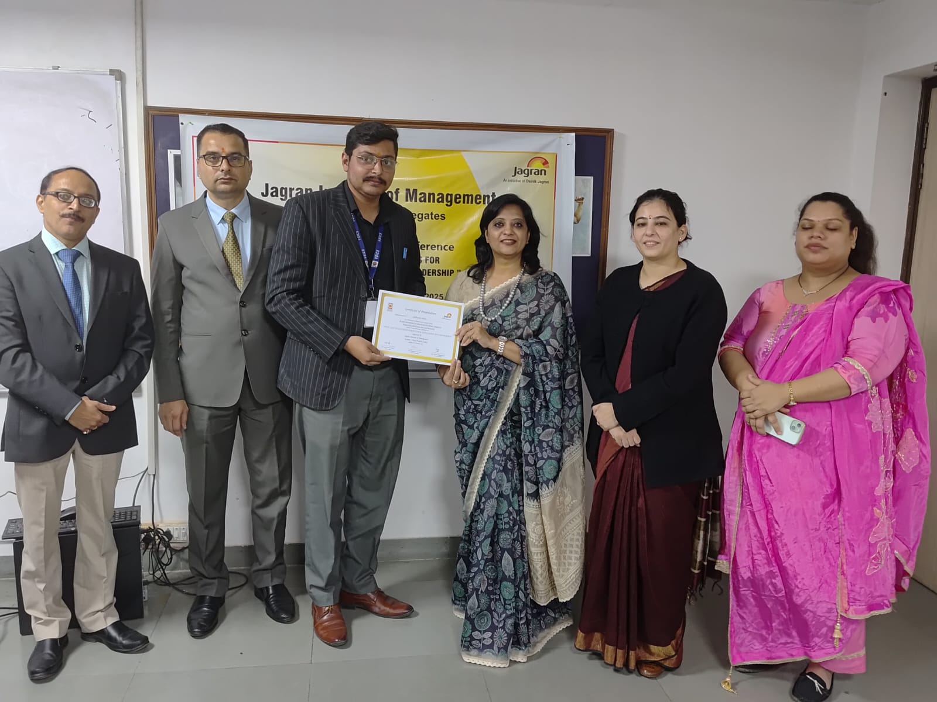

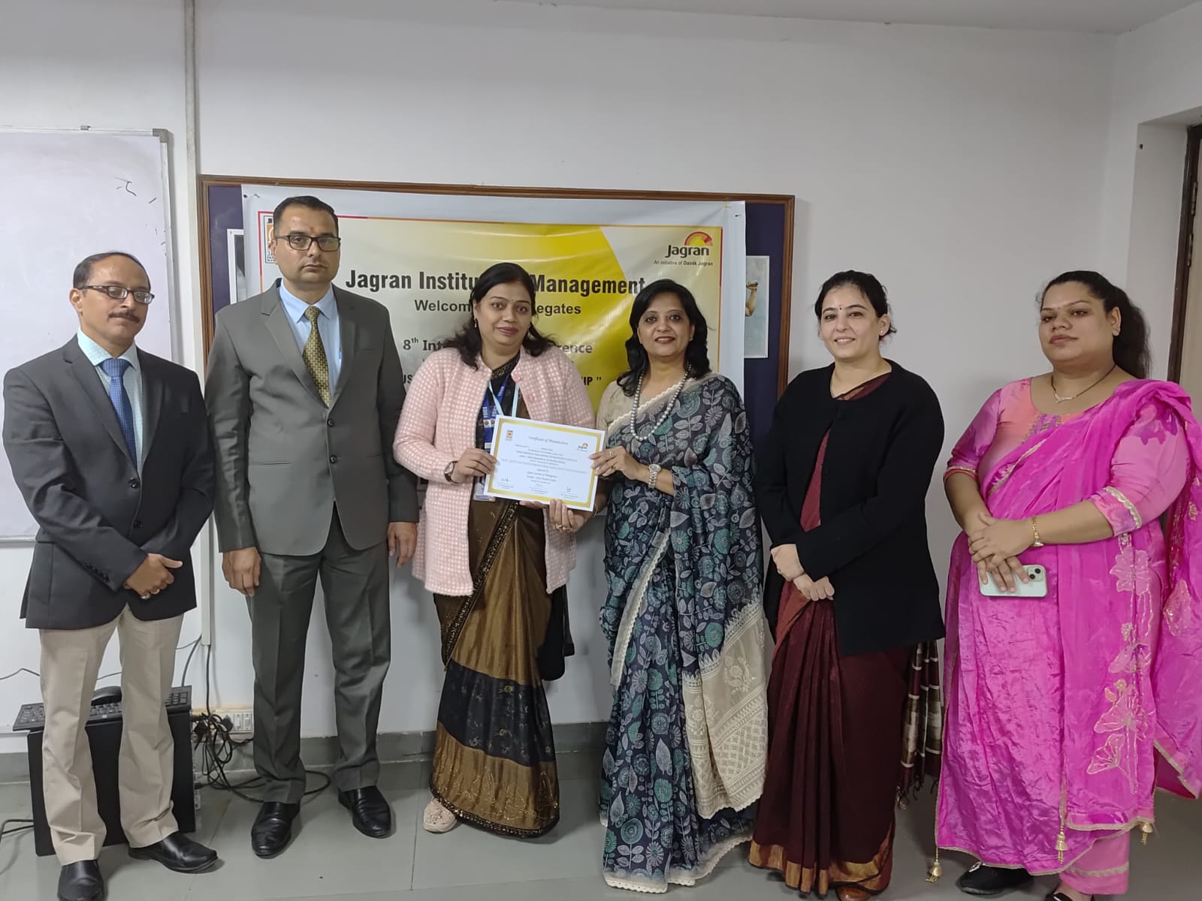

Digital Certificates given to online paper presenters
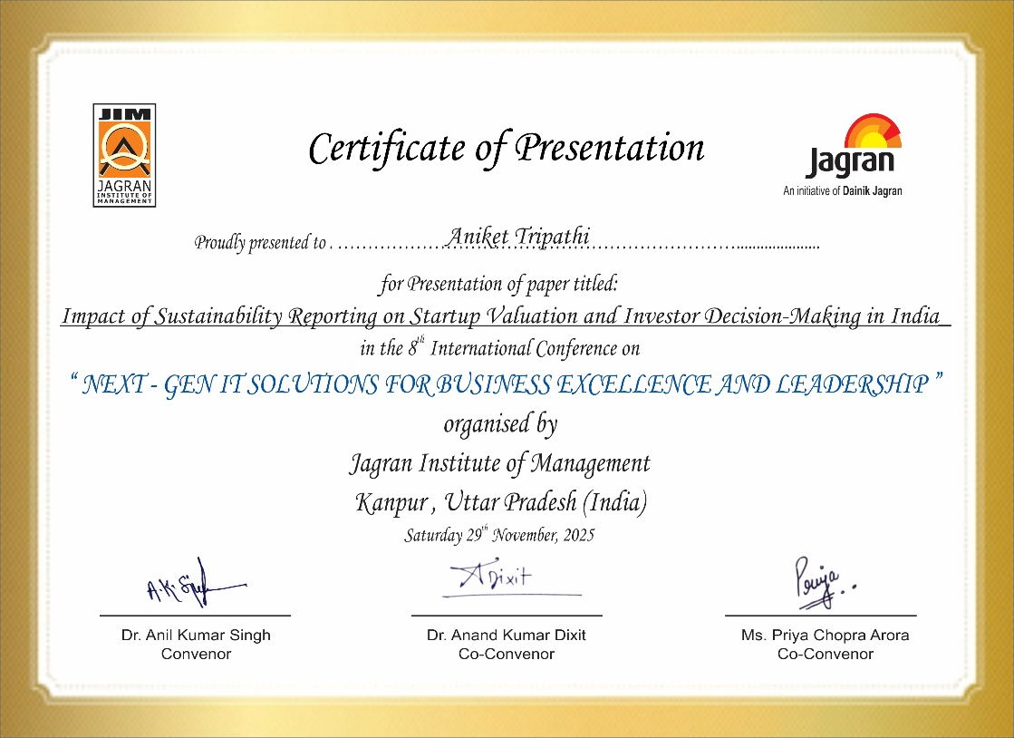

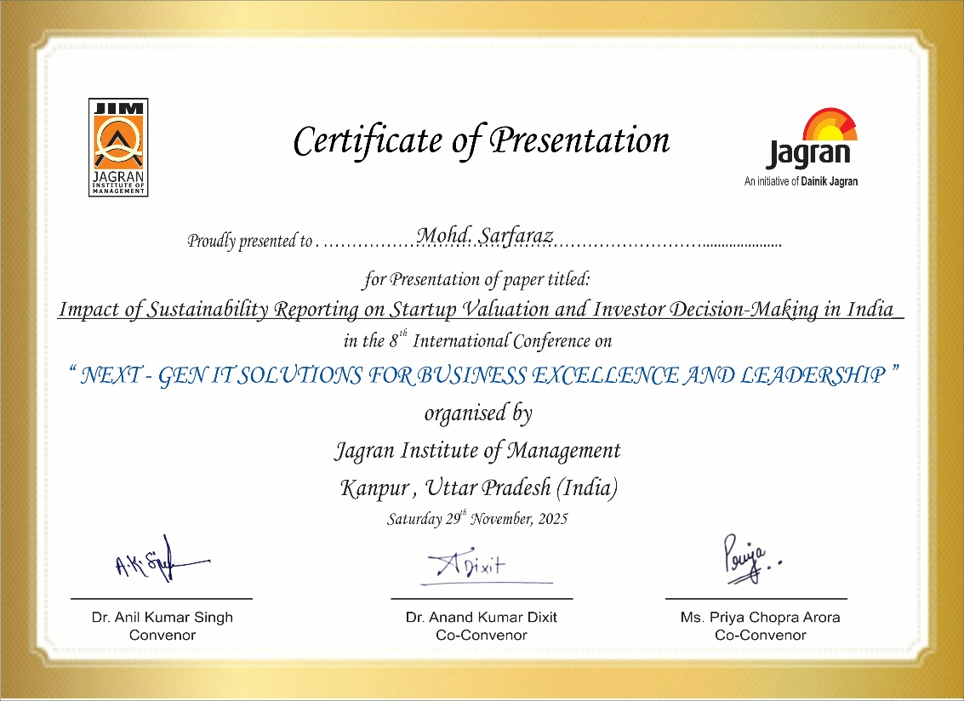

NEWSPAPER COVERAGE

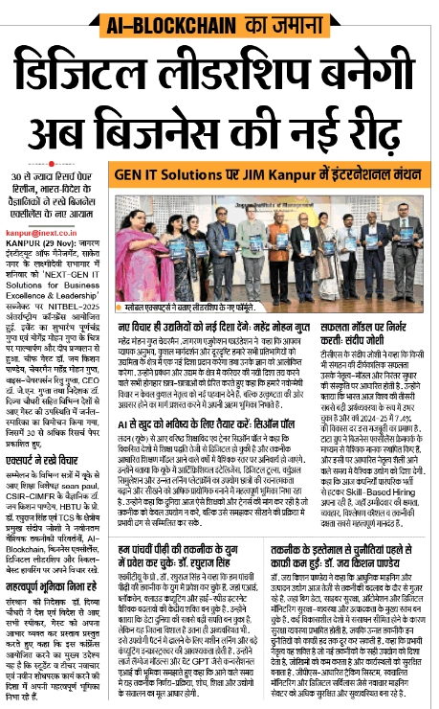

News coverage by I-NEXT Newspaper

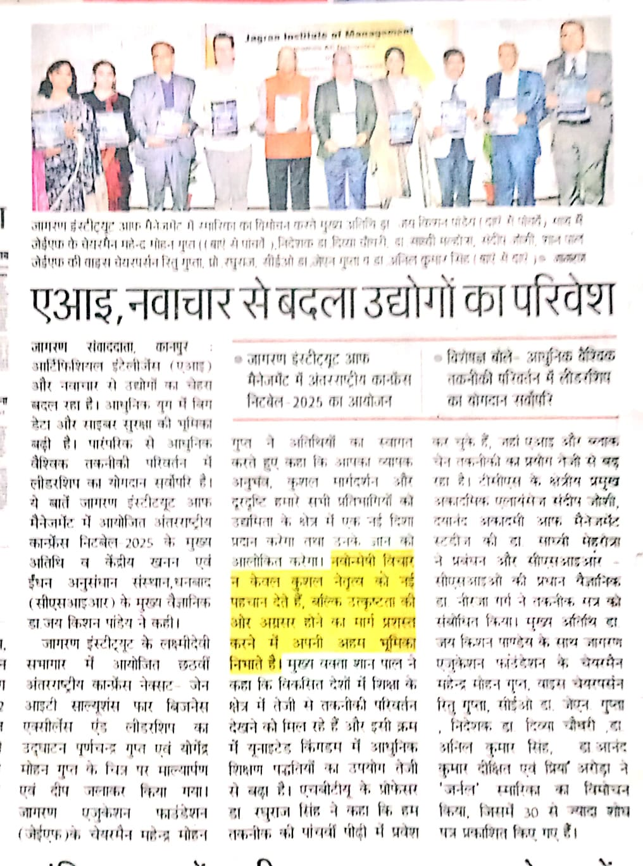
News coverage by Danik Jagran Newspaper

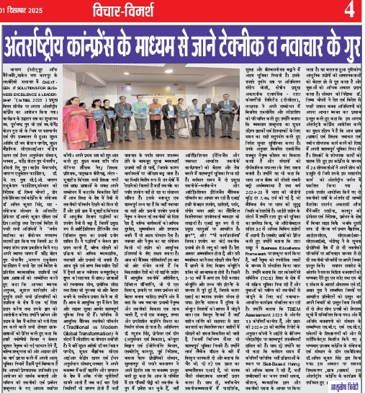

News coverage by The Banner Daily Newspaper

