“Cyber Security Awareness Workshop 2025”

Event: Cyber Security Awareness & Safety Workshop
Topic: Stop Think Act
Date & Time: Monday, Nov 04th,2025
Venue:Yogendra Mohan Gupta Academic Hall - JIM Campus.
Participants: Students of MCA & MBA

“Cyber safety begins with awareness, grows with practice, and stays with vigilance.”
Jagran Institute of Management organised an insightful Cyber Security Awareness& Safety Workshop on 03 November 2025 in the Yogendra Mohan GuptaAcademic Hall. The workshop aimed to educate students about the growing challenges of cybercrime, digital safety measures, and the need for responsible online behaviour in today’s increasingly connected world.
The program commenced with a traditional lamp-lighting ceremony and floral tribute to Goddess Saraswati by the Additional Police Commissioner of Kanpur, Ms. Anjali Vishwakarma - IPS, Sub-Inspector Ms. Riya Tiwari, and Mr. Vasudev from Kanpur Police Commissionerate. Their presence added great value and inspiration to the event.
Addressing the students as the keynote speaker, Ms. Anjali Vishwakarma emphasized the crucial importance of cyber awareness in the modern digital age. She stated that as our lives become deeply intertwined with technology,whether through mobile phones, computers, online banking, social media, or e-commerce-the threats associated with cyber misuse are also rising at an alarming rate. “Cyber security is no longer an option; it is a necessity for ensuring the safety of our personal, social, and economic life,” she remarked.
Ms. Vishwakarma and her team emphasized on the increasing cases of phishing, hacking, cyber stalking, Digital Arrest, sextortion and online financial frauds, which have now become common forms of cybercrime. She informed the students that any such incident can be immediately reported through the National Cyber Crime Reporting Portal or by calling the 1930 Cyber Helpline Number for prompt assistance.
They strongly advised students to adopt essential safety practices such as enabling two-step verification on platforms like Facebook, Instagram, and WhatsApp, refraining from sharing personal information over public Wi-Fi or unknown email links, and staying alert while interacting on digital platforms.
In her inspiring message on social responsibility, she encouraged the youth to not only safeguard themselves but also ensure the safety of their parents and family members. In the context of women’s empowerment, she stressed that young individuals must act with mutual respect, awareness, and cooperation to build a secure and crime-free environment.
The session proved highly informative and interactive, giving students practical insights into real-life cybercrime scenarios and preventive measures.
Towards the conclusion of the event, (Prof.)Dr. Divya Chowdhry, Director of the Institute, extended her sincere gratitude to Ms. Anjali Vishwakarma for sharing her valuable experiences and enlightening thoughts. She acknowledged the efforts of the Kanpur Police in consistently promoting cyber awareness among students and society.
The workshop was graced by Dean Academics, HOD’s, faculty members, staff, and a large number of enthusiastic students, making the event both impactful and successful.

Glimpses of the event:-
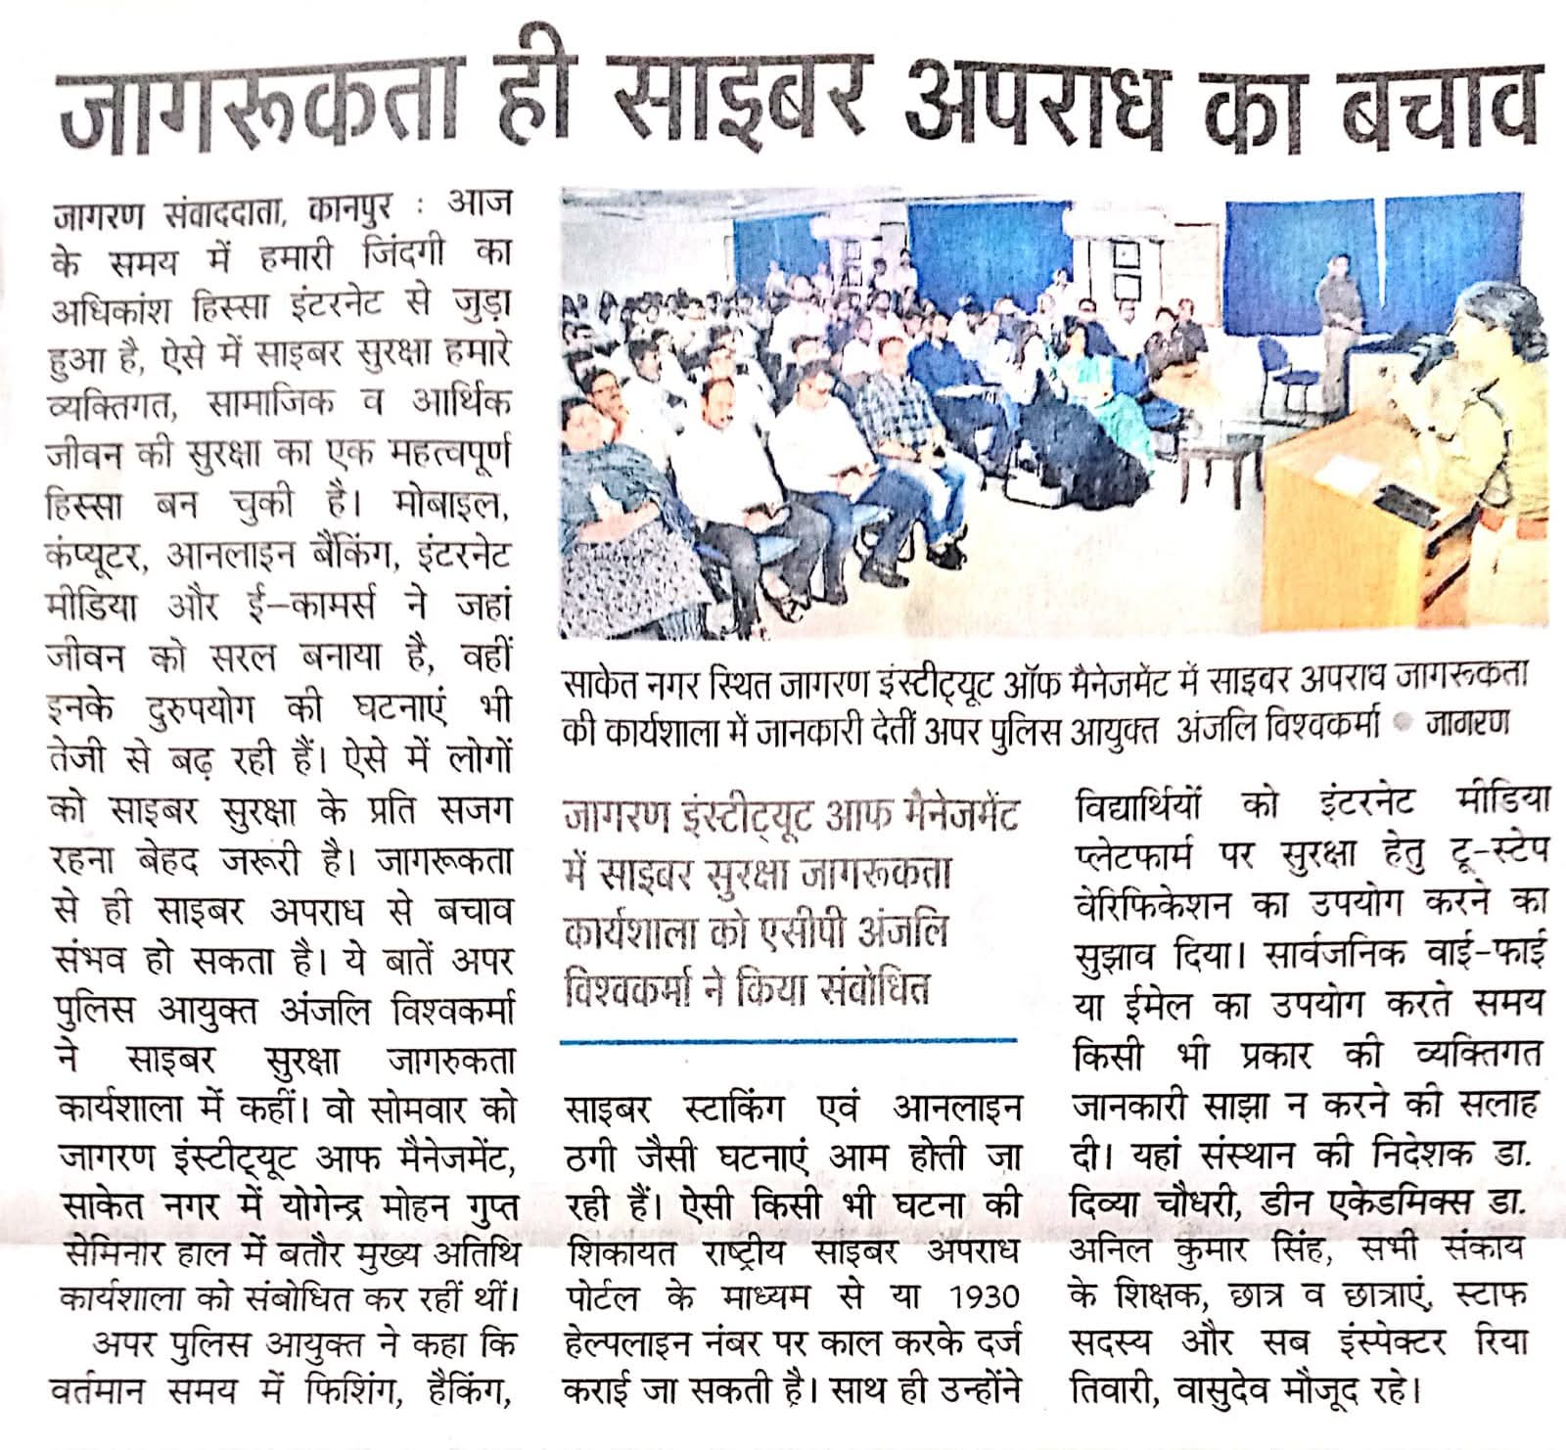
Dainik Jagran news coverage

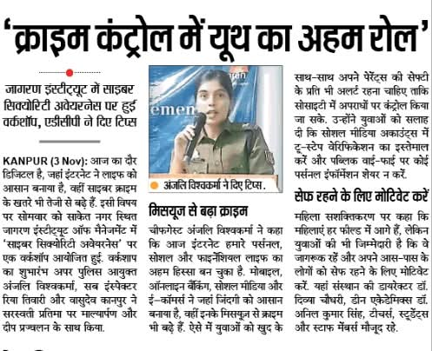
I next News Coverage on page

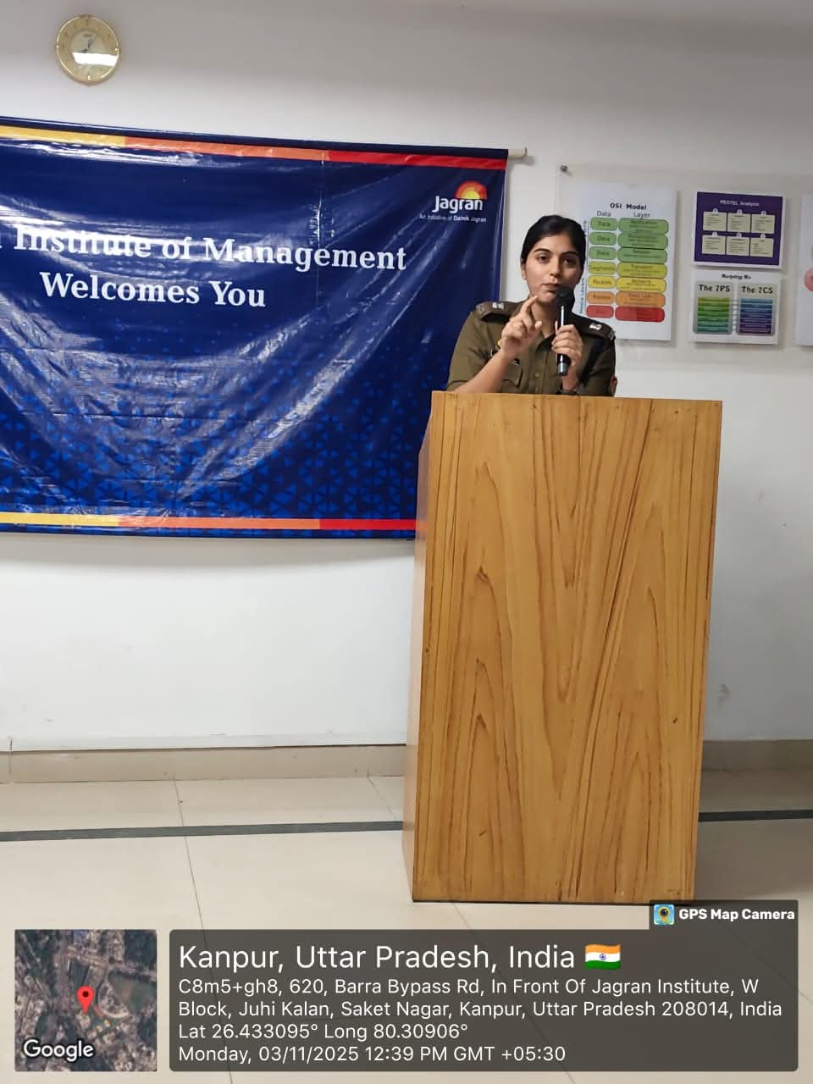
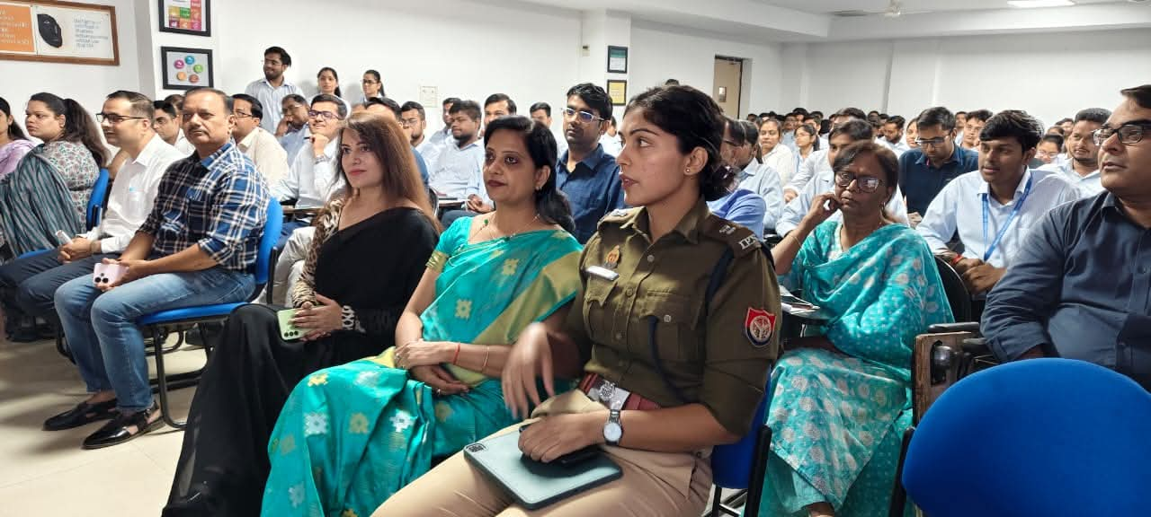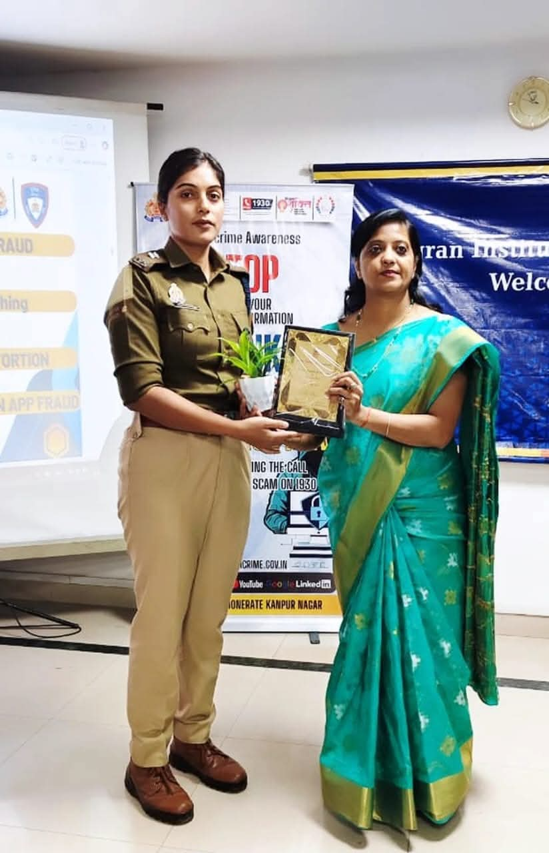
Appreciation and gratitude to Ms. Anjali Vishwakarma-IPS by the Director.

