Web Report: Blood Donation Camp
Event: One-Day
Date : 17th September,2025
Time : 11:00 a.m. onwards
Venue: JIM Campus

On the occasion of World Patient Safety Day, 17th September 2025, a blood donation camp was organized by the Social Club of Jagran Institute of Management (JIM) in association with the Rotary Club of Kanpur North at the JIM Campus, Kanpur. The noble initiative was carried out under the theme “Be Someone’s Lifeline!!”.
The event was graced by Dr. Divya Chaudhary, Director of JIM, along with the Dean and faculty members, who motivated the students and encouraged them to contribute to this noble cause. Their presence inspired participants and reinforced the importance of social responsibility.
A team of medical experts and social workers joined hands to ensure the smooth conduct of the camp. They guided and motivated participants, highlighting that one unit of blood can save up to three lives.
The activity of blood donation was enthusiastically initiated by the students of JIM, followed by faculty members and volunteers. The overwhelming participation reflected the sense of compassion and community service among the youth.
Many health checkups, including blood pressure and preliminary fitness tests, were conducted by the medical staff to ensure donor safety. Proper arrangements were made for refreshments, and volunteers took special care of every participant after donation to prevent any discomfort.
A total of 30–35 units of blood were successfully collected during the camp. Each donor was awarded a certificate of appreciation as a token of gratitude for their life-saving contribution.
The event not only helped in collecting precious blood units but also created awareness about the importance of voluntary blood donation and the role of youth in supporting healthcare needs. It truly inspired everyone to “be the reason someone smiles, survives, and sees tomorrow.”

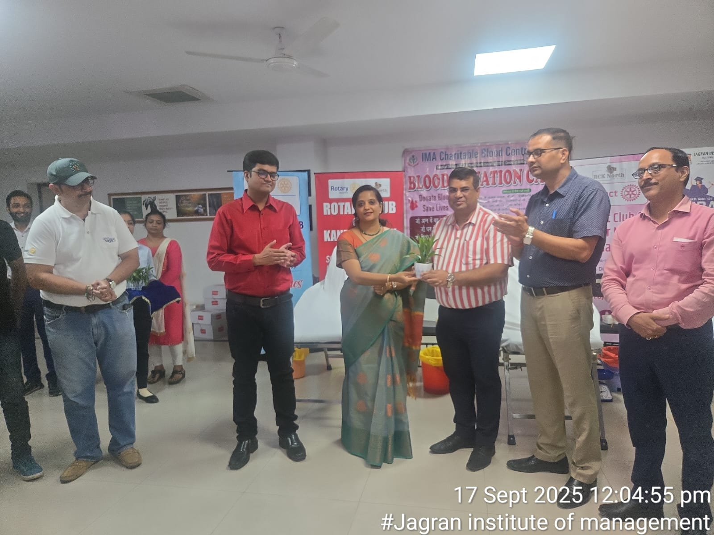
“The Director presented a sapling to the representative of the Rotary Club members as a token of appreciation.”

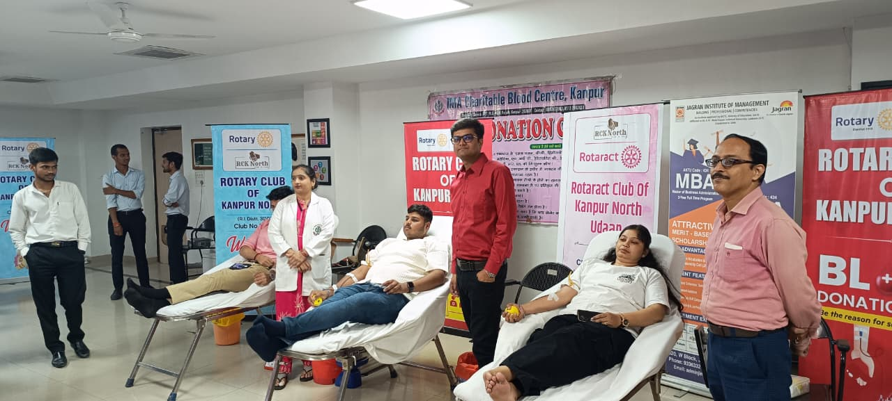
“Students donating blood during the campaign’’.

Press Coverage
