Mandatory Disclosure 2025-2026

1 | AICTE File No. | Northern/1-44640366394/2025/EOA
 | Date & Period of last approval | 2025-2026
2 | Name of the Institution | Jagran Institute of Management  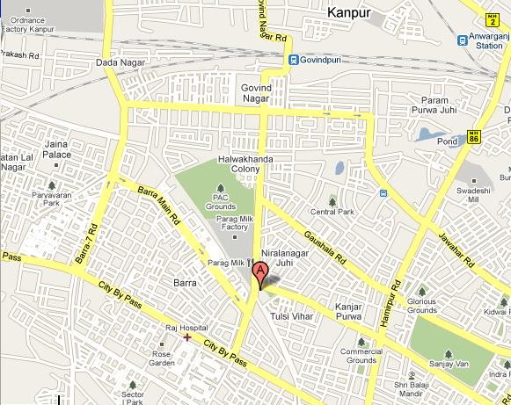
 | Address of the Institution | 620, W-Block, Juhi,
 |  | Saket Nagar,
 | City & Pin Code | Kanpur-208 014
 | State / UT | Uttar Pradesh
 | Phone No. with STD code | 0512-2601126
 | Fax No. with STD code | N/A
 | Office hours at the Institution | From 10:00 AM to 05:00 PM
 | Email | admin@jimkanpur.ac.in
 | Website | www.jimkanpur.ac.in
 | Nearest Railway Station (dist in Km) | Kanpur Central (8 Km)
 | Nearest Airport (dist in Km) | Chakeri Airport, Kanpur (18.2 Km)
3 | Type of Institution | Govt /Govt aided /University Dept /Deemed Univ /Private-Self Financed
 | Category (1) of the Institution | Non Minority /Minority (Specify minority) : Non Minority
 | Category (2) of the Institution | Co-Ed / Women only
4 | Name of the organisation running the Institution | Sri Puranchandra Gupta Smarak Trust
 | Type of the organisation | Society / Trust / PPP
 | Address of the organisation | Jagran Building,
 |  | 2, Sarvodaya Nagar, Kanpur-208 005
 | Registered with | Registrar
 | Registration date | 11/03/2022 (Renewal)
 | Website of the organisation | NO
5 | Name of the affiliating University | MCA and MBA from AKTU Lucknow
 | Address | Dr. A.P.J. Abdul Kalam Technical University, Sec-11, Jankipuram Vistar, Lucknow, Uttar Pradesh India
 | Website | www.aktu.ac.in
 | Latest affiliation period | 2025-26
6 | Name of Principal / Director | 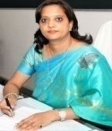  Dr. Divya Chowdhry
 | Exact Designation | Director
 | Phone No. with STD code | 0512-2601126
 | Fax No. with STD code | N/A
 | Email | director@jimkanpur.ac.in , directorjim@jef.org.in
 | Highest Degree | M.Com, PGDM, Ph.D
 | Field of Specialization | Marketing & Finance
7 | Governing Board Members | Dr. M.M. Gupta, Sri. Sanjay GuptaCEO-JPL, Jagran Prakashan Limited, Mrs. Ritu Gupta,Prof. Sanjay G. Dhande  Ex-Director, Indian Institute of Technology, Kanpur, Dr. J.N. Gipta, Mr. V.P. Aditya, Sri. Mukhtarul Amin,Chairman & MD, Super House GroupRegional Officer (Ex.-Officio) AICTE Kanpur, Director JIM Kanpur
 | Frequency of meetings & date of last meeting | Once a year & 06/07/2023
8 | Academic Advisory Body | Dr. J.N. Gupta, Dr. M.P. Gupta, Dr. Divya Chowdhry, Dr. Anil Kumar Singh
 | Frequency of meetings & date of last meeting | Once a year & 10/07/2023
9 | Organizational Chart
Chairman
Vice-Chairperson
Chief Executive Officer
MCA Faculty
MBA Faculty
Training Officer Placement Officer

Dean (Academics)

Administration
Training and Placement
Admin officer
Computer Lab Assistant
Librarian
Counselor
Accounts & HR
Director

10 | Student Feedback mechanism on Institutional Governance / Faculty performance | Yes
11 | Grievance redressal mechanism for Faculty, Staff and Students | Yes
12 | Name of the Department* | Computer Application
 | Course | MCA
 | Level | PG
 | 1st Year of approval by the Council | 2008
 |  | 2020-21 2021-2022 2022-2023 2023-2024 2024-2025
 | Year wise Sanctioned Intake | 60 60 60 60 60
 | Year wise Actual Admissions | 52 61 62 63 46
 | Cut off marks - General quota | As per AKTU norms
 | % Students passed with Distinction | 95%
 | % Students passed with First Class | 100%
 | Student Placed | 33
 | Average Pay package, Rs./Year | 4.2 Lakh
 | Student opted for Higher Studies | 11
 | Doctoral Courses | NA
 | Name of the Department* | Management
 | Course | MBA
 | Level | PG
 | 1st Year of approval by the Council | 2019
 |  | 2020-21 2021-2022 2022-2023 2023-2024 2024-2025
 | Year wise Sanctioned Intake | 60 60 60 60 60
 | Year wise Actual Admissions | 49 44 61 55 56
 | Cut off marks - General quota | As per AKTU norms
 | % Students passed with Distinction | 0%
 | % Students passed with First Class | 88%
 | Student Placed | 37
 | Average Pay package, Rs./Year | 3.45 Lakh
 | Student opted for Higher Studies | 4
 | Doctoral Courses | NA
 | Foreign Collaborations, if any | NA
 | Professional Society Memberships | NA
 | Professional Activities | NA
 | Consultancy Activities | NA
 | Grants fetched | NA
 | Departmental Achievements | NA
 | Distinguished Alumni | NA
13
Name of Teaching Staff* | 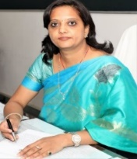  Prof. (Dr.) Divya Chowdhry
Designation | Director (Management/Computer Application)
Department | Management
Date of Joining the Institution | 02/11/2017
Qualifications with Class/Grade | M.Com,PGDM,Ph.D
Total Experience in Years | Teaching 13 Industry 5 Research 16
Papers Published | National 5 International 35
Papers Presented in Conferences | National 29 International 17
PhD Guide? Give field & University | Ex-Guide of Rama University,Kanpur. Ph.D Student awarded Degree from Mewar University.
PhDs / Projects Guided | One Scholar, Awarded in Commerce from Mewar University.
Books Published / IPRs / Patents | Patent-2, Author of Text Book-2, Editor or Co-Editor of Book- 4, Chapter Contribution 6 , Editor of Journals-10,Editor of Monthly E-Newsletter
Professional Memberships | Life Member of Indian Commerce Association, Life Membership-The Indian Science Congress Association,Life Membership-SSHRA,Life Membership-ISCKON
Consultancy Activities | Two Senior employee enhancement trainings for a Listed Company
Awards | 5 in Academics & Research, Various Teacher's day honors and also awards in fields of Social work
Grants fetched | No
Interaction with Professional Institutions | Nominated Member of various BOS and Academic Committees, Convener of 7-8 International Conference, Co-ordinator of 12 FDP/MDP & National Seminar or Symposium, Keynote Speaker/Guest Speaker in areas of Mannagement/Personality Development & Communication Skills, Session Chair/Resourse Person of International & National Conferences, External Ppaer setter/Ph.D Evaluator/Practical Expert/External Examiner/Judge of Various events of differnt colleges, Invite as Chief Guest.

14 | Name of Teaching Staff* | 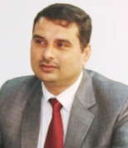  Dr. Anil Kumar Singh
 | Designation | Professor & Dean (Academic affairs)
 | Department | Information Technology
 | Date of Joining the Institution | 01/09/2005
 | Qualifications with Class/Grade | Ph.D. M.Sc., MCA First Division
 | Total Experience in Years | Teaching 25 Years Industry Nil Research 16 Years
 | Papers Published | National 04 International 21
 | Papers Presented in Conferences | National 02 International 04
 | PhD Guide? Give field & University | Nil
 | PhDs / Projects Guided | Nil
 | Books Published / IPRs / Patents | Nil
 | Professional Memberships | - Indian Science Congress Association (Life Time)  - Continuing Education Growth and Research(Life Time)
 | Consultancy Activities | Nil
 | Awards | - Best Computer Teacher award 2013 by Gaurwanjali, Kanpur  - Yiung Faculty award 2017 by CEGR New Delhi
 | Grants fetched | Nil
 | Interaction with Professional Institutions | Session Chair, Reviewer, Technical Advisor & Judge of various events, Exteranal Examiner

15
Name of Teaching Staff* | 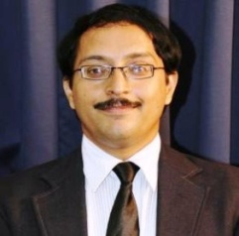  Mr. Anand Kumar Dixit
Designation | Assistant Professor
Department | MCA
Date of Joining the Institution | 10/07/2017
Qualifications with Class/Grade | Ph.D., M.Tech (IT), MCA (1st with Hons)
Total Experience in Years | Teaching 18 Years Industry Nil Research 6
Papers Published | National 07 International 19
Papers Presented in Conferences | National 01 International 12
PhD Guide? Give field & University | Nil
PhDs / Projects Guided | Nil
Books Published / IPRs / Patents | Nil
Professional Memberships | Member of an International Association of Engineers (IAENG)¬  Member of Internet Society (IS)¬  Member of Computer Science Teachers Association (CSTA)¬
Consultancy Activities | Nil
Awards | Rewarded by Akhil Bharatiya Vidyarthi Parishad  Shikha Gaurav Samman 2017 by Asha Smridhi Foudation
Grants fetched | Nil
Interaction with Professional Institutions | Pranveer Singh Institute of Technology, Kanpur  Subhash Institute of Software Technology ,Kanpur

16
 | Name of Teaching Staff* | Mr. Adarsh Srivastava
 | Designation | Assistant Professor
 | Department | 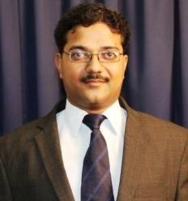  MCA
 | Date of Joining the Institution | 16/02/2009
 | Qualifications with Class/Grade | MCA, M.Tech (IT), Ph.D(Pursuing)
 | Total Experience in Years | Teaching 16 Years Industry NilResearch Nil
 | Papers Published | National 06 International 06
 | Papers Presented in Conferences | National Nil International 06
 | PhD Guide? Give field & University | Nil
 | PhDs / Projects Guided | Nil
 | Books Published / IPRs / Patents | Nil
 | Professional Memberships | Nil
 | Consultancy Activities | Nil
 | Awards | Nil
 | Grants fetched | Nil
 | Interaction with Professional Institutions | Nil

17
Name of Teaching Staff* | Ashish Mishra
Designation | Assistant Professor
Department | 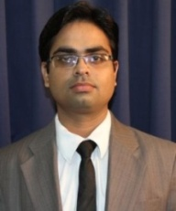  MCA
Date of Joining the Institution | 16/08/2010
Qualifications with Class/Grade | MCA First Class, Ph.D(Pursuing)
Total Experience in Years | Teaching 17 Years Industry 2 Years Research Nil
Papers Published | National Nil International 04
Papers Presented in Conferences | National Nil International 01
PhD Guide? Give field & University | Nil
PhDs / Projects Guided | Nil
Books Published / IPRs / Patents | Nil
Professional Memberships | Nil
Consultancy Activities | Nil
Awards | Nil
Grants fetched | Nil
Interaction with Professional Institutions | Nil

18
 | Name of Teaching Staff* | 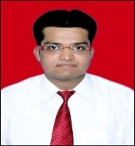  Pawan Omar
 | Designation | Assistant Professor
 | Department | MBA
 | Date of Joining the Institution | Sept 13,2019
 | Qualifications with Class/Grade | B.Com,MBA,CMA(Intermediate),PGDBO,Ph.D(Pursuing)
 | Total Experience in Years | Teaching 8 Industry 3 Research NA
 | Papers Published | National 04 International 07
 | Papers Presented in Conferences | National NA International 07
 | PhD Guide? Give field & University | NA
 | PhDs / Projects Guided | NA
 | Books Published / IPRs / Patents | NA
 | Professional Memberships | NA
 | Consultancy Activities | Imparting consulting activities as Guest faculty at renowned Colleges,Institutes,organisations etc for Motivations,communications,Personality development,placements,career counselling sessions.
 | Awards | Falicitated as "Best Teacher & Innovator" in Guru Brahma Awards-2020 by Muskuraye Kanpur,,Awarded for the unwavering Commitment to solve Social problem by Dr.Reddy's Foundation(DRF).Awarded as the Best External Faculty for Communication Skills by Ordinance Equipement Factory of Learning(OEFL,Knp),Best Motivational Speaker Award by CSJMU-Kanpur,Also received Various awards in the field of Education,Teaching,Skillups & Career Development by Various Institutions and Government Organisation.
 | Grants fetched | Nil
 | Interaction with Professional Institutions | Kanpur Management Association(KMA),All India Management Association(AIMA),ICSI,ICWAI,IRCCI(Indian Rural Chamber of Commerce & Industry),NCSDE,National Entrepreneurship Development edgeCouncil(NEDC),Institute of Business Management(CSJMU),VSIPS,SIIC-IIT,Kanpur,MSME &NSIC,Guest Speaker in areas of Management/Personality Development,Entrepreneurship & Communication Skills,Bank-Edge Academy

19
Name of Teaching Staff* | Mr. Vishnu Kumar Shukla
Designation | Assistant Professor
Department | M.C.A.
Date of Joining the Institution | 11/12/2017
Qualifications with Class/Grade | B.Sc. (MATHS), M.C.A.
Total Experience in Years | 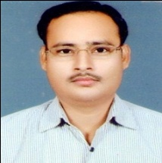  Teaching 19 I ndustry 01 Research Nil
Papers Published | National 06 International 08
Papers Presented in Conferences | National 02 International 06
PhD Guide? Give field & University | Nil
PhDs / Projects Guided | Guiding several UG & PG (Computer Science) Aspirants for their Research Work, Company Internship (Project Training), Industrial Job Oriented Training Program and Software Development.
Books Published / IPRs / Patents | Nil
Professional Memberships | Nominee Member of CSI (Computer Society of India)
Consultancy Activities | Intellectual Knowledge Partner for Private Body, delivering a Special Lecture on ICT for Medical UG Courses, Production of Intellectual works such as chapter writing, articles and research papers, Serving of Academic Activity for Higher Education, CBSE,NCTE,NCVT (Affiliation, Approval, Teacher Approval Process, Seat Increment/Decrement), Serving on Government related activity for private body and Counsellors/Mentors/Software Trainer for Computer Science-UG & PG Aspirants.
Awards | Nil
Grants fetched | Nil
Interaction with Professional Institutions | External Examiner /(Engaging with evaluation work in various universities), Judge of various events (e.g. Nehru Yuva Kendra Sangathan Programmes, Kanpur Chapter, Senior Wings of WKPS, Kanpur) and Industry Interaction (TCS, Infosys, HCL , Accenture, Tech Mahindra) & Academic Interaction (Engineering, Management Institute and University -Private and Government body -IIT Kanpur, HBTU, Dept. of Heigher Education UP, Lucknow University, Kanpur University, AKTU, AICTE )
20
Name of Teaching Staff* | 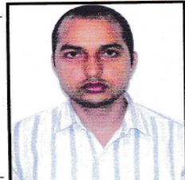  Mr. Sandeep Singh
Designation | Assistant Professor
Department | MCA
Date of Joining the Institution | 1/12/2017
Qualifications with Class/Grade | MBA
Total Experience in Years | Teaching 08 Industry 11 Research Nil
Papers Published | National Nil International 02
Papers Presented in Conferences | National Nil International Nil
PhD Guide? Give field & University | Nil
PhDs / Projects Guided | Nil
Books Published / IPRs / Patents | Nil
Professional Memberships | Nil
Consultancy Activities | Nil
Awards | Nil
Grants fetched | Nil
Interaction with Professional Institutions | Nil

21 | Name of Teaching Staff* | Ms. Priya Chopra Arora  
 | Designation | Assistant Professor
 | Department | MBA
 | Date of Joining the Institution | 01/08/2020
 | Qualifications with Class/Grade | B.com, MBA, B.ED and pursuing PHD
 | Total Experience in Years | Teaching 5 years Industry 5.5 years Research Nil
 | Papers Published | National -4 International -5
 | Papers Presented in Conferences | National International -5
 | PhD Guide? Give field & University | Nil
 | PhDs / Projects Guided | Nil
 | Books Published / IPRs / Patents | Nil
 | Professional Memberships | Nil
 | Consultancy Activities | Nil
 | Awards | Nil
 | Grants fetched | Nil
 | Interaction with Professional Institutions | Nil
22

 | Name of Teaching Staff* | Dr. Meenakshi Jaiswal  
 | Designation | Assistant Professor
 | Department | MBA
 | Date of Joining the Institution | 05/09/2021
 | Qualifications with Class/Grade | B.Sc, MBA , EPAF, PhD
 | Total Experience in Years | Teaching 11 Years Industry 0 Research Nil
 | Papers Published | National International
 | Papers Presented in Conferences | National International
 | PhD Guide? Give field & University | Nil
 | PhDs / Projects Guided | Nil
 | Books Published / IPRs / Patents | Nil
 | Professional Memberships | Nil
 | Consultancy Activities | Nil
 | Awards | Nil
 | Grants fetched | Nil
 | Interaction with Professional Institutions | IIM-CALCUTTA, INTEGRAL UNIVERSITY

23 | Name of Teaching Staff* | Dr. Akshat Gupta  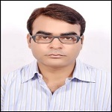
 | Designation | Assistant Professor
 | Department | MBA
 | Date of Joining the Institution | 16/02/2021
 | Qualifications with Class/Grade | B.com., M.com., MBA, Ph.D, LL.B, B.Ed
 | Total Experience in Years | Teaching 11 Yrs Industry 3 yrs Research 3yrs
 | Papers Published | National-04 International-04
 | Papers Presented in Conferences | National International-04
 | PhD Guide? Give field & University | Nil
 | PhDs / Projects Guided | Nil
 | Books Published / IPRs / Patents | Nil
 | Professional Memberships | Nil
 | Consultancy Activities | Nil
 | Awards | Nil
 | Grants fetched | Nil
 | Interaction with Professional Institutions | College of Management Studies(CMS), VSGOI , PT. Kundanlal Sharma College , Allenhouse Businees School , Motilal Rastogi School of Management (LKO)

24
Name of Teaching Staff* | Mr. Aman Kesharwani  
Designation | Assistant Professor
Department | MCA
Date of Joining the Institution | 01.11.2024
Qualifications with Class/Grade | BCA, MCA, PHD(Pursuing)
Total Experience in Years | Teaching 8 Yrs Industry yrs Research
Papers Published | National-2 International- 8
Papers Presented in Conferences | National -0 International - 8
PhD Guide? Give field & University | Nil
PhDs / Projects Guided | Nil
Books Published / IPRs / Patents | 2
Professional Memberships | Nil
Consultancy Activities | Nil
Awards | Nil
Grants fetched | Nil
Interaction with Professional Institutions | Kanpur Institute of Technology, Rooma ,Kanpur  Allenhouse Institute of Technology, Rooma ,Kanpur

25

Name of Teaching Staff* | CS SHANTANU KUMAR  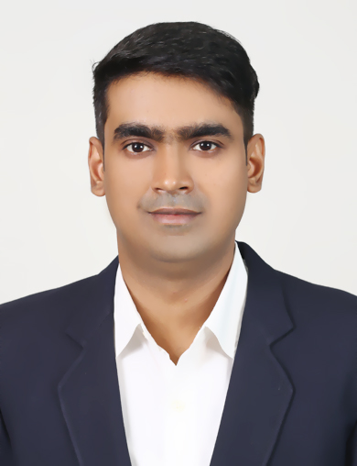
Designation | Assistant Professor
Department | Management Department
Date of Joining the Institution | 11.04.2025
Qualifications | Member of Institute of Company Secretaries of India  Associate Member of Chartered Institute for Securities & Investment,U.K  Qualified CA PCC (Intermediate) in November,2010  Qualified M.COM in May,2017  Qualified MBAfrom Shobhit University, Meerut (Distance Learning School) in May,2014  Registered GST Practitioner with GSTN, Govt. Of India  Certified CSR Professional  ESG Analyst (awarded by ICSI)  Pursuing PhD in Business Managementfrom CSJM University-K
Total Experience in Years | Teaching 11 Yrs Industry yrs Research
Papers Published | National-2 International- 2
Papers Presented in Conferences | National -0 International - 6
PhD Guide? Give field & University
PhDs / Projects Guided | Nil
Books Published / IPRs / Patents | Patent-AI- Enabled Mobile Device for Logistics Facility Management (Design No- 438796-001, date- 28/11/2024)  Book Chapter-Pathways to Viksit Bharat 2047: Aligning India’s Development Vision with the Sustainable Development Goals (Book Name- Viksit Bharat @ 2047)
Professional Memberships | Institute of Company Secretaries of India (Membership No- 68595)  Chartered Institute for Securities & Investment, London, U.K (Membership No- 354957)
Consultancy Activities | Nil
Awards | National Stock ExchangeCertified Market Professional (NCMP)
Grants fetched | Nil
Interaction with Professional Institutions | The Institute of Chartered Accountants of India,  Institute of Company Secretaries of India,  Chartered Institute for Securities & Investment, U.K,  Singapore Green Finance Centre (SMU)
26
 | MCA | MBA
Admission quota# | UPSEE | UPSEE
Entrance Test / admission criteria | As per AKTU norms | As per AKTU norms
Cut off / last candidate admitted | As per AKTU norms | As per AKTU norms
Fees in rupees | Rs. 68700/- p.a. | Rs. 74000/- p.a.
Number of Fee Waivers offered | Nil | Nil
Admission Calendar | As per AKTU norms | As per AKTU norms
PIO quota | Nil | Nil
27

Infrastructural information | 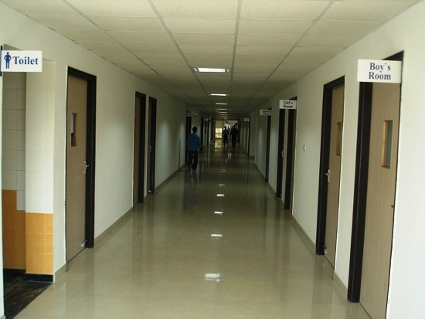
Class Room /Tutorial Room facilities | Yes  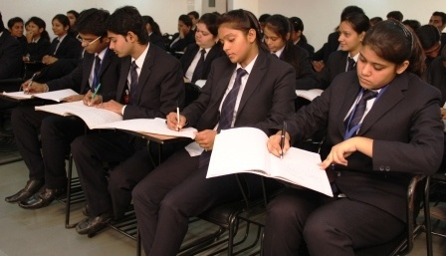
Laboratory details | Yes
Computer Centre facilities | Yes  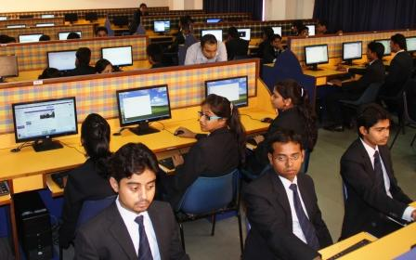
Library facilities | 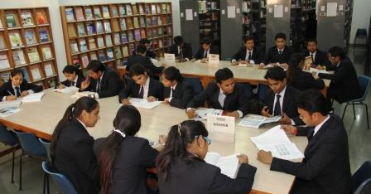  Yes
Auditorium /Seminar Halls /Amphi | 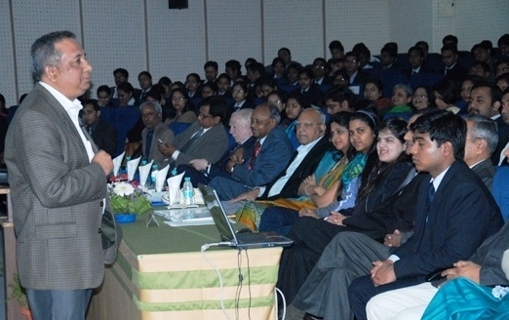  Yes
Cafeteria | Yes
Indoor Sports facilities | 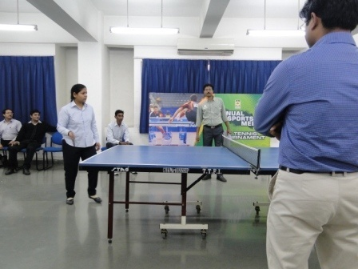  Yes
Outdoor Sports facilities | 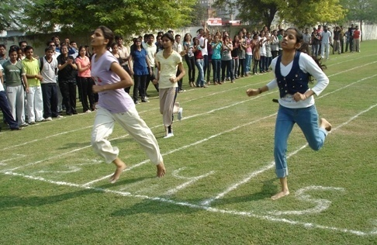
Gymnasium facilities | No
Facilities for disabled | Ramp,Lift, Special Washroom for Disabled
Any other facilities | Wi-Fi Campus; Centralised air-conditioned classes & DTH
Boys Hostel | Yes
Girls Hostel | PG
Medical & other facilities at Hostel | No
Academic Sessions | 2024-25
Examination system, Year / Sem | MCA/MBA - Semester (6 Months)
Period of declaration of results | 2 Years
Counseling / Mentoring | Yes – Through various counseling committees
Career Counseling | Yes – Through training & placement
Medical facilities | Yes
Students Insurance | Yes- Group Insurance for Students
Students Activity Body | Yes
Cultural activities | Yes
Sports activities | Yes
Literary activities | Yes
Magazine / Newsletter | Yes  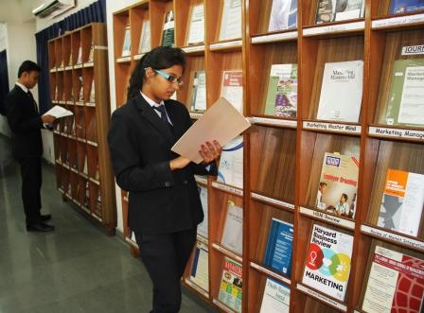
Technical activities / TechFest | Yes
Industrial Visits / Tours | 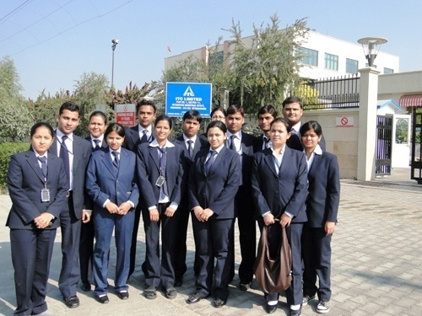  Yes
Alumni activities | Yes
Name of the Information Officer for RTI | NA
Designation | NA
Phone No. with STD code | 0512-2601126
Fax No. with STD code | NA
Email | adminjim@jef.org.in

